# Citric Acid Cycle

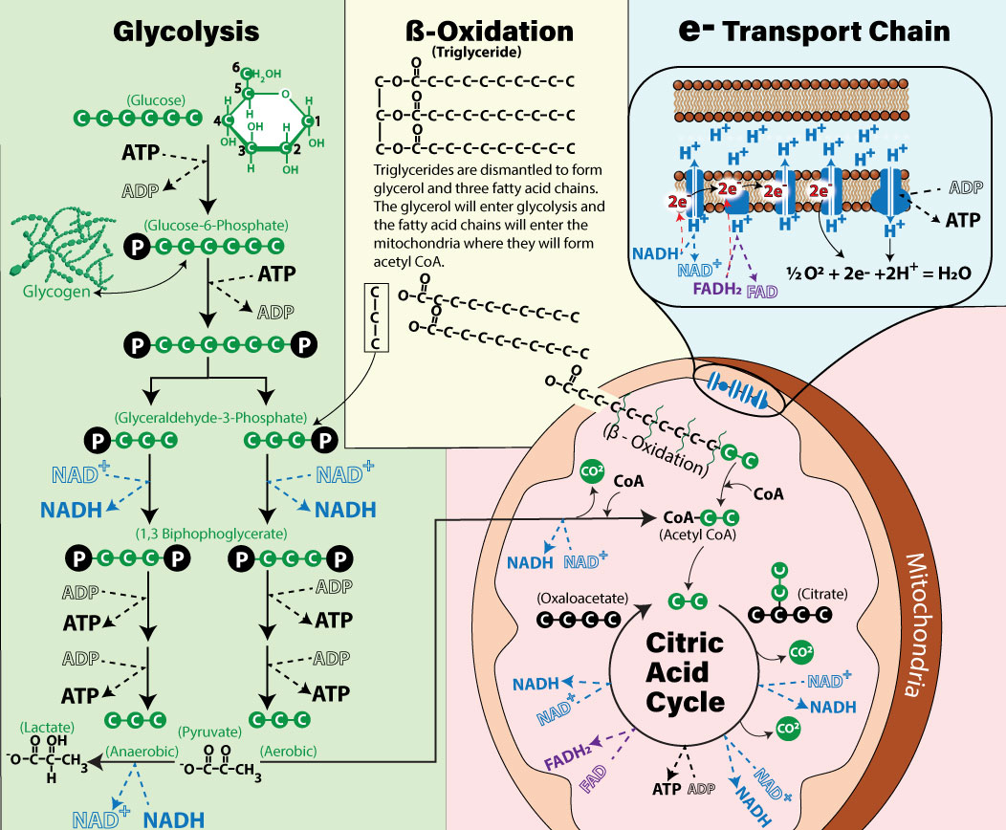

Image by JS W25

Before high-energy electrons can be delivered to the electron transport chain with NADH and FADH2 , they are first harvested in an earlier part of metabolism known as the **Citric Aid Cycle**, or the **Krebs Cycle**. This cycle also takes place in the mitochondria (represented by the pink shaded area of the image above) and is a critical step in cellular respiration. It begins with a molecule called acetyl-CoA. Through a series of chemical reactions, the citric acid cycle generates NADH and FADH2 by removing electrons and hydrogen ions from carbon-containing molecules. These electron carriers, NADH and FADH2, then transport the high-energy electrons to the electron transport chain. The citric acid cycle also produces a small amount of ATP directly and releases carbon dioxide as a byproduct. However, its primary role is to continue breaking down fuel molecules and to produce the NADH and FADH2 needed for the electron transport chain.

The citric acid cycle can start extracting energy from lipids, proteins, and carbohydrates after they are broken down to intermediates that enter the mitochondrial matrix. All of the intermediates will eventually form acetyl-CoA.

* **Carbohydrates**: Carbohydrates like glucose are broken down into two molecules of pyruvate. Pyruvate then undergoes a reaction to form acetyl-CoA, which enters the citric acid cycle.
* **Lipids:** Lipids, particularly triglycerides, are broken down into fatty acids and glycerol. Fatty acids go through a process called beta-oxidation, where they are broken down into two carbon units that form acetyl-CoA. This acetyl-CoA then feeds directly into the citric acid cycle.
* **Proteins:** Proteins are first broken into amino acids. Some amino acids can be converted into acetyl-CoA.

As stated, all three macronutrients: carbohydrates, fats, and proteins, can contribute to the citric acid cycle by generating acetyl-CoA. What Is Acetyl-CoA?Coenzyme A (CoA) is derived from Vitamin B5 (pantothenic acid), CoA acts as a carrier for acetyl groups. The “acetyl” prefix indicates the 2-carbon group attached to CoA, forming acetyl-CoA.

#### Key Points of the Citric Acid Cycle

The citric acid cycle has many steps, but the most important takeaways are:

* **Cycle Start:** Combining Acetyl and Oxaloacetate. The cycle begins with a 4-carbon molecule, oxaloacetate, which combines with the 2-carbon acetyl group from acetyl-CoA. This combination forms a 6-carbon molecule, citric acid.
* **Progress citric acid through the cycle:** As citric acid progresses through the cycle, it undergoes changes, eventually regenerating oxaloacetate, hence, the name “Citric Acid Cycle.”
* **CO2 Production:**During the cycle, carbon dioxide (CO2) is released. This means that each carbon from glucose, fats, or amino acids is ultimately expelled as CO2 , explaining why breathing is necessary to expel this byproduct.
* **NADH Formation:** As hydrogens and electrons are transferred to NAD+, NADH is formed (reduced), yielding NADH molecules.
* **FADH2 Production:** FAD is reduced to FADH2 during the cycle.
* **Substrate Level Phosphorylation:**  ATP Production occurs as ADP is phosphorylated directly. This ATP generation does not require the electron transport chain to generate the ATP. Each cycle turn generates one ATP through substrate-level phosphorylation.

The citric acid cycle lies at the heart of cellular energy production, converting diverse fuel sources into ATP.  Carbohydrates, fats, and proteins contribute to the citric acid cycle by supplying a constant source of Acetyl CoA. In the next section we will take a closer look into how Carbohydrates are used to provide acetyl CoA to the mitochondria.

Read this online at <https://books.byui.edu/bio_264_anat_phys_I/qjoowiidmm>