# Membrane Composition

## Fluid Mosaic Model of the Cell

One of the challenges faced by all living things including cells is to separate their internal environment from the external environment. Critical nutrients must get into the cells, and waste must get out. To make matters more complex, cells need to be able to regulate that movement, letting the materials cross sometimes and preventing them from crossing at others. The solution to these challenges lies in the properties of the cell membrane (also called the plasma membrane). This delicate structure is essential to the life of cells. When the membrane loses its ability to carry out these processes, the cell dies.

The plasma membrane is more than just a sack to hold the contents of the cell. The cell membrane responds to countless chemical messengers in ways that alter the activity of the cell. As we discuss the structure of the plasma membrane, keep in mind that eukaryotic cells also have membrane bound organelles and this description also applies to internal membranes.

The current model of the cell membrane is called the **Fluid Mosaic Model of the Cell Membrane**. The word fluid implies that the membrane is constantly changing and moving. Indeed, it is not a static structure but one that changes depending on cellular needs and environment. Fluidity, in the context of cell biology, refers to the ability of a biological membrane to move, flex, and adapt its structure. It describes how the lipid molecules and proteins within the membrane can shift and reorganize, allowing the membrane to remain dynamic and flexible rather than rigid. Cell membrane fluidity is influenced by several factors:

1. **Temperature**: Higher temperatures increase fluidity by causing lipid molecules to move more freely, while lower temperatures make the membrane more rigid.
2. **Lipid Composition:** The types of lipids in the membrane affect fluidity. For example, membranes with more unsaturated fatty acids (which have kinks in their structure) are more fluid because they prevent tight packing, whereas saturated fatty acids (with straight chains) pack more tightly and reduce fluidity.
3. **Cholesterol:** Cholesterol helps to maintain membrane fluidity by preventing the membrane from becoming too rigid at low temperatures and too fluid at high temperatures (explained below).

The term mosaic conjures up an image of numerous small and different pieces. Indeed, the membrane contains many different components including various lipids, many unique proteins, and carbohydrates (oligosaacarides).

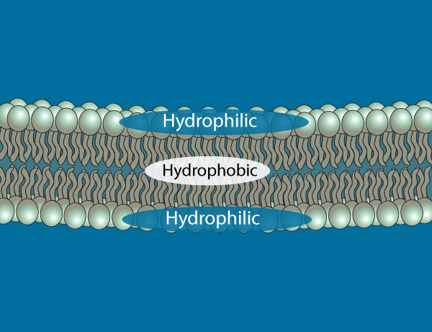

Image by BYUI student Hannah Crowder 2013

A key component of the membrane is a double layer of phospholipids, the phospholipid bilayer. Recall that phospholipids are composed of a hydrophilic head containing a phosphate group and two hydrophobic tails composed of long chain fatty acids. In water, phospholipids can form a bilayer. The hydrophobic fatty acid tails turn away from the water, and the hydrophilic phosphate heads turn towards the water. The hydrophobic core of the membrane creates a barrier, preventing hydrophilic substances, such as ions and large polar molecules, from moving across the membrane. Hydrophobic (lipid soluble or lipophilic) materials, on the other hand, typically move readily across the membrane.

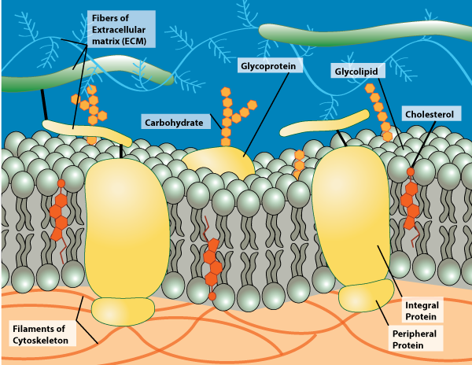

Image by BYUI student Hannah Crowder 2103

Because some things easily pass through the membrane and others do not, we describe the membrane as being selectively permeable or semipermeable. Cholesterol In addition to the phospholipids, another important lipid found in membranes is cholesterol. Cholesterol is a hydrophobic molecule and resides among the fatty acid tails of the phospholipid bilayer. As mentioned above, the membrane exhibits fluidity, allowing movement of components within the membrane. Cholesterol plays an important role in regulating the fluidity of the membrane across a range of temperatures the body is exposed to. While it is true that our core body temperature remains fairly constant, temperatures in our extremities may vary considerably. Think of the range of temperatures the cells in your hands are exposed to. At high temperatures, cholesterol enhances the interactions between phospholipid fatty acids and prevents destabilization and melting of the membrane. At low temperatures, cholesterol prevents phospholipid tail groups from interacting too strongly with each other, a condition which would stiffen the membrane and decrease fluidity. Thus, without cholesterol the membrane might be compromised leading to impaired cellular function.

Together, phospholipids and cholesterol comprise nearly 50% of the membrane (by weight).

## Membrane Proteins

#### Membrane Proteins-peripheral

Making up another 50% of the membrane mass are the membrane proteins. Some of the proteins are found only on the inner or outer surface of the membrane. These are called peripheral or extrinsic proteins because they do not extend through the membrane.

#### Membrane Proteins-integral

Other proteins pass all the way through the membrane. These proteins are called integral or intrinsic proteins and have segments that associate with the hydrophobic region of the membrane. These integral proteins perform a number of important functions in the cell. Based on their functions, these integral proteins can be grouped into six categories outlined below.

|  |  |
| --- | --- |
| **Attachment Proteins:** Integral proteins are involved in attaching cells to each other, as well as to the extracellular matrix (components outside the cell) and to intracellular structural proteins. Often, a peripheral protein functions as a link between the integral proteins and the structural proteins or the extracellular matrix. These attachments can confer tissue strength and shape. The inability to form these connections can result in several pathological conditions, including muscular dystrophy. |  |
| **Marker Proteins:** These proteins allow cells to identify one another. Functions of these marker proteins include the ability of sperm cells to recognize the oocyte during fertilization, as well as the ability of our immune cells to distinguish between our own cells and a foreign cell, such as a bacterial cell, that might be trying to invade our bodies. Glycoproteins (a protein with a *carbohydrate attached) make up a large number of our cellular marker proteins. |  |
| **Transport Proteins:** Integral proteins can act as transporters that facilitate the movement of compounds across the membrane. One type of transport protein, called channels, form a ‘tunnel’ for hydrophilic materials, such as ions and even water to cross the membrane. These channel proteins are usually gated; like a door, they allow substances to cross only when they are open. We will have more to say about channel gating later. |  |
| **Carrier proteins:** Carrier proteins are another type of transport protein. Carriers have sites that bind to specific solutes. For example, one type of carrier binds with glucose, while another carrier binds to urea. Once the solute binds, the carrier protein changes shape, allowing the solute to move across the membrane. Imagine a revolving door. As these doors turn (change shape), they are open to either the inside of the building or to the outside but never to both at the same time. You can enter a revolving door from the outside of a room and move the door until it is open to the inside of the room. At no time in this process was the door open to both sides at the same time. This is how carrier proteins work. Carrier proteins bind to solutes and then move them across the membrane by changing shape. |  |
| **Enzymes:** Integral membrane proteins can function as enzymes, catalyzing important chemical reactions. The enzyme, lactase, which digests the disaccharide lactose in the small intestine, is an integral membrane protein in the cells that line the lumen (inside) of the small intestine. The discomfort associated with lactose intolerance is caused by having insufficient amounts of this enzyme in the body. |  |
| **Receptor Proteins:** Integral proteins may act as receptor proteins and allow the cell to respond to extracellular chemical messengers which regulate the activity of the cell. When a chemical signal (also known as a ligand) binds to its specific receptor protein, it transmits a signal to the inside of the cell through a shape change in its transmembrane protein structure or through receptor aggregation. This shape change will then activate or inhibit intracellular events that result in altered cell function. For example, epinephrine (adrenaline) is a ligand that binds to receptors on specialized cardiac cells causing intracellular changes that make your heart rate increase when you are frightened or experiencing an ‘adrenaline rush.’ |  |

#### G-Proteins - An important group of Receptor Proteins

There are many types of receptor proteins expressed in our bodies, but we will look at one of the most abundant and well-studied: **G-protein coupled receptors(GPCR)**. To date, approximately 800 genes for G protein-coupled receptors have been identified in humans. G-proteins are very common in physiology, and it is important to remember in general terms how they function. The images below give a synopsis.

|  |  |
| --- | --- |
| **The GPCR** complex is composed of two units: a receptor protein that binds to the chemical signal (the **ligand**) and the G protein complex associated with the inner side of the membrane (i.e. a peripheral protein complex). The GPCR has a ligand binding site on the external surface and a G protein binding site on the internal surface. The **G protein complex** is composed of three subunits: the **alpha, beta, and gamma subunits**. |  |
| In its inactive form, the G-alpha, beta and gamma subunits are bound to the GPCR. When a ligand binds to the receptor on the surface of the cell, the GPCR changes shape and the alpha, beta and gamma subunits separate from the GPCR. |  |
| Once separated, the alpha subunit (and sometimes the beta/gamma dimer) can then bind to and either activate or inhibit other proteins. In the image to the right, the alpha subunit has activated another protein called the "effector" in this example. The effector proteins upon activation will create intracellular signaling cascades called ‘**second messengers**’ that result in various cell responses. Examples of cell responses that we will see in this course over future chapters include:   * Activation of metabolic enzymes * Opening or closing ion channels or transporters * Initiation of gene expression * Regulation of cell motility or contractility * Stimulation of glandular secretions |  |

Read this online at <https://books.byui.edu/bio_264_anat_phys_I/hotopfvndn>