# Unit 5 Scriptures

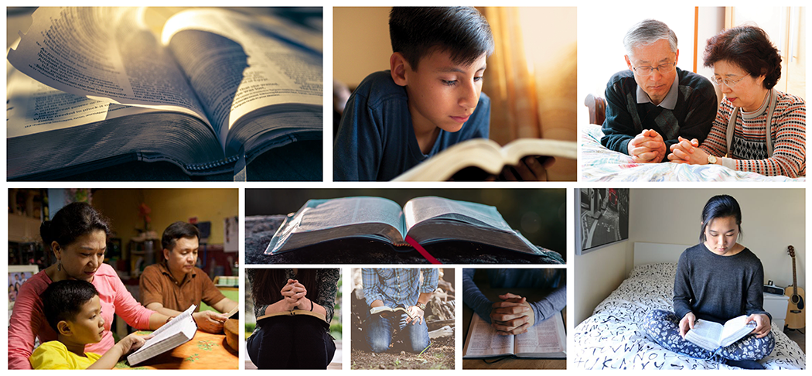

## Husbands and wives have a solemn responsibility to love and care for each other

### John 13:34-35

1. A new commandment I give unto you, That ye love one another; as I have loved you, that ye also love one another.
2. By this shall all men know that ye are my disciples, if ye have love one to another.

### John 15:13

1. Greater love hath no man than this, that a man lay down his life for his friends.

### Ephesians 5:23, 25, 28

1. For the husband is the head of the wife, even as Christ is the head of the church: and he is the saviour of the body. . .
2. Husbands, love your wives, even as Christ also loved the church, and gave himself for it . . .
3. So ought men to love their wives as their own bodies. He that loveth his wife loveth himself.

### D&C 25:5

1. And the office of thy calling shall be for a comfort unto my servant, Joseph Smith, Jun., thy husband, in his afflictions, with consoling words, in the spirit of meekness.

### D&C 42:22

1. Thou shalt love thy wife with all thy heart, and shalt cleave unto her and none else.

### D&C 83:2

1. Women have claim on their husbands for their maintenance, until their husbands are taken; and if they are not found transgressors they shall have fellowship in the church. Mothers and Fathers have a sacred duty to love, teach, and nurture their children.

### Mosiah 4:14-15

1. And ye will not suffer your children that they go hungry, or naked; neither will ye suffer that they transgress the laws of God, and fight and quarrel one with another, and serve the devil, who is the master of sin, or who is the devil spirit which hath been spoken of by our fathers, he being an enemy to all righteousness.
2. But ye will teach them to walk in the ways of truth and soberness; ye will teach them to love one another, and to serve one another.

### D&C 68:25-31

1. And again, inasmuch as parents have children in Zion, or in any of her stakes which are organized, that teach them not to understand the doctrine of repentance, faith in Christ the Son of the living God, and of baptism and the gift of the Holy Ghost by the laying on of the hands, when eight years old, the sin be upon the heads of the parents.
2. For this shall be a law unto the inhabitants of Zion, or in any of her stakes which are organized.
3. And their children shall be baptized for the remission of their sins when eight years old, and receive the laying on of the hands.
4. And they shall also teach their children to pray, and to walk uprightly before the Lord.
5. And the inhabitants of Zion shall also observe the Sabbath day to keep it holy.
6. And the inhabitants of Zion also shall remember their labors, inasmuch as they are appointed to labor, in all faithfulness; for the idler shall be had in remembrance before the Lord.
7. Now, I, the Lord, am not well pleased with the inhabitants of Zion, for there are idlers among them; and their children are also growing up in wickedness; they also seek not earnestly the riches of eternity, but their eyes are full of greediness.

### D&C 93:40-43, 50

1. But I have commanded you to bring up your children in light and truth.
2. But verily I say unto you, my servant Frederick G. Williams, you have continued under this condemnation;
3. You have not taught your children light and truth, according to the commandments; and that wicked one hath power, as yet, over you, and this is the cause of your affliction.
4. And now a commandment I give unto you—if you will be delivered you shall set in order your own house, for there are many things that are not right in your house. . . .
5. My servant Newel K. Whitney also, a bishop of my church, hath need to be chastened, and set in order his family, and see that they are more diligent and concerned at home, and pray always, or they shall be removed out of their place.

### D&C 83:4-5

1. All children have claim upon their parents for their maintenance until they are of age.
2. And after that, they have claim upon the church, or in other words upon the Lord’s storehouse, if their parents have not wherewith to give them inheritances.

## Happiness in family life is most likely to be achieved when founded upon the teachings of the Lord Jesus Christ

### Matthew 5:7-9

1. Blessed are the merciful: for they shall obtain mercy.
2. Blessed are the pure in heart: for they shall see God.
3. Blessed are the peacemakers: for they shall be called the children of God.

### Matthew 7:12

1. Therefore all things whatsoever ye would that men should do to you, do ye even so to them: for this is the law and the prophets

### 3 Nephi 11:29-30

1. For verily, verily I say unto you, he that hath the spirit of contention is not of me, but is of the devil, who is the father of contention, and he stirreth up the hearts of men to contend with anger, one with another.
2. Behold, this is not my doctrine, to stir up the hearts of men with anger, one against another; but this is my doctrine, that such things should be done away.

### D&C 68:9-11

1. Wherefore, I say unto you, that ye ought to forgive one another; for he that forgiveth not his brother his trespasses standeth condemned before the Lord; for there remaineth in him the greater sin.
2. I, the Lord, will forgive whom I will forgive, but of you it is required to forgive all men.
3. And ye ought to say in your hearts—let God judge between me and thee, and reward thee according to thy deeds.

Read this online at <https://books.byui.edu/the_eternal_family/unit_5_scriptures>