# Layers of the Digestive Tract

The digestive system is comprised of a series of hollow organs stretched from mouth to anus. Although subtle differences exist, the anatomy of the digestive tract is very similar among all sections. In cross section the layers of the digestive tract, starting from the lumen, are identified as the: **mucosa, submucosa**, **muscularis** and **serosa** layers.    
Layers of the Digestive Tract.Image by Nate Shoemaker Spring 2016

#### Mucosa

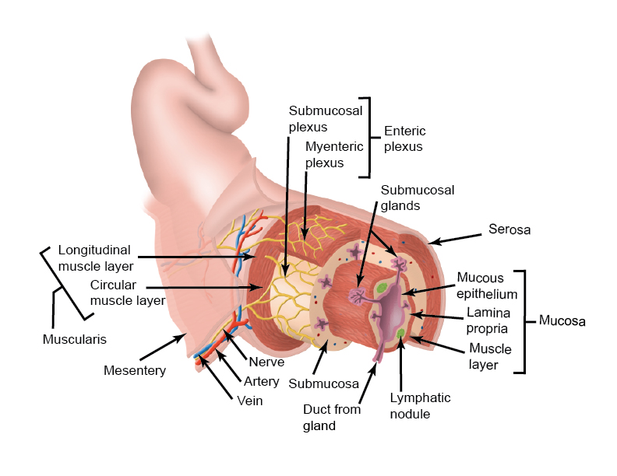

The mucosa is comprised of an epithelial layer and an underlying loose connective tissue layer called the **lamina propria** and a thin layer of smooth muscle called the **muscularis mucosae**. The epithelial cells are organized in a single layer with the most abundant type being the **enterocyte**. The enterocyte is in turn divided into **absorptive enterocytes**, those that express different proteins important for digestion and absorption, and **endocrine enterocytes** (enteroendocrine cells), or those that release hormones necessary for the regulation of digestion. The epithelium of the mucosa varies greatly from one part of the digestive system to the next. For example, the esophageal epithelium is non-keratinized stratified squamous designed solely for transportation, whereas the intestinal epithelium is columnar designed for absorption. In addition, the available surface area also varies being arranged into **villi** and **crypts**. Villi are finger-like projections which are designed to increase surface area and crypts are invaginations designed to house the enteroendocrine cells, as well as stem cells that replace the epithelial cells every 4 to 5 days. The lamina propria is rich in lymph tissues and vessels, capillaries and nerve fibers. The folds and ridges of the mucosa are a result of contractions of the muscularis mucosae.

#### Submucosa

The submucosa, as the name implies (sub) is below the mucosa and consists of loose connective tissue full of interweaving large blood vessels. In addition, the submucosa in some sections contains large glands that secrete material into the lumen of the digestive system. The submucosa also contains one of the two neural plexuses of the enteric nervous system, the **submucosal plexus**, which primarily directs the glandular secretions.

#### Muscularis

The muscular layer contains two layers of smooth muscle, an **inner circular layer** and an **outer longitudinal layer**. Within these two layers is the second nerve plexus called the **myenteric nerve plexus** that controls the contraction of these layers. An important action of this layer is its ability to generate **peristalsis** contractions which propel the food through the tract.

#### Serosa

The serosa is connective tissue that envelops the tubes and maintains lubrication. Imagine what might happen to the tubes following a good trampoline jumping without the serosa to keep them from sticking together.

Read this online at <https://books.byui.edu/bio_461_principles_o/511__layers_of_the_d>