# Carbohydrates

The digestive process can be initiated by sight, smell, taste, and even the thought of experiencing those things. Although some enzymatic digestion begins in the mouth, most of this process occurs in the small intestine. We will begin our discussion of digestion by starting with the carbohydrate, which provides 45% of the total energy needs of the American diet.

Carbohydrates are classified into three groups: **monosaccharides**, **disaccharides** and **polysaccharides**. The small intestine has the ability to absorb monosaccharides but not disaccharides or polysaccharides. Therefore, enzymes are necessary to convert the disaccharides and polysaccharides to monosaccharides prior to absorption. About 50% of dietary carbohydrate is in the form of starch which is the storage form of carbohydrates in plants. The storage form of carbohydrates in animals is the polysaccharide glycogen.  Both plants and meat are polymers of glucose molecules. Most of the dietary carbohydrates that are disaccharides are ingested as sucrose or lactose (40%). Dietary monosaccharides are fructose and glucose, and make up the remaining 10%.

Remember, only monosaccharides can be absorbed from the small intestine into the blood, therefore all carbohydrates must be enzymatically digested to their simplest form (monosaccharide) before transport can take place. Some polysaccharides cannot be broken down at all because our bodies lack the necessary enzymes. These polysaccharides are known as **fiber**. Fiber is found in all kinds of plants, for example, the outer covering of corn kernels is composed of fiber. Thus, if you don't chew the corn, it can move through the entire digestive system without receiving a single scratch—in fact it won't even change color. Still, fiber is a very important component for the digestive system as it helps keep the stool loose and moving. Stool that doesn't move through the digestive system can be very unpleasant.

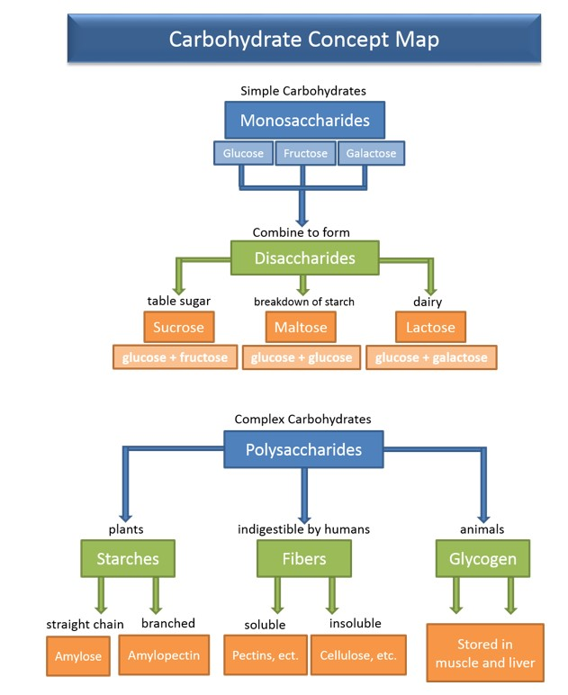

#### Carbohydrate Digestion

The process of digestion is really a discussion of enzymes and their ability to cleave or break bonds. Polysaccharides are put together using three different kinds of bonds between the monomers, these bonds are called: alpha 1- 4, alpha 1- 6 and beta 1- 4 linkages. The first enzyme that a carbohydrate will encounter is found in the salivary secretions of the mouth and is known as **salivary amylase**. Salivary amylase can hydrolyze (break) alpha 1- 4 bonds but is quickly inactivated by the stomach acid. The majority of carbohydrate digestion occurs in the small intestine through the actions of **pancreatic amylase**. Pancreatic amylase is also specific for most alpha 1- 4 bonds, but since carbohydrates are a combination of all types of bonds, the digestion is incomplete.

Amylase only acts on internal bonds in the polysaccharide chain, it cannot cleave individual glucose molecules from the chain. To complete digestion the small intestine has specific enzymes that are located on the apical membranes of the enterocytes (small intestinal epithelial cells), called **brush border enzymes**. These enzymes are able to hydrolyze alpha 1- 4 bonds left by amylase as well as alpha 1- 6 bonds and some beta 1-4 bonds. You have probably heard of some of these brush border enzymes as they are named after the carbohydrate that they are most specific for, for example, **lactase,** **sucrase and maltase**. Lactase is specific for the disaccharide lactose (beta 1-4 bonds), and sucrase is specific for the disaccharide sucrose (Alpha 1-2 bonds). Maltase digests maltose (alpha 1-4 bonds but too small for amylase), which is a product of the action of amylase on starch and glycogen. The end result is that all of the ingested carbohydrates are converted to their simplest form; **glucose**, **galactose** or **fructose**.

Most animals do not contain enzymes that can break beta 1- 4 bonds. These bonds are found in fiber, however, certain types of bacteria can breakdown the bonds. Cows or animals that eat grass (high in fiber) have large amounts of bacteria in different chambers of their stomachs that help them break down the fiber to usable sources of monosaccharides. Even though we cannot breakdown fiber, it is still an important component of a healthy diet to help keep the stool loose and moving. High fiber diets have also been shown to reduce the risk of colon cancer and to decrease absorption of cholesterol. Individuals that are lactose intolerant have stopped making the brush border enzyme lactase and therefore have lost the capacity to digest lactose. This is actually the normal process since most mammals do not consume milk as adults. It is only humans that are descendants of groups that have domesticated cattle and goats that are not predominantly lactose intolerant. Undigested carbohydrates that are washed down to the large intestine can cause a plethora of unwanted side effects, such as diarrhea, cramping and extreme flatulence, the latter is only desirable at a few unique events like scout camp or when you stay up too late with your friends.

#### Carbohydrate Absorption

Following digestion and, in order to be moved from the lumen to the blood, the three monosaccharides, glucose, galactose or fructose, must first enter in through the apical membrane of the enterocyte and then exit through the basal membrane to complete absorption. Glucose and galactose are brought through the apical membrane through a Na+ co-transporter known as the sodium-glucose transport proteins (SGLT). This co-transporter is a secondary active transporter that is driven by the Na+ gradient established by the primary active transporter Na+/K+ ATPase. Fructose cannot be transported with Na+ but instead is moved through the membrane by facilitated diffusion through a transporter called GLUT 5. Once inside the cell a single basally located transporter is used to transport glucose, galactose or fructose called GLUT 2.

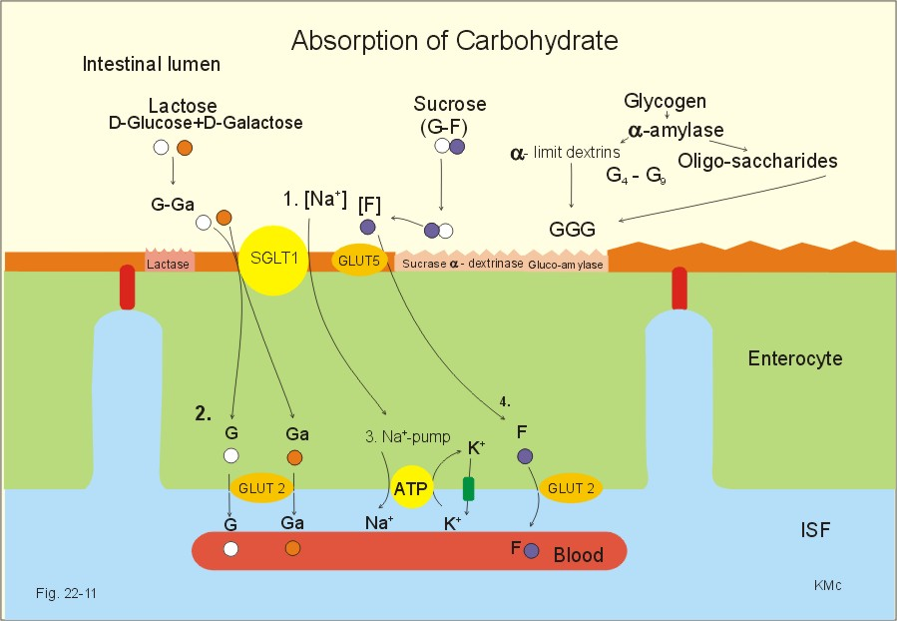

### Clinical Pearl - (Fructose Metabolism)

The metabolism of macronutrients like proteins, carbohydrates and fats are used to produce energy in the form of ATP. However, in the case of the monosaccharide fructose, metabolism can cause a rapid depletion in ATP. This is because the enzyme that uses ATP to phosphorylate fructose during metabolism (fructokinase) does not slow down as ATP levels drop. Thus, consuming high amounts of fructose can lead to rapid ATP depletion. With the rapid decrease in ATP there is a correlated increase in ADP and AMP. So much so, that ADP and AMP begin to overwhelm the enzymes trying to rebuild ATP. Whenever enzymes begin to be overwhelmed, they often turn to shuttle pathways to remove the buildup. In the case of AMP, this shuttle pathway leads to the activation of another enzyme called AMP deaminase, which breaks down AMP to uric acid. Uric acid can then be extruded from the cell and excreted in the urine, but if uric acid builds up to quickly it results in oxidative stress which effects the mitochondria by inhibiting the citric acid cycle. This inhibition leads to the accumulation of citrate, and this accumulation leads to another shuttle pathway that stimulates fat production.

Stated as simply as possible, the consumption of fructose can lead to excess accumulation in fat, but not in all cases. In the case of fructose there seems to be two possible pathways: a caloric pathway and a non-caloric pathway. In the caloric pathway, fructose gets metabolized to CO2 and water, just like glucose and adds a net gain of ATP to the system. However, in the non-caloric pathway, the metabolism of fructose activates an additional reaction that produces uric acid, which leads to fat accumulation. The non-caloric pathway appears to be activated when the animal is constantly in caloric excess. Consider a grizzly bear that is preparing for hibernation. The bear eats everything in sight, keeping itself in an overfed state, so that any fructose (berries, fruits) that enter the system will go through the non-caloric pathway, increasing fat storage in preparation for hibernation. It is an amazing system to help hibernating animals, but in our current culture of caloric excess, the high consumption of fructose, in addition to high calories, appears to be a major factor in metabolic syndrome and obesity.

It gets worse! Apparently, there is another enzyme that is turned on during high glucose states that converts the excess glucose (shuttle pathway, i.e., polyol pathway) to sorbitol and then fructose. This is best measured by the glycemic load of the food, where the higher the glycemic load of the food the higher the level of glucose and the increased chance of the polyol pathway being activated. Thus, as a lead researcher in this area says: “But now we know that it isn’t just the fructose you drink, it’s the fructose you make.” (Rick Johnson).

These effects seem to be exacerbated by age. In other words, youth have very healthy, even hyperactive mitochondria that are almost resistant to the non-caloric pathway of fructose. As a person ages, especially without a lot of exercise, the mitochondria become less and less efficient, and more susceptible to oxidative stress. Interestingly, there are some people born with what is called fructosuria meaning they lack the enzyme fructokinase. These individuals pee out 10% of the fructose they eat and the rest is metabolized through the caloric pathway. Currently, no one with this condition has been shown to be obese or to struggle with diabetes and, most importantly, they can eat all the sugar they want! If only!! You can imagine that research to develop a fructokinase inhibitor is a hot ticket item!

Read this online at <https://books.byui.edu/bio_461_principles_o/carbohydrates>