Regulation of Digestive Secretions
The regulation of digestive secretions results from a complex interplay between cells, hormones, signals, and enzymes. Perhaps a series of teleological questions will help set the stage to explain this interplay:
1. Why does the stomach produce acid, and how does it "know" when to produce acid?
2. How the does the pancreas "know" when to secrete digestive enzymes and bicarbonate into the small intestine?
3. How does the gallbladder "know" when to secrete bile to help emulsify lipids?
To explain the answers to these questions, we'll start with a population of epithelial cells in the stomach. We'll identify six cell types of the stomach: chief cells, mucus-secreting cells, enterochromaffin-like cells, G-cells, D-cells and the parietal cell.
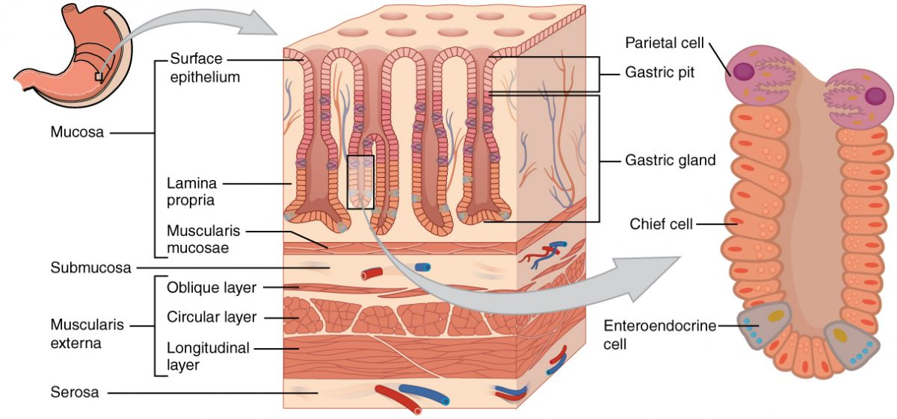

Chief Cells
Chief cells secrete pepsinogen, the inactive form of the protease pepsin, into the stomach lumen. Pepsinogen is converted to pepsin in the presence of acid, thus the stimulus that increases acid production also increases pepsinogen secretion. Chief cells also secrete gastric lipase which can help break down fat, but it is relatively unimportant as most lipid digestion will require pancreatic enzymes that come after the stomach.

Enterochromaffin-like cells (ECL cells)
Enterochromaffin-like cells release histamine that is important in stimulating acid production. Histamine is released locally into the interstitial spaces and stimulates the histamine receptor located on the parietal cell.

G-cell
G-cells produce a hormone called gastrin that they release into the blood which circulates around in the blood until it interacts with receptors found on various cells. Ironically, most of the cells that respond to gastrin are in the stomach, but because gastrin is a protein, secreting it into the stomach acid would render it useless. G-cells are stimulated to release gastrin in response to stomach stretch (distension), acetylcholine from the nervous system through the Vagus nerve, food products like amino acids, and pH changes that are greater than 3. Gastrin essentially turns the digestive system “ON” and stimulates the production of acid and the secretion of pepsinogen.

D-cell
D-cells are found in the stomach, intestine and the Islets of Langerhans in the pancreas. D-cells release somatostatin which has inhibitory actions on the parietal cell, G-cell and the ECL cell. This inhibitory action acts as a type of negative feedback which slows down the digestive system.

Parietal cell
The parietal cells secrete acid and intrinsic factor into the stomach lumen. Intrinsic factor is required for vitamin B12 absorption later on in the ileum of the small intestine. Without intrinsic factor, a person will become severely anemic because vitamin B12 is very important to the production of red blood cells.
As may be evident, many of these cells have actions on the hydrochloric acid production of the stomach. The parietal cell is one of these and therefore a detailed explanation of acid secretion is illustrated below:
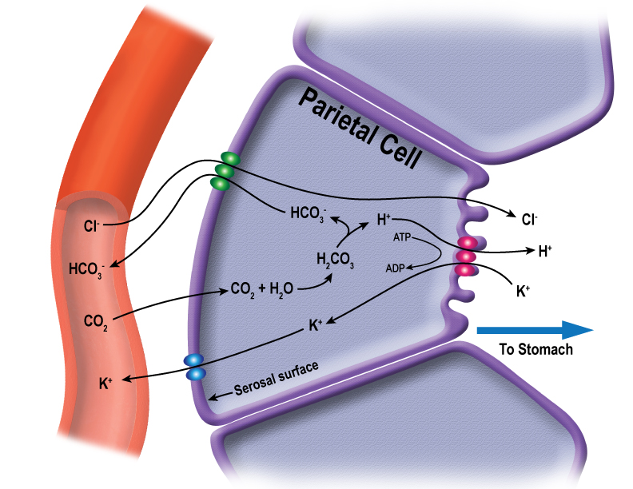
The parietal cell contains a number of important proteins that help regulate acid production. On the basal side is a HCO₃⁻/Cl⁻ exchanger and on the apical side is a H⁺/K⁺ ATPase pump and a Cl⁻ channel. When a parietal cell is stimulated the H⁺/K⁺ pumps extrude H⁺ into the lumen of the stomach in exchange for K⁺. The Cl⁻ that is absorbed from the blood in exchange for HCO₃⁻ is then secreted into the lumen through the Cl⁻ channel. The H⁺ used for the pump is provided by the entry of CO₂ and its conversion to HCO₃⁻ and H⁺ by the actions of the enzyme carbonic anhydrase. Stimulation of the parietal cells occurs directly through the actions of gastrin and histamine binding to their specific membrane receptors on the parietal cell.
In addition, the brain can regulate secretion by releasing acetylcholine, from enteric neurons, which also binds to specific receptors on the parietal cell. Acetylcholine and gastrin can also regulate secretion indirectly by acting on the enterochromaffin-like cell to release histamine. All kinds of drugs have been developed to help reduce acid production; these include histamine receptor blocker drugs (cimetidine) or drugs that selectively block the H⁺/K⁺ ATPase activity (omeprazole).

Mucus-secreting cells
Mucus-secreting cells secrete mucus…. surprise! Finally, something in biology that is named after what it actually does. The mucus is very important to help protect the sensitive cells from the acidic environment of the stomach. The mucus barrier is so effective that ulcers caused by acid damage of the stomach are very rare; in fact, 95% of stomach ulcers are caused by bacterial infections from Helicobacter pylori which destroys the protective mucous membrane and provokes excess acid secretion.

Ulcers
Besides H. pylori infections, peptic ulcer disease can also develop as a result from situations that disturb the balance of digestive hormones, stomach mucosal lining or pH, such as:
- Taking medications that destroy at the lining of the stomach, such as NSAIDs (example: ibuprofen) and corticosteroids.
- Hyperparathyroidism where the high calcium levels in the blood stimulate increased gastric acid secretions.
- Gastrin-producing tumors of the pancreas which increase the production of acid.
- Anything that causes a decrease in the production of pancreatic secretions which buffer stomach acid in the small intestines.
- Increased pepsinogen from chief cells which increases the likelihood that pepsin could digest gastric tissues.
- Reduced somatostatin production from the D-cells which reduces the signal to turn down acid production in the stomach.
Now we will move our discussion on to cells of the small intestines and pancreas. How the does the pancreas "know" when to secrete digestive enzymes and bicarbonate into the small intestine? This answer requires identifying a few more cell types, but these cells are located in the small intestinal epithelium. Within the small intestine are specific cells known as S-cells, I-cells and K-cells.

S-cell
The cell releases a hormone into the bloodstream called secretin. Secretin is released by the S-cell in response to acid from the stomach. Secretin acts in a number of ways:
1. Secretin will bind to receptors on pancreatic cells and induces the release bicarbonate or HCO₃⁻. HCO₃⁻ is released into the ductal system of the pancreas which eventually empties into the small intestine. HCO₃⁻ will help buffer the acidic pH from the stomach make a pH of around 7 in the small intestine. This pH is essential for the activity of the pancreatic enzymes.
2. Secretin will also interact with the G-cell reducing the secretion of gastrin, thus slowing the rate of acid production.
3. Secretin stimulates bile production by the liver.

I-Cell
The I-cell releases a hormone into the bloodstream called cholecystokinin (CCK). Cholecystokinin release is regulated by acid as well as the presence of lipids in the chyme entering the duodenum. Cholecystokinin will act in the following ways.
- Cholecystokinin will interact with pancreatic cells inducing the release of digestive enzymes.
- Cholecystokinin will interact with cells of the gallbladder and induce contraction of the gallbladder, thus releasing bile into the small intestine. Cholecystokinin (CCK) if broken down into its medical terminology means: chole = ‘bile’; cysto = ‘sac’; kinin = ‘move’ or activate; so, all together, the term means a hormone that moves, or activates, the bile-sac or gallbladder. CCK relaxes the sphincter of Oddi while releases pancreatic and gallbladder secretions into the small intestines.
- Cholecystokinin will interact with the pyloric sphincter, causing the sphincter to contract, resulting in a reduced gastric (stomach) emptying.
- Cholecystokinin also has some interactions with the brain in interacting with the satiety (feeling of fullness) centers.
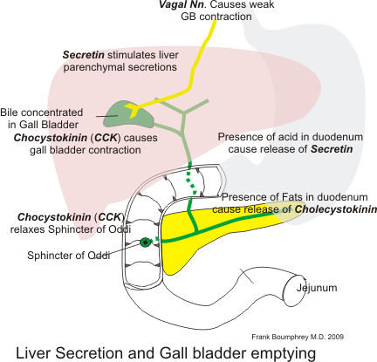

K-cell
Another important cell is the K-cell which releases glucose-dependent insulinotropic polypeptide also called Gastric inhibitory peptide (GIP) that binds to pancreatic beta cells and stimulates the release of insulin. This insulin release is in preparation for the glucose that will start to enter the blood from the small intestine. The effect of GIP is called the incretin effect. Incretins are hormones that induce the release of insulin, in fact, up to 70% of insulin release is due to the effect of incretins, while only 30% is due to the effect of rising blood glucose. GIP is also lipogenic, meaning that it promotes fat storage.

L-Cell
In addition to GIP another important incretin is called glucagon-like peptide (GLP-1) and it is released from L-cells. Both GIP and GLP-1 induce the release of insulin and they stimulate more insulin production by the beta cells, but GLP-1 also decreases glucagon production. GLP-1 reduces gastric emptying and reduces appetite. In fact, agonists to the GLP-1 receptor have shown benefits in obesity treatments.
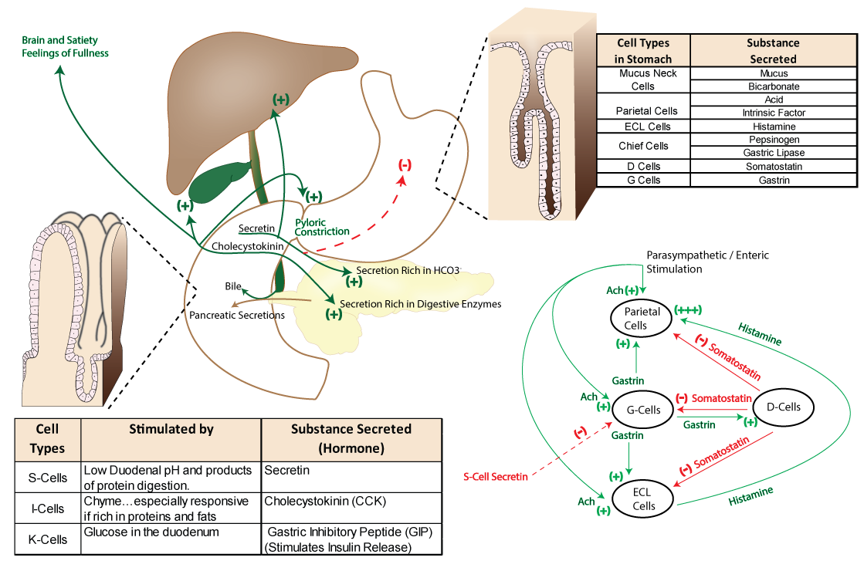
Perhaps a story about a hamburger might help in our understanding of these processes. In our experiences, stories about hamburgers always help.... As we walk into the hamburger joint, our olfactory system is stimulated and immediately our brain sends out signals (acetylcholine) to various parts of the digestive system to "prime" the system. These parts include the salivary glands and the stomach cells (G-cell, ECL-cell, Parietal cell, chief cell). You many have noticed that you begin to salivate even before food enters your mouth. This process is called the cephalic phase of digestion.
As you begin to eat the hamburger the distension of the stomach as well as a reduction in acid, due to the food "soaking" it up, will stimulate additional gastrin release from the G-cells. During this gastric phase of digestion, the gastrin further stimulates production of acid by the parietal cell as well as pepsinogen production by the chief cell. The D-cell will also become involved by the release of somatostatin to serve as a type of brake, to help modulate the system, not stopping it, but rather slowing it down a bit. Partial digestion of the carbohydrate portion of the hamburger begins in the mouth through the actions of salivary amylase, but as the pH in the stomach changes back to a more acidic environment, the amylase will be inactivated. In contrast, the enzyme pepsin will become more active in the presence of acid and begin breaking down proteins. It will take between 3 to 5 hours for the hamburger to completely clear the stomach. This time is dependent on how many hamburgers you ate and the amount of material already present in the intestines.
As the partially digested hamburger chunks begin to move from the stomach to the small intestine, the S-cell will respond to the acid (pH <4) releasing secretin, and the I-cell and the K-cell will respond to the partially digested food products, releasing cholecystokinin and GIP respectively. CCK will in turn stimulate the pyloric sphincter to contract, slowing gastric emptying. It will take 3 to 6 hours to pass all the way through the small intestine. The remaining material that was not absorbed in the small intestine will move to the large intestine where it can take anywhere from 30 to 60 hours to clear.
Read this online at https://books.byui.edu/bio_461_principles_o/regulation_of_digest

