Female Reproductive Anatomy
The images below show the internal female reproductive organs. The first image is a frontal view, and the second image is a sagittal view of these organs. The vagina is an approximately 10 cm long muscular canal that extends from the cervix of the uterus to the vaginal orifice in the vestibule. It has three functions: 1) it is the female organ of copulation and receives the male penis during intercourse; 2) it is the birth canal; and 3) it provides a channel for the monthly menstrual flow. The vagina ends at the cervix of the uterus. The cervix is the outlet of the uterus through which the fetus passes during the birth process. The uterus (also known as the womb) is a pear-shaped organ about 7.5 cm long, 5 cm wide and 3.0 cm thick. These dimensions apply to the non-pregnant uterus. During pregnancy, it will be much larger. As can be seen above, the uterus bends anteriorly and sits on top of the bladder. This position creates issues during pregnancy, as it pushes down against the bladder and significantly reduces the volume of the bladder.
The walls of the uterus are divided into three layers. The first layer, starting from the inside, is the endometrium. This is an epithelial lining composed of simple columnar epithelium. The endometrium can be further divided into two layers - an outer functional layer and an inner basal layer. The functional layer undergoes the changes associated with the menstrual cycle, and it is this layer that is sloughed off during menstruation. The inner layer is composed of the stem cells that will proliferate to replace the functional layer as a new menstrual cycle begins. The changes that occur in the endometrium during the menstrual cycle will be described later. The bulk of the uterine wall, the myometrium, is a thick layer of smooth muscle. During labor, the smooth muscle of the myometrium contracts rhythmically and is responsible for expelling the fetus from the uterus. The outermost layer, the perimetrium, is a serous membrane that covers the uterus.
Extending from the uterus to the ovaries are the uterine or fallopian tubes. These tubes are about 10 cm long and are lined with ciliated, simple columnar epithelium. They conduct the ovum from the ovary to the uterus. The beating of the cilia and the peristaltic-like contractions of smooth muscle in the uterine wall help move the ovum towards the body of the uterus. The uterine tubes can be divided into several distinct regions. The uterine portion passes through the walls of the uterus. Next is the short, narrow isthmus. The isthmus then widens and becomes the ampulla, the longest and widest part of the uterine tubes (7–8 cm). The ampulla is where fertilization takes place. The distal end of each uterine tube is called the infundibulum. It is not physically attached to the ovary but is open ended and constantly moves over the surface of the ovary to "capture" the ovum upon ovulation. To aid in this function the edges of the infundibulum have long, finger-like extensions called fimbriae that partially surround the ovary.
The ovaries are the female gonads. They are 2–3.5 cm long. Within the ovaries, two important processes occur: folliculogenesis and oogenesis. Folliculogenesis is the process of developing the ovarian follicle while oogenesis is development of the mature ova. As explained later, these two processes occur simultaneously and are intimately associated with each other. In addition, the ovaries produce the key female sex steroids: estrogen and progesterone. These hormones are produced by the cells of the ovarian follicle and later by the corpus luteum. Histologically, the ovaries can be divided into two regions. The central part is called the medulla. Its primary purpose is to provide a path for the blood vessels and nerves to enter the ovary.The outer layer is called the cortex. It is in the cortex that the processes of folliculogenesis and oogenesis take place.
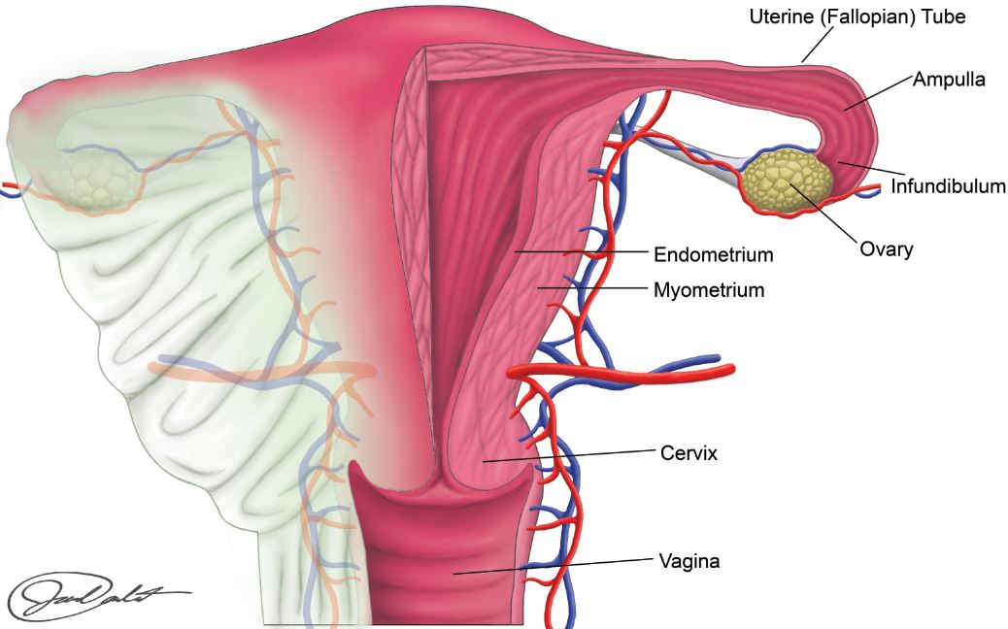
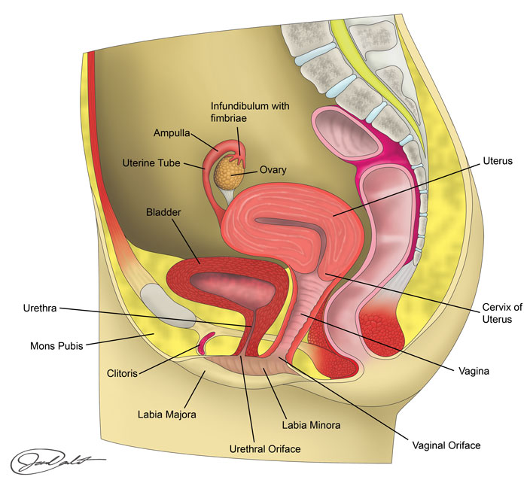
Read this online at https://books.byui.edu/bio_461_principles_o/female_reproductive_

