Filtration
As we discussed in the previous section, filtration is the first step in urine formation. Blood enters the kidneys to be filtered. Blood travels to the afferent arterioles and enters into the glomerulus where it can be filtered through the fenestrated endothelium, the basement membrane and the visceral layer and podocytes. The filtrate then spills into Bowman’s capsule and from there is taken on its journey through the rest of the nephron.
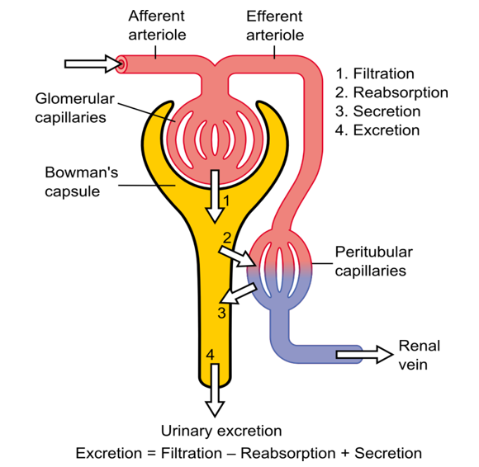

Glomerular Filtration Rate (GFR) and Net Filtration Pressure (NFP)
Although the filtration barrier is very important for the selection of substances, filtration would not occur without pressure. To move from the glomerulus to Bowman’s capsule, pressure must be higher in the glomerulus than in Bowman’s capsule.
The kidneys put special emphasis on glomerular pressure. The rate at which the kidneys filter blood is called the glomerular filtration rate (GFR). The normal GFR is around125 mL plasma/min. If systemic pressure were to drop suddenly, the glomerular pressure would also drop, resulting in a decrease in the glomerular filtration rate, which would result in imbalances in glomerular filtration. To compensate for the drop in blood pressure, the afferent arteriole can dilate, allowing more blood to enter the glomerulus and thus maintaining the pressure. An alternative method would be to constrict the efferent arteriole, causing a "back-up" in blood and increase in the pressure. In contrast, if the systemic blood pressure were to increase, the afferent arteriole would be stimulated to constrict, reducing blood flow, or the efferent arteriole could dilate. These mechanisms of constriction or dilation are part of a regulatory system called autoregulation (discussed later).
Not only is filtration pressure regulated by the afferent and efferent arterioles, but also from the forces within the glomerulus. Just like we learned when studying capillary exchange in the blood, there are hydrostatic and osmotic pressures at work in the glomerulus. The main outwardpressure forcing blood through the filters of the glomerulus is the Hydrostatic Pressure of the glomerulus (HPg) created by the blood flow regulated by the afferent and efferent arterioles of the glomerular capillaries. The HPg is carefully regulated between 50 to 55 mmHg. This outward pressure is resisted or counteracted by the inward pressure from the hydrostatic pressure of the fluid already within the nephron or Hydrostatic Pressure of Bowman’s capsule (HPc) which is typically 15 mmHg. Another inward force drawing fluid back into the blood is created by the proteins that remain in the capillaries, or blood colloid osmotic pressure (BCOP) which is roughly 30 mmHg. The Net Filtration Pressure (NFP) is the outward pressure minus the inward pressure.
Net Filtration Pressure = Hydrostatic Pressure of glomerulus (HPg) minus the sum of Hydrostatic Pressure of the capsule (HPc) and the Oncotic Pressure of the glomerular capillaries (OPg).
NFP = 55 mmHg – (30 mmHg + 15 mmHg) = 10 mmHg
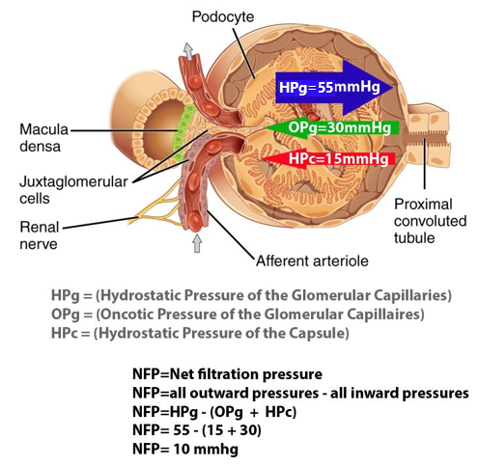
Most capillary beds in the body have a maximum pressure of about 25 mmHg under normal conditions, but the kidney's glomerular capillaries have a pressure of about 55 mmHg. This high pressure is necessary for filtration to occur but also presents some interesting problems that the kidney must compensate for. Since capillaries are very thin walled, they are not designed to withstand high pressure for long periods of time. To help compensate, the renal corpuscle relies on the contractile properties of the mesangial cells.
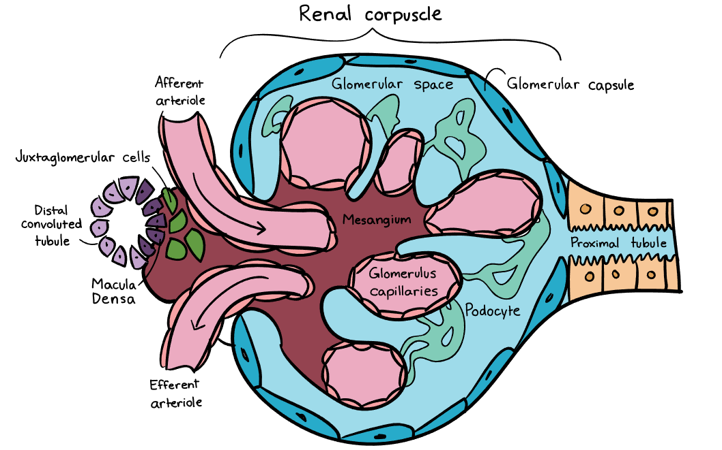
Because the pressure in the glomerulus is so important for filtration, the kidneys go to great lengths to ensure that the pressure stays as close to 55 mmHg as possible.

Regulation of GFR
How do the kidneys "know" when to constrict or dilate the arterioles to maintain GFR? This function falls to the autoregulator components of the kidney.
Autoregulation has two components to it, a myogenic response and a tubuloglomerular feedback response. The myogenic response is due to the intrinsic nature of smooth muscle to “push back when it is pushed”. In other words, the smooth muscle cells surrounding the afferent arteriole contain stretch activated Ca²⁺ channels. If blood systemic blood pressure were to increase that would translate to an increase pressure in the afferent arteriole and a subsequent increases in pressure at the glomerulus. Without regulation, this increase in pressure would increase filtration rates, altering the GFR. In response to the increased pressure and “stretch” of the afferent arteriole wall, the stretch activated Ca²⁺ channels will induce smooth muscle contraction and vasoconstriction. Vasoconstriction will reduce blood flow, returning the pressure in the glomerulus back to normal. This is part of autoregulation because the nervous system doesn’t have to be involved, it is just an intrinsic reflex in the kidney nephron. The myogenic response works well against high blood pressure, but what about low systemic blood pressure situations?
During low systemic blood pressure situations and to ensure that pressure within the glomerulus remains normal, the afferent arteriole must be induced to dilate. This is accomplished through the tubuloglomerular feedback system. This system involves specialized cells in the nephron located at the junction between the ascending and distal tubules. These cells are called macula densa cells and they function to monitor the Na⁺ and Cl⁻ concentrations in the filtrate. If the cells detect lower than normal amounts (due to inadequate filtration) they will release a paracrine hormone called nitric oxide which acts to vasodilate the afferent arteriole. This vasodilation will increase blood flow through the afferent arteriole to the glomerulus helping to maintaining adequate pressure in the glomerulus. When needed, the macula densa cells can also induce vasoconstriction by releasing adenosine. Normally adenosine is a vasodilator, but in the case of the nephron, adenosine works as a vasoconstrictor (different adenosine receptor).This mechanism can occur because of the close association of the macula densa cells with the afferent arteriole. Together they form a structure known as the juxtaglomerular apparatus.
Under extreme conditions of blood loss and subsequent low blood pressures, the kidneys will “ask” for help from the nervous system and the endocrine system. The nervous system will activate sympathetic neurons to release norepinephrine which acts on alpha-1 receptors at the efferent arteriole to vasoconstrict. The endocrine system will release angiotensin II which also acts at the efferent arteriole to vasoconstrict. This vasoconstriction will reduce blood from leaving the glomerulus, and as stated previously, “back-up” blood flow, increasing pressure at the glomerulus.
Read this online at https://books.byui.edu/bio_461_principles_o/filtration

