# Renal Clearance

The concept of renal clearance is a very useful diagnostic tool in medicine. Clearance is a measurement that compares the rate that a substance is filtered back into the bloodstream with the rate at which the kidneys excrete the substance in the urine. The units for renal clearance are milliliters of plasma per minute. This represents the volume of plasma that is completely cleared of a particular substance per minute. For example, if 100 milliliters of filtrate enters the kidney tubules and all of the water is reabsorbed but none of a particular solute, we would say that the renal clearance for that solute is 100 ml/min. On the other hand, if 100 milliliters of filtrate enter the kidney tubules and all of the water is reabsorbed and one-half of a particular solute is reabsorbed, we would say that the renal clearance for the solute is 50 ml/min (i.e. one half of the filtered plasma is cleared of the solute). Each substance that is filtered has a specific clearance value. This value is a function of glomerular filtration, reabsorption, and in some cases, secretion (from the peritubular capillaries into the nephron). Measuring the difference between filtration and excretion allows us to see how the nephron is handling a particular substance in terms of filtration, reabsorption and/or secretion. Renal clearance can be measured by collecting urine over a given time and comparing the concentration of a given substance found in the urine with the concentration of the same substance found in the blood. Mathematically, the relationships for a given substance, say X, are expressed as:

**Cx  =  Ux * V / Px**

Where, Clearance (Cx) = the amount of plasma cleared of a substance (x) per minute;    Ux = the concentration of x in the urine; V= the urine flow rate (or Volume of Urine/time); and Px = the plasma concentrations of x.

As an example, consider that a substance is measured in the urine at a concentration of 100mg/ml, the urine flow rate is 1ml/min, and the plasma concentration is 1mg/ml. The clearance of this substance would be 100ml/min. This means that 100 ml of plasma are cleared of this substance per min. Note: Urine flow rate is computed by collecting all of the urine produced in a certain amount of time, say 60 minutes, and then dividing the volume collected by the time interval. If 60 ml were collected in 60 minutes the flow rate would be 60 ml divided by 60 minutes or 1 ml per minute.

We can also use the clearance equation to determine the glomerular filtration rate (GFR), but only if the substance meets a very strict set of criteria. For a clearance value to equal the GFR the substance must meet the following criteria:

1. The substance must be small and non-charged. In other words, the substance must be freely filtered at the glomerulus with no impediment by the negatively charged membrane or the pore size of the filtration barrier.
2. The substance must not be reabsorbed, secreted, degraded or produced by the nephron. Remember, we are trying to figure out the filtration rate, so the amount filtered must match that found in the urine.

Most substances in the body do not meet these strict criteria, as they are mostly reabsorbed, so their clearance rates will not tell us the GFR. However, the body does produce a substance called creatinine (a metabolic product of creatine) at a constant rate and creatinine meets the above criteria. Thus, determining the clearance of creatinine, by collection of urine through time, will give a good estimate of the GFR, which in turn gives us an overall view of kidney function. A healthy kidney should yield a clearance rate for creatinine and thus a GFR of 97 to 137 ml/min for a male, and 88 to 128 ml/min for a female. Thus, if we apply this concept of clearance and GFR to other substances processed by the kidneys we could use these values to determine:

* How the kidneys handle the particular substance. If the clearance value was 20ml/min (way below the clearance for creatinine) we could deduce that about 80% of the substance was reabsorbed into the plasma. In contrast, if the clearance value was 150ml/min (above the clearance for creatinine) we could deduce that the substance was secreted into the urine.
* The overall health of the kidney. If we measured a creatinine clearance value of 65ml/min, and knowing that a typical clearance for creatinine is between 88 to 137ml/min we could then determine that the GFR is compromised. In the clinical setting it is actually a bit easier than that. Since the production rate of creatinine is constant, creatinine levels will remain constant as long as the kidney is functioning properly. If levels of creatinine in the blood begin to increase, it is a sign that the kidneys are beginning to fail.

More recently, clinicians are starting to use Cystatin C (a cysteine protease inhibitor) for estimating GFR. Cystatin C is a small protein produced by all nucleated cells and it is produced at a constant rate, is freely filtered and is not secreted or reabsorbed. In addition, if offers some advantage over creatinine because its levels are not affected by muscle mass, age, sex, or protein intake (creatine supplementation). This makes it more reliable in populations where creatinine may be misleading (elderly, malnourished, obese, or muscular individuals). Recent studies also suggest that cystatin C levels are more closely correlated with the risk of cardiovascular events and mortality when compared to creatinine-based estimates.

The graph below illustrates typical renal clearance of various solutes. Inulin is a substance with the same clearance as creatinine and is an indicator of how well the kidney is filtering. Creatinine and Inulin are neither secreted nor absorbed, only filtered and excreted and therefore will indicate the GFR. Glucose is typically 100% reabsorbed, which means that none of it is excreted in the urine. This should make sense as glucose is our main source of energy and it would be inefficient to excrete it. However, if plasma glucose exceeds the threshold of 180mg/dL, the kidney will no longer be able to completely reabsorb all the filtered glucose, and some will be excreted with the urine (“glucosuria”).

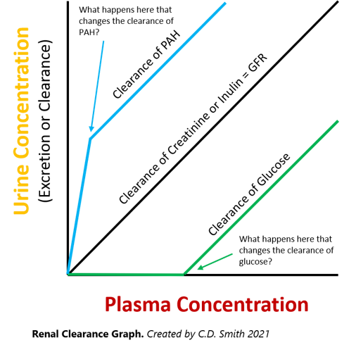

When this occurs we say that the **renal threshold** for that substance has been met. This is due to **saturation** of the glucose transport proteins in the proximal tubule and is what happens in diabetics who become severely hyperglycemic. Conversely, para-aminohippurate (PAH), is a non-harmful substance also used to test kidney function. Since PAH is both filtered and secreted by the kidneys, and 90% is removed from the blood on a single pass through the kidney, the clearance of PAH is often used to estimate renal blood flow (the amount of blood going through the kidneys per minute). Notice that like glucose reabsorption, the proteins responsible for PAH secretion in the DCT can also become saturated if the plasma concentration of PAH is too high. At this point, any additional PAH found in the urine would be due to increased filtration.

Read this online at <https://books.byui.edu/bio_461_principles_o/renal_clearance>