# Tubular Reabsorption

The main function of the nephron tubules is to recover most of the fluid (water) and solutes filtered at the glomerulus. Reabsorption of substances mainly occurs through secondary active transport with Na+. This transport is made possible by the activity of the primary active transporter, the Na+/K+/ATPase pump.

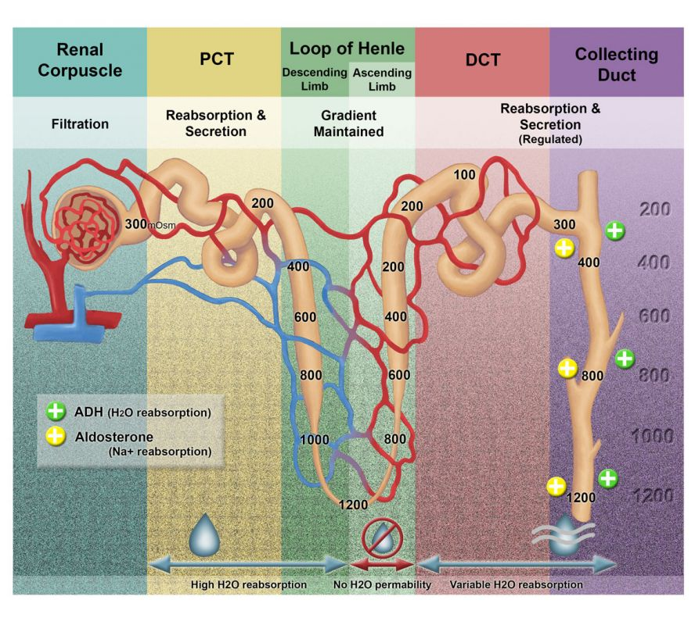

Up to this point, we have discussed one structure of the nephron (the renal corpuscle) and its relation to filtration, the first step in urine formation. We will now move our discussion to the remaining tubule compartments of the nephron. The tubule compartments of the nephron include: the **proximal** tubule (convoluted and straight), the descending tubule, the ascending tubule, the **loop of Henle**, the **distal** tubule (early and late) and the **collecting duct**. The purpose of the tubule components is to selectively reabsorb tubule fluid back into the blood. If the majority of the fluid was not recovered, the kidneys would excrete the entire blood plasma volume in about 20 minutes!

As mentioned, the capillary beds of the nephron are unique in that they form two capillary beds in succession (three in juxtamedullary nephrons). The first capillary bed, the glomerulus, functions as the site of filtration. The second capillary bed, the peritubular capillaries and vasa recta, which are associated with the tubular components, function as the site of reabsorption. Reabsorption is necessary because the process of filtration does not decipher between what is "good" and what is "bad". The filtration system only works through pressure, size and charge. Thus, things like glucose (good), that are necessary for all cells, are filtered out of the blood.

The nephron must selectively put glucose back into the blood so that it is not lost in the urine. In fact, the nephron is so efficient at reabsorbing glucose that glucose in the urine is a sure sign that things are terribly wrong in the body (diabetes). Thus, the main function of the nephron tubules is to recover most of the fluid (water) and solutes filtered at the glomerulus. Substances in the nephron can be reabsorbed one of two ways: through the cells, **transcellular pathway** or between the cells, **paracellular pathway**.

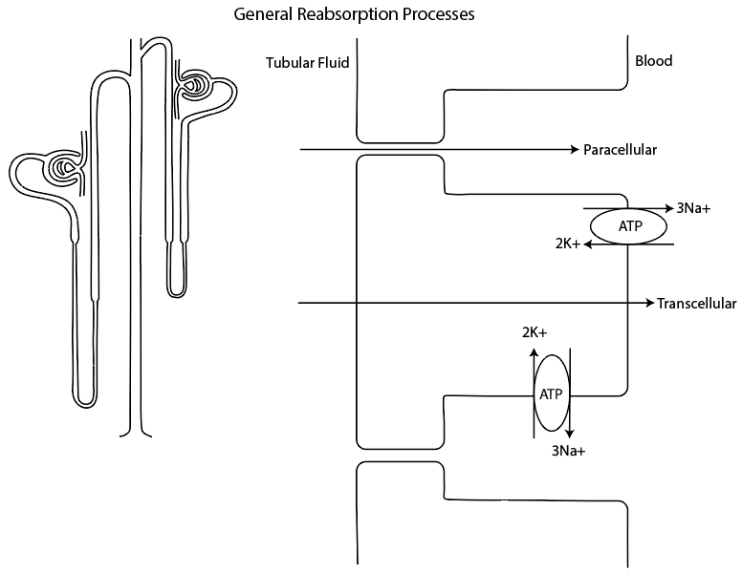

**Proximal Tubule**: The proximal tubule is responsible for the reabsorption of the largest fraction of filtrate. It reabsorbs about 70% of filtered NaCl and water and 100% of the filtered glucose and amino acids. Reabsorption of substances mainly occurs through secondary active transport with Na+. This transport is made possible by the activity of the primary active transporter, the Na+/K+ ATPase pump. This pump creates a large gradient for the reabsorption of Na+ which can be coupled with a variety of other substances. Because this process is protein specific it can become saturated. For example, in diabetics, the blood glucose can become so high (> 350mg/dl; normal 100mg/dl) that the reabsorption proteins in the proximal tubule can become saturated with glucose. As a result, glucose reabsorption may be incomplete since glucose reabsorbing proteins are only found in the proximal tubule. Any glucose that is not reabsorbed will be found in the urine. The Nephron has enough transporters to compensate for an increased glucose load in the blood plasma of 200 mg/dl, and anything greater will exceed the renal **threshold**. Each substance filtered by the nephron has an independent renal threshold value.

In the first half of the nephron (convoluted tubule) Na+ reabsorption occurs through an antiporter (NHE3) coupled to H+, or through specific symporters coupled with a variety of solutes each with their own unique specific protein transporter (Na+/glucose  or galactose (SGLT), Na+/HCO3-, Na+/amino acids, or Na+/lactate). The source of H+ is the result of the enzymatic reaction involving carbonic anhydrase and the substrates CO2 and water and the products H+ and HCO3-. This reaction, coupled with specific transporters, results in the net secretion of H+ and net reabsorption of HCO3-. All of the Na+ that enters the cell will leave the cell to the blood via the Na+/K+ ATPase pump. Other solutes use a variety of passive mechanisms to enter the blood once they are reabsorbed into the cell. Since Na+ reabsorption is coupled to so many different solutes, the aggressive reabsorption of Na+ results in a negative voltage in the lumen compared to the interstitium and blood. The negative voltage contributes to the driving forces observed for Cl- and other negative molecules to be reabsorbed. In addition, the increase in Na+ accumulation in the interstitium serves to drive the reabsorption of water both intracellularly and paracellularly. The correlation with Na+ and water reabsorption is so strong that the fluid in the lumen of the proximal tubule remains essentially **isosmotic**, despite the massive reabsorption of solutes and water. As water follows the Na+ gradient paracellularly it “drags” with it other ions such as Ca2+ and K+. This concept is called solvent drag.

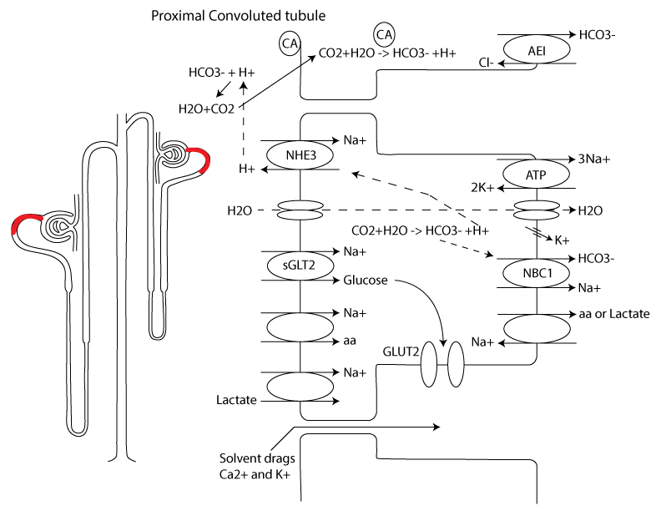

The second half of the proximal tubule (straight tubule) not only targets Na+ but is also the main site of Cl- reabsorption. Since the first half of the tubule focused primarily on Na+ reabsorption, the concentration of Cl- increases from 105 mEq/L to 140 mEq/L in the second half. The second half uses the higher concentration of H+ (secreted during the first half) to drive Cl- reabsorption. H+ will combine with a negative base to freely move across the apical membrane only to separate again once inside the cell. The base then exits the apical cell through a specific antiporter in exchange for Cl- and the H+ through a different antiporter in exchange for Na+. Na+ leaves the cell through the Na+/K+ pump and Cl- either through a leak channel or a symporter coupled to K+.

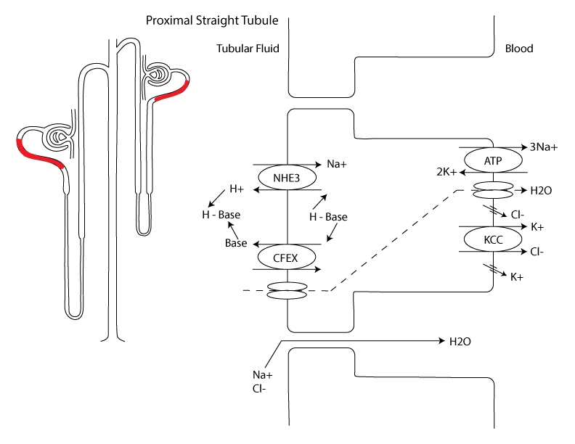

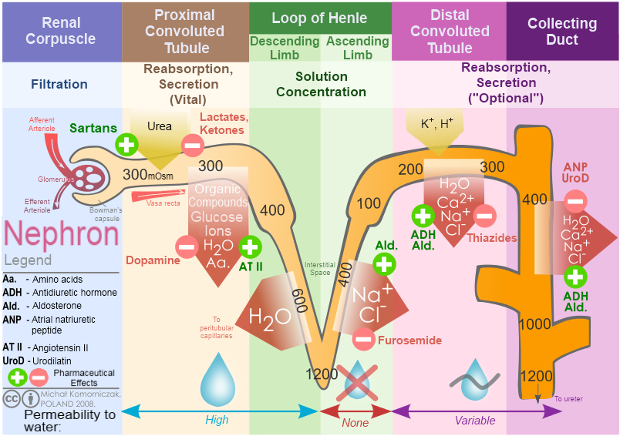

The proximal tubule is also very important for the secretion of solutes. Secretion is defined as moving a substance from the peritubular capillaries to the kidney tubules. This can occur after the substance has passed through the glomerulus without being filtered. Interestingly, the nephron has the ability to both filter and secrete some substances. Filtering and secreting a substance greatly increases its clearance rate. This increased rate of clearance for certain substances presented an interesting problem for physicians during WWII. Penicillin was the first antibiotic drug developed that was effective against infections. During WWII, the demand for penicillin exceeded the ability to manufacture the drug. In addition, penicillin is rapidly cleared from the body because it is both filtered and secreted in the nephron. Fortunately, secretion is a very specific process that uses proteins to bind to the substance and secrete it from the peritubular capillaries into the nephron. Because of this specificity, scientists discovered that if they added another substance that competed for the same transporter as penicillin, the life span of penicillin in the body could be extended. This resulted in a longer half-life (decreased clearance rate) for penicillin and allowed the physicians to use less penicillin per soldier, thereby alleviating the manufacturing woes. Have you ever wondered why certain drugs warn against taking them in combination with other drugs? Well, consider that a drug’s dose is typically determined by age and weight. The drug amount also assumes that the kidney is working properly, thus the clearance of the drug is also considered as part of the dosing. Taking two drugs that compete for the same transporter could indirectly increase the dose of one of the drugs to lethal levels. The kidneys can also secrete substances like H+ or HCO3- to help with acid/base disorders (discussed later) or even K+ or PO4- depending on circumstances.

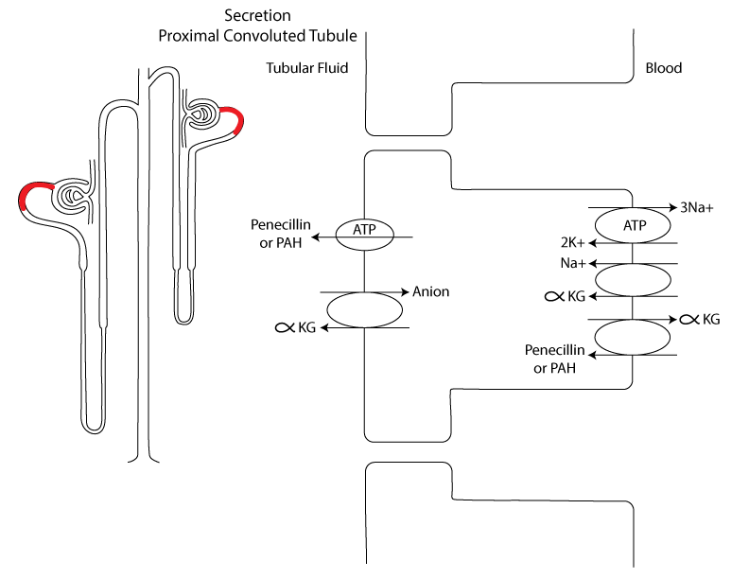

**Loop of Henle** (descending and ascending tubules). The sections of the tubule found in the loop of Henle act to concentrate and dilute the filtrate. These sections reabsorb 25% of filtered NaCl and 15% of the filtered water. Interestingly, the descending tubule is designed for water reabsorption while the ascending tubule is designed for NaCl reabsorption. Water reabsorption occurs through aquaporin channels type I. As the filtrate moves through the descending tubule the osmolarity will begin to increase because of the loss of water without NaCl. As the filtrate moves through to the ascending tubule the increased NaCl concentration will force passive reabsorption in the initial sections of the ascending tubule (thin ascending). Moving to the thick portion of the ascending tubule requires more active processes. Reabsorption is mediated by the Na+/K+/2Cl- symporter (NKCC2). This transport uses the “downhill” gradients of Na+ and Cl- to drive the “uphill” movement of K+. Na+ leaves the cell through the Na+/K+ ATPase while K+, Cl- through leak channels. The ascending tubules are completely impermeable to water, thus as the filtrate moves through this section it will continue to become more and more dilute, which is why this section is often called the diluting segment.

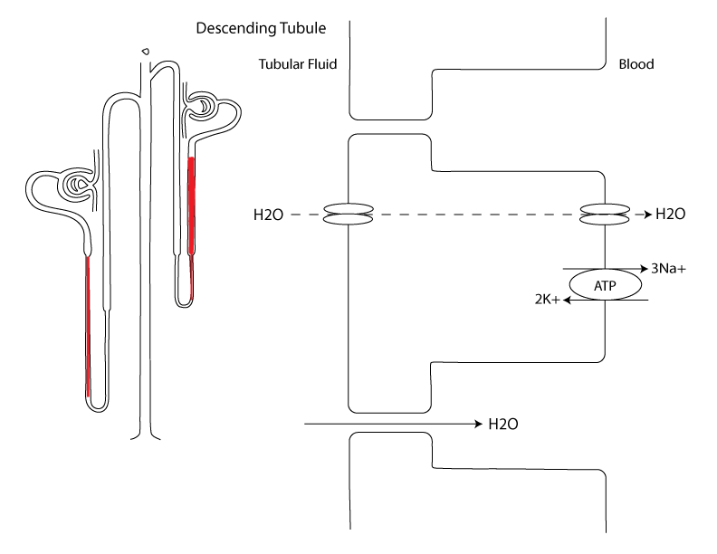

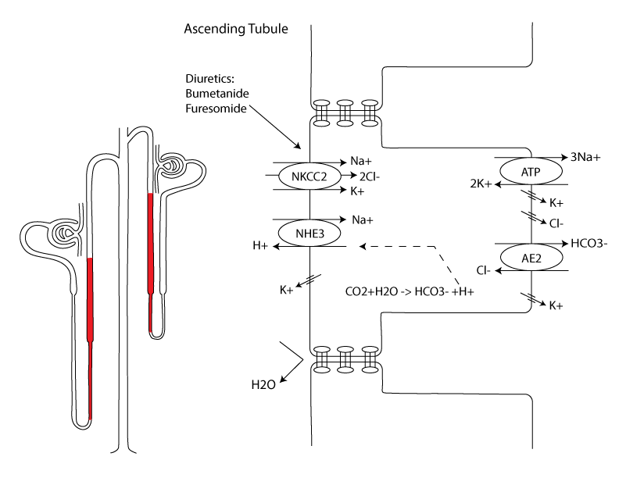

**Distal Tubule and Collecting tubule**: The first portion of the distal tubule (early distal) is impermeable to water but does contain a symporter for Na+ and Cl- (NCC). These cells are also called macula densa cells (explained earlier). Na+ exits the cells through the Na+/K+ ATPase and Cl- through a leak channel. There is a class of diuretics called thiazide diuretics that inhibit this symporter.

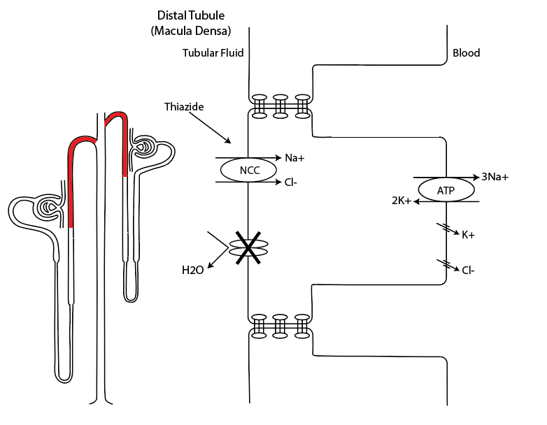

The last segment of the distal tubule (late distal) and collecting duct are composed of two cell types: principal cells and intercalated cells. Principal cells reabsorb Na+ and secrete K+ through apical leak channels and intercalated cells are essential in acid/base balance (discussed at length later). The reabsorption and secretion of Na+ and K+ in this segment is highly dependent upon the activity of the Na+/K+ ATPase pump.

Most importantly, the late distal and collecting duct are impermeable to water but have the ability to insert aquaporin type II channels in response to hormones. Thus, in the absence of hormones the filtrate will become very dilute (50mOsm) and in the presence of hormones can become very concentrated (1200mOsm). The exact actions of these hormones will be discussed next.

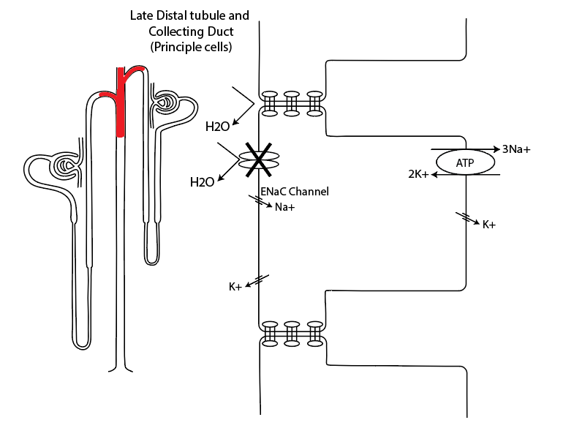

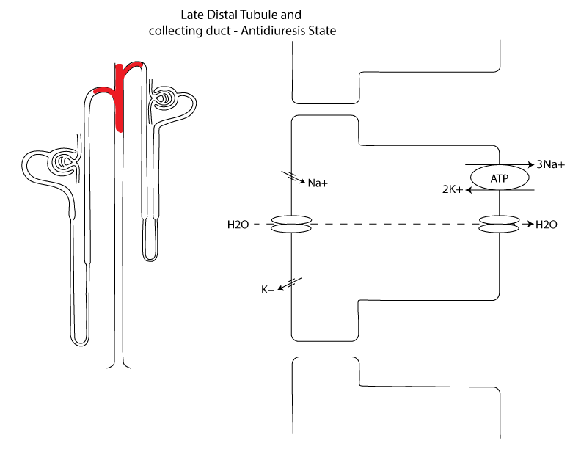

## TF/P ratio

A mathematical model that is often applied to help understand the concepts of reabsorption is called the TF/P ratio. This ratio compares the concentration (mOsmoles) of a substance in tubular fluid (TF: fluid inside nephron) to the concentration of the same substance in the plasma (P). Using micropipettes, samples can be taken at various points along the nephron and then compared to the plasma concentrations. The assumption that holds is that plasma concentrations stay relatively constant so that any change in the ratio will be reflected in the TF variable.

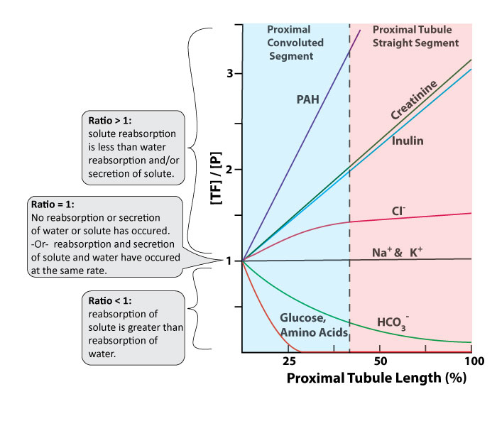

For example, consider the TF/P ratio for plasma electrolytes. These electrolytes are filtered at the glomerulus freely, giving the filtrate an isosmotic concentration after it is filtered. In other words, if the osmolarity is 300 mOsmolar for the blood, it is also 300 mOsmolar in the tubular fluid right after filtration. Thus, the TF/P ratio for the osmotically active solutes is (300/300), immediately following filtration, would be 1. In fact, any substance that is freely filtered at the glomerulus will have a TF/P ratio of 1 in Bowman's capsusle prior to any reabsorption.

However, we know that reabsorption of electrolytes is a major function of the kidney.  Lets consider just Na+. The concentration of sodium in the blood is about 140 meq/L and we would expect a TF/P ratio of Na+ to be 1 in Bowmans capsule before any reabsorption takes place. However, as the filtrate moves down the proximal convoluted tubule, we know that there are many tranporters that contribute to the reabsorption of sodium  back to the blood. It would seem that we would start to see TF/P ratio changes as Na+ dissapeared from the filtrate  (i.e., 130/140; 120/140; 100/140 etc.). However, what is actually seen is that the ratio stays the same (140/140 and at the end of the proximal convoluted tubule we still find 140/140 or a ratio of 1.

How can concentrations stay the same even though reabsorption is occurring? Well, this is possible only if the reabsorption of the substance occurs at the same rate as water reabsorption. To better illustrate, let’s try a hypothetical situation using Kool aid. Imagine pouring a cup of kool aid from a larger container of Kool aid. If we measured the total amount of sugar in the large container and compared it to total amount in the cup, we would find way more sugar in the container. However, if we compared the sugar distribution per volume (or concentration) between the two containers, they would be the same. In other words, pouring Kool aid from the larger container to the smaller cup, would still result in the same concentration of sugar per volume, even though the volume is substantially less in the cup, because the sugar and the water moved together. The ratio, if the substance and the water move together, between the large container and any other subsequent container would always be one. Now back to the kidneys.

If we sampled the fluid at the end of the proximal tubule, where most of the reabsorption has occurred, and we see a value less than 1, then we can deduce that reabsorption of that substance occurred quicker than water. However, as explained above, a value that is still 1 at the end of the proximal tubule (even if the solute was reabsorbed) means that water and the solute were reabsorbed at the same rate. A TF/P ratio of 1 at the end of the proximal tubule is exactly what is observed for Na+. A value greater than 1 could mean that

* reabsorption did not occur (inulin, creatinine)
* or solute reabsorption occurred much slower than water (Cl-)
* or that secretion occurred (PAH; see figure above).

Let’s consider TF/P ratios for the various substance shown in the figure above.

**Inulin and Creatinine**. Since inulin and creatinine are freely filtered, the TF/P ratio would be 1 immediately after filtration. However, since neither inulin nor creatinine is reabsorbed or secreted, each subsequent sample of tubular fluid throughout the nephron would yield higher and higher concentrations as water is reabsorbed and inulin or creatinine remain. This would be reflected in the TF/P ratio as a value greater than 1 at the end of the proximal tubule, in fact, the number would continue to climb as samples were taken in the descending, ascending, distal, and collecting tubules (see figures). Additionally, because the total amount of inulin or creatinine in the TF is not changing (it is not reabsorbed or secreted), but the concentration (amount per volume) is changing, we can make some deductions about water reabsorption. For example, a TF/P ratio for inulin or creatinine of 3.3 at the end of the proximal tubule means that the TF concentration is approximately three times that of the plasma, and since these substances are not reabsorbed, then 70% of the water must have been reabsorbed (1/3.3 = .30). *Remember, all substances that are freely filtered start out with a TF/P ratio of 1.

Since the TF/P ratio for inulin or creatinine is directly correlated to water reabsorption, we can use this value as a correction factor to give us specific details about other TF/P ratios. For example, if we take a sample of a substance (X) at the end of the proximal tubule and we find a TF/P ratio of 1, we know that the substance was reabsorbed at the same rate as water, but we don’t know the actual amount of substance that was reabsorbed. However, if we take that ratio of 1, and then divide that by the [TF/P] inulin ratio from the same segment (end of proximal tubule) of 3.3 ([TF/P]x/[TF/P]inulin; 1/3.3) we would get a value of .3 or 30%. This means that 30% of the substance remained in the TF and that 70% of substance X was reabsorbed.

Thus, the [TF/P]x might be 1, suggesting isosmotic reabsorption, but that tells us nothing about the amounts reabsorbed. However, with the correction factor applied, we learn that 70% of the substance was reabsorbed. What if the TF/P ratio for substance X was 2.1 (2.1/3.3 = .64 or 36% reabsorbed)?

**Para-aminohippurate (PAH)**. PAH is a chemical that is freely filtered at the glomerulus but also secreted. Thus, the TF/P ratio of PAH is quite high compared to other substances. Additionally, because of both filtration and secretion, the amount of PAH in the sample of blood that enters the kidney is completely removed from the blood in one pass. This unique TF/P ratio allows PAH to be used to assess another important function of the kidneys called **renal plasma flow**. Stated another way, the rate at which the kidneys clear PAH is directly correlated with how quickly or slowly the blood flows through the kidney. Renal plasma flow is calculated using the amount of PAH in the blood (pPAH), the amount found in the urine (uPAH), and the urine flow rate (V). The equation is:

RPF = uPAH/pPAH(V)

The normal values of RPF are around 600ml/min.

**Glucose and Amino acids**. Since both filtered glucose and amino acids are 100% reabsorbed, the TF/P ratio is essentially zero. Interestingly, these TF/P ratios will reach zero within the first half of the proximal tubule.

**HCO3-**: About 80% of filtered HCO3- is reabsorbed in the proximal tubule, the majority of which occurs in the first half, making the TF/P ratio less than 1. The reabsorption of HCO3- will be explained further in the Acid/Base section, but briefly, because there are no apical HCO3- transporters in the proximal tubules, reabsorption of HCO3- occurs indirectly, coupled to the secretion of H+ and a membrane-associated enzyme called carbonic anhydrase.

This next image shows estimates of the TF/P ratios through other parts of the nephron. Notice how the ratios change as substances hit different parts of the nephron where water or solutes are absorbed differently. Check to make sure that the shape of these curves as they travel through the different segments of the nephron make sense to you.

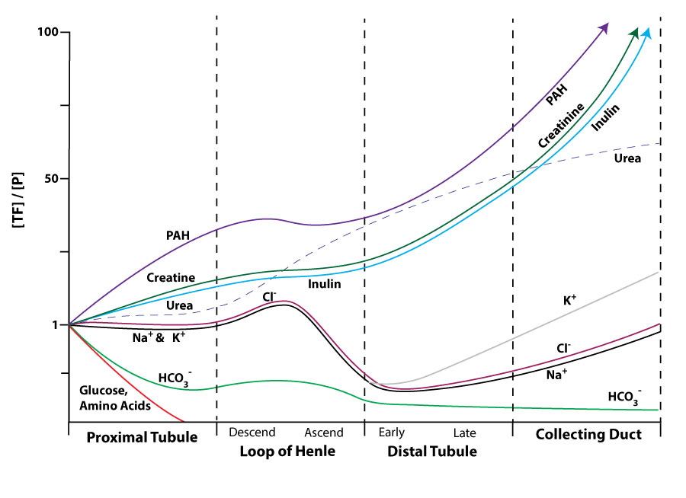

Read this online at <https://books.byui.edu/bio_461_principles_o/tubular_reabsorption>