# Respiratory pressures and Inspriation/Expiration

Ventilation or breathing is the movement of air into and out of the lungs. In order for air to move, there must be differences in air pressure. An area of high pressure and an area of low pressure is often referred to as a pressure gradient. Air will always flow from a region of high pressure to a region of low pressure (P1and P2 in the equation below represent the two different pressures). Additionally, the rate of airflow through the respiratory passages is affected by the amount of resistance of the passageway.

Recall when we studied the mean arterial pressure (MAP) of blood that total peripheral resistance was dependent on the diameter of the blood vessels and that if you constricted a blood vessel it would increase MAP.  The same principles apply to air flow in our respiratory passages.  According to the formulas below, the diameter of the tube has the greatest influence on resistance: they are inversely proportional - as diameter goes up, resistance goes down.

**Flow = (P1****- P2)/R**

**R α 1/r4**

The greater the difference between the two pressures and the lower the resistance in the tube, the faster air will flow. Upon inhalation of air, the atmospheric pressure is greater than the pressure inside the lungs so air enters the lungs.

Under quiet resting conditions, the respiratory rate is about 12 breaths per minute. This air movement or ventilation is necessary from moment to moment to sustain life. The process of moving air from the external environment into the lungs is called inspiration (this is where we get our oxygen). Expiration is air moving from the lungs out of the body into the environment (this is where we get rid of carbon dioxide). As described previously, air will always move from a region of high pressure to a region of lower pressure. But what actually brings about the pressure differences to ensure air movement into and out of the lungs? The answer lies in the relationship between pressure and volume described by Robert Boyle.

#### Boyle’s Law

**Boyle’s law** is P = k/V, where P is the pressure of a gas, V is the volume of the gas, and k is a constant. This equation shows that there is an inverse relationship between pressure and volume. It shows that if the volume of a container of gas decreases, the pressure exerted by that gas will increase.

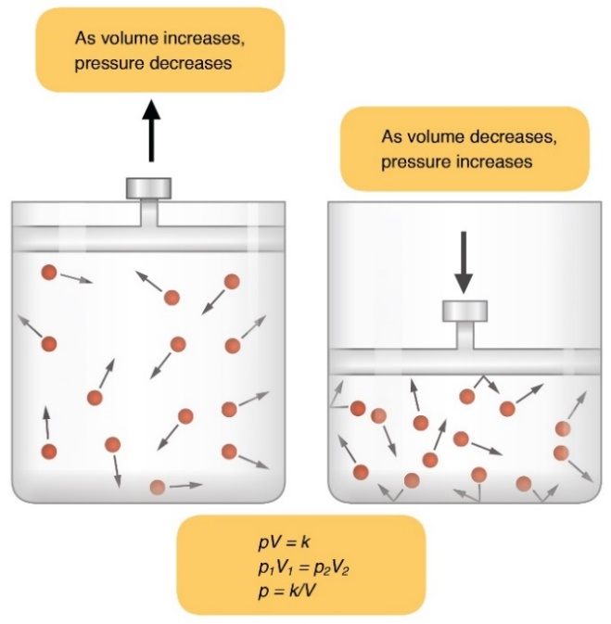

A good example is a bicycle tire. If you pump air into a bicycle tire (container) you are forcing air into a much smaller volume than the same number of air molecules would occupy if they were floating in the atmosphere. You have increased the pressure in the tire by confining the molecules to a much smaller space. The body allows ventilation or air movement to happen by changing the volume of the thoracic cavity. Think for a moment. For inspiration to happen, there would have to be a lower pressure inside the lungs compared to the atmosphere. This can be achieved by increasing the volume of the thoracic cavity. To do this we use muscles to change the size of the internal space inside the thoracic cavity.

The two main muscles of quiet inspiration are the diaphragm and the external intercostal. The diaphragm, in its relaxed state, is dome-shaped. When it contracts it moves inferiorly and assumes a flattened shape pushing down on abdominal organs. This inferior movement of the diaphragm, increases the volume inside the thoracic cavity by increasing the height or vertical dimension of the cavity. Under resting conditions, about 2/3 of the volume increase leading to inspiration is due to depression of the diaphragm. The rest comes from contraction of the external intercostals. This action elevates the ribs and sternum, increasing thoracic cavity volume in the anterior-posterior dimension, as well as the medial-lateral dimension.

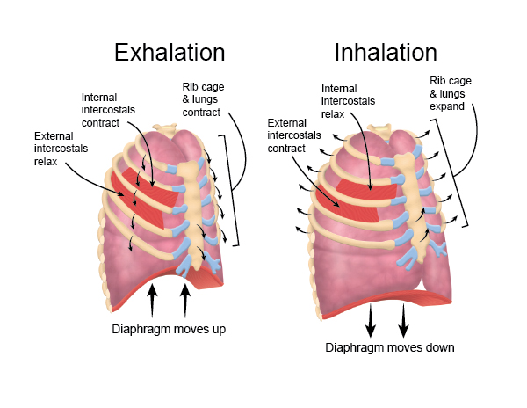

Thoracic cavity dimensions increase when the ribs and sternum elevate. Increases in dimensions in these previously mentioned planes results in increased lung volume of about 500 ml under quiet-breathing conditions. Alveolar pressure is now negative ( ≈ -1 mmHg) relative to the atmosphere, so air rushes into the lungs and inspiration happens (see image below). Inspiration stops when the pressures are equalized and alveolar pressure is equal to atmospheric pressure. Accessory muscles including the sternocleidomastoid, scalene muscles, and pectoralis minor are additionally important during more labored, intense breathing with exercise or in certain lung diseases to more fully, and rapidly elevate the ribs and sternum to increase inspiration rate and volume. Are you a little out of breath after reading this paragraph? Take a deep breath because we're not done yet.

During quiet expiration, the movement of air out of the lungs is mostly due to the relaxation of the muscles of inspiration, which allows the natural elasticity of the lung tissue to recoil and assume its natural “more collapsed resting position”. The diaphragm relaxes and reassumes its dome-shape and the external intercostals relax, and the assume a smaller volume. This makes alveolar pressure now slightly greater than atmospheric pressure causing the higher-pressure gases inside the lungs to move out resulting in expiration. Forced expiration involves contraction of the internal intercostals and the oblique and transverse abdominal muscles. The internal intercostals cause more rapid rib depression and contracting abdominals push the internal organs against the diaphragm to cause it to more rapidly assume its resting dome-shape.

#### Pressure Differences in the Thoracic Cavity

Respiratory pressures are always given in relation to **atmospheric pressure** (Patm) which is the pressure exerted by the atmosphere around the body. Atmospheric pressure is always considered to be zero. It doesn't matter whether you are in Rexburg at nearly 5000 ft. where atmospheric pressure is about 630 mm Hg or at sea level which is 760 mm Hg. A negative pressure such as -5 mm Hg, describing any area in the respiratory system, means that the particular respiratory area being described is 5 mm Hg lower than Patm. With **alveolar pressure** (Palv), the pressure inside the alveoli is -1 mm Hg. During inhalation, due to the negative pressure, air will flow into the lungs until alveolar pressure is zero (same as atmospheric pressure). Remember, there must be a pressure difference to have air flow. When Palv is +1 mm Hg air will flow the opposite direction and exhalation will occur.

Pressure inside the pleural cavity or **pleural pressure** (also known as intrapleural pressure) is usually -4 mm Hg. Where does this negative pressure in relation to atmospheric come from? The fact that lymphatic vessels constantly pump fluid out of the pleural cavity, essentially creates a partial vacuum and contributes to a lower pleural pressure compared to alveolar pressure. There are also a couple of forces that attempt to pull the lungs away from the thoracic cavity wall and cause the lungs to assume the smallest size possible. The first is the lungs inward elastic force. Think of a stretched rubber band - it would like to return to its resting state of not being stretched. The lungs are elastic and would like to be as small as possible. Secondly, there is surface tension exerted by water molecules inside the alveoli that are attracted to one another. This force attempts to make the alveoli as small as possible. If you imagine these forces trying to collapse the lung, you can see how the space between the surface of the lung and the chest cavity wall would tend to increase. This increasing volume lowers pressure until it is negative enough to “suck” or pull on the lung surface which keeps the lung from fully collapsing.

The fact that our alveoli are placed in an environment that has a negative pressure, makes it much easier for them to expand.  Imagine filling a balloon with air. In order to make it expand, it would be necessary to vigorously blow up the balloon or attach it to a compressed air hose. This would be an example of how **positive-pressure ventilation** works, in which you must force air in.  In cases where a person is on a ventilator positive-pressure ventilation is used to force oxygen into the lungs.

But is it also possible to get a balloon to expand by decreasing the pressure around it? Yes, it is. Put a balloon in a vacuum or take the balloon out to space and see if it expands (as long as the opening to the balloon is at atmospheric pressure). In the same way, it is easier to inflate the alveoli when they are surrounded by a partial vacuum like that in the pleural cavity. If it weren't for this lower pleural cavity pressure compared to alveolar pressure, the lungs would collapse. This is known as **negative-pressure ventilation.**

The difference between the pleural pressure and alveolar pressure is called **transpulmonary pressure**. The larger the transpulmonary pressure (more negative) the more the alveoli and the lungs will be inflated at any given moment.

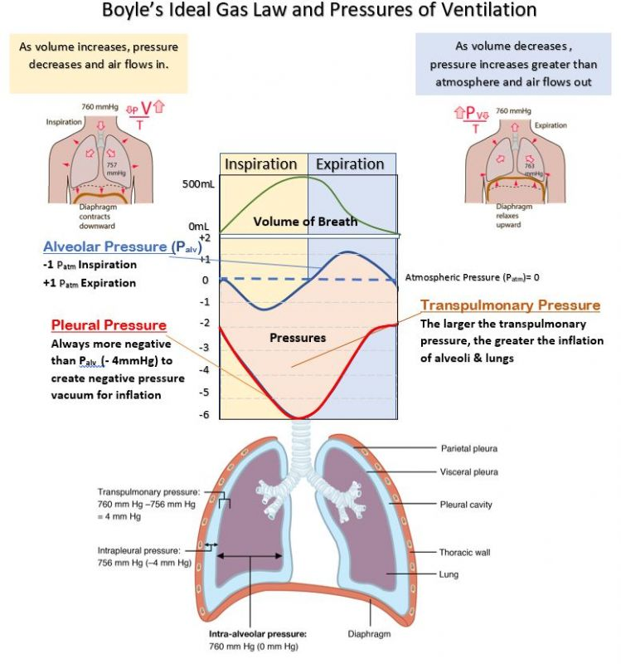

Read this online at <https://books.byui.edu/bio_461_principles_o/respiratory_pressure>