# Oxygen and Carbon Dioxide Transport in the Blood

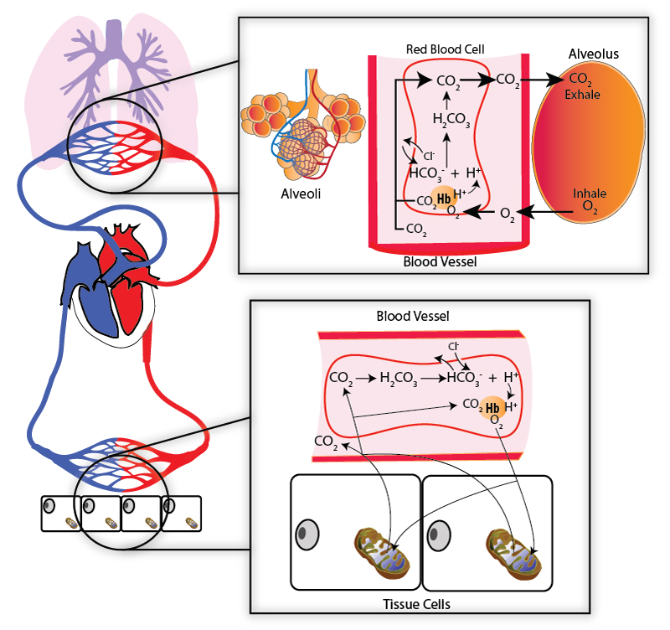

The image above shows how oxygen and carbon dioxide move at the tissue level and the alveolus of the lung. Notice that oxygen is carried either dissolved in the plasma or attached to hemoglobin (really only a small amount of the total oxygen is dissolved in the plasma at any given time). Carbon dioxide is carried either dissolved in the plasma (a small amount), or attached to the hemoglobin (but not at the same binding spot as oxygen) or converted to bicarbonate (this is what happens to most of the carbon dioxide that is carried in the blood).

#### Oxygen Transport

In the alveoli, oxygen crosses the respiratory membrane by diffusing down its pressure gradient to pass into the blood where it is mostly transported bound to hemoglobin (98.5%). Since oxygen is not very soluble in water, only a small portion dissolves in the plasma (1.5%). In capillaries feeding the tissues, oxygen is released from hemoglobin and diffuses into the tissues where it is used for cellular respiration. Since oxygen is mostly transported by hemoglobin, the majority of our discussion will be about factors that influence how tightly hemoglobin binds to oxygen (hemoglobin’s affinity for oxygen) including oxygen partial pressures, pH of the blood, partial pressures of carbon dioxide, temperature, and effect of 2,3-diphosphoglycerate, sometimes referred to as 2,3 BPG (This may also be called 2,3 DPG).

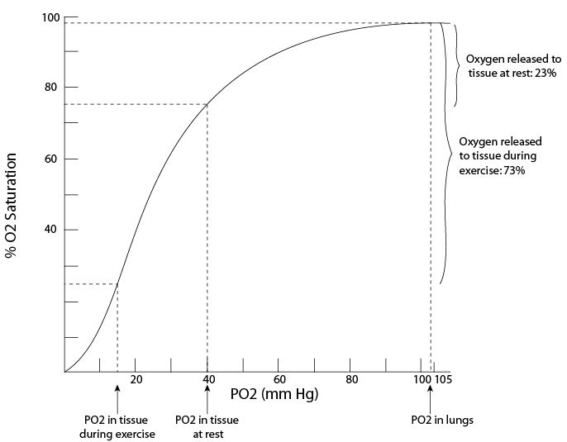

#### The Oxygen Hemoglobin Dissociation Curve

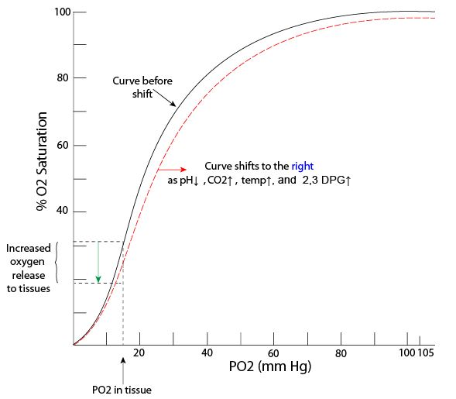

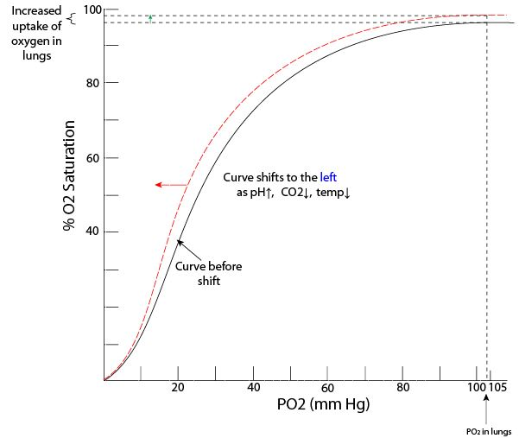

The graphs above show the oxygen hemoglobin dissociation curve. Things such as pH, CO2, temperature and 2,3 DPG can change the affinity of hemoglobin to bind oxygen.

This has the effect of shifting the curve to the right or the left.

Let's first consider the effect of oxygen partial pressures. The percent oxygen saturation of hemoglobin at different partial pressures of oxygen is represented by the oxygen-hemoglobin dissociation curve shown in the images above. A hemoglobin molecule has four heme groups, each of which can bind to one molecule of oxygen. The partial pressure of oxygen in the alveoli is normally ≈ 104 mm Hg (sea level) and as the blood leaves the pulmonary capillaries, the hemoglobin is very near 100% saturated with oxygen. Notice that even if PAO2 drops into the 80s, our hemoglobin would still be more than 95% saturated.

Imagine an asthma attack where our ability to ventilate is compromised and maybe our PAO2 drops to 60 mm Hg. Oh no, this isn't good. Luckily, viewing the curve, you can see that even with this extreme drop, hemoglobin is still able to become almost 90% saturated. This isn't the best but you can see that it would be a lot worse if the curve was steep at higher partial pressures for oxygen. A flatter curve at the top ensures that even with relatively large decreases in partial pressures for oxygen, hemoglobin is still able to become almost completely saturated. But notice what happens to the curve at about 50 mm Hg - it becomes much steeper. This means that at these lower partial pressures for oxygen, even small changes in partial pressures will result in big decreases in hemoglobin's ability to bind oxygen. Such is the case in the tissues where the goal is to release oxygen from the hemoglobin so it can enter the cells that need it. With metabolically active tissue like skeletal muscle where tissue levels of oxygen can get down to 15 mm Hg, an even greater percentage will be released to resupply oxygen-starved tissue. To sum up, in the lungs where the partial pressures for oxygen is high, hemoglobin binds more tightly to oxygen so that more can be picked up. In the tissues, where partial pressures are low, hemoglobin's affinity for oxygen greatly decreases so that more oxygen can be released.

The reason that hemoglobin works this way has to do with its molecular structure.  Hemoglobin is often described as having two “states” it can exist in. It can be in the Tense or T-state and the relaxed or R-state. This terminology refers to intramolecular forces that position the heme group to have more attraction to oxygen (R-state) or less attraction for oxygen (T-state). The binding of oxygen to a heme group alters these intramolecular forces to increase affinity for oxygen on nearby heme groups. So, you can imagine in the lungs that oxygen is entering the blood and progressively increasing hemoglobin oxygen binding affinity (the flat part of the curve). This works the opposite as well. As oxygen leaves a heme group, intramolecular forces shift in a way that nearby heme groups decrease affinity for oxygen. This happens in the tissues (the steeper part of the curve).

As an interesting side note, this oxygen hemoglobin association curve illustrates why climbers who climb higher than 15,000 feet have oxygen saturation that drops below 90% and begin to experience acute altitude sickness. At 30,000 feet, the height of Mt. Everest, the pO2 mmHg drops to 31, which is only 60% O2 saturation on the curve. At this level, oxygen dissociates from hemoglobin so quickly that downstream tissues will not be able to get enough oxygen and organs of the body will be impacted. The muscles, including the heart, lungs and brain, will be weak and it is hard to even think straight. If hypoxia (low oxygen) is prolonged it can lead to death. This is why climbers at high elevations may temporarily begin to hyperventilate. They are attempting to increase alveolar ventilation and thus increase PAO2, However, hyperventilation decreases carbon dioxide levels, and puts their body into a state of respiratory alkalosis.

The second factor influencing hemoglobin's affinity for oxygen is pH of the blood. Hydrogen ions binding to hemoglobin cause it to move toward the T-state (lower binding affinity for oxygen). So, lower pH of the blood means lower oxygen affinity. Lactic acid production increases in certain cells that are starved for oxygen. This acts as a signal to the hemoglobin that it needs to release more oxygen to these cells. The lower pH of the tissues will shift the oxygen-hemoglobin dissociation curve to the right.  Hemoglobin now has a lower affinity for oxygen at any given oxygen partial pressure. The opposite shift happens if pH increases. The effect of pH on hemoglobin binding to oxygen is known as the **Bohr effect**. Increasing the partial pressures of carbon dioxide can result in changes in pH.

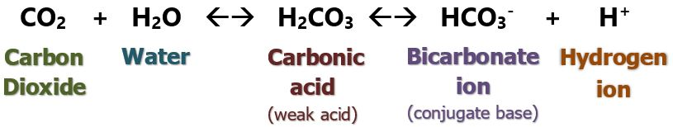

The enzyme carbonic anhydrase found inside red blood cells catalyzes the above reaction. Increasing levels of carbon dioxide will bring about increases in hydrogen ion and drop the pH. Cells that are metabolically active, such as during exercise, are producing lots of carbon dioxide. Elevated hydrogen ions and increased carbon dioxide both cause right shifts.

Increased temperature and 2,3-bisphosphoglycerate (BPG) binding to hemoglobin also decreases hemoglobin's affinity for oxygen. Temperature is elevated in metabolic active tissues. 2,3 BPG is produced by red blood cells in glycolysis. This process is stimulated to increase during periods of hypoxia.  Decreased affinity caused by elevated temperatures and 2,3 BPG ensures that metabolically active tissues receive higher amounts of oxygen. The acronym “CADET” is an easy way to remember which factors will shift the oxygen-hemoglobin curve to the right: ‘C’ – Carbon Dioxide; ‘A’ – Acidic pH; ‘D’ – DPG; ‘E’ – Exercise; ‘T’ – temperature. A decrease in these factors would shift the curve to the left.

#### Carbon Dioxide Transport

See image below.  Carbon dioxide is released in the tissues as a byproduct of cellular respiration and diffuses into the blood. It is transported to the lungs via the blood in three ways: directly dissolved in the blood (7%), bound to the amino acids of the globin portion of hemoglobin (23%), or dissolved in the plasma as bicarbonate ion (HCO3-) (70%).



In the tissues, carbon dioxide levels elevate, so it diffuses into blood and enters the red blood cells to be converted to carbonic acid by the enzyme carbonic anhydrase. Hydrogen ions are released and bind to hemoglobin causing more oxygen to be released to the tissues (Bohr effect). Hydrogen ions are buffered since they bind to hemoglobin, so pH changes of blood is blunted. Bicarbonate ions produced in the reaction leave the red blood cell in exchange for chloride ions. This process is called the **chloride shift**. Carbon dioxide more easily binds to hemoglobin that has released its oxygen (See "Haldane Effect below).

In the lungs, carbon dioxide diffuses down its gradient into the alveoli. This shifts the equation to the left and bicarbonate and hydrogen ions are more readily converted to carbonic acid which then breaks down into carbon dioxide that can cross into the alveoli. In the lungs, oxygen enters the red blood cells and binds to hemoglobin causing hemoglobin's affinity for carbon dioxide to decrease. The effect that oxygen has on carbon dioxide transport is called the **Haldane Effect**. Specifically, the Haldane effect can be explained like this. Oxygen leaving the hemoglobin at the tissue level increases the affinity that hemoglobin has for carbon dioxide. But, oxygen binds to hemoglobin in the lungs and this causes a decrease in affinity for carbon dioxide. The additional released carbon dioxide diffuses across the respiratory membrane into the alveoli to be exhaled.

#### Carbon Monoxide and Fetal Hemoglobin

Carbon monoxide is released from fires and other forms of combustion (i.e., automobiles). It is an odorless, colorless gas and its toxicity arises from its strong affinity, up to 300 times that of oxygen, for hemoglobin. Carbon monoxide attaches to the same binding site as oxygen and severely reduces hemoglobin's ability to carry oxygen. When carbon monoxide binds to hemoglobin it forms a complex called carboxyhemoglobin. Carboxyhemoglobin can revert back to hemoglobin but it takes time, and time is not something that the person suffering from carbon monoxide poisoning has. Thus, to speed up the rate of recovery, treatment consists of giving 100% oxygen in a hyperbaric (high pressure) oxygen chamber. The higher pressure and 100% oxygen can work as antidotes by increasing the PaO2. Carbon monoxide poisoning is the most common type of fatal poisoning. The Symptoms of carbon monoxide poisoning include lightheadedness, confusion, headache and flu-like symptoms.

The fetus is obviously unable to inhale oxygen, so a couple of cool modifications in design allow it to steal oxygen from the mother. Fetal hemoglobin is more concentrated in red blood cells and it is also missing the ability to bind 2,3 BPG. The placenta tissue makes a lot of 2,3 BPG which acts on the maternal red blood cells and causes the maternal oxygen hemoglobin dissociation curve to move right of the fetal curve.  Therefore, fetal hemoglobin has a greater affinity for oxygen compared to maternal hemoglobin. Its oxygen-hemoglobin dissociation curve is to the left of that for maternal hemoglobin. This allows fetal blood to "grab" oxygen from maternal blood when they mix in the placenta. When oxygen attaches to fetal hemoglobin, more CO2 is released (Haldane effect).

Read this online at <https://books.byui.edu/bio_461_principles_o/oxygen_and_carbon_di>