# Chronic Bronchitis and Emphysema

A Common disease that affects the lungs is **COPD**. Smoking causes 80% of the cases of chronic obstructive pulmonary disease (COPD) which includes both emphysema and chronic bronchitis.

In **emphysema**, smoking, other chemicals, or hereditary factors damage the walls of the alveoli, making them less elastic and enlarged.  Remember that exhalation relies on the natural elastic recoil of the lungs to decrease volume and increase pressure.  If the elastance decreased, then the respiratory passageways are more likely to collapse before the normal amount of air is exhaled and air is trapped in the lungs. Inspiration becomes much easier than exhalation and “air hunger” causes a person to do big breaths in and smaller / labored breaths out. This leads to the development of a "barrel chest".  You might imagine how much extra energy it would take to constantly force yourself to expire - this becomes extremely exhausting.

**Chronic bronchitis** comes from long-term exposure of air passageways to irritants, especially cigarette smoke.  The ciliated pseudostratified epithelium that lines the lower respiratory airways becomes damaged from smoke, pollution, or other irritants.  The cilia become fewer and blunted and can no longer adequately clear mucus.  Consequently, the mucus and debris build up and obstruct the air passages compromising one’s ability to ventilate.  The chronic hacking cough seen in smokers is evidence of this damage.  Increased resistance to air flow also comes from a permanent thickening of bronchial walls resulting from hyperplasia of goblet cells.  The resulting narrowed airway lumen makes it more difficult to breathe. The labored breathing is called dyspnea.

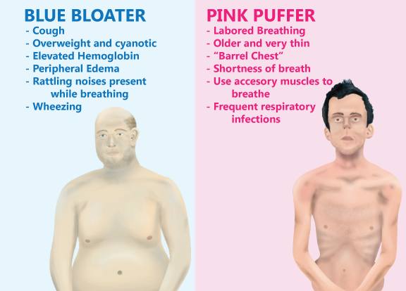

In the past, those with emphysema have been referred to as "**pink puffers**".  They spend a lot of energy "puffing" in an effort to exhale and are often thin from burning so many calories.   Their main problem isn't inhaling so they are able to deliver sufficient oxygen to their blood giving their skin a pink appearance.

The term **"blue bloaters**" on the other hand, refers more often to those with chronic bronchitis.  Since they are unable to inhale sufficient amounts of air, their arterial oxygen levels are often low so they become cyanotic.  This gives their skin tone a blue appearance.

**Hypoxia,** or having tissue that is deprived of oxygen, causes constriction of pulmonary vessels which increases the workload for the right ventricle posing a strong risk for developing right-sided heart failure. Failure of the right side of the heart causes venous back up which leads to edema and thus the “bloated” appearance.

Most patients with COPD don't fall exactly into the category "pink puffer" or "blue bloater" but are usually some combination of the two.  It makes sense because smoking leads to both chronic bronchitis and emphysema.

Read this online at <https://books.byui.edu/bio_461_principles_o/chronic_bronchitis_a>