# Respiratory Control by the Medulla Oblongata

Brainstem areas in the medulla oblongata and pons contain groups of neurons that are particularly important in regulating ventilation. The **ventral respiratory group (VRG)** and the **dorsal respiratory group (DRG)** are located in the medulla oblongata and make up the medullary respiratory center.

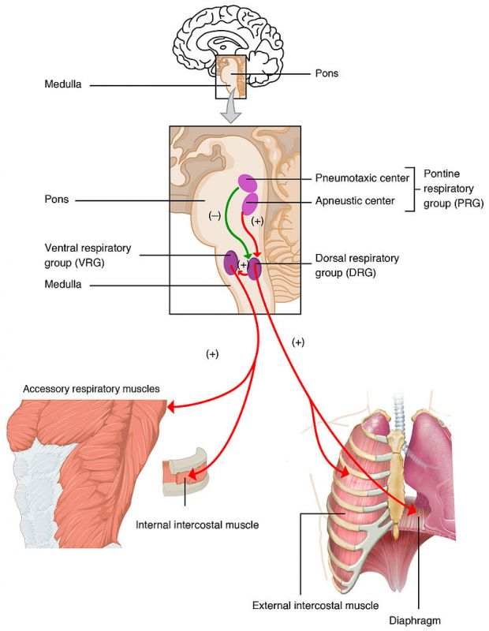

The DRG helps maintain a constant breathing rhythm by stimulating the muscles of inspiration to contract at regular intervals after a passive exhalation. The DRG is not active during passive exhalation. A normal and regular stimulating signal to inspiratory muscles will create a breathing rate that falls somewhere between 12-15 breaths/minute.

With alcohol and opioid narcotic overdose, these medullary centers may become suppressed to the point of complete breathing cessation. The drug BIMU-8 has the opposite effect and will stimulate medullary neurons to increase respiratory rate.

The **DRG** receives information coming from peripheral chemoreceptors (monitor blood gas levels) and mechanoreceptors (monitors movement of muscles and joints).  The DRG also receives information from the pontine respiratory group. All of this information is assessed and then signals are sent to the VRG to modify its actions on ventilation to either breath more rapidly or deeply or less frequently depending on the need of the muscles and body.

The **pontine respiratory group (PRG) receive** information from chemoreceptors and mechanoreceptors in the body.  The PRG also receives signals from higher areas of the brain and acts to modify activities in the DRG. The PRG is in the pons of the brain and includes both the pneumotaxic center (which inhibits the DRG to slow down the respiratory rate) and the apneustic center (which controls deep breathing or gasping). The PRG helps adjust breathing rate and patterns for activities like sleep or exercise.

When we take a very large breath, what prevents us from over inflating the lungs?  There are pulmonary stretch receptors in the lungs. Once these stretch receptors are activated, action potentials travel through the Vagus nerve to the inspiratory areas of the medulla and turns off or inhibits the signal of inspiration and begins expiration. This is known as the **Hering-Breuer Inspiratory Reflex.**

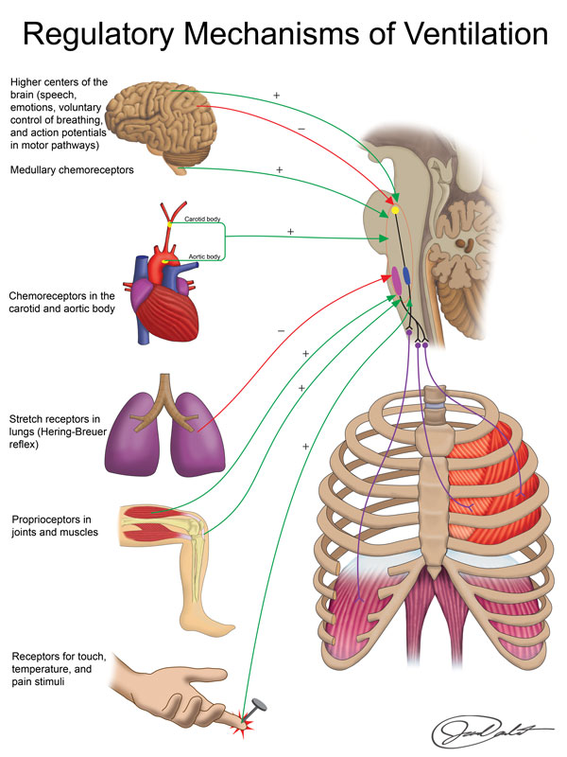

Read this online at <https://books.byui.edu/bio_461_principles_o/respiratory_control_>