Action Potentials in Cardiac Muscle Cells
Action potentials in cardiac muscle are significantly different from those in axons and skeletal muscle. In addition, action potentials differ among the different cell types. In cardiac muscle, there are two major cell types; contractile cells and pacemaker cells. Cardiac action potentials are regulated by four major time-dependent currents:
- Na⁺current (I_{Na}). Na⁺ currents, similar to other systems, are responsible for depolarizing phases in the contractile cells.
- Ca²⁺ current (I_{Ca}). Ca²⁺ currents are responsible for depolarizing phases in pacemaker cells. The Ca²⁺ current is also essential for triggering contraction in contractile muscle cell types.
- K⁺ current (I_{K}). K⁺ current is responsible for RMP and repolarization of all cardiac muscle cell types.
- Pacemaker currents (I_{f}). Pacemaker currents are responsible for spontaneous depolarizations of pacemaker cells.
We will explain each current as it pertains to the action potential phases of both cardiac cell types. Let’s walk through the phases of contractile cardiac muscle action potentials first. The figure labels the unique currents observed at each phase of the action potential.
Notice that the little bars below the picture represent when the channels are open. When the bar is black, we assume the channel to be fully opening and when it is gray, we assume the channel to be just starting to close and the white space represents the period that we assume the channel to be fully closed.
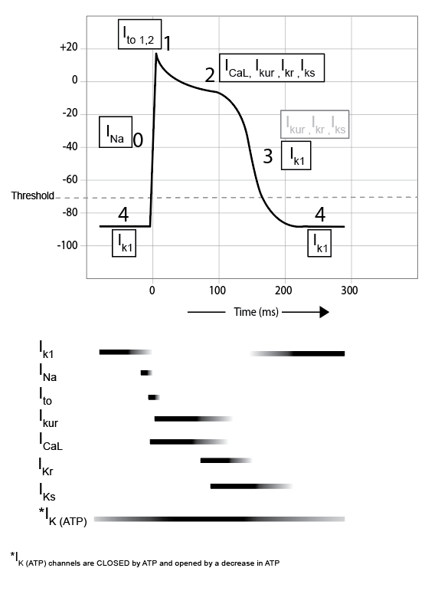
Phase 4: Resting membrane potential (RMP). Note that unlike the -70 to -80 mV RMP we are familiar with in axons and skeletal muscle, in cardiac muscle, the RMP is around -90 mV. Cardiac cells are extremely permeable to K⁺ making the resting RMP of contractile cardiac cells very close to the NERNST for K⁺. In addition, there are several types of K⁺ channels found in cardiac muscle. During phase 4 the K⁺ current through the channel is designated as I_{k1}.
Phase 0: The depolarization phase. The upstroke characterizing this phase is due to the opening of voltage-gated Na⁺ channels and the influx of Na⁺ referred to as I_{Na}. These are the same channels found in axons and skeletal muscle and, hence, have both activation and inactivation gates and therefore refractory periods. Note that when the membrane depolarizes the K⁺ channels mentioned in phase 4 close, removing the contribution of the I_{K1} current.
Phase 1: Rapid repolarization. At the end of the depolarization phase the inactivation gates on the Na⁺ close, stopping the influx of Na⁺. At the same time, a small number of K⁺ and Cl⁻ channels open and the membrane begins to repolarize. These channels are called transient outward K⁺ channels (I_{to1}) and calcium activated Cl⁻ channel (I_{to2}). This current is a repolarizing current and the steepness of the repolarization is determined by the density of channels within the membrane. Thus, contractile cells in different regions of the heart show slightly different tracings at this phase due to different densities.
Phase 2: Plateau. This is the phase that distinguishes the cardiac muscle action potential from other excitable tissues and is the result of the opening of voltage-gated Ca²⁺ channels. Ca²⁺ channels activate and inactivate much slower than Na⁺ channels so they contribute current (I_{CA}) only after Na+ channels respond. With the opening of these channels, Ca²⁺ enters the cell. Two types of Ca²⁺ channels exist, L-type and T-type channels, so designated based on their inactivation rates. L-type (long lasting) inactivate slower than the T-type (transient) counterparts. Additional K⁺ channels also open at about the same time called delayed K⁺ channels. In contrast to Ca²⁺ channels, the two subtypes of K⁺ channels are designated by their rates of activation. These channels are slow delayed (I_{Ks}) and more rapidly delayed (I_{Kr}). There is even an “ultra rapid” delayed type called I_{Kur}. During the plateau, the influx of Ca²⁺ essentially negates the effect of the efflux of K⁺. Because of the movement of these two ions, K⁺ out and Ca²⁺ in, the membrane potential remains fairly constant and does not repolarize rapidly. In addition to prolonging the action potential, the Ca²⁺ that is entering the cell plays a critical role in triggering muscle contraction (more on this later).
Phase 3: Repolarization. During the plateau phase more and more K⁺ channels open and toward the end of the plateau phase the K⁺ efflux definitely becomes greater than the Ca²⁺ influx and the membrane begins to repolarize (mainly due to the I_{Kr} and then I_{Ks} currents). As the membrane becomes more negative, the Ca²⁺ channels close and some I_{K1} channels open. The membrane quickly returns to RMP. As RMP is reached, the “delayed” K⁺ channels are all closed. I_{K1} however, becomes maximally open returns the membrane to RMP around 90 mV. This is a very negative RMP caused by all the extra permeability to K⁺. This is the reason that this action potential has no hyperpolarization phase like action potentials we have seen before.
The prolonged nature of the action potential in cardiac muscle has at least 2 important outcomes. First, it prevents the membrane from being restimulated until the muscle has had time to contract and then relax. The absolute refractory period for cardiac muscle cells lasts until the membrane repolarizes, preventing the muscle from being restimulated until it has time to totally relax. Recall that in skeletal muscle, if the frequency of action potentials is high enough the muscle will enter a state of tetany in which the muscle remains continually contracted. If this happened in the heart, blood flow would stop, since refilling of the chambers requires relaxation of heart muscle. Second, contraction of cardiac muscle requires the contribution of extracellular Ca²⁺. During the plateau phase, Ca²⁺ is entering the cell from the extracellular fluid, contributing to total intracellular calcium concentration.
An additional channel called the ATP-sensitive K⁺ channel, is recruited during times of hypoxia, and is found in both pacemaker and contractile cells. These channels are activated by low levels of ATP (high levels of ADP) and may serve as a protective mechanism against arrhythmias caused by ischemia (lack of blood flow). Specifically, if blood supply drops, so does available oxygen. With lower levels of oxygen, ATP production is compromised and becomes unavailable for the Na⁺/K⁺ ATPase pump. The reduction in pump activity alters both Na⁺ and K⁺ gradients. The altered K⁺ gradient effects the RMP (i.e., changes gradient for leak channels) and the affected cells RMP become more positive, sometimes even exceeding threshold, which increases the likelihood of spontaneous depolarizations (arrhythmias). To protect against spontaneous depolarizations, cells are able to open additional K⁺ channels thereby increasing the K⁺ conductance, moving the RMP back to more negative values and away from threshold. This additional increase in K⁺ conductance is the result of the ATP-sensitive K⁺ channels. It is the ratio of ATP/ADP that sensitizes the K⁺ channels and induces their opening. ATP appears to be inhibitory while ADP is stimulatory to these channels.
Read this online at https://books.byui.edu/bio_461_principles_o/action_potentials_in

