# Cardiac Measurements and Pressure Volume Loops

If you look at the volume curve in the cardiac cycle graph above you will notice that ventricular volume changes from about 120 ml at the end of diastole to about 50 ml at the end of systole. We refer to these volumes, respectively, as the **end-diastolic volume (EDV)** and the **end-systolic volume (ESV)**. The difference between them (EDV-ESV) is the **stroke volume** or the volume of blood pumped with each beat. In this example, we see that 120 ml – 50 ml =70 ml, therefore the stroke volume would be 70 ml/beat. If this person's heart rate were 70 beats per minute their heart would be pumping 4900 ml/minute (70 beats/minute X 70 ml/beat = 4900 ml/minute). The volume of blood that the heart pumps in one minute is the **cardiac output**. Average cardiac output at rest is generally in the neighborhood of about 5 liters per minute.

**Stroke Volume = End-Diastolic volume (EDV) – End-Systolic Volume (ESV)**

**Cardiac output (CO) = Heart Rate (HR) X Stroke Volume (SV)**

**CO = HR X SV**

During exercise EDV increases and ESV decreases resulting in an increase in stroke volume. In an untrained individual, the stroke volume may increase from 70 ml/beat at rest to around 120 ml/beat during strenuous exercise. In contrast, the stroke volume of an elite cross-country skier can go from around 80 ml/beat at rest to well above 200 ml/beat during strenuous exercise. Couple this with a increase in heart rate and cardiac output can increase to as much as 22,000 ml/minute in the average person, with cardiac output in well trained athletes nearing twice this much.

One other measurement that is important in cardiac medicine is the **ejection fraction**. This is expressed as the percent of the EDV that is pumped each beat. In the example above, EDV was 120 ml and stroke volume was 70 ml, thus the ejection fraction is 58% (70/120 X 100). An ejection fraction above 55% is considered normal.

**Ejection Fraction = (SV/EDV)**

If we take the cardiac cycle and plot it as pressure against volume we can create a **pressure-volume loop**. The pressure volume loop removes time from the axis, instead focusing solely on pressures and volume. In the image below, we see an abbreviated version of the cardiac cycle on the left and an associated pressure volume loop in the middle. The far right is a key of terms. Notice that colors and definitions are the same between both images. To explain the pressure volume loop we will start in the bottom left quadrant in the region or interval labeled A (between VF and M; middle figure). At the beginning of A, the mitral valve has just opened allowing the ventricle to begin passive filling. This is possible because the ventricular pressure has dropped below atrial pressure and will remain lower throughout the passive filling stage. In this particular example, the figure shows that the ventricular volume will start at around 50ml (residual volume) and increase to 120ml (end of A) with only a 10mmHg increase in pressure.

#### Pressure Volume Loops

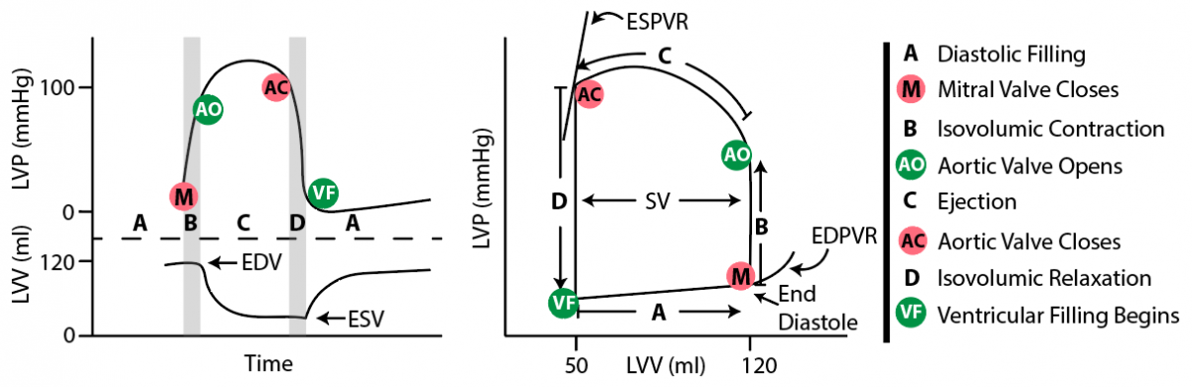

The point labeled “**VF”** (ventricular Filling) represents the point that the mitral valve opens and diastolic filling of the ventricle begins. The point “**M”** (Mitral Valve Closing) represents the closure of the mitral valve in response to ventricular contraction. The interval “**B**” (Isovolumetric Contraction) represents ventricular contraction with all valves closed and no blood entering or leaving the ventricle. Notice that during B the volume will remain at 120ml until pressure rises enough to surpass the pressure in the aorta. Once pressure in the ventricle is higher than pressure in the aorta, the aortic semilunar valves will open at point “**AO**” (Aortic Valves Open).

When the aortic semi-lunar valves open, blood will begin to leave the ventricle even as ventricular pressure is increasing (see “**C**” or Ejection). Point “**AC**” (Aortic Valves Closing) illustrates the closure of the aortic valves. Additionally, at point **“AC”** the higher pressure in the aorta causes the blood to push back on the  aortic valves and close them. Interval “**D**” is also called isovolumetric relaxation. During isovolumetric relaxation all valves are closed and volume does not change, even though pressure is decreasing.

You can compare the points (M, AO, AC, VF) and intervals (A-D) on both graphs to see where events are happening in each graphical representation.

There are two additional areas on our graph, one labeled as **ESPVR** which stands for End Systolic Pressure Volume Relationship and the other labeled as **EDPVR** which stands for End Diastolic Pressure Volume Relationship. The ESPVR is a pressure volume relationship that is represented at maximal contraction (maximal shortening) of cardiac fibers. EDPVR is a pressure volume relationship that is represented at maximal ventricular relaxation. Clinically, both areas represent important characteristics of heart function. We will discuss ESPVR, and how it relates to a term called **“Inotropy”**.

#### Inotropy

Inotropy is sometimes referred to as contractility of the heart. It might help to think of it as the force of contraction that heart muscle generates as it contracts. Increasing contractility is mostly a function of calcium influx. Increased calcium in the cytoplasm leads to a greater movement of tropomyosin off actin active sites and this leads to more binding of myosin to these binding sites. The greater the degree of myosin binding on actin there is, the greater the force of contraction. Keep in mind that in most cases, more myosin binding leads to greater force and a more shortened sarcomere. However, in some cases like high afterload (to be discussed later), greater myosin binding can lead to greater force, but not as much sarcomere shortening.

Changes in inotropy are essential to heart function because the heart cannot modify strength by recruiting more fibers or activating motor units. In essence, all the cardiac fibers are activated with a stimulus, but not all myosin heads need to engage. Thus, the only way to modify strength is by activating more myosin heads, which is accomplished by regulating cytoplasmic calcium levels. The flow charts in the section (3.2.3) identify the ways that inotropy can be regulated at the cellular level.

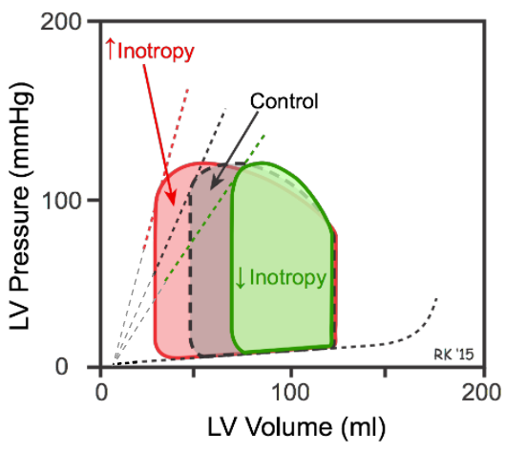

In the image above, inotropy is represented as a line that runs from the point on the graph where there is no pressure on the ventricular walls (zero value on Y-axis) and not quite zero on the ventricular volume (X-axis), to the point where the ventricle is at a maximum contracted state (point AC). Ideally, the inotropy line should intersect at zero for both pressure and volume, but physiologically it is impossible for the heart muscle cells to contract small enough to eject all the volume.

Inotropy is the **slope** of this line. The slope is a representation of the rise over run ratio or ΔP/ΔV. Mathematically, a slope represents a rate of change or rate of growth. Thus, the steeper the line, the quicker the rate of change. In the case of inotropy, the slope will increase as the ratio of ΔP/ΔV becomes greater (basically telling us that it takes more pressure to change the volume). The change in pressure is measured as the result of myosin and actin interactions within the heart muscles and the change in volume is measured as a result of blood being ejected. To understand this ratio better and how it relates to inotropy and the slope let’s try an analogy.

Imagine if you cupped both of your hands together and wrapped them around a small balloon full of water that was open at the top so you could squeeze water out of it like a fountain. Your fingers could represent the interaction between myosin and actin within the sarcomeres of the heart muscle, and your palms the sides of the heart chamber. Just like in the heart, consider that the degree of finger overlap (ie. myosin and actin) is regulated by the amount of calcium. Hopefully it will become clear that as you hold the balloon of water in your palms, and then start to overlap your fingers, and bring your palms together, that water would begin to squirt out the top of the balloon. The more you overlap your fingers (ie. myosin and actin interaction and subsequent shortening of the sarcomere) the more fluid you would be able to squirt out of the balloon. In other words, the amount of water left in the balloon could be correlated to how much overlap you did with your fingers. It is important to understand that even if the pressure applied with your palms remains consistent or the same, as you continue to increase the finger overlap (sarcomere shortening), more water will be squirted out because the space between your palms will get smaller and smaller.

Consider what this might look like if we graphed the degree of finger overlap to the volume of water left in the balloon. Lets look again at the pressure volume loop diagram. In essence, when trying to understand inotropy, bringing your palms together would be analogous to the changes in pressure (ΔP), and the amount of water left would be analogous to volume (ΔV). The degree to which finger overlap effects how much volume of water is left in the balloon, or the ratio of ΔP/ΔV, is inotropy. Thus to increase inotropy, we could increase finger overlap, but keep the same pressure, which would still decrease the water in the balloon, indirectly making the ratio of pressure to volume greater, and thereby increasing the slope (See red graph tracing above).

The ratios of pressure to volume are also used to describe two very important terms: **elastance** and **compliance**.

**ΔP/ΔV** is the mathematical representation of a characteristic we call **Elastance**.

**ΔV/ΔP** is the inverse of Elastance and is called **Compliance**.

Let’s look at this relationship again. An increase in the ratio of ΔP/ΔV (increased inotropy) is also saying that it takes a lot of pressure to get a small change in volume. This is the clinical way of looking at inotropy as measured by elastance. Elastance is a variable that represents the stiffness of the ventricular wall during its maximally contracted state. We will try to explain elastance using the following graph.

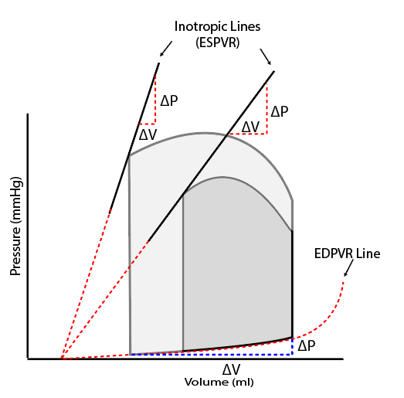

If we take a closer look at the graph above, we see that the lighter colored loop has more inotropy (greater contractility or a “steeper slope”). The graph for the lighter colored loop illustrates that the ventricle must have contracted with a greater force (more myosin and actin interaction) because less volume remains in the ventricle at the end of contraction. As predicted, the inotropic line is much steeper when compared to the darker colored graph. According to our definition of elastance, the lighter colored ventricle is also more stiff (or contracted down) at the point of maximal contraction. Let’s try another imagination experiment to interpret what the slope of the line at this point is telling us as it pertains to elastance. Imagine that it was possible to go into the ventricle at the very moment of maximal contraction. If we pushed on the walls and tried to return (stretch) them back to normal, we would have to put a lot of pressure on the ventricle walls before it moved a little bit.  We know this because the rise or vertical component of the red triangle on the inotropic line is quite large compared to the volume or horizontal line.  So, it takes a lot of pressure to get any increase or change in volume.

Hopefully, you can see how measuring the slope of this inotropic line also gives us an idea of how “stiff” the ventricle is at maximal contraction which gives us an idea of how much calcium was allowed to be in the cytoplasm during this contraction loop.

However, in the darker colored loop, the inotropic line has a slope that is more shallow, which tells us that there is likely less cytoplasmic calcium allowing for less myosin to pull on actin and the end contraction state is such that the ventricle is not as “contracted down”  or “as stiff” at the end of its contraction phase. The decreased stiffness can be seen by noticing in the little triangle that the vertical pressure line is much closer to the size of the horizontal volume line. Again, you could imagine going into the ventricle at this exact time and pushing on the walls.  Because it is not as “contracted down” or “as stiff”, we would be able to stretch the ventricle walls (increase volume) much more with the same unit of pressure.

Summing things up…the slope of the inotropic line gives us an idea of the contractility or calcium regulation during cardiac muscle contraction and is an integral part of **ESPVR**.

Now a quick look at the other pressure volume relationship line called **EDPVR**. This line occurs when the ventricle is maximally relaxed. This is represented by the red line at the bottom called the EDPVR line. Notice how much the volume increases (horizontal blue line) with just a small change in pressure (vertical blue line). Relaxed cardiac muscle without calcium in the cytoplasm has very little elastance, but a lot of **compliance**.

However, an injured or diseased heart, might have connective tissue and scar tissue in and around the fibers and this would not be as compliant. We would see this on a pressure volume loop when the slope of the hypotenuse for the blue triangle on the bottom of the loop is increased.

#### Afterload

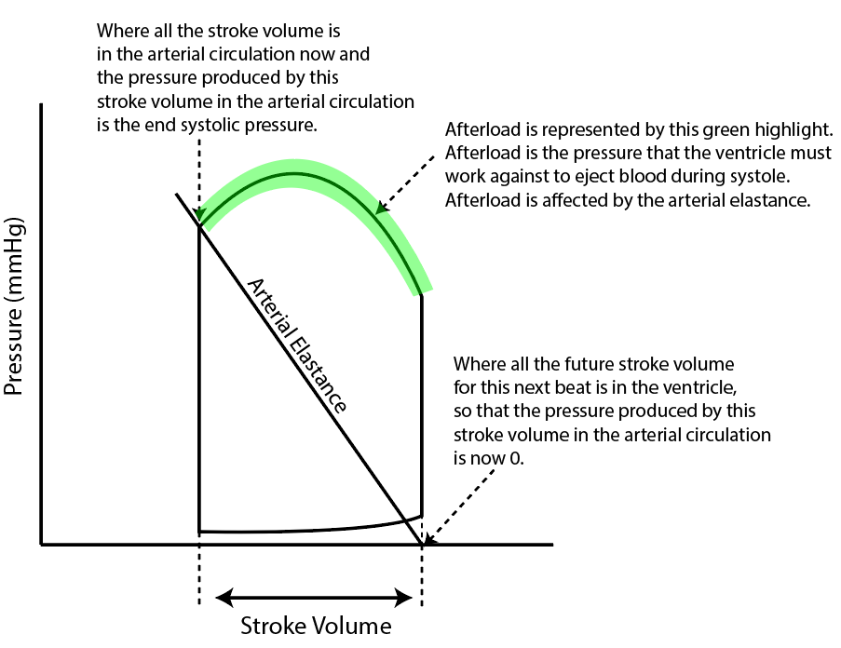

The graph above can help us begin to grasp a concept called **Afterload**. Consider the following attempts from various texts to give a definition of afterload:

* Afterload is the force against which the heart must pump to expel blood into the vasculature.
* Afterload is the resistance to blood coming out of the ventricle during the ejection phase.
* Afterload is the sum of forces that include elastic and kinetic that oppose ventricular ejection.
* Myocytes contract, and when they contract, they overcome some level of resistance in order to move blood. The resistance that must be overcome is called afterload.
* Remember that the heart is a muscle that contracts to displace a viscous fluid into a stretchy elastic receptacle. Anything that resists this movement of blood, is Afterload.

Ok, lets take a look at the graph above. Notice that there is a different line with a slope through the middle of the loop. The slope of this line will also teach us about elastance, but in this case we will use the line to estimate **Arterial Elastance**. Arterial elastance is not the elastance discussed before. Arterial elastance is the elastance in the arterial tree and NOT the ventricle itself.

The bottom of the line labeled arterial elastance represents the place where all the blood that is about to enter the arteries is actually in the heart and not in the arteries.  So, the contribution of this volume of blood to stretching or pushing on the arteries is actually “0”.  The other point on this line is at the end of the period of ejection.  At this point, all the blood that was ever going to enter the arteries is now in the arteries. So, whatever pressure this particular stroke volume of blood was going to contribute to the arterial walls is now fully realized because all the stroke volume has left the ventricle. If we draw a line between these two points, and assess its slope, we see that the steeper the slope, the more pressure it takes to get a unit of volume change. The more shallow the slope, the less pressure it takes to see a unit of volume change. Once again, we are talking about elastance. This time, however, we are talking about arterial elastance. Arterial elastance is part of **afterload**. Revisiting our balloon analogy, afterload would be equivalent to having your lab partner pinch the top of the balloon to restrict water flow as you tried to squeeze the balloon with your palms. When this happens, to squirt out an equivalent amount of water, in the same time period, would require you to push more with your palms and try to overlap your fingers more. The key word is “try” to overlap your fingers more. If water is more difficult to squeeze out because of the increased resistance (from your lab partner), you may find that overlapping your fingers is more difficult. This can be seen in the afterload diagram below. As you increase afterload, inotropy stays the same (stiffness and degree of myosin/actin overlap), but pressure increases as well as the amount of blood remaining in the heart. In the red loop the pressure increased, but this increase in pressure was unsuccessful in ejecting more blood. This is because myosin and actin were unable to shorten the sarcomeres completely, despite lots of calcium present in the cytoplasm. At the molecular level, myosin was binding and undergoing the power stroke but was unable to pull actin across itself. Thus the ratio of ΔP/ΔV remained the same. Is it evident that the heart would not be very happy with this situation as stroke volume would decrease making cardiac output decrease?  Keep in mind however, that if stroke volume does decrease, it may be possible to keep cardiac output from dropping if heart rate increases enough (CO= SV  *  HR).

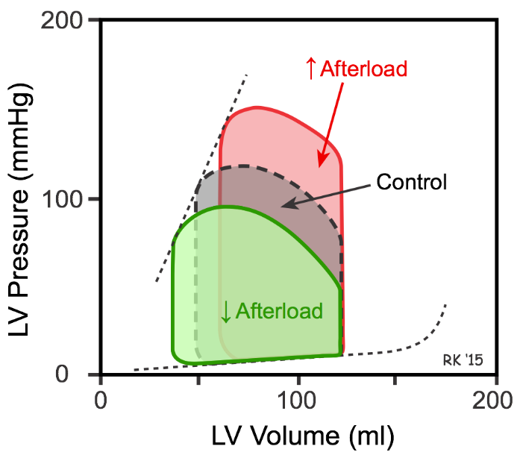

Even though increases in arterial elastance is the most common contributor to changes in afterload, there are other things that can resist movement of blood from the ventricle. There may be anatomical change to the valvular openings for example that would resist blood movement and this would certainly raise afterload.

Anything that causes the pressure to rise during the ejection phase or anything that causes the arterial resistance elastance line to increase its slope will cause afterload to increase.

Here are some examples.

* Increased viscosity of blood will require greater pressure to overcome inertia and create kinetic energy. This will raise the pressure generated during the ejection phase.
* Vasoconstriction will make the arterial tree less compliant and the ventricle will have to generate greater pressure to move blood into the arterial tree. This will increase afterload as the end systolic pressure will have to be higher.
* A narrowed opening of the aortic semilunar valves will make it more difficult to move the same stroke volume of blood into the arterial tree. This will require the pressure to increase in the ventricle in order to compensate for the difficulty of moving blood through the smaller opening.
* Arteriosclerosis or “hardening of the arteries” will make it more difficult to move blood out of the ventricle because the aorta will not stretch as well. Rather, the arteries will be more “stiff” even before the blood starts to come. The ventricle will have to generate more pressure to continue the flow of adequate blood supply into this stiffer aorta.

#### Preload

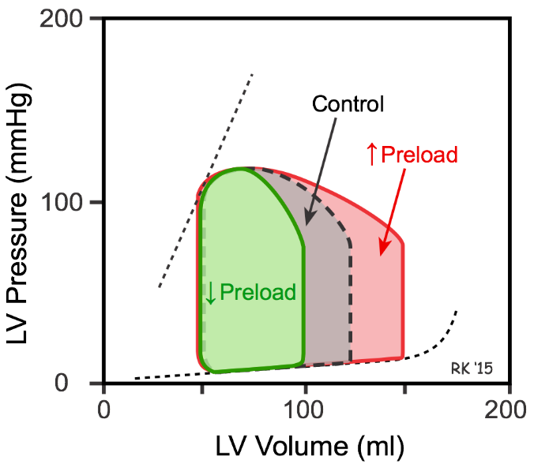

Preload can best be thought of as the amount of stretch in the cardiac sarcomeres before they contract. Sarcomeres are passively stretched during diastole when the ventricle is filling with blood. The volume of blood on the x axis of a pressure volume loop when isovolumic contraction begins is a good index for preload.

Notice that if inotropy and afterload stay constant, and the amount of blood returning to the heart increases, the total volume of blood in the heart also increases. Since afterload and inotropy stay the same, the heart will contract to the same end-systolic volume (50ml). Moving from the green loop to the red loop results in a substantial increase in stroke volume and ejection fraction.

This is an interesting phenomena. How is it that the same amount of cytoplasmic calcium and the same amount of afterload can result in progressive increases in stroke volume and ejection fraction by simply filling the ventricle more?  Doesn’t it seem like the heart would have to come up with more energy and force (more inotropy) somehow to pump progressively larger amounts of blood?  Well, it turns out that increased cardiac muscle stretch will actually put the sarcomeres in a more optimized length tension relationship. This is the other way that heart muscle contraction force is adjusted. Relaxed cardiac muscle is in a very shortened sarcomere position. As the preload increases, the sarcomeres are stretched out to expose more and more actin active sites to myosin. This is the same length tension relationship we talked about with skeletal muscle.

The idea that increasing preload causes increased force production without having to cause more calcium influx is called the **Frank-Starling mechanism**. There are limits of course, as over stretch would actually make the cardiac muscle much less capable of force production (also similar to the over stretch and length tension relationship weakness discussed in skeletal muscle).

But, for the functional ranges that humans use their hearts in rest and activity, we find that the increased venous return stretches the heart to more optimal sarcomere length which will increase stroke volume for any given inotropy and afterload values.

Preload is impacted by veins that pump blood back toward the heart. Veins are unique from arteries in that they contain hardly any pressure at all and they have one-way valves that open as blood flows toward the heart but will close as blood falls away from the heart and back to the extremities because of gravity. As the muscles in our body contract they squeeze the veins of the legs and arms and force the blood back to the heart. This is known as the skeletal muscle pump for venous return. As we stand, walk or run, blood is pumped back to the heart, increasing the preload. We also have a respiratory pump that functions as we breath. When we breath in and out, the movement of the diaphragm helps to create changing pressure gradients in our body cavities that can kind of “massage” blood back to the heart. Through the utilization of these venous return mechanisms, the body maintains preloads that are necessary to keep cardiac output at homeostasis.

Look at the charts above one more time and try to imagine how a change in inotropy, afterload or preload could affect stroke volume and then cardiac output. One day, when you begin treating patients, you will realize that the treatments at your disposal will have a major effect on inotropy, afterload or preload.  So, knowing how these variables affect cardiac output and how they affect each other can help you make wise cardiovascular treatment decisions.

Read this online at <https://books.byui.edu/bio_461_principles_o/cardiac_measurements>