Cellular Mechanisms of Inotropy and Chronotropy
Changes in inotropy (also known as contractility) are essential to heart function because the heart cannot modify strength by recruiting more fibers or activating motor units. In essence, all the cardiac fibers are activated all the time, so the only way to modify strength is by changing individual fiber contraction strength (shortening length) through the regulation of calcium. The flow chart below identifies the mechanisms by which inotropy can be regulated.
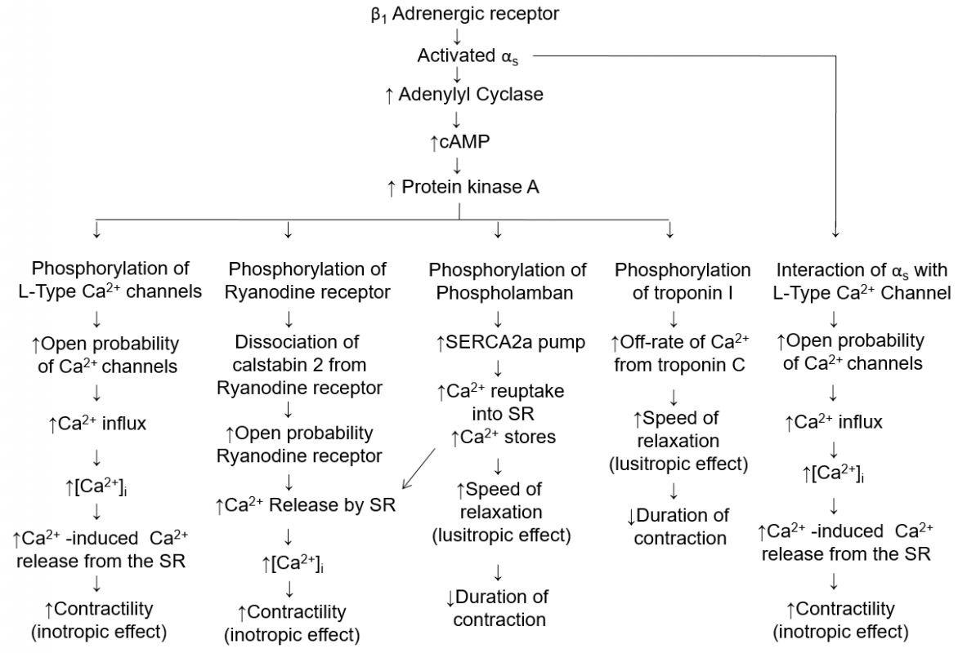
In addition to altering the contractility (inotropy) of the heart we can also alter the rate at which contractions occur. This effect is known as chronotropy. Below are two charts that illustrate the different effects on both positive and negative chronotropy.
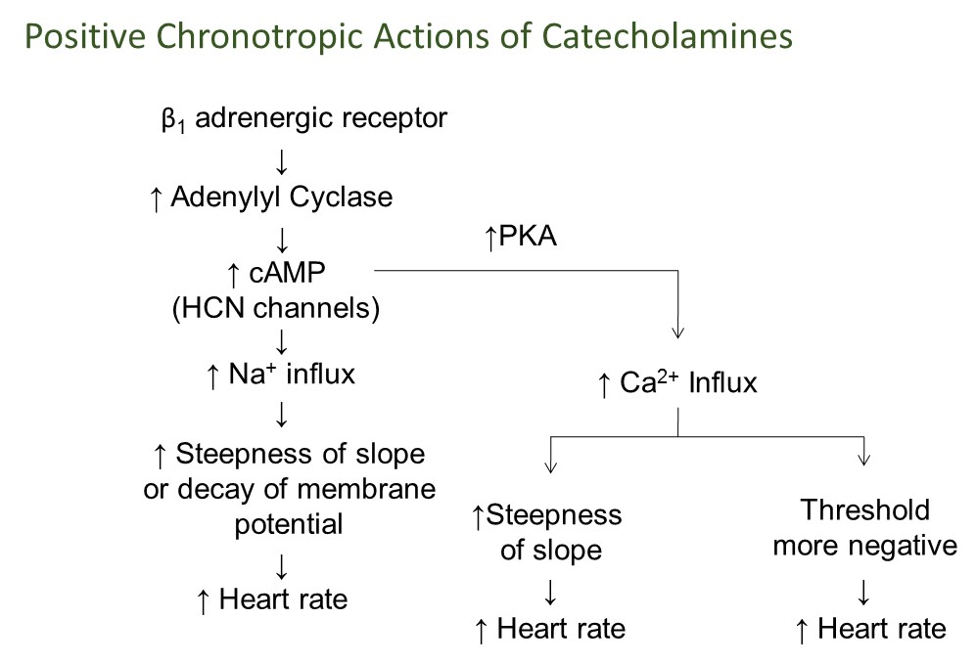
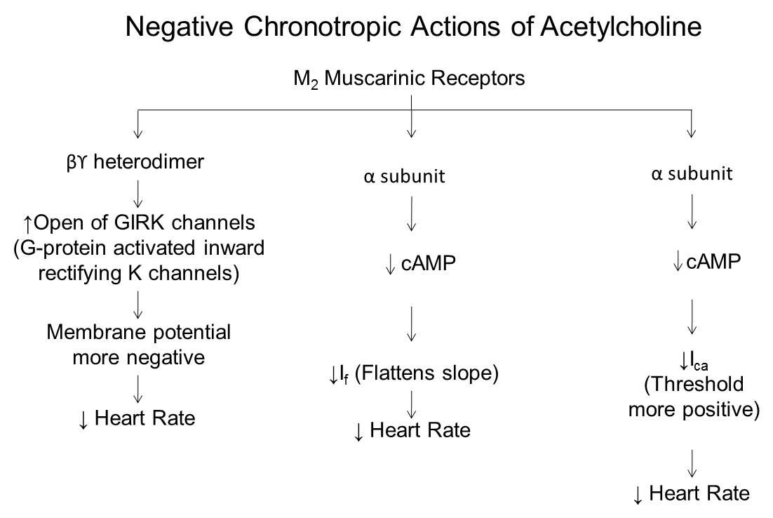
The primary players in the chronotropic regulation of the heart are the autonomic nervous system and the endocrine system. The heart is innervated by both the parasympathetic and sympathetic divisions of the autonomic nervous system. Parasympathetic fibers reach the heart via the Vagus nerve and act on the autorhythmic cells through the neurotransmitter acetylcholine. Acetylcholine slows the heart by hyperpolarizing the membrane through G-protein activated inward rectifying K⁺ channels (GIRK). When acetylcholine binds to the muscarinic G-protein, the beta-gamma subunit diffuses to a binding site on a neighboring GIRK channel which opens the channel. Opening the channel results in an outward K⁺ current, hyperpolarizing the cell and moving the "resting" membrane potential further from threshold, as well as flattening the slope of the pacemaker potential. Both actions increase the time required for the cells to reach threshold. The overall effect is to slow the heart rate. At rest there is constant parasympathetic activity or parasympathetic tone maintaining the resting heart rate slower than the intrinsic rate or the SA node. Sudden loss of parasympathetic stimulation results in an increased heart rate. Strong parasympathetic stimulation alone can decrease heart rate by about 10–20%. Obviously, there is a limit to how slow the heart can beat. The cardiac muscle contractile cells have little or no parasympathetic innervation so parasympathetic stimulation has little effect on the strength of contraction.
Sympathetic fibers reach the heart via sympathetic cardiac nerves and innervate both the autorhythmic cells and the contractile cells. The actions in both tissue types are mediated via β₁ adrenergic receptors. In the autorhythmic cells, sympathetic innervation increases heart rate by increasing the slope of the pacemaker potential and lowering the threshold for the voltage-gated calcium channels. Sympathetic stimulation of the contractile cells increases the amount of calcium released from the sarcoplasmic reticulum, resulting in increased strength of contraction, hence an increase in stroke volume (see chart above).
The endocrine system also influences the actions of the heart, primarily through epinephrine (sometimes referred to as just “E”) and norepinephrine (also referred to as NE) released from the adrenal medulla. These hormones bind to the β₁ adrenergic receptors and have the same effect as sympathetic stimulation of the heart.
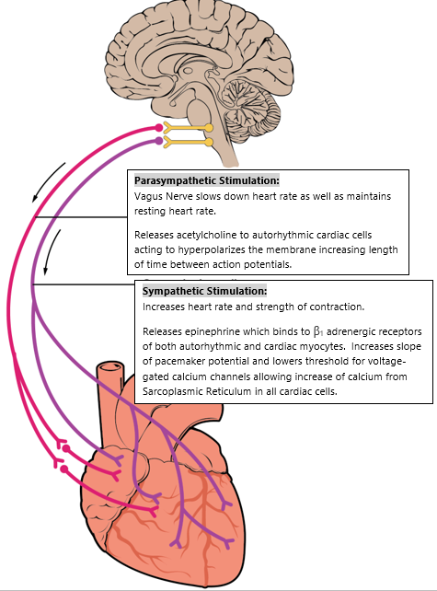
Videos that might help with the flow charts in this section are found below:
Helpful Video on Inotropy and Lusitropy
Helpful Video on Chronotropy
Read this online at https://books.byui.edu/bio_461_principles_o/cellular_mechanisms_

