# Arteries and Veins

It may help to see a good image of blood vessel anatomy.  Here are a couple of links of images we like.

[https://books.byui.edu/-NtzM](https://media-us.amboss.com/media/thumbs/big_59a839222fb17.jpg)

[https://books.byui.edu/-LUJo](https://i.pinimg.com/originals/85/87/3e/85873eadb91a8e9c3eaa313fd5187170.jpg)

Three main kinds of blood vessels are found in the human body: arteries, capillaries, and veins. Arteries are systemic vessels which transport blood from the left ventricle to cells and tissues throughout the body. The arteries nearest the left ventricle are massive vessels, having walls composed mostly of elastic tissue and to a lesser extent, smooth muscle. As blood travels further through the system, the arteries become increasingly branched and decrease in size. As this branching occurs, arterial wall composition changes as well, incorporating more smooth muscle and less elastic tissue. Owing to this change in composition, arteries are categorized from largest to smallest as elastic arteries, muscular arteries, and finally arterioles. Arterioles are particularly sensitive to neural and endocrine influences. Arterioles change diameter under these influences and this impacts the amount of resistance to blood flow. Blood within arterioles courses into the smallest type of vessels known as capillaries. Capillary walls are extremely thin which allows the blood to exchange oxygen, nutrients, and waste products with surrounding cells and tissues. The thinness of the walls also reduces their ability to withstand high pressure, thus a major reduction occur at the arterioles before reaching the capillaries. By the time blood hits the capillaries the pressure has been reduced from 120mmHg to around 25mmhg and the flow has gone from a rapid pulsating flow to a slow smooth consistent flow.

Capillaries connect the arterial blood flow to veins, which transport blood from the cells and tissues of the body back to the right atrium of the heart. Veins are categorized from smallest to largest as venules, small veins, and medium/large veins. Venous wall composition differs from arterial wall composition because they have less smooth muscle and elastic tissue.

**Tunica Adventitia**

The outermost tunica adventitia is made up of connective tissue which vary in consistency and tissue type based on depth. The deepest layers are composed of dense connective tissue while the outermost layers are composed of loose connective tissue continuous with that of the surrounding tissues.

**Tunica Media**

The tunica media is the most variable of all the layers between different types of arteries. It is composed of circular bands of smooth muscle cells which can contract or relax and change a vessels diameter. The tunica media also contains various amounts of elastic and collagen fibers. An elastic layer known as the external elastic membrane divides the tunica media from the tunica adventitia. This layer is especially prominent in large vessels like the aorta.

**Tunica Intima**

The innermost tunica intima is composed of an endothelial layer, a connective tissue basement membrane and a slim layer of connective tissue known as the lamina propria. An elastic layer known as the internal elastic membrane divides the tunic intima from the tunica media.

**Vasa Vasorum**

Recall that blood vessels exist because all cells within the human body require oxygen, nutrients, and the disposal of waste products in order to survive. Considering that the vessels themselves are composed of living cells many layers thick, they are not exempt from these requirements. The requirements of vessels under 1 mm in diameter are easily satisfied by diffusion between the lumen of the vessel and its surrounding layers. However, vessels larger than this size must be sustained by a capillary network of vessels known as vasa vasorum within the tunica adventitia and tunica media layers.

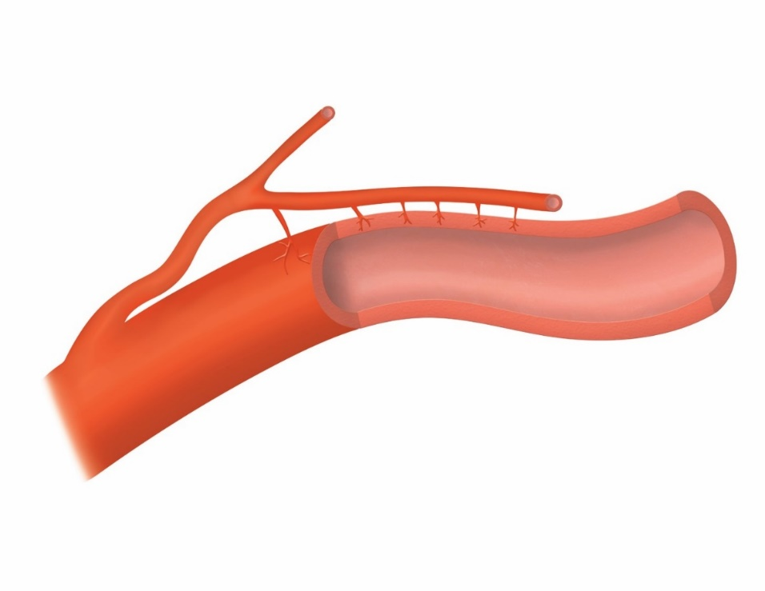

#### Arterioles

**Arterioles** are the smallest type of artery and are similar in composition to muscular arteries.  The tunica adventitia is extremely thin and devoid of an external elastic membrane.  The tunica media is composed of smooth muscle tissue, but contains few layers.  The tunica intima does not have an internal elastic membrane.

#### Veins

Veins are thinner than arteries. The tunica media has less smooth muscle in it. The thinner vessels with less smooth muscle makes them have more compliance. Because of the extensibility of the veins, we find that at any moment, there can be around 70 percent of a persons blood in the veins. When the body needs to increase cardiac output, the veins can contribute more blood by some vasoconstriction but also by more skeletal muscle contraction such as occurs during exercise.

#### Venules

Venules are the smallest type of vein.  Venules receiving blood directly from capillaries are very similar to the capillaries themselves.  As the venules increase in size, an increasing number of smooth muscle cells are found surrounding the tunica intima.

#### Small Veins

Once venules reach a certain diameter, a tunica media layer of smooth muscle cells completely surrounds them.  At this point they are known as **small veins**.  A tunica adventitia layer of collagen fibers is also found surrounding the smooth muscle tissue of the tunica media.  All veins tend to be larger than arteries at a similar point in the vascular tree.  This is because veins have thinner walls and Tunica layers.  These thin layers allow veins to stretch a lot.  This ability to stretch is called “compliance”.  Veins have a lot more compliance than arteries.

#### Valves

Valvesare common components of medium and large veins greater than 2 mm in diameter.  A valve is formed by two overlapping sections of tunica intima tissue that converge to close off their respective vein should back flow occur.  Valves are far more prevalent in medium veins and in veins of the legs than in veins of the arms. Sometimes valves can be stretched if there are excessive amounts of pressure in the vein.  This can sometimes happen if a person stands or sits for long periods of time (over many months and years). In these situations, blood can have a hard time moving up the venous vessels because of gravity or compression of lower extremity soft tissue. We tend to find more valves in the veins of the lower extremities. This is likely because we spend so much time upright and gravity pulls on the venous blood. Having more valves will allow more "gates" that blood would have to move past to descend downward toward the feet (under the pull of gravity).

Read this online at <https://books.byui.edu/bio_461_principles_o/arteries_and_veins>