# Capillary Exchange

The video on [capillary exchange](https://video.byui.edu/media/t/1_ke8llk9u) can help with the following reading.

Having discussed the anatomy of the circulatory system, we are now ready to study the very reason why the circulatory system exists: **capillary exchange**. Capillary exchange is simply the flow of water and dissolved particles from the capillaries to the tissues and from the tissues to the blood. In reality, it is a relatively clear liquid called interstitial fluid, not blood that the body's tissues are bathed in. The dissolved solutes that pass from capillaries to interstitial spaces and from interstitial spaces to capillaries include everything a cell needs to have in ready supply to survive as well as everything a cell needs to get rid of. Examples of things that cells need include nutrients, regulatory chemical messengers, and electrolytes. Examples of things that cells need to get rid of include CO2, acids, and other waste products of metabolic processes. Please keep this image below in mind as we discuss the capillary exchange process in detail.

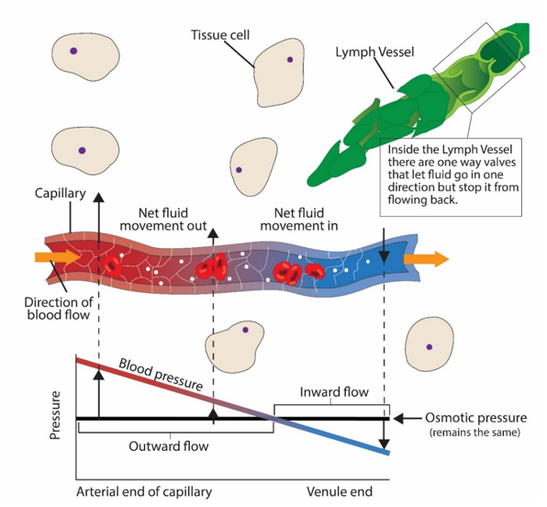

Water, oxygen and nutrients move from inside the capillaries to the interstitial fluid on the arterial end of a capillary bed and from the interstitial spaces back to the inside of the capillaries on the venous side of a capillary bed.  In order for this exchange of water, oxygen, carbon dioxide and other nutrients to happen in the capillary bed, there must be pressure that “push” things out and pressure that “pull” things back into the capillary.

There are two main pressures to understand in the capillary exchange process.  One is known as the “**Net Hydrostatic Pressure**” and the other is the “**Net Osmotic Pressure**” and the difference between these two pressures equals the “**Net Filtration Pressure**.”  The term hydrostatic relates to the pressure of all the liquids involved – the blood pressure, the interstitial fluid, etc. The term osmotic relates to the solutes (proteins and electrolytes) and the power they have to pull water from a higher concentration to lower concentration (osmosis) in order to reach equilibrium. Other important terms include: **Transmural pressure** = pressure across vessel wall, **Driving pressure** (force) = P1 – P2, **Hydrostatic pressure** = pressure at any point along the MAP line.

Let’s study in detail all the pressures that combine to create the net hydrostatic pressure and the net osmotic pressure as they contribute to the process of the exchange that happens in the capillaries. There are four pressures that we try to keep track of as we determine the 'Net' filtration pressure.

1. **Blood pressure (BP):**Notice in the picture below how blood pressure oscillates between about 120 mmHg and 80 mmHg in the large arteries like the aorta. As blood moves peripherally and enters many branches into smaller vessels, the blood pressure oscillations are dampened. Finally, by the time the blood is branching into the capillaries, the pressure is around 30 mmHg. Blood pressure tends to drive fluid and solutes out of the capillary.

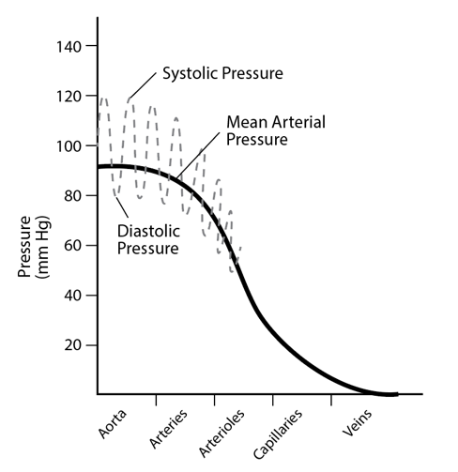

1. **Blood colloid osmotic pressure (BCOP):**BCOP is an osmotic force that tends to move water towards an area of more solutes. The word colloid refers to the concentration of solutes that cannot leave the capillary. This is primarily plasma proteins (mostly albumin). Albumin is a large protein in the plasma and generally cannot fit between the pores of the endothelial cells that make up the capillary wall.  If we imagined that there were no solutes outside of a capillary and calculated the number of solutes in the capillary, we could say that there is an osmotic pressure that tends to drive water into the capillary. This calculated pressure would be about 28 mmHg. Let's take a look at the table below to help keep track of what has happened so far.

#### Arterial End

|  |
| --- |
| **So Far…** |
| Pressure moving fluid  out (  +)  of the capillary | Blood Pressure in the arterial end of the capillary | +30 mmHg |
| Pressure moving fluid  into (-)   the capillary | Blood Colloid Osmotic Pressure | -28 mmHg |
| **Net Pressure and Direction** | +2 mmHg  out   of the Capillary |

Let's keep going, we have two more pressures to consider:

1. **Interstitial Colloid Osmotic Pressure (ICOP):**ICOP is an osmotic force that tends to move water out of the capillary and into the interstitial space. If we imagined that there were no solutes in the capillary and only focused on the number of solutes in the interstitial space, then we could calculate an osmotic force pulling water out of the capillary. This osmotic pressure would be about 8 mmHg.
2. **Interstitial Fluid Pressure (IFP):**IFP refers to the pressure that the fluid in the interstitial space puts on the capillary membrane. As it turns out the lymphatic system is pulling fluid away from the interstitial space and so, the pressure on the capillary is actually a 'suction'.

|  |
| --- |
| **So Now…** |
| Pressure moving fluid  out (+)   of the capillary | Blood Pressure in the arterial end of the capillary | +30 mmHg |
| ICOP at the arterial end of the capillary | +8 mmHg |
| IFP at the arterial end of the capillary | +3 mmHg |
| **Net Pressure Moving Fluid Out of a Capillary** | 41 mmHg |
| Pressure moving fluid  **into (-)**   the capillary | Blood Colloid Osmotic Pressure | -28 mmHg |
| **Net Pressure Moving Fluid into a Capillary** | -28 mmHg |
| **NET FILTRATION PRESSURE AND DIRECTION**  **AT ARTERIAL END** | 41 mmHg  **out**    - 28 mmHg  **in**    _____________    +13 mmHg  Out |

So far, we have examined the 4 forces that control flow of water and dissolved fluids out of a capillary at the arterial end. Now, let’s look at how these 4 forces work at the **venous end** of a capillary.

1. **Blood pressure (BP):**The capillaries are very small and there is significant friction on the flow of blood as it moves from the arterial end to the venous end. This friction causes the pressure that the blood puts on the capillaries to drop. For this reason, we find a significant decrease in blood pressure on the venous end of capillaries (around 10 mmHg instead of 30 mmHg).
2. **Blood colloid osmotic pressure (BCOP):**BCOP is largely determined by the concentration of albumin in the capillary. Albumin does not cross the capillary membrane and so the concentration of this solute stays about the same through the length of the capillary. On the venous end, the BCOP is still 28 mmHg.
3. **Interstitial Colloid Osmotic Pressure (ICOP):**ICOP is largely a product of the proteins in the interstitial space. This does not change from the arterial to the venous end of a capillary so we find ICOP to be about 8 mmHg on the venous end.
4. **Interstitial Fluid Pressure (IFP):**IFP remains about the same on both the arterial and venous ends of a capillary because the lymph system is steadily pulling fluid away from the interstitial spaces. IFP is calculated at about a 3mmHg force pulling fluid away from the capillary. Sometimes this 'suction' effect is expressed as a negative pressure, so it is not uncommon to see some texts express IFP as -3 mmHg.

#### Venous End

|  |
| --- |
| **On the Venous end…** |
| Pressure moving fluid  out (+)   of the capillary | Blood Pressure in the venous end of the capillary | +10 mmHg |
| ICOP at the venous end of the capillary | +8 mmHg |
| IFP at the venous end of the capillary | +3 mmHg |
| **Net Pressure Moving Fluid Out of a Capillary** | 21 mmHg |
| Pressure moving fluid  **into (-)**   the capillary | Blood Colloid Osmotic Pressure | -28 mmHg |
| **Net Pressure Moving Fluid into a Capillary** | 28 mmHg |
| **NET FILTRATION PRESSURE AND DIRECTION**  **AT VENOUS END**  *The negative sign suggests that relative to the inside of the capillary, fluid is being pulled in (reabsorbed) rather than pushed out (filtered). | +21 mmHg  **out**    - 28 mmHg  **in**    ____________________    - 7 mmHg  In |

We see that there is a net flow of fluid moving out of the capillary on the arterial end of a capillary and see that there is a net flow of fluid moving into the capillary on the venous end of a capillary. **The net flow on the arterial end is larger than the net flow on the venous end**. Logic would suggest that we would continually accumulate fluid in the interstitial spaces if more fluid always left on the arterial end and was not all reclaimed on the venous end. However, this does not happen because the lymphatic system drains away the extra fluid and returns it to the circulation at the subclavian veins (where converging lymphatic vessels connect to venous blood).

To summarize, the Net Hydrostatic Pressure (NHP) is the combination of the blood pressure (BP) and the interstitial fluid pressure (IFP).  The Net Osmotic Pressure (NOP) is the difference between the blood colloid osmotic pressure (BCOP) and the interstitial colloid osmotic pressure (ICOP).  The Net Filtration Pressure (NFP) is the difference between the Net Hydrostatic Pressure and the Net Osmotic Pressure.

**Net Hydrostatic Pressure (NHP) = BP + IFP**

**Net Osmotic Pressure (NOP) = BCOP – ICOP**

**Net Filtration Pressure = Net Hydrostatic Pressure – Net Osmotic Pressure**



**The previous figure above shows how blood pressure drops through the length of the capillary. ICOP and BCOP don't change so the net osmotic pressure stays the same. On the graph we see that an outward flow of fluid on the arterial end eventually becomes an inward flow on the venous end. Even though the inward flow is smaller, the total volume of the outward flow is eventually returned to the circulation as the lymphatic vessels continually pull fluid away.**

The four forces at work on net fluid movement are in a careful balance and equilibrium so that the volume of fluid and solutes that leave the capillary equals the volume that is eventually returned to the circulation. This balance of fluid movement keeps the interstitial fluid volume around the cells relatively consistent. If one or more of the 4 forces is increased or decreased then the balance may be lost, resulting in **edema** or dehydration.

#### Edema

Edema is an abnormal accumulation of fluid in the interstitium. Imbalances of the forces of capillary exchange explains many of the cases of edema that health professionals see.

#### Hydrostatic Edema

Hydrostatic edema occurs when there is excess fluid moved into the interstitial spaces because of an increase in the hydrostatic pressure inside the capillary. Normally, the pre-capillary sphincters regulate how much blood can enter the capillaries and so even under the influence of high blood pressure the hydrostatic pressure in the capillary remains relatively normal. However, if systolic pressure rises above 160 mmHg for a long time, it is possible to see more blood move past the pre-capillary sphincter than is normal. This often raises hydrostatic pressure in the capillary and more fluid accumulates in the interstitial space to cause edema.

Another cause of hydrostatic edema is the increased hydrostatic pressure on the venous side of the capillary beds. Normally blood pressure is very low on the venous side of a capillary bed. However, if there is a venous blockage or if the heart pump cannot pump the blood that returns to it adequately, then we see pressure begin to build up in the veins. When this pressure rises in the capillary bed, we can see less fluid reclaimed from the interstitial spaces and fluid accumulates causing edema.

#### Permeability Edema

Permeability edema occurs when macromolecules begin to cross the capillary endothelial cell membranes or they begin to cross interstitial cell membranes. Many macromolecules like proteins do not readily cross cell membranes but stay within the blood or intracellular compartments. These macromolecules basically increase the interstitial colloid osmotic pressure and create an imbalance in the capillary exchange physiology that results in edema as water follows the molecules to the interstitial spaces. Physical trauma or toxic chemicals are the primary causes of sudden increases in cell membrane permeability that leads to edema. For example, a burn can disrupt cell membranes in the skin and cause cells to allow more solutes (atoms and intracellular molecules) to leak out. Inflammation from our immune responses can also change the permeability characteristics of capillaries and tissue cells which can lead to accumulation of solutes and water (edema) in the interstitial spaces.

#### Lymph Edema

Lymph edema occurs when lymph vessels become damaged and the damage results in obstruction of lymph flow. If lymph flow cannot occur adequately, the interstitial fluid volume rises. As the fluid accumulates edema occurs.

#### Osmotic Edema

Normally, the osmolarity of plasma and extracellular fluids is very similar (around

300 mOsm).  If plasma becomes diluted through a loss of osmotically active solutes or if the blood experiences a significant increase of free water, then plasma osmolarity will be lower than extracellular fluid and water will leave the capillary at a rate higher than normal and extracellular fluid edema will result (remember that water likes to move to an area of higher solute concentration). An example could be liver failure where albumin production is compromised which causes a significant decrease in blood colloid osmotic pressure (loss of solutes from the plasma) and this results in more water leaving the capillary on the arterial end of a capillary and less returning on the venous end. Excessive water intake could also dilute the plasma solutes and result in a similar movement of water from the capillary to the extracellular space. Let’s look at one more example. Antidiuretic hormone works at the level of the kidney to retain water in a way that less free water is lost in the urine. If a condition exists where this hormone is excessively released then plasma osmolarity will decrease as the kidneys retain more free water which effectively lowers the osmolarity and can again lead to an osmotic edema.

Read this online at <https://books.byui.edu/bio_461_principles_o/capillary_exchange>