Hematopoeisis
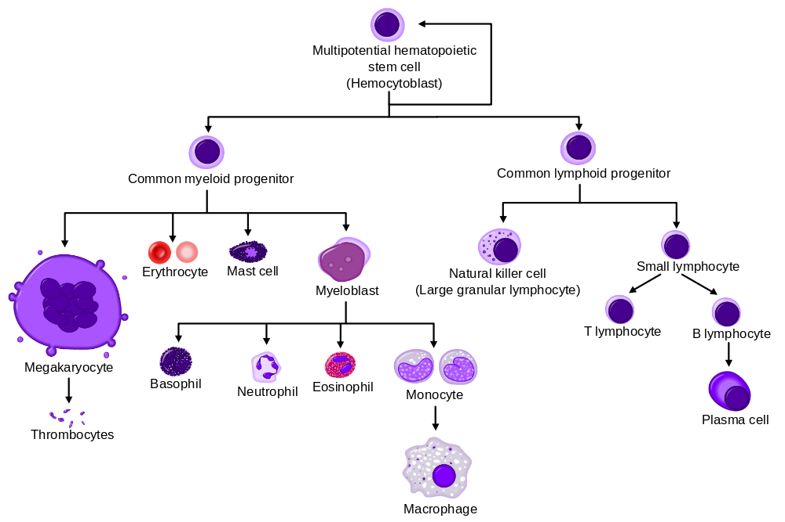
Each of the cells and platelets found in the blood arise through a process called hematopoiesis. Hematopoiesis begins with a single type of stem cell. These stem cells, known as hemocytoblasts, are located in red bone marrow in children and adults. In a developing fetus, hemocytoblasts are also found in the liver, spleen and lymph nodes as well as bone marrow. Ultimately, through the process of hematopoiesis, hemocytoblasts will differentiate into red blood cells, white blood cells, and cell fragments known as platelets. As we will learn later, platelets are important in blood clotting processes. White blood cells include macrophages, neutrophils and lymphocytes. Macrophages are large phagocytic cells that gobble up foreign material and damaged cell parts. Macrophages perform an important step in the breakdown of red blood cells. Neutrophils are very common with infections and Lymphocytes are an important part of our immune system and are the source of antibodies which you have probably heard about.

Platelets
Platelets or thrombocytes are not actually whole cells. Rather they are denucleated cell fragments of a large bone marrow cell known as a megakaryocyte. Though they are cell fragments, they still contain mitochondria and several other types of organelles. Platelets play an important role in blood clotting.

Red Blood Cells
The most abundant blood cell is the red blood cell, or erythrocyte. Erythrocytes possess a disk-like shape and are considered to be biconcave, as they possess a central indentation on both sides of the cell. This shape is critical to the proper function of a red blood cell, as it provides greater surface area for the rapid exchange of oxygen and carbon dioxide. This biconcave shape also allows the red blood cells to bend which helps them flow through small vessels.
Red blood cells contain a specialized type of protein known as hemoglobin, which is responsible for binding to and transporting oxygen and carbon dioxide. It should be noted, however, that while hemoglobin is solely responsible for transporting oxygen, it is only minimally involved in carbon dioxide transport. Most carbon dioxide is located in the blood in the form of bicarbonate ions. The conversion of carbon dioxide to bicarbonate occurs through a process that is catalyzed by a protein enzyme known as carbonic anhydrase, which is also located within red blood cells. The role of red blood cells in oxygen and carbon dioxide transport will be discussed in more detail during the respiratory chapter.

Hemoglobin
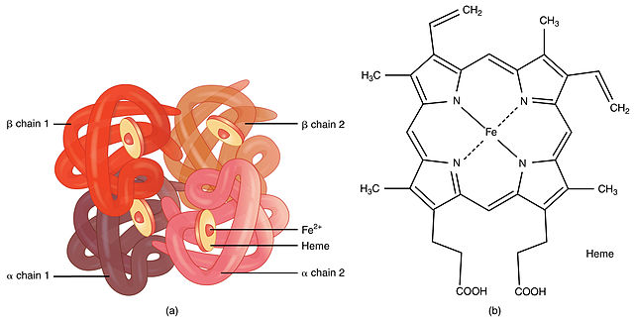
Hemoglobin is composed of 8 subunits: 4 polypeptide chains known as globins (2a and 2b) and 4 iron-containing heme-groups. Each heme group contains a single iron atom, which lends erythrocytes their distinctive red crimson color. Each heme group can transport one molecule of oxygen. When oxygen is bound to hemoglobin, the complex (can also be referred to as a pigment) is known as oxyhemoglobin, which possesses a bright red color. Hemoglobin without oxygen is known as deoxyhemoglobin, which possesses a dark red color.

Erythropoiesis
In a healthy adult's body, it is estimated that around twenty-five trillion red blood cells exist at any given moment. These blood cells will last for approximately 120 days before being broken down by macrophages. If not continually replaced, the overall oxygen containing capacity of the blood decreases. To maintain the twenty-five trillion cells, over two million new red blood cells enter the bloodstream each second to replace those lost! If you are ever accused of being lazy, wait two seconds, look up and say: “who you calling lazy, I just made 4 million new red blood cells!” This process of producing new red blood cells is called erythropoiesis and occurs within the red bone marrow of the axillary skeleton.
Erythrocytes (or Red Blood Cells) are unique in that they contain no nucleus or any organelles. During erythropoiesis, hemocytoblast stem cells ultimately differentiate into mature erythrocytes. Small signaling molecules known as hematopoietic growth factors (HGF's) stimulate the production and differentiation of the various types of blood cells. The HGF responsible for the production of red blood cells is known as erythropoietin (EPO). Upon sensing low blood oxygen levels, special cells in the kidneys release EPO into the bloodstream where it travels to target cells within the red bone marrow. Erythropoietin stimulates hemocytoblasts to differentiate into cells known as proerythroblasts. Ultimately, several more intermediates will be produced via mitotic division before the cells reach the reticulocyte stage, which is the final stage before maturation is reached. By this point, hemoglobin is contained within the cells, the nuclei are absent, and only a few ribosomes remain in the cytoplasm. Upon staining a reticulocyte, these remaining ribosomes give the appearance of a sort of net-like or reticular network which explains the origin of the name reticulocyte.
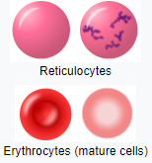
Reticulocytes have a reticular (mesh - like) organization of ribosomes that can be seen with certain microscopic staining techniques. Reticulocytes are found in the blood for about a day after leaving the bone marrow and then they mature into a fully formed red blood cell and cannot be distinguished as a reticulocyte anymore.
The reticulocytes are released into the blood where they differentiate to become mature erythrocytes about 24 hours later. It is interesting to note that in certain conditions which require accelerated erythrocyte production, the number of reticulocytes in the blood increases. A measurement of the number of reticulocytes in the circulation can give an indication of how strong the recent EPO stimulus has been (*Note: measuring the number of reticulocytes is one way in which athletes who cheat by using synthetic EPO are caught).
Erythropoiesis requires dietary intake of iron, folic acid, and vitamin B12. Any sort of deficiency related to these required dietary elements can cause a condition known as anemia. Anemia results when the bloodstream is unable to properly distribute oxygen throughout the circulatory system to the cells of the human body.
If a vitamin deficiency results in the decreased production of red blood cells, then the oxygen carrying capacity of blood is certainly diminished. Anemia caused by Vitamin B12 deficiency is called pernicious anemia. Vitamin B12 absorption requires a molecule synthesized by the stomach called intrinsic factor. Individuals with certain types of stomach issues may also develop anemia (more specifically, pernicious anemia) because they do not release intrinsic factor and therefore cannot absorb Vitamin B12, even though they eat plenty of it.
Anemia may also be caused by severe hemorrhaging (called hemorrhagic anemia), conditions that result in defective hemoglobin production (sickle cell anemia is one example), or any condition that causes excessive destruction of red blood cells (also called hemolytic anemia).
Read this online at https://books.byui.edu/bio_461_principles_o/hematopoeisis

