# Cardiac cycle

Each time the heart beats, a series of highly coordinated events occurs. These events are essential for the proper pumping of the blood and include pressure changes, volume changes, and the opening and closing of valves. This series of events is known as the cardiac cycle.

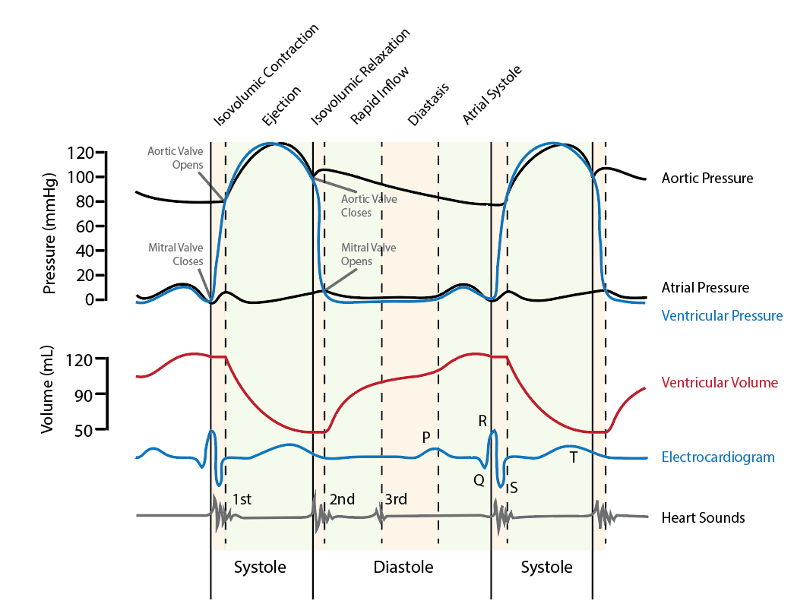

The image above shows the changes that take place in the heart during this cycle. Before we begin to study the cycle, however, there are two terms we need to define: systole (sis'tō-lē) and diastole (dī-as'tō-lē). Systole is contraction of the chambers. As was discussed earlier the atria contract slightly before the ventricles so we have atrial systole followed by ventricular systole. By convention, if we use the term systole alone (without the adjectives atrial or ventricular) it is understood that we are referring to ventricular systole. Diastole is relaxation of the heart. Again, if we use the term diastole alone it refers to ventricular diastole.

Take a close look at the image above. The top panel shows changes in pressure, expressed as mmHg, during the cycle. There are three curves on this graph, one for aortic pressure changes, one for ventricular pressure changes, and one for atrial pressure changes.

It should be pointed out that this figure represents pressures associated with the left side of the heart. If it were for the right side, the shapes of the curves would be similar but the maximum pressures would be much lower, only 20-30 mmHg. The middle of the figure shows volume changes in the left ventricle.

The two other lines at the bottom show when the various waves of the ECG appear with respect to the cycle and when the various heart sounds occur. The labels across the bottom show when the heart is in systole and diastole. From the figure it is important to note that diastole composes about 2/3 of the cycle and systole about 1/3. The labels across the top list the different phases during the cycle, the vertical lines showing approximately when these phases begin and end. Notice that this figure represents more than one cycle, reinforcing the idea that these cycles are occurring repetitively with a new cycle beginning as soon as the previous cycle ends.

One other point of clarification before we begin, there are two valves associated with each ventricle, the atrioventricular valves between the atria and ventricles (mitral or bicuspid on the left side and tricuspid on the right) and the semilunar valves between each ventricle and the large artery it pumps into (aortic on the left side and pulmonary on the right). Opening and closing of these valves is pressure dependent (upper graph). For example, if the pressure in the aorta is greater than the pressure in the left ventricle the aortic valve will be closed and if the pressure in the aorta is less than the pressure in the left ventricle the valve will be open. Also, for the mitral valve, if the pressure in the ventricle is greater than that of the atrium the valve will be closed and if the pressure in the ventricle is less than that of the atrium the valve will be open. Since it is a cycle we could begin our analysis at any point so let's begin during diastole at the point when the ventricles begin to fill, preparing for the next pumping cycle, this is labeled at the top as the period of rapid inflow.

**Diastole - Rapid Inflow:** This phase begins when the mitral valve opens shortly after the beginning of diastole and lasts approximately the first 1/3 of diastole. The aortic valve is closed during this phase. Look at the pressure differences in the aorta, ventricle and atrium to make sure you understand why the valves are either open or closed. During this phase the ventricle rapidly fills with blood. This filling is passive meaning that the blood returning to the heart is merely running through the atrium and directly into the ventricle. During this phase the ventricles fill to about 70-80% capacity. As they fill the volume change slows and by the end of the phase little blood is entering the ventricle.

**Diastole - Diastasis** (dī-as'tă-sis): During the second 1/3 of diastole there is very little change in ventricular volume. As the ventricles near capacity passive inflow of blood slows.

**Diastole - Atrial systole:** In the final 1/3 of diastole the atria contract adding the final 20-30% of the ventricular volume, also referred to as active ventricular filling.  At rest this "topping off" of the ventricles is of little significance but when we begin to exert ourselves it becomes much more important.

**Systole – Isovolumic contraction:** As systole begins the pressure in the ventricle, which at this point is close to 0 mmHg) increases rapidly. When the ventricular pressure exceeds atrial pressure the atrioventricular valve closes. The closing of these valves is responsible for the first heart sound. Since the semilunar valve is still closed (ventricular pressure less than aortic pressure) pressure increases rapidly but there is no change in volume. This phase is very brief and ends as soon as the ventricular pressure exceeds aortic pressure (~80 mmHg).

**Systole – Ejection:** Once the pressure in the ventricle exceeds that of the aorta the semilunar valve opens and blood is ejected from the ventricle into the aorta. During the first part of this phase pressure continues to increase and reached a maximum of approximately 120 mmHg at about the middle of the phase. Ejection of blood is rapid during this part of the ejection phase as can be seen on the volume curve of the graph. As ejection begins to slow pressure start to decrease in both the ventricle and the aorta.

**Diastole – Isovolumic relaxation:** At the beginning of diastole, pressure starts to drop rapidly and ventricular pressure drops below aortic pressure resulting in the closing of the aortic valve. The closing of the aortic valves is responsible for the second heart sound. Since ventricular pressure is still greater than atrial pressure the atrioventricular valves remain closed and there is a brief period when volume doesn't change (both valves are closed) but pressure drops. Once the ventricular pressure drops below atrial pressure the atrioventricular valves open, the ventricles begin to fill and the cycle starts again.

Check out the following link for a good tutorial/animation on the cardiac cycle:

[https://books.byui.edu/-Xwz](http://library.med.utah.edu/kw/pharm/hyper_heart1.html)

Before we leave this section, we should discuss a few other aspects of the cardiac cycle. If you look at the aortic pressure wave you see that it fluctuates between about 80 mmHg at the end of diastole and 120 mmHg during the ejection phase of systole. Later when we address blood pressure we will refer to these pressures as the **diastolic and systolic blood pressures**, respectfully, since the lower pressure occurs during diastole and the higher pressure during systole. Another interesting aspect of the aortic pressure curve is the little blip we see at the beginning of diastole. Aortic pressure drops and then as soon as the aortic valve closes there is a sudden, small increase in pressure. This increase is due to the fact that the aorta is very elastic and during systole as blood is being pumped in it expands. At the beginning of diastole, the aorta begins to recoil pushing blood forward to the systemic circulation but also back toward the ventricle. The sudden closing of the aortic valve produces a pressure wave as the blood pushes against it, resulting in the observed spike in aortic pressure. This spike is called the **dicrotic notch**.

Another interesting feature of the figure is the ECG tracing that is superimposed on the cycle. Notice that the P wave (atrial depolarization) coincides with atrial systole and the QRS complex (ventricular depolarization) coincides with ventricular systole.

Finally, if you look at the line showing when the heart sounds occur you will see a 3rd heart sound. We explained that the first two sounds were generated by the closing of the atrioventricular (1st heart sound) and semilunar valves (2nd heart sound). It should be pointed out that the actual sound is due to vibration (reverberation) of the valves and the walls of the heart and aorta that happens when the valves close. The third sound is generated as blood rapidly flows into the ventricles causing the ventricular walls to vibrate. When it occurs (it isn't detected in all patients) it is considered to be normal.

Read this online at <https://books.byui.edu/bio_461_principles_o/cardiac_cycle>