# Neuromuscular Junction, Excitation-Contraction Coupling

This video on [muscle contraction](https://video.byui.edu/media/t/1_cw2f1io0) can be helpful with the following text.

An important part of understanding the full story of muscle contraction is understanding how a nerve communicates an electrical signal to a muscle fiber. This area where a neuron communicates with a muscle cell is called a **Neuromuscular Junction (NMJ).**Below is an image of a zoomed-in NMJ. There are a lot of parts to this story to keep track of, so it might be helpful to practice sketching your own NMJ and labeling it as you memorize the mechanisms of a neuromuscular junction activation. To help with this, the second image below is labeled for you.

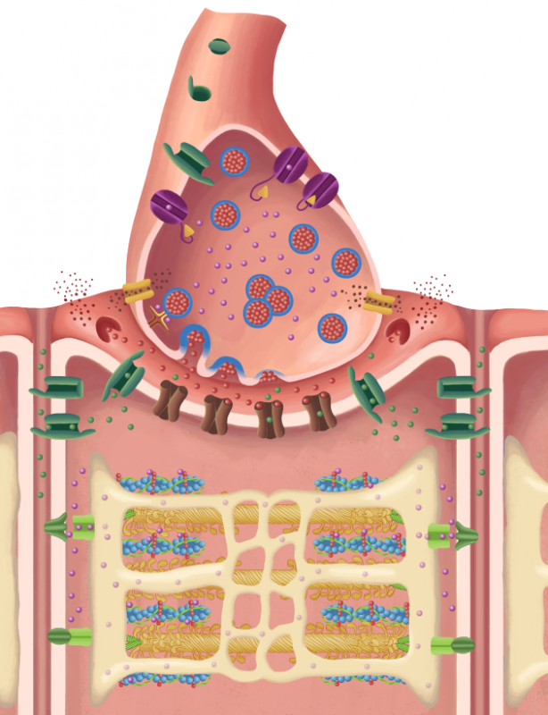

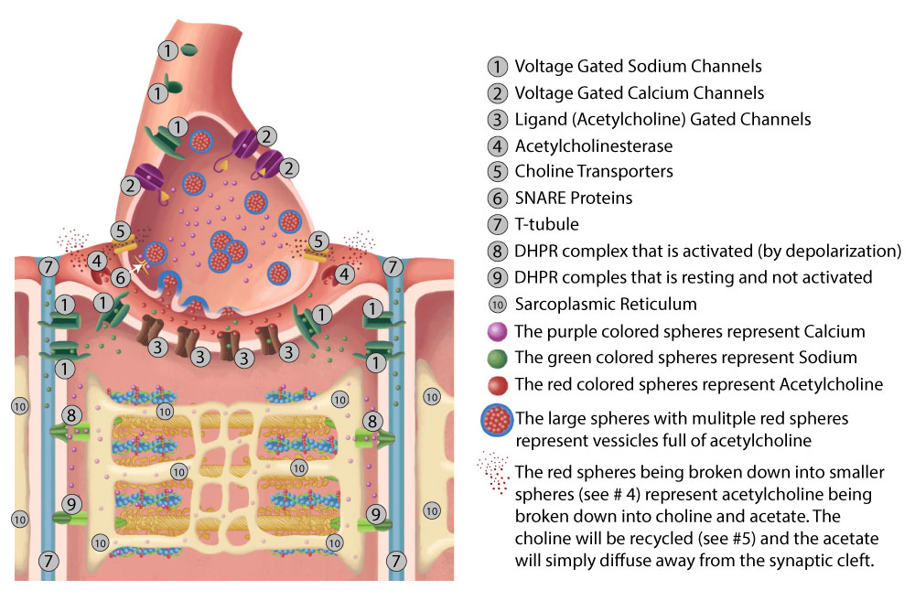

In order for skeletal muscle fibers to contract, there needs to be an electrical event (an action potential) that is followed by a mechanical event (the contraction of the muscle fiber).

Recall that we have already mentioned the fact that the thick and thin myofilaments slide over each other, like the parts of an extension ladder. The proteins themselves don't shorten. The muscle contraction and shortening occur as the myofilaments grip each other, slide past each other, and shorten the sarcomeres. Thus, this is known as the **sliding filament model** of muscle contraction. Let's also remember that in order for action potentials to both start and propagate (travel), it is necessary for various ion channels to open and close at just the right time. Some of these ion channels open in response to the binding of a ligand. These types of ion channels are known as ligand-gated ion channels (Nicotinic 1). Other ion channels open in response to a change in voltage (electricity) and are known as voltage-gated ion channels. Now, we'll discuss the sequence of events that occur when an action potential reaches the end of the motor neuron.

1. An action potential arrives at the axon terminal of a somatic motor neuron. Remember that in skeletal muscle, stimulation by a motor neuron is required for contraction. (This is not necessarily true for smooth and cardiac muscle, but we'll get to that later.) The axon terminal of the motor neuron connects to the muscle fiber via the neuromuscular junction (a synapse).
2. The arrival of the action potential stimulates voltage-gatedCa2+ channels in the axon's membrane to open, and Ca2+ enters the axon terminal from the extracellular space.
3. Theaxon terminal contains synaptic vesicles filled with the neurotransmitter acetylcholine (ACh). The increased Ca2+ levels is the signal that stimulates exocytosis (SNARE proteins) of these synaptic vesicles and the release of ACh into the synaptic cleft.
4. The ACh diffuses across the synaptic cleft, binding to acetylcholine receptors on the ligand-gated ion channels (nicotinic type I) in the sarcolemma of the post synaptic tissue (the muscle fiber). This specialized region of the sarcolemma is known as the **motor end plate**, and this is the location of the ACh receptors.
5. ACh binding causesligand-gated Na+/K+ channels to open. These ion channels are permeable to both Na+ and K+. However, more Na+ diffuses into the cell than K+ diffuses out of the cell due to driving forces. The Na+ entering the cell depolarizes the sarcolemma, which then will cause adjacent voltage-gated Na+ channels to open, initiating an action potential that spreads out from the neuromuscular junction. The action potential not only travels across the sarcolemma but also down the T-tubules. Remember, T-tubules are just invaginations (inward protrusions) of the sarcolemma and are filled with extracellular fluid that is high in sodium (Na+) and low in potassium (K+). Also, please notice that the ACh receptors are ligand-gated, but movement of Na+ through them (sphere of influence) causes the closely associated voltage-gated Na+ channels to open, resulting in generation and propagation of an action potential.
6. While the action potential spreads, let's take a break and describe how the stimulation of the ACh receptors is terminated. Without termination of the signal the signal would continue to induce action potentials. This is done when ACh is cleaved (split) by an enzyme that resides in the cleft called acetylcholinesterase.  This enzyme splits ACh into its two components, acetate (acetyl) and choline, rendering it nonfunctional. The acetate portion of acetylcholine diffuses out of the synaptic cleft. The choline, which is an essential nutrient in the Vitamin B group (B4), is taken up by the axon terminal, where it is recycled to make more acetylcholine. Although our bodies can make choline, we cannot produce enough for our needs and must get it in our diet and recycle what we have.
7. As the action potential spreads along the sarcolemma and the T-tubules, the resultant change in potential causes other voltage-gated channels in the T-tubule to respond. These channels are called dihydropyridine channels (DHP) or L-type Ca2+ Interestingly, although these channels are Ca2+  channels, they are not used as Ca2+  channels, instead muscles use them simply as voltage sensors. Like all muscles, skeletal muscles depend on intracellular Ca2+  but the source of Ca2+ comes from the sarcoplasmic reticulum not from extracellular sources. The signal to release Ca2+  from intracellular sources comes from the DHP and its mechanically linked interaction with ryanodine receptor channels (RyR), which are calcium channels located in the sarcoplasmic reticulum membrane. These two protein channels span the distance between the T-tubule and the terminal cisternae of the sarcoplasmic reticulum. In response to the change in membrane potential, the DHP channel causes the RyR to open and allows Ca2+ ions to leave the sarcoplasmic reticulum and diffuse into the sarcoplasm. These calcium ions bind to the low affinity binding sites of troponin C, causing it to move the tropomyosin molecules off of the active sites on each G-actin molecule.
8. Uncovering the active sites allows the myosin heads to bind to the actin binding sites, forming **cross bridges**. In the muscle relaxed state, the myosin head is "cocked" which means it is in a high-energy complex but is not able to bind to an actin active site. It also has ADP and phosphate (Pi) attached to it. When troponin binds calcium, it goes through a confirmational change that moves tropomyosin off an actin active site. With this active site exposed, myosin binds to the actin and initiates a bond formation that releases energy. Some of this energy is recaptured in the phosphate bond which causes the bond to break. The rest of the energy escapes as heat. Removing the phosphate will cause the myosin hinge region to return (bend or "uncock") to it low energy state. This bending, called the **power stroke,** forcefully pulls the actin past the myosin. During the power stroke, the ADP is also released from the myosin. Recall that in the arrangement of the thick filaments, half of the myosin molecules are pointing one way, and half are pointing the other. Since the myosin heads on the opposite ends of the thick filaments all pull towards the middle, the overall effect is to cause the sarcomere to shorten. As all of the sarcomeres in the muscle fiber shorten, the entire muscle shortens or contracts.
9. In order for significant shortening of a skeletal muscle fiber to occur, the myosin heads must detach from the G-actin active sites and then re-attach to a different active site further along the neighboring actin molecule. This is rather similar to the fact that in order to climb a ladder, we must pull ourselves up a rung and then let go and move our hands and feet to higher rungs. In order for this release to occur, each myosin head must bind an ATP molecule. The binding of ATP to the myosin head forms another bond, releasing more energy, but in this case some of the energy is captured in the myosin-actin bond and breaks it, releasing myosin from the actin. The ATPase then hydrolyzes the ATP into ADP and a phosphate group, which causes the head to "re–cock" (the **recovery stroke),** preparing it for the next power stroke. Hence, binding of ATP allows the head to release, and hydrolysis of ATP re–energizes the head for the next power stroke. During a single muscle cell contraction, each myosin molecule undergoes the entire cross-bridge cycle many times—a process known as **cross-bridge cycling**. As long as Ca2+ is present and the active sites are exposed, the process will continue.

One other important concept: Using the analogy above, when we climb a ladder, we don't take both hands off of the rungs at the same time. Likewise, when muscles contract, the myosin heads are cycling asynchronously, meaning that they don't all bind actin at the same time, and they don't all release at the same time. At any given time, the 300 or so myosin heads in one thick filament will be at different stages of the cross-bridge cycle.

The movement of myosin heads occurs in two phases:

1. Thepower stroke occurs when the myosin heads bend and ratchet the actin molecules past the myosin.
2. Therecovery stroke involves the myosin heads detaching from actin and being cocked back into the high energy position to prepare for the next power stroke.

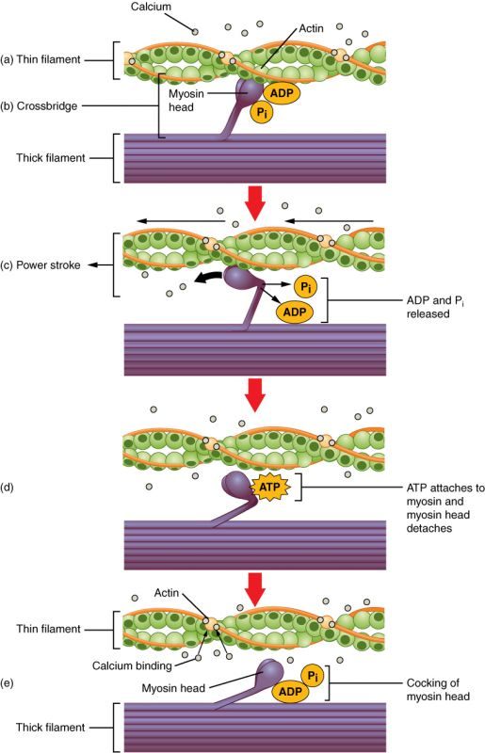

**(a) Calcium binds to Troponin and active site on actin exposed. (b) Myosin binds to Actin forming cross-bridge. (c) Phosphate released in a power stroke causing the myosin head to pivot and releasing ADP/Phosphate group released. (d) ATP attached to myosin head detaching cross bridge. (e) Myosin head hydrolyzed ATP to ADP and phosphate turning myosin back to ready position**.

Relaxation can only occur when Ca2+  is removed from the sarcoplasm. Removal of Ca2+  occurs from the actions of **SERCA pumps**. SERCA stands for "Sarco / Endoplasmic Reticulum Calcium ATPase". These pumps are primary active tranporters that use ATP to pump Ca2+ against a gradients as it moves back into the sarcoplasmic reticulum. They are concentrated at the terminal cisternae. As quickly as calcium escapes through the RYR channel, it is actively put back into the SR. This active pumping is not as quick as diffusion causing the relaxation phase to be longer than the contraction phase. In addition, that activity of the SERCA pumps is the largest consumer of ATP consumption in contracting muscle.

To quickly review, the sliding filament model of muscle contraction explains the fact that when skeletal muscle fibers contract, the individual proteins (actin and myosin) don't shorten. Rather, they slide over each other. ATP is necessary for the detachment of myosin heads from actin. Notice also that when a sarcomere contracts, both the H zone and the light I band shrink in width, while the dark A band doesn't appear to narrow.

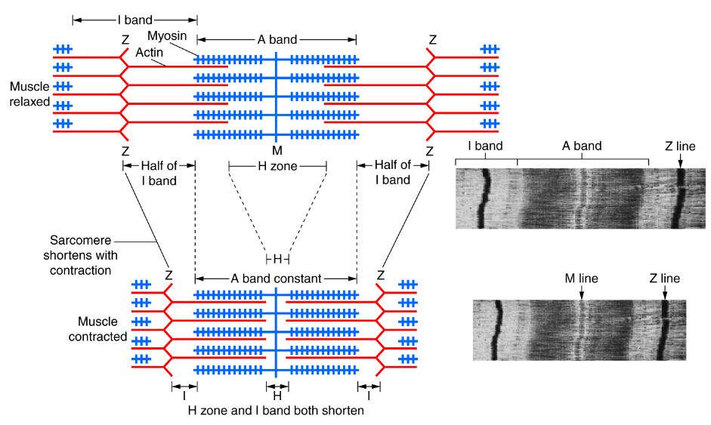

Read this online at <https://books.byui.edu/bio_461_principles_o/neuromuscular_juncti>