# Reflexes

Reflexes take place automatically and unconsciously for good reason. Can you imagine what your life would be like if you had to think about the temperature of the room you just entered and then make conscious adjustments in order to maintain your internal temperature within the normal range? In order to understand how reflexes work, we will examine the basic components of a reflex arc and how they interact to generate the desired effect.

Reflexes can be classified in many different ways, but we will examine them as either somatic: involving control of skeletal muscle, or autonomic: involving control of smooth muscle, cardiac muscle, glands etc. Regardless of their classification, all reflexes have 5 basic components:

1) A **receptor** that detects change. Here are the different types of receptors we see in the body:

* A **mechanoreceptor** is a sensory receptor that responds to mechanical pressure or distortion. Touch, pressure, stretching, sound waves, and motion can all activate mechanoreceptors.
* A **chemoreceptor** detects certain chemical stimuli in the environment. For example, chemoreceptors in the carotid artery are sensitive to the partial pressure of carbon dioxide in the blood; they signal the respiratory center in the brain to increase or decrease the rate of breathing. The sensations of smell and taste happen because of chemoreceptors located in the sensory organs of your body.
* **Thermoreceptors**are specialized nerve cells that are able to detect differences in temperature.
* **Photoreceptors**are the cells in the retina that respond to light. These receptors convert light into signals that give us our vision.
* **Nociceptors**are sensory receptors that detect signals from damaged tissue or the threat of damage and indirectly also respond to chemicals released from the damaged tissue by sending signals to the spinal cord and brain. Nociceptors conduct signals that are generally perceived as pain.

2) An **afferent** or **sensory neuron** that relays information.

3) A **control center** that evaluates the incoming information and determines an appropriate response.

4) an **efferent** or **motor neuron** that carries information away from the control center.

5) An **effector** where the action is carried out.

These components form a basic circuit that is called a reflex arc. The control center portion of the reflex arc can be quite simple (as in the synapse of an afferent neuron onto an efferent neuron in a stretch reflex), but it is often more complex involving one or more interneurons. Simple reflexes involving a single synapse between two neurons are termed **monosynaptic**, whereas reflexes involving two or more synapses are termed **polysynaptic**. We will examine several types of somatic and autonomic reflexes because of their clinical significance. However, please keep in mind that this is not an exhaustive list, and there are many other significant reflexes.

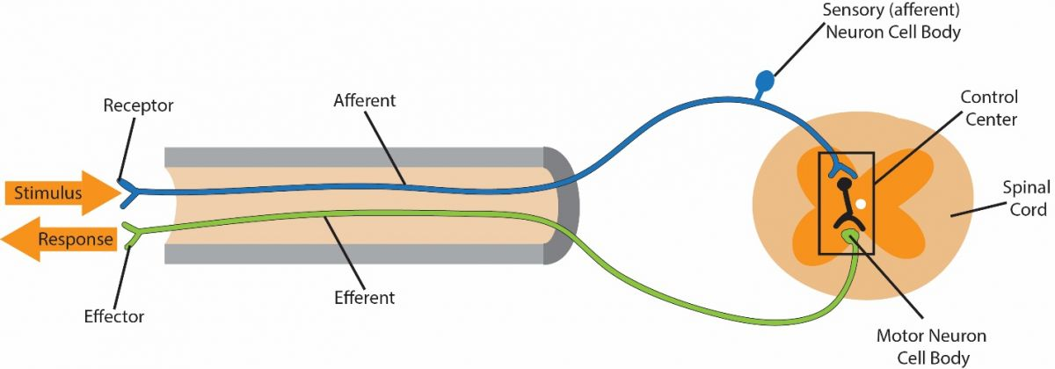

#### Somatic Reflexes

In our discussion, we will examine four major reflexes that are integrated within the spinal cord: the stretch reflex, the Golgi tendon reflex, the withdrawal reflex and the crossed extensor reflex. Although each of these reflexes is integrated within the spinal cord, they can be influenced or modified by higher brain centers to either exaggerate or suppress the response. Somatic reflexes involve specialized sensory receptors called **proprioceptors** that monitor the position of our limbs in space, body movement, and the amount of strain on our musculoskeletal system. The effectors involved in these reflexes are located within skeletal muscle.

#### Stretch Reflex

Think back to the last time you had a sports physical or a routine physical examination. Why did the doctor tap your leg just below the knee? What information can he possibly gather from this simple procedure? The magic of examining reflexes comes from the phenomenon that, under normal circumstances, a specific stimulus will elicit a predictable response. In the case of the knee-jerk reflex, the expected response is an extension of the leg at the knee. If the reflex is greater than expected (hyperactive), less than expected (hypoactive) or totally absent, that suggests potential pathology. Now let's look at how the stretch reflex works.

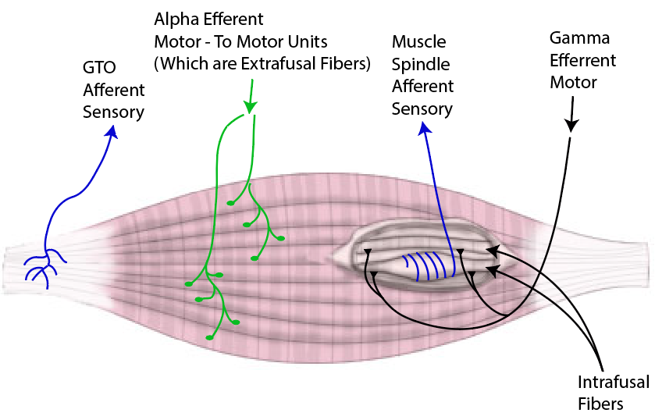

Image by JS F21Muscle Spindle and Golgi Tendon Organ

Muscle spindles are specialized proprioceptors that monitor muscle length. They are bundles of modified skeletal muscle fibers with extensive sensory and motor innervation. These fibers, called **intrafusal fibers**, run parallel to the contractile skeletal muscle fibers called **extrafusal fibers** that make up the bulk of skeletal muscle. Muscle spindles are scattered throughout skeletal muscle, but they occur in the highest density near tendinous insertions and in muscles involved in fine motor control (i.e. the small muscles of the hand etc).

Muscle spindles can be broadly categorized into two types, nuclear bag fibers or nuclear chain fibers. The names are derived from the arrangement of nuclei within the fibers. Bag fibers are larger than chain fibers and have their nuclei clumped together in the center causing the fiber to bulge. Chain fibers have nuclei arranged in a row on the outer edges, similar to regular (extrafusal) skeletal muscle fibers. Because a clear understanding of the anatomy of the neural innervation is essential to understanding function of the spindles, we will discuss that next.

Spindles are innervated by both sensory and motor neurons. The sensory innervation includes the groups Ia and II. Group Ia or II is the naming convention adopted for separating and identifying sensory fibers. The group Ia signifies that these fibers belong to a group of neurons with the largest diameter and myelinated, allowing them to conduct impulse very rapidly (up to 120m/sec). Group II are smaller but still myelinated and conduct impulses slower (up to 75m/sec). Bag fibers are innervated by group Ia fibers that wrap around the bulging nucleated center. This arrangement makes the neurons very sensitive to any movement the bag fiber undergoes. Chain fibers are innervated by type II fibers. If a muscle spindle is stretched, the sensory fiber associated with the muscle spindle will be activated and result in stimulation of an alpha motor neuron (a type of lower motor neuron) in the anterior horn of the spinal cord (more detailed explanation below).

In addition to sensory innervation, each spindle is also associated with a motor neuron innervation. The motor neuron is much smaller than the alpha motor neuron innervation of regular muscles, belonging to the gamma motor neuron group. Since spindles are only capable of contraction at their tapered ends, innervation by gamma motor neurons occurs there. The resultant contraction of a spindle in response to gamma stimulation is too weak to contribute to gross muscle movement but is important in maintaining the sensitivity of the muscle spindle while the muscle is either shortened or lengthened. Because the sensitivity of spindles to stretch or contraction differ, the gamma motor neurons are further divided into dynamic gamma (bag fiber innervation) and static gamma (chain fiber innervation).

Muscle spindles are designed to respond when the muscle changes length. Because of their different anatomy and innervation, the two types of spindles respond to stretch differently. Bag fibers (associated type Ia sensory neuron) are most sensitive responding to the rate of stretch. Chain fibers respond more slowly and are sensitive to the amount or length of time the stretch is occurring. What happens when the sensory fibers are activated? Remember, these fibers are part of a reflex arc so their activation results in modification of movement.

Imagine stepping out of the driver's seat of your car onto a patch of ice in the parking lot. As your weight transfers to your left foot and starts to slide out from under you, what happens? The muscle spindles in your left inner thigh (adductors) are quickly stretched and send a message to your alpha motor neurons in the spinal cord begging for help. The alpha motor neurons then cause contraction of the same inner thigh muscles (adductors) that were stretched, and you narrowly avoid the pain of a groin injury. All of this happens so fast (signals are sent at speeds around 350 miles per hour) that you have already recovered by the time you are aware that you were in trouble. When a muscle is stretched, the muscle spindles are stimulated and thus increase the frequency of action potentials sent to the lower motor neurons in the CNS. The increased action potential frequency causes alpha motor neurons to rapidly fire, resulting in muscle shortening. This reflexive contraction, in the direction directly opposite to the initial stretch, protects skeletal muscle from damage due to overstretching.

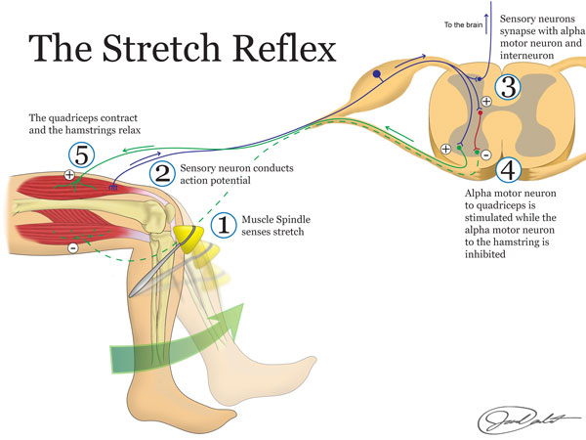

The same process that we described above also relates to other very common situations. For example, as you are reading this you may be experiencing some drowsiness. We will assume that is because you have stayed up way too late! As you get tired you may have experienced the feeling of nodding off, where your head starts to fall forward followed by an almost violent jerking motion as you bring your head upright again. Your muscle spindles are key in maintaining posture, whether we are talking about nodding off in class or whether we are talking about staying upright as you walk down the street.

So far it would appear that muscle spindles respond to a stretching muscle, which is true, but what about the spindles in the contracting or shortening muscle? When a muscle shortens the overall length of the muscle also decreases thus “unloading” tension on the spindle. To illustrate, imagine rubber bands strung between your two pointer fingers on opposite hands and another band on each thumb. The band over the index fingers represents the muscle and the band over the thumbs represents the spindle. If you move your hands apart both bands becomes taunt, but if you move your hands closer together the bands lose tension, even sagging at the point when your fingers almost touch. Since there is no tension at this point, to make the rubber bands taunt again you have to start moving your hands apart, but before the tautness occurs there will be a delay until tension is re-established, even though your hands are visibly moving. Because delays in signals are unacceptable in the human body, something must occur to keep the spindle (thumb) from “sagging” as a muscle shortens. The prevention in sagging is the function of the gamma motor neuron which innervates each spindle at the contractile end. At the same time that alpha motor neurons activate extrafusal fibers, causing shortening of the muscle, gamma motor neurons activate the muscle spindle, at the contractile end and cause it to contract. However, since only the ends have contractile filaments, this activation acts to lengthen the spindle, or pull on the middle, thus maintaining tension within the spindle, even though the muscle shortening would act to lower spindle tension. We refer to this as **alpha-gamma co-activation**. This causes the tapered ends to contract, thus maintaining a baseline tension on the central region of the muscle spindle that is sensitive to stretch. It is in this manner that the muscle spindle is able to maintain its sensitivity through a wide range of muscle length. In fact, even when a muscle is at rest the muscle and spindles receive a steady stream of alpha-gamma activation which helps to maintain a low level of muscle activity. Back to our rubber band example, this would be like having your thumbs move against your index fingers and slide the rubber band to keep it tight as your hands move closer together, ensuring that tension is still maintained in the spindle. In fact, even when a muscle is at rest the muscle and spindles receive a steady stream of alpha-gamma activation which helps to maintain a low level of muscle activity. This constant tension of the muscle is what we refer to as **muscle tone**.

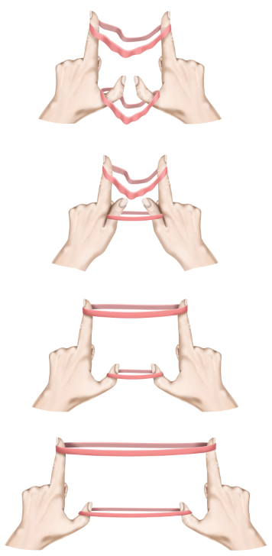

Up to this point, we have only addressed activation of the muscle group that is being stretched. This is important, but body movement is also controlled by opposing muscle groups, often categorized as the agonist or the antagonist muscle. The agonist muscle is the muscle that contracts to cause a certain movement to happen and the antagonist is the muscle group that would do the opposite action. In the example of the knee jerk reflex, the quadriceps would be the agonist and the hamstring would be the antagonist. In order to extend the leg at the knee, we must contract the quadriceps, which we do via activation of the alpha motor neurons, but we must also relax, or inhibit, the hamstring. We accomplish this through a phenomenon called **reciprocal inhibition**. The sensory neuron that synapses with and excites alpha motor neurons supplying the quadriceps also synapses with an inhibitory interneuron. The inhibitory interneuron effectively shuts down the alpha motor neurons to the hamstring. This allows the leg to extend at the knee (see stretch reflex figure).

#### Golgi Tendon Organ

Whereas muscle spindles respond to stretch another type of sensory system responds to tension. You might think that stretch and tension are pretty much the same thing but they are not. Have you ever tried tying your shoes really tight and as you are pulling on the laces, which increases tension, one of the laces snaps? It is pretty inconvenient when you have to replace a shoelace but think if that was your muscle! At times our muscles are capable of generating sufficient power to damage tendons or even break bones. They can cause avulsion, where the tendon tears off a piece of the bone at its attachment site. In order to prevent this, we have a safety mechanism in place called the Golgi tendon organ. Where we could consider the stretch reflex to be excitatory and cause contraction of the stretched muscle group the Golgi tendon reflex would be considered inhibitory and causes relaxation of the affected muscle. Therefore the result of activation of a Golgi tendon organ would be the opposite of the activation of a muscle spindle. The main purpose of Golgi tendon organ is to prevent excessive tension on tendons and thus prevent injury, however, it should be noted that the Golgi tendon organ response also assists in regulating muscle contraction force. Golgi tendon organs signal muscle force through the entire physiological range, not only at high strain.

Golgi tendon organs are composed of encapsulated nerve endings that are found interwoven with collagen fibers near the transition from muscle to tendon. These nerve endings monitor tension on the tendon rather than muscle length as muscle spindles do. As muscle contracts it develops tension on the tendon which is detected by the Golgi tendon organ. The Golgi tendon organ then sends action potentials, via afferent neurons, to the dorsal horn of the spinal cord where they synapse with inhibitory interneurons. The interneuron then synapses with and inhibits the alpha motor neurons in the anterior horn of the spinal cord. Inhibition of alpha motor neurons will effectively shut off the "power" to the muscle causing it to relax. You can think of this phenomenon almost like a circuit breaker. If there is a spike in power coming into your home that could potentially damage electrical devices the circuit breaker is tripped, temporarily shutting off electricity to those electrical devices.

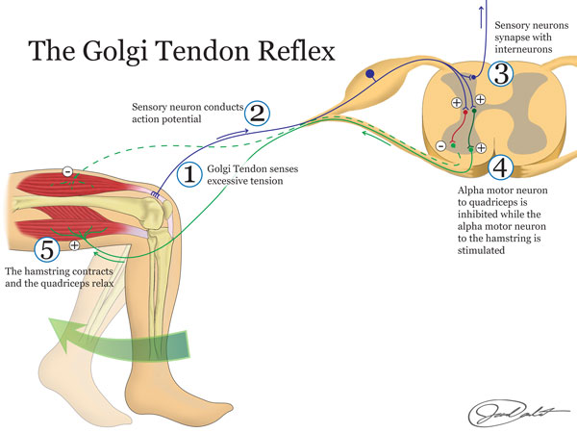

You might ask yourself, "If this prevents excessive tension on muscles, what about those stories I have heard about mothers lifting cars off of babies and such?" Well, remember that this is a reflex and is generally managed from the bottom up without too much oversight from the upper motor neurons. In some circumstances, such as the super human feats of strength you have heard about, the CNS has the ability to override the reflex of the Golgi tendon organ. This happens as upper motor neurons modify the reflex at the level of the spinal cord. This allows extreme amounts of force and tension to be achieved, but the downside is that it usually causes pretty severe damage to the musculoskeletal system.

#### **Withdrawal Reflex and Reciprocal Inhibition**

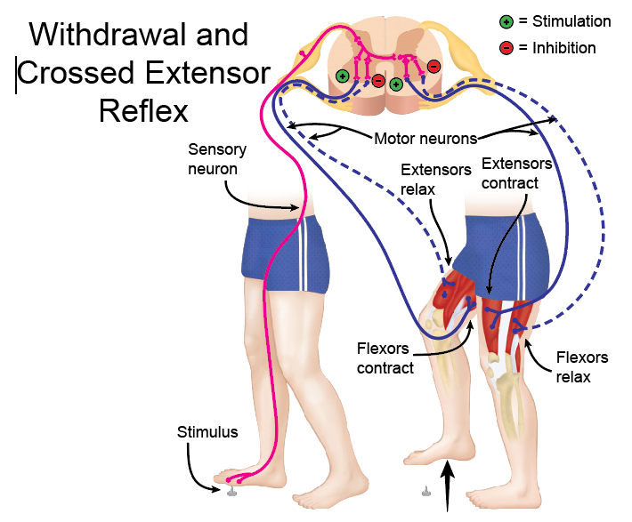

The withdrawal reflex is yet another way that we are hard-wired to avoid pain and tissue damage. We have free nerve endings, called **nociceptors**, scattered throughout our body that are sensitive to pain. When stimulated these sensory neurons activate lower motor neurons in the spinal cord. The lower motor neurons then stimulate contraction of skeletal muscle to remove or withdraw ourselves from the pain generator. In general, this will take place as flexor muscles are stimulated to contract, such as the hamstrings and hip flexors if you step on a tack or the biceps when you touch a hot stove. For this reason, the withdrawal reflex is sometimes called the flexor reflex.

In order for this to happen efficiently, we need to stimulate the flexor muscles and at the same time inhibit the extensor muscles. This phenomenon, called **reciprocal inhibition,** that was discussed in terms of the knee-jerk reflex is also at play here. The pain neuron, as it enters the dorsal horn of the spinal cord, will branch to stimulate an excitatory interneuron and an inhibitory interneuron. The excitatory interneuron then stimulates muscle contraction of the flexor muscle while the inhibitory interneuron causes the antagonist muscle, or the extensors, to relax.

#### Crossed Extensor Reflex

Without the crossed extensor reflex, instead of standing on one leg after stepping on a tack you would probably wind up on your backside. Again, when you step on a tack and stimulate the pain fibers in your foot they send signals to the spinal cord through the dorsal horn. In addition to sending branches to excitatory and inhibitory interneurons on the same side of the body, the pain neuron also sends a branch to an excitatory interneuron that crosses over to the opposite side of the spinal cord and stimulates a lower motor neuron. This lower motor neuron stimulates the extensor muscles on the opposite side of the body in preparation for the increased load as you shift your weight to that side. You can observe the crossed extensor reflex as you walk to and from class during Fall, Winter and most of Spring semester because of the presence of ice and snow. As individuals hit a patch of ice and lose balance, the crossed extensor reflex is the reason for the flailing antics that you see as the person desperately tries to stay on their feet. There are varying levels of success for individuals staying upright, but you can easily pick out the seniors or locals as their reflexes have been honed in to better keep them upright.

Read this online at <https://books.byui.edu/bio_461_principles_o/reflexes>