# The Retina

The structure of the eye responsible for converting light waves into action potentials is the retina. The neural layer of the retina is composed of three main types of cells: the **photoreceptors**, the **bipolar neurons** and the **ganglion cells**. The photoreceptors, as the name implies, have the responsibility of capturing the light and converting it to an electrical signal. There are two types of photoreceptors in the retina, the **rods** and the **cones**. The rods see only in black and white and are mainly responsible for our night vision. The cones, on the other hand, can see in color and are responsible for color vision as well as sharp vision. Each eye contains about 120,000,000 rods and 6,000,000 cones. Although they detect light of different wavelengths, structurally, rods and cones are similar. They are composed of an **outer segment** that touches the pigment epithelium and is composed of numerous flattened discs stacked on each other (think of a stack of dinner plates). The only difference is that in the rods, all of the discs are the same size while in the cones they gradually decrease in diameter as they move to the end of the cell. This results in the shape for which the cones were named. The outer segment connects to the **inner segment** which houses the nucleus and other organelles of the cell. The inner segment, in turn connects to the **synaptic terminal** which forms the connection between the photoreceptor and the bipolar neuron (see the images below).

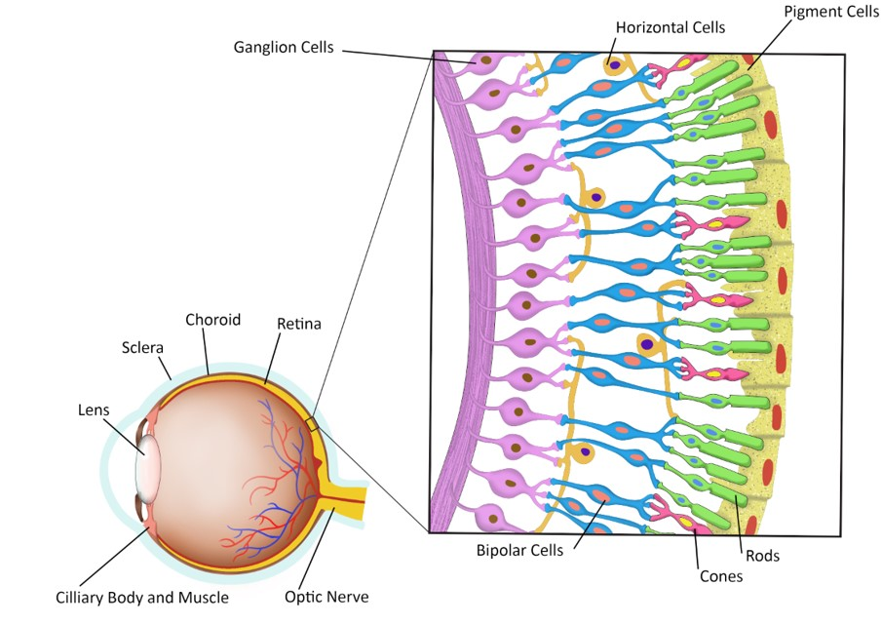

The bipolar neurons, so named because they have one dendrite and one axon, are the connections between the photoreceptors and the ganglion cells. The axons of the ganglion cells form the optic nerve which exits the eye via the optic nerve. Two other cell types are shown in the image above. The **horizontal cells** can be seen in the layer where the photoreceptors synapse with the bipolar neurons and the **Amacrine cells** can be seen in the layer where the bipolar cells synapse with the ganglion cells. These two cells are involved in modulating the visual signals.

The distribution of the photoreceptors in the retina is not uniform. In the fovea centralis we find only cones. Moving more out from the fovea we start to see rods intermixed with the cones. The further out from the fovea we move the greater the number of rods and the fewer the number of cones.

In the image above note that the photoreceptors are located at the back of the retina. Light entering the eye must pass through the ganglion cells and the bipolar neurons before it gets to the photoreceptors. This doesn’t seem to be the best arrangement. However, at the fovea, the ganglion cells and the bipolar neurons radiate away from the cones in the fovea. Think of the crown of your head. All of the hairs radiate out from this point exposing the scalp. Because of this arrangement light striking the fovea has direct access to the photoreceptors, enhancing vision in this region of the retina.

Now let’s examine the unique characteristics of the different photoreceptors, starting with the rods. The rods are very sensitive to light and will respond to a single photon of light. In addition, they are part of convergent circuits in which several rods will converge on a single bipolar neuron and several bipolar neurons will converge on one ganglion cell. This allows for the summation of signals from several rods resulting in an action potential being sent to the brain. These properties make the rods ideal for seeing in very dim light, therefore rods are responsible for our night vision. During the day when there is plenty of light, the rods are essentially inactivated due to a process called bleaching (more on this later). You are aware of how hard it is to see in a darkened theater when you first enter from bright light. After you have been there for a while and the rods become active we can see quite well in the room. Indeed, after about 40 minutes in the dark room our eyes are about 25,000 times more sensitive than they were when we first entered the room. There are two downsides to the use of rods, however. First, they do not see in color, rods see only in black and white. Second, due to the convergence their visual fields are quite large. Light striking any of the rods that converge on one ganglion cell will produce the same “pixel.” Therefore, vision with rods is very sensitive but not very acute (sharp). Cones, on the other hand, have essentially the opposite characteristics. First, there is very little convergence in their circuitry. Light striking two cones located next to each other would produce two different pixels in the brain. This allows for very sharp (acute) vision for images striking the fovea since there are only cones in the fovea. Second, the cones are much less sensitive than rods. At night, the intensity of light usually is not sufficient to stimulate the cones. Third, the cones are responsible for our color vision. We have three types of cones that respond to light in the red, green or blue wavelengths. By mixing the input from these three cones, humans can perceive about 1,000,000 different hues of color. You may know someone who is “color blind.” Color blindness is most often due to a genetic condition where the subject does not produce one or more of the cones. The most common condition is red-green colorblindness, where the person lacks either the red or green cone. Individuals with this condition can see colors, but they have a difficult time distinguishing between shades of green and red. The genes for the green and red cones are found on the X chromosome, therefore males have a much higher incidence of color blindness since males only have one X chromosome. Women have two X chromosomes so even if they inherit a defective gene there is a good chance the gene on the other X chromosome will be normal. For a women to be red-green colorblind, both her father and her mother would have to have the condition. Another type of color blindness called Blue-yellow color blindness involves genes for the blue cones, but these genes are not on the X chromosome so it occurs at the same rate in both males and females.

Read this online at <https://books.byui.edu/bio_461_principles_o/the_retina>