# Phototransduction

Now for the underlying question, how do the proteins that absorb photons of light produce the action potentials that travel to the brain to produce what we perceive as vision? This process is called **phototransduction** (see figure below). Since the process is essentially the same in both the rods and the cones we will look at the rods and then explain the subtle differences that occur in the cones. It all starts with the visual pigments that are embedded in the membranes of the disks found in the outer segment of the rods. This visual pigment is called **rhodopsin** and is composed of protein called **opsin** and a derivative of vitamin A called **retinal**. In the unexcited state, retinal has a bend in its hydrocarbon chain (11-cis retinal) and fits nicely in a binding site on the opsin. When light of the proper wavelength is absorbed by the visual pigment the energy of the light causes retinal to change shape and the hydrocarbon chain loses its bend (all-trans retinal) and no longer fits in the binding site. It should be noted that even though rods provide only non-color vision, light of the green wavelength is the most efficient in activating rhodopsin. When the retinal detaches from the opsin, the retinal essentially becomes inactive being unable to associate with opsin until it regains its original cis conformation. This process is known as **bleaching**. Although retinal becomes inactive, the left over Opsin protein becomes activated, stimulating the alpha subunit of its G-Protein coupled receptor (GPCR). Thus, by definition, since the GPCR opsin is activated by light we call it a photoreceptor. Once activated the GPCR activates the G-protein, separating the alpha subunit from the beta/gamma subunit. In the photoreceptors of the eye, the G-protein is called **transducin**. The alpha subunit then brings about a change in the cell. More on this later.

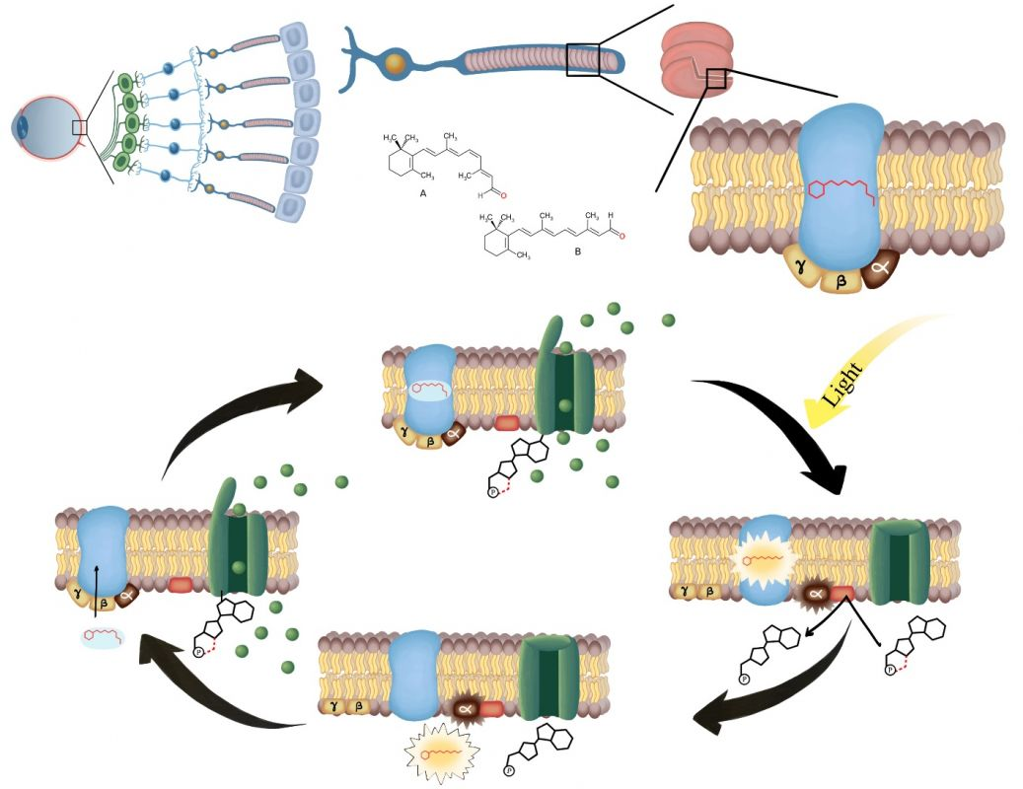

**Phototransduction. The top image of the cycle represents the photoreceptor in the dark. The green channel is the cGMP gated cation channel which is open and allowing cations (Na+ and Ca2+ ) to depolarize the cell. When light strikes and changes the retinal from 11-cis to all-trans retinal, it activates the G-protein transducin which results in the activation of PDE –“phosphodiesterase” ( which causes breakdown of cGMP) and the closing of the cation channel. The cell will then hyperpolarize. Finally, All-trans retinal is converted back to 11-cis retinal by the pigmented epithelium and it re-attaches to opsin (PDE no longer activated) allowing cGMP to open the cation channel and once again depolarize the cell.**

Photoreceptors are different than any receptors we have discussed to date in that they release neurotransmitter when they are **not**being stimulated. Here is how this works.

There are three important ion channels in the membranes of the photoreceptor cells, **K+ leak channels**, **voltage-gated Ca2+ channels** and **cyclic GMP (cGMP) gated cation channels** (Na+and some Ca2+ move through this channel). When the photoreceptor is not being stimulated (in the dark), cGMP is bound to the cation channel and Na+and Ca2+ diffuse into the cell maintaining it in a depolarized state. This depolarization causes the voltage gated Ca2+ channels to open, allowing more Ca2+to diffuse into the cell. This Ca2+triggers the release of the neurotransmitter glutamate by the process of exocytosis. The binding of glutamate to receptors on the bipolar neurons may be excitatory or inhibitory; it depends on what receptors are expressed on the bipolar neuron. For now we will focus on just the bipolar neurons that express receptors that cause **inhibition** when glutamate is attached.

When light is absorbed by rhodopsin and the G-protein (called transducin) is activated, the alpha subunit of the G-protein activates the enzyme **phosphodiesterase**. This enzyme breaks down cGMP to GMP. Once the cGMP is removed the cGMP-gated cation channels close and the membrane hyperpolarizes. This results in the closing of the voltage-gated Ca2+ channels and glutamate release ceases. Removal of the inhibitory signal to the bipolar neurons allows them to fire and an action potential is sent to the brain. Eventually, the G-protein is inactivated and phosphodiesterase is turned off. However, the rhodopsin cannot respond to light again until the retinal is returned to its bent, 11-cis, state. To do this, it diffuses into the pigment epithelium where enzymes act to restore the 11-cis state. It can then diffuse back into the rod cell and bind to opsin. The rod cell is ready to be activated again. The original bleaching process is very fast, fractions of seconds, but restoring the rhodopsin to its intact state can take several minutes. During the day, when we are exposed to sufficient light, the rhodopsin remains in the bleached state and the rods are essentially unresponsive to light. The mechanism is similar in the cones. The main difference is in the proteins of the visual pigment. The visual pigments in cones are similar to rhodopsin but they respond to different wavelengths of light allowing us to perceive different colors. Another difference, as stated above, is that the cones are much less sensitive to light. This is why the cones do well in full daylight when everything is brightly illuminated. Finally, cones do not stay deactivated (bleached) as long as rods. Cones appear to be fairly resistant to large scale “bleaching” as they are able to recover 11-cis-retinal much more quickly so that at any given time there are at least some visual pigments ready for stimulation.

It is interesting that what we perceive isn’t always what our eyes see. For example, as you gaze around the room everything seems like it is in sharp focus. The reality is that our eye is only capable of producing sharp vision on a very small portion of our visual field. If you hold your thumb at arm’s length in front of you, the area covered by your thumbnail is about all the eye can focus sharply. Why then does everything seem clear? It is because our brain makes us think it is clear. Try focusing on something and then pay attention to the things on either side. They will not be in sharp focus but you didn’t notice that until you thought about it. In reality, much of what we see is a product of our brains and not necessarily what the eye is seeing.

For proof of this statement watch or listen to the TED talk below about, but beware they may blow your mind.

[https://books.byui.edu/-Rxv](http://www.ted.com/talks/beau_lotto_optical_illusions_show_how_we_see)

Read this online at <https://books.byui.edu/bio_461_principles_o/phototransduction>