# The Hearing Apparatus

Anatomically the ear can be divided into three regions: the **external ear**, the **middle ear**, and the **inner ear**. As the structure of the ear is described, try to follow along on the image below. The external ear consists of the **auricle**, or pinna, and the **external auditory canal**. The auricle is designed to capture the sound waves and channel them into the auditory canal, which then conducts the sound waves to the **tympanic membrane** (ear drum). Within the auditory canal are ceruminous glands that secrete cerumen (ear wax). Cerumen acts as a lubricant, preventing the auditory canal from drying out, and it has some antibacterial properties to help prevent microorganismsa from growing in the ear. Additionally, along with the hairs that grow in the auditory canals, the cerumen helps prevent foreign objects from entering the ear.

The tympanic membrane is the boundary between the external ear and the middle ear. Its primary function is to vibrate in response to the sound waves entering the ear. It is composed of a sheet of connective tissue covered on the outside by simple squamous epithelium and on the inside by simple cuboidal epithelium. The tympanic membrane is very sensitive and merely touching it with the end of a Q-tip can elicit sharp pain.  
  
The middle ear is an air filled cavity between the outer ear and the inner ear. The most conspicuous components of the middle ear are the three **auditory ossicles** that form a bridge between the tympanic membrane and the oval window of the inner ear. These three bones are the **malleus** (hammer), the **incus** (anvil), and the **stapes** (stirrup). The malleus sits on the tympanic membrane and the stapes connects to the oval window while the incus sits between the two. The middle ear is connected to the back of the **pharynx** (back of the throat) by the **Eustachian tuben**. The Eustachian tube allows the middle ear to equilibrate with the atmospheric pressure. If the pressure in the middle ear is different from atmospheric pressure it will either push or pull on the tympanic membrane resulting in discomfort or pain. The Eustachian tube is typically closed but can open briefly in response to yawning, swallowing or chewing. This is why chewing gum can help alleviate the pressure changes you feel in the eSar when you drive over a mountain pass.  
  
The inner ear is imbedded in the petrous portion of the temporal bone and consists of three structures, the **vestibular apparatus**, the **semicircular canals**, and the **cochlea**. It is composed of a network of tunnels in the bone collectively referred to as the **bony labyrinth**. Within the bony labyrinth are membranes that essentially line the tunnels. These membranes form the **membranous labyrinth** and contain the structures for generating action potentials. The vestibular apparatus and semicircular canals are involved with equilibrium and balance while the cochlea is involved with hearing.

#### The Cochlea

Before we discuss how sound waves are converted to action potentials, we need to understand the structure of the **cochlea**. This structure gets its name from its shape, cochlea means spiral, or snail shell. The cochlea is a spiral-shaped structure about 3.5 cm long (1.5 inches) that makes 2 ½ turns from top to bottom. It is composed of three parallel chambers that are filled with fluid. The oval window (recall this is a membrane attached to the stapes) communicates with the first chamber, the **scala vestibuli**, which runs the entire length of the cochlea. When the stapes vibrates, it causes the fluids in the scala vestibuli to vibrate.

At the very tip of the cochlea, the **helicotrema**, the scala vestibuli makes a U-turn and becomes the **scala tympani**. Although they have different names, they are actually one long chamber that folds back on itself. The scala tympani runs parallel to the scala vestibuli and ends at the **round window**. The round window is a thin membrane between the scala tympani and the middle ear. Thus, when the oval window is pushed in by the stapes, the round window bulges out. Conversely, when the oval window is pulled out, the round window moves in. It is, therefore, acting as a pressure release valve, allowing the fluids in these chambers to vibrate (recall that fluids do not compress). The scala vestibuli and scala tympani are filled with **perilymph**, a fluid that is similar to extracellular fluids. Between these two chambers and also running the length of the cochlea is the **cochlear duct**. This chamber is filled with **endolymph**, which unlike the perilymph, resembles intracellular fluid in composition, and thus has a high K+ concentration.

Within the cochlear duct is the organ that converts mechanical vibrations to electrical action potentials. This structure is the **Organ of Corti** or **Spiral Organ**(see the images below for a cross section of the cochlea and a close up of the spiral organ). The spiral organ sits on the membrane that separates the cochlear duct from the scala tympani, the **basilar membrane**. As we will explain later, this membrane is responsible for detecting sound waves of different frequencies. Structurally, it is narrow and stiff near the oval window and as it moves toward the helicotrema it becomes wider and more limber. This allows each segment to vibrate at a different frequency. Think of the xylophone you had as a child. The keys on one end were very short and when you struck them they emitted a high pitched sound while the keys at the opposite end were long and emitted a low pitched sound when struck, this is basically the structure of the basilar membrane.

Separating the cochlear duct from the scala vestibuli is the **vestibular** or **Reisner's membrane**. This is a very flexible membrane that allows the fluid in the cochlear duct to vibrate with the fluid in the scala vestibuli. Located on top of the basilar membrane are four rows of **hair cells**. There are three **outer rows** of hair cells and one **inner row**. These rows run parallel to each other and stretch from the oval window to the helicotrema. As explained later, these are the receptor cells that will generate action potentials. These cells get their name from the rows of stereocilia on their apical surface. Stereocilia are actually not cilia but instead are more like microvilli. Recall that cilia contain parallel rows of microtubules and are capable of movement whereas microvilli are finger-like projections of the plasma membrane that are supported by microfilaments. In reality, hair cells do have one true cilium called the kinocilium which is adjacent to the longest microtubule. Interestingly, in mammalian cochlea, the kinocilium disappear shortly after birth and no one knows what their function is. Each hair cell has 50-150 stereocilia of different lengths. They are arranged much like the reception bars on your cell phone, gradually increasing in length from one side of the cell to the other. At the point where the stereocilium attaches to the rest of the cell, its diameter is much smaller, creating a hinge-like structure that allows it to bend back and forth. Located on these stereocilia are the mechanically-gated ion channels that will respond to the vibrations of the basilar membrane. Just above the hair cells is another structure called the **tectorial membrane**. It extends like a shelf over the hair cells and the longest stereocilia in the outer three rows of hair cells are embedded in this membrane.

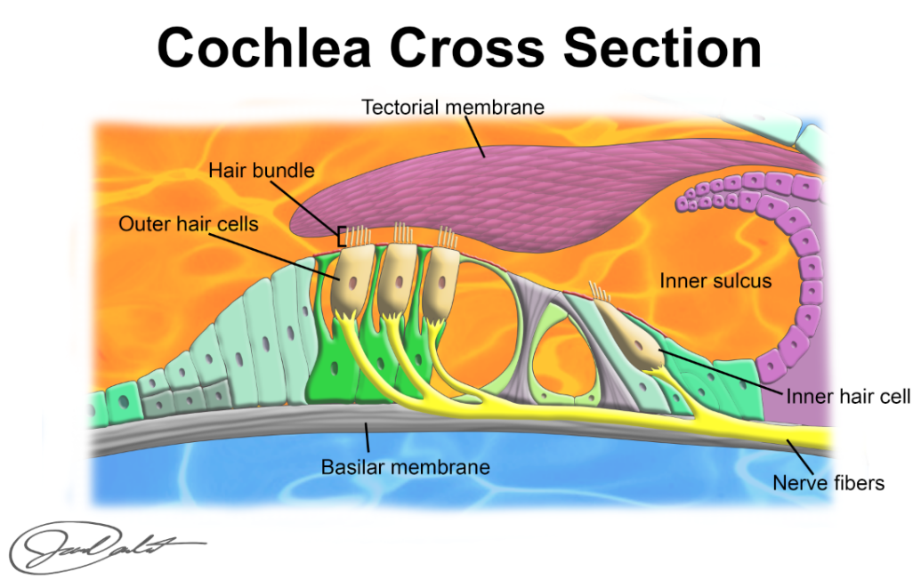

Read this online at <https://books.byui.edu/bio_461_principles_o/the_hearing_apparatu>