# 1 - Chromosome Structure

The first reading assignment this semester examines the general features of the chromosomes found within viruses, prokaryotes (bacteria), and eukaryotes (fungi, protozoa, algae, plants, and animals).

### **Viral Chromosomes**

The genetic material (**genome**) of viruses can be composed of either RNA or DNA; however, a single virus type never has both DNA and RNA in the same virus particle.

The genomes of viruses can be in several forms:

* **Double-stranded DNA (dsDNA)**. A dsDNA genome contains two individual DNA strands held together by hydrogen bonds. Even though you will not be required to know examples of viruses with dsDNA genomes, several human pathogens have dsDNA genomes, including the smallpox virus and the herpes viruses.
* **Single-stranded DNA (ssDNA)**. The genomes of many viruses are composed of a single DNA strand. Parvovirus, which infects dogs and cats, has a single-stranded DNA genome.
* **Double-stranded RNA (dsRNA)**. A dsRNA genome contains two individual RNA strands held together by hydrogen bonds. Rotavirus, which causes severe diarrhea in humans, has a double-stranded RNA genome.
* **Single-stranded RNA (ssRNA)**. The genomes of many viruses are composed of a single RNA strand. Many disease-causing viruses, such as poliovirus, influenza virus, SARS-CoV-2 (causes COVID-19), and the human immunodeficiency virus (HIV) contain single-stranded RNA genomes.

The genomes of viruses can also be **circular** or **linear**. One way to determine if a viral genome is circular or linear is to isolate the viral genome and treat the genome with **nucleases**, enzymes that digest (cut) DNA or RNA. **Exonucleases** digest nucleic acids into nucleotides only if there is a free end; **endonucleases** cut DNA or RNA in the middle of a nucleic acid molecule.  As a result, circular genomes are sensitive to endonucleases, while linear genomes are sensitive to both exonucleases and endonucleases.

The virus genome can be contained within one continuous nucleic acid molecule, or the viral genome can be divided into **segments**. The genome of the influenza virus, for example, contains eight linear ssRNA segments.

When the genome of a virus is located within a virus particle, the genome is inert, meaning that the genome is not copied and viral genes are not transcribed. A virus genome is copied and viral genes are transcribed only during the infection of a host cell.

Viral genomes can range from a few thousand base pairs to 250,000 base pairs in length. For comparison, the genome of the bacterium E. coli is 4 million base pairs in length, while the haploid human genome is 3 billion base pairs in length.

### Key Questions

* What are the four major criteria used for classifying viral genomes?
* How can a scientist determine if a viral genome is linear or circular?

### **Bacterial Chromosomes**

The genome within a bacterial cell is typically composed of a single **chromosome**.  Bacteria are prokaryotic, and since prokaryotes do not contain nuclei, the bacterial chromosome is not contained within a nuclear membrane.  Instead the bacterial chromosome is found in a region of the bacterial cytoplasm called the **nucleoid** (see **Figure 1.1**).

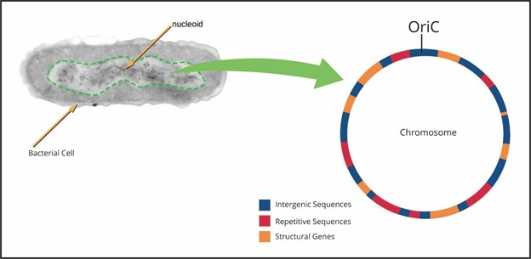

 A bacterial chromosome has the following features:

* The bacterial chromosome is usually a single, circular double-stranded DNA molecule.
* The bacterial chromosome is usually 2-5 million base pairs (bp) in length.
* The bacterial chromosome contains 1,000-3,000 **structural genes**. These structural genes are transcribed and translated to make protein products.
* The bacterial chromosome has a single **origin of replication**. The origin of replication serves as the binding site for proteins involved in copying the DNA molecule (i.e., DNA replication). The origin of replication in the bacterium E. coli is called oriC.
* The bacterial chromosome includes **intergenic DNA sequences**. Intergenic sequences are located between structural genes and are not typically transcribed. Intergenic sequences serve as the binding sites for proteins that function to activate or deactivate structural genes (see Chapter 9 and Chapter 14).
* The bacterial chromosome contains **repetitive DNA sequences**. Repetitive sequences are repeats of a particular base pair sequence, are often found within the intergenic DNA sequences, and are involved in compacting the chromosome to fit into the nucleoid region of the bacterial cell (see Chapter 2).

### **Eukaryotic Chromosomes**

The genome within a eukaryotic cell is subdivided into multiple chromosomes. Each eukaryotic chromosome is a single, linear double-stranded DNA molecule that is approximately 10-100 million base pairs (bp) in length (see **Figure 1.2**).

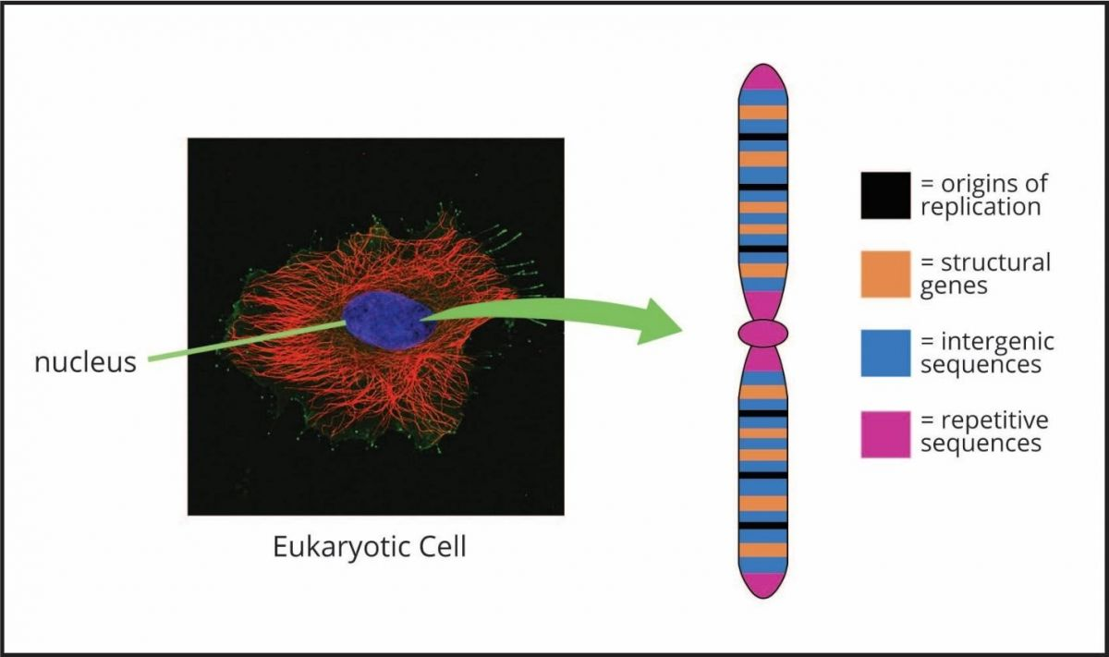

A typical eukaryotic chromosome has several important features:

* **Origins of replication**. Eukaryotic chromosomes contain many origins of replication, spaced at approximately 100,000 base pair (bp) intervals along the chromosome. In the model eukaryote Saccharomyces cerevisiae (a budding yeast responsible for bread and alcohol production), each origin is called an **ARS element.**
* **Centromeres**. Each eukaryotic chromosome has a single centromere DNA sequence, covered by a **kinetochore** protein structure. The kinetochore functions to link the centromere DNA to the microtubule spindle within the dividing cell, ensuring proper chromosome movement during mitosis and meiosis.
* **Telomeres**. Telomeres are the two ends of linear eukaryotic chromosomes. Telomeres function to prevent chromosomes from sticking together end to end, protect the ends of chromosomes from exonucleases, and prevent chromosome shortening during DNA replication (see Chapter 6).
* **Structural genes**. Thousands of structural genes that encode protein products are found within a typical eukaryotic chromosome. Each of these eukaryotic structural genes is composed of two types of DNA sequences: **exons** and **introns**. The exon sequences encode the amino acids within the protein product, while the intron sequences between exons do not code for the protein product.  We will learn in Chapter 10 that the intron sequences are removed from the mRNA molecule after the structural gene is transcribed.
* **Intergenic DNA sequences.** Intergenic sequences are located between structural genes and are not typically transcribed. Intergenic sequences include DNA sequences that serve as the binding sites for the proteins that function to activate or deactivate genes.
* **Repetitive DNA sequences**. Repetitive DNA sequences are repeats of the same DNA sequence and comprise approximately 60% of the human genome. Most of the repetitive DNA sequences do not encode protein products. Repetitive DNA sequences will be discussed in more detail below.
* **Heterochromatin**. Heterochromatin refers to regions along a chromosome that contain highly condensed DNA. These heterochromatin regions either lack structural genes altogether or contain structural genes that are not actively transcribed. The centromere and telomere regions of chromosomes are composed of heterochromatin.
* **Euchromatin**. Euchromatin refers to the loosely condensed regions along the chromosome. Most structural genes are located within euchromatin.

### Key Questions

* How are prokaryotic and eukaryotic chromosomes similar?
* How are prokaryotic and eukaryotic chromosomes different?
* What is meant by the term structural gene?
* What is the difference between an exon sequence and an intron sequence?
* What are the functions of centromeres and telomeres?
* What is the difference between heterochromatin and euchromatin?

### **Repetitive Sequences in Eukaryotes**

Some DNA sequences found within eukaryotic chromosomes are **unique DNA sequences.** It may be reasonable to assume that eukaryotes have one copy of each unique DNA sequence; however, keep in mind that most eukaryotes are diploid, having two copies of each chromosome (i.e., forming a homologous chromosome pair).  As a result, eukaryotes typically have two copies of each unique DNA sequence; one copy of the gene on each chromosome within a homologous chromosome pair.  Most structural genes are examples of unique DNA sequences. As mentioned above, eukaryotic genomes also contain **repetitive DNA sequences**. These repetitive DNA sequences include **moderately repetitive DNA sequences** and **highly repetitive DNA sequences.** Moderately repetitive DNA sequences are present in a few hundred to a few thousand copies per genome. Highly repetitive DNA sequences are present in tens of thousands to millions of copies per genome.

### **DNA Reassociation Experiments**

How did we learn that eukaryotic genomes have unique, moderately repetitive, and highly repetitive DNA sequences?  Before scientists were able to determine the base pair sequences of genomes, **DNA reassociation experiments** were done to determine the composition of the genome, focusing on repetitive DNA sequences. In a typical DNA reassociation experiment, entire chromosomes are isolated and are mechanically sheared into fragments. The chromosome fragments are then denatured into single strands by increasing the temperature of the reaction. The reaction mixture is then cooled. As the reaction cools, single-stranded DNA molecules attempt to find each other and form hydrogen bonds to re-create double-stranded DNA molecules; different DNA fragments do so at different rates (see **Figure 1.3**). Think of it this way, a single-stranded DNA molecule will move around in the reaction looking for its complement to reattach to base-for-base to form a double-stranded molecule. For highly or moderately repetitive DNA sequences, there are many single strands in the reaction with complementary DNA sequences to choose from. In contrast, unique DNA sequences have two complementary sequences to form hydrogen bonds with.  As a result, highly and moderately repetitive sequences will find each other more rapidly than unique DNA sequences. The DNA reassociation experiment measures the amount of time it takes for single-stranded DNA fragments to form double stranded fragments. DNA reassociation experiments showed that there are three populations of DNA within the genome: the DNA sequences that reassociated most rapidly were called highly repetitive, moderately repetitive DNA sequences reassociated next, and finally, unique DNA sequences had the slowest rate of reassociation.

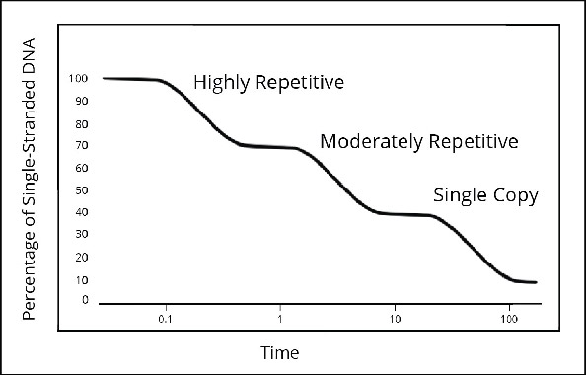

### Key Questions

* Describe how highly repetitive, moderately repetitive, and unique DNA sequences behave in a DNA reassociation experiment.

### **Moderately Repetitive Sequences**

Moderately repetitive DNA sequences include some genes that produce products. For example, the genes that produce the **ribosomal RNA (rRNA)** components of ribosomes (see Chapter 11) and the genes that make **histone** proteins (see Chapter 2) are moderately repetitive DNA sequences. Moderately repetitive DNA sequences also include DNA sequences of unknown function. For example, **variable number tandem repeat (VNTR)** sequences are typically 15 to 100 base pairs long, are often located between genes, and are present in multiple copies repeated along the length of the chromosome. The number of VNTR repeats on each chromosome is unique to each individual. As a result, this variation in VNTR repeats is the basis of the forensics technique **DNA fingerprinting** (see **Figure 1.4**). The **telomere repeat** sequences (see **figure 1.6**) are also moderately repetitive DNA sequences.

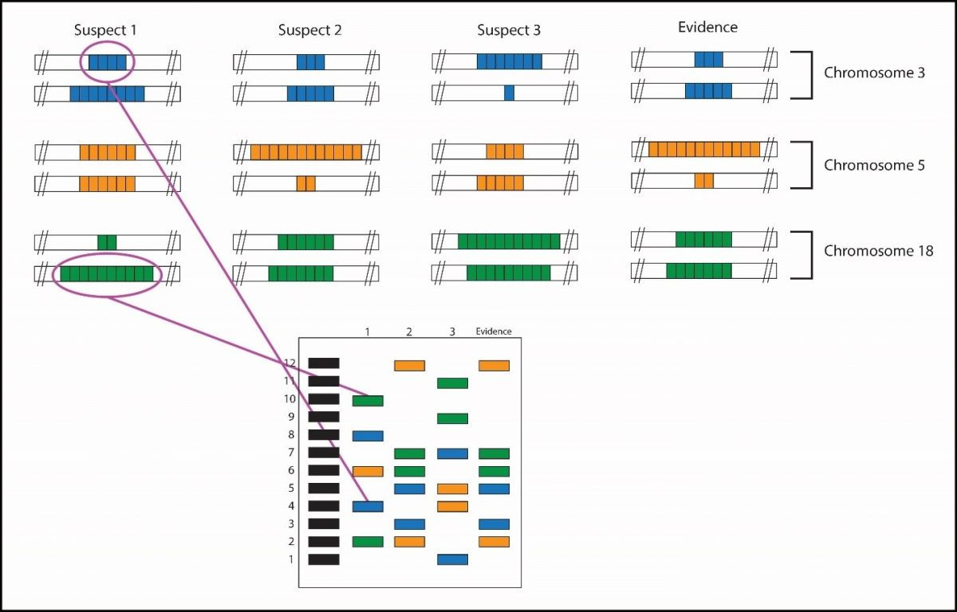

### Key Questions

* What are four examples of moderately repetitive DNA sequences?
* Why are VNTRs well suited for forensics?

### **Highly Repetitive Sequence**

The centromere region (**CEN** region) of the chromosome contains highly repetitive DNA sequences. In humans, the CEN region is approximately 106 (one million) base pairs (bp) long, consisting of a 170 bp **tandem repeat**(i.e., copies of the same 170 bp DNA sequence repeated many times in a row). The Alufamily of DNA sequences in humans is another example of a highly repetitive DNA sequence. Each Alu sequence within the human genome is only 300 bp long; however, there are so many copies of this Alu sequence scattered throughout the human genome that approximately 10% of the genome is thought to be composed strictly of Alu sequences (see **Figure 1.5**). To put this into perspective, only 2% of the human genome is composed of structural genes that produce protein products.  Some of these Alu sequences are particularly interesting because they have the potential to move from one location in the genome to another. DNA sequences that move within the genome are called **transposable elements**. Finally, the **heterochromatin** regions of a chromosome often contain highly repetitive DNA sequences.

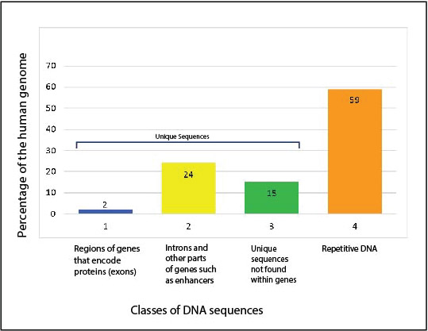

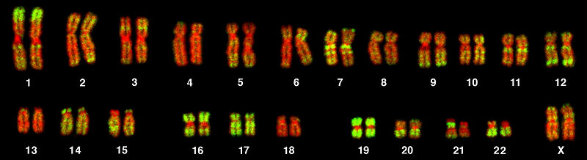

### Key Questions

* What are three examples of highly repetitive DNA sequences?
* What makes transposable elements unique?

### **Telomeres**

The telomeres of eukaryotic chromosomes have the following features:

* **Telomeres contain repetitive DNA sequences.** The repeat DNA sequences within telomeres are 6–8 base pairs (bp) long; each repeat contains multiple G and T nucleotides. For example, the telomere repeat sequence in humans is 5’-TTAGGG-3’. Depending on the eukaryotic species, each telomere may contain several hundred to several thousand tandem repeats of the same telomere DNA sequence (see **Figure 1.6**).  Thus, the telomere repeat sequences are moderately repetitive (see above).
* **Each telomere contains a 3’ single-stranded overhang sequence.**The 3’ single-stranded overhang contains multiple copies of the telomere repeat DNA sequence (5'-TTAGGG-3' in Figure 1.6). The 3' single-stranded overhang is typically 12–16 bp in length.

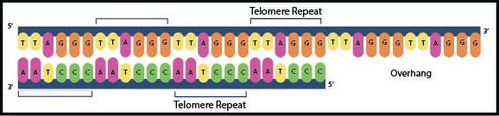

* **Telomere 3' single-stranded overhangs form loops**. The 3' single-stranded overhang within the telomere can turn back on itself to form a **t-loop** (see **Figure 1.7**). Within the t-loop, the 3’ single-stranded overhang of the telomere invades another portion of the same chromosome and forms unusual hydrogen bonds between guanine (G) nitrogenous bases.  These unusual hydrogen bonds involve four G bases, producing a **G quartet** structure. The t-loop is thought to be the actual structure that protects the ends of eukaryotic chromosomes from exonucleases.

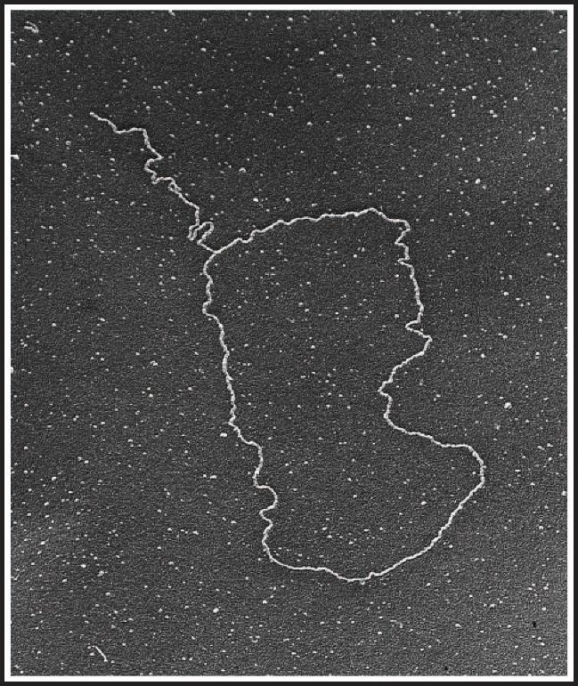

### Key Questions

* At what locations on a chromosome are you likely to find repetitive DNA sequences?
* What is the function of a t-loop?

### **Classifying Chromosomes**

Eukaryotic chromosomes are distinguished from each other in the microscope by the location of the centromere (see **Figure 1.8**), the size of the chromosome, and the banding patterns produced along the chromosome after staining with certain chemical dyes. The centromere separates the chromosome into halves (each half is called an arm); the shorter of the two chromosome arms is designated p, while the longer arm is designated q. In terms of centromere location, chromosomes are classified as follows:

* **Metacentric**. The centromere of a metacentric chromosome is located near the center of the chromosome.
* **Submetacentric**. The centromere of a submetacentric chromosome is located slightly off center.
* **Acrocentric**. The centromere of an acrocentric chromosome is located significantly off center. In humans, there are five pairs of acrocentric chromosomes: 13, 14, 15, 21, and 22. These five pairs of chromosomes contain short p arms having multiple copies of the same **ribosomal RNA (rRNA)** genes. The number of rRNA gene copies varies among individuals, but the average is 100 copies per genome.  Thus, the rRNA genes are considered moderately repetitive DNA sequences (see above). Having many copies of the ribosomal RNA genes ensures that the cell is able to produce enough ribosome components for translation (see Chapter 11).
* **Telocentric**. The centromere of a telocentric chromosome is located near the end of the chromosome. The human genome does not contain telocentric chromosomes; however, the mouse genome contains telocentric chromosomes.

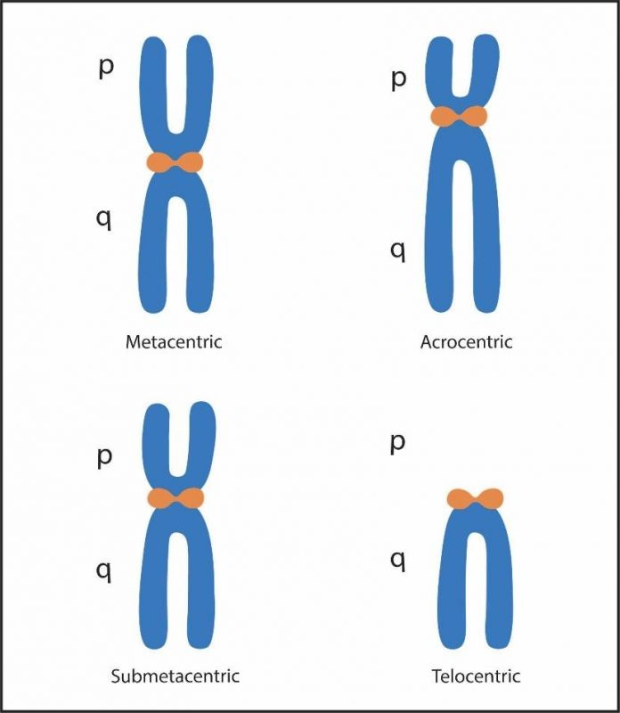

### Key Questions

* What is meant by the terms metacentric, submetacentric, acrocentric, and telocentric?
* What family of genes is found on the short arms of the five acrocentric human chromosomes?
* Does the human genome contain telocentric chromosomes?

### **Human Karyotype and Staining**

A **karyotype** is an image of all of the chromosomes within a dividing cell, in which the homologous chromosomes (recall that one chromosome in a homologous pair is inherited from mom; the other chromosome is inherited from dad) are arranged in pairs (see **Figure 1.9**). The chromosomes are aligned so that their p arms are above the centromere and the q arms are located below the centromere. Human **autosomes** (non-sex chromosomes) are numbered from the largest to the smallest chromosome, 1 to 22. The **sex chromosomes** are labeled X and Y.

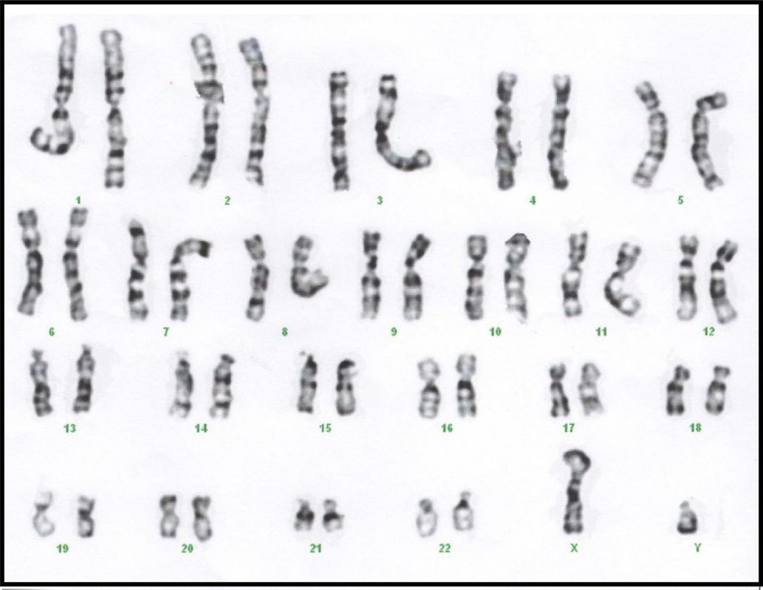

Some chromosomes are similar in size and in centromere location. As a result, these chromosomes are difficult to distinguish from each other in the microscope, unless the chromosomes are stained with chemical dyes to reveal banding patterns that are unique to each chromosome. A common staining procedure involves the chemical dye **Giemsa**, which produces a unique pattern of light and dark bands (G banding) on each chromosome. Dark bands on the chromosomes represent areas of the DNA that are tightly compacted (heterochromatin); light bands represent areas of the DNA that are loosely compacted (euchromatin).

### Key Questions

* What are three ways that scientists can distinguish chromosomes from each other?

### **Chromosome Nomenclature**

A numbering system has been established to describe human chromosomes based on the size, centromere location, and banding pattern. This numbering system assists in determining where chromosome mutations, such as deletions and duplications (see Chapter 3) occur and helps to delineate the exact location of the abnormality. For example, band 22q12 refers to chromosome 22, the long arm (q), region 1 (closest to the centromere), band 2. If a deletion mutation removes a portion of chromosome 22, the exact location of that deletion can be identified based on this numbering system.

## **Review Questions**

**Fill in the blanks:**

1. A(n) ___________________ is an enzyme that cuts the ends of linear nucleic acid molecules.
2. A(n) _________________ is an enzyme that cuts both linear and circular nucleic acid molecules.
3. Bacterial chromosomes are found in a region of the cytoplasm called the ______________.
4. One distinction between prokaryotic and eukaryotic chromosomes is that bacterial chromosomes have one origin of replication.  The E. coli origin of replication is called ____________, while eukaryotic chromosomes have multiple origins of replication.  The yeast origin of replication is called an _______________.
5. Eukaryotes contain highly condensed DNA that lacks genes.  These regions called _________________ are not generally transcribed and appear as __________ bands on a Giemsa-stained chromosome.
6. ________________ are highly repetitive DNA sequences that compose up to 10% of the human genome.
7. The ends of a linear chromosome are called __________________ and the portion where spindle proteins attach is called the ________________.
8. Two types of genes that are moderately repetitive include __________ and __________ genes.
9. The shorter piece of a chromosome is called the _____ arm while the longer piece is called the _____ arm.
10. _____________ genes are found on the p arms of chromosomes 13, 14, 15, 21, and 22.
11. _____________ sequences are used in forensics to determine if a suspect left a DNA sample at a crime scene.
12. There are five pairs of ____________________ chromosomes within the human genome, while the human genome contains _________ pairs of telocentric chromosomes.

Read this online at <https://books.byui.edu/genetics_and_molecul/chromosome_structure>