# 11 - Translation

**Translation**is the cellular process thatconverts the language of nucleotides contained within the mRNA molecule (the nitrogenous bases A, U, G, and C) into the language of amino acids in the synthesized protein (methionine, alanine, histidine, etc.). This translation process relies on a **genetic code** that converts nucleic acid sequence into amino acid sequence. Note that the genetic code that is translated into protein functions within the mRNA molecule, not in the DNA.

### **mRNA Features**

The mRNA molecule is read by the **ribosome** during translation as a group of three consecutive nitrogenous bases, a so-called **triplet code**. Each combination of three nitrogenous bases within the mRNA sequence is a **codon**. In addition to the codons that encode amino acids, the mRNA contains additional sequence features that play important roles in both transcription and translation (**figure 11.1**). These sequence features are listed from 5’ to 3’ along the mRNA molecule below:

* **5’ untranslated region (5’-UTR)**. The 5’-UTR of the mRNA is not translated by the ribosome. Instead, the 5’-UTR allows the ribosome to bind to the mRNA and positions the ribosome to interact properly with the start codon (see below). In bacteria, the 5’-UTR of the mRNA contains a **Shine-Dalgarno sequence** that serves as the binding site for the ribosome. In eukaryotes, the 5’-UTR contains the **7-methylguanosine (7-mG)** cap added during RNA modification (see Chapter 10), which serves as the ribosome binding site.  The 5'-UTR in eukaryotes also contains a **Kozak sequence**, which positions the ribosome to recognize the start codon.
* **Start codon**. The **start codon** in the mRNA encodes the first amino acid in the synthesized protein. The start codon is usually **5'-AUG-3’** and encodes the amino acid **N-formylmethionine (fmet)** in bacteria and **methionine (met)** in eukaryotes.
* **Sense codons.**After the start codon, the mRNA is read as consecutive three nitrogenous base-long **sense codons**. Each sense codon specifies an amino acid in the protein; the specific amino acid sequence of the protein depends on the nitrogenous base sequences of the sense codons. Note that since the start codon and the sense codons encode amino acids, these codons constitute the **coding region** of a gene.
* **Stop codon.**The stop codon in the mRNA serves as a signal to end translation. The possible stop codons within prokaryotic and eukaryotic mRNAs include **5’-UAG-3’**, **5’-UAA-3’**, or **5’-UGA-3’**; each mRNA uses only one of these three stop codons. The stop codon does not encode an amino acid within the synthesized polypeptide.
* **3’ untranslated region (3’-UTR).**The 3’-UTR of the mRNA, located downstream of the stop codon, plays a role in transcription termination. In prokaryotes, the 3’-UTR contains the rut, stem-loop, and the uracil-rich sequences that function in either rho (ρ)-dependent or rho (ρ)-independent transcriptional termination (see Chapter 9). In eukaryotes, the 3’-UTR contains the polyadenylation signal sequences recognized by the CPSF and CstF proteins during transcription termination (see Chapters 9 and 10).

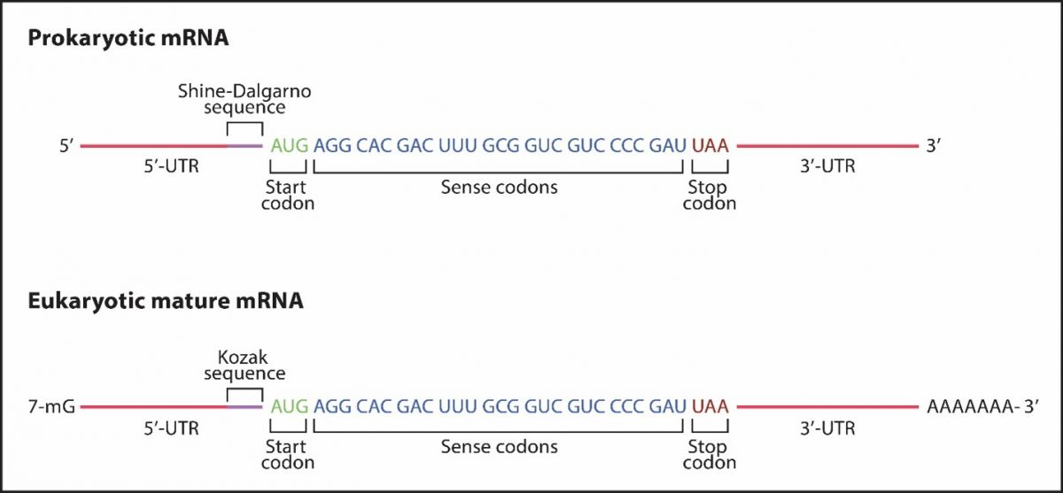

### Key Questions

* Describe one important RNA sequence feature found within the 5’-UTR of bacterial mRNAs.
* Describe two important RNA sequence features found within the 5’-UTR of eukaryotic mRNAs.
* What amino acid is encoded by 5’-AUG-3’ in bacteria?
* What amino acid is encoded by 5’-AUG-3’ in eukaryotes?
* What is the function of the coding region?
* What is the function of the stop codon?
* Is the stop codon part of the coding region?
* What is the function of the 3’-UTR?

### **The Genetic Code**

There are 20 different types of amino acids typically incorporated in proteins; however, there are 64 possible combinations of nitrogenous bases (A, U, G, and C) in triplet codon RNA sequences. As a result, there are more codons than amino acid possibilities (see **figure 11.2**). Thus, the genetic code is **degenerate**, meaning that more than one codon encodes a particular amino acid type.  For example, four codons (5’-GUU-3’, 5’-GUC-3’, 5’-GUA-3’, and 5’-GUG-3’) encode the amino acid valine (val).  These four valine codons differ only in the 3’-most nitrogenous base (**wobble base**) and are called **synonymous codons** because they all encode valine.

The genetic code is also **unambiguous**, meaning that a particular codon sequence only encodes one type of amino acid. For example, the codon 5’-AAA-3’ always encodes the amino acid lysine (lys). Further, the genetic code is **commaless**, meaning that codons are read by the ribosome consecutively one triplet sequence after another, with no spacer nucleotides between codons. The codons are also **nonoverlapping**, meaning each nucleotide in the coding region of the mRNA is a member of only one codon. Finally, the genetic code is **universal**, meaning that the same genetic code is used in nearly all organisms.

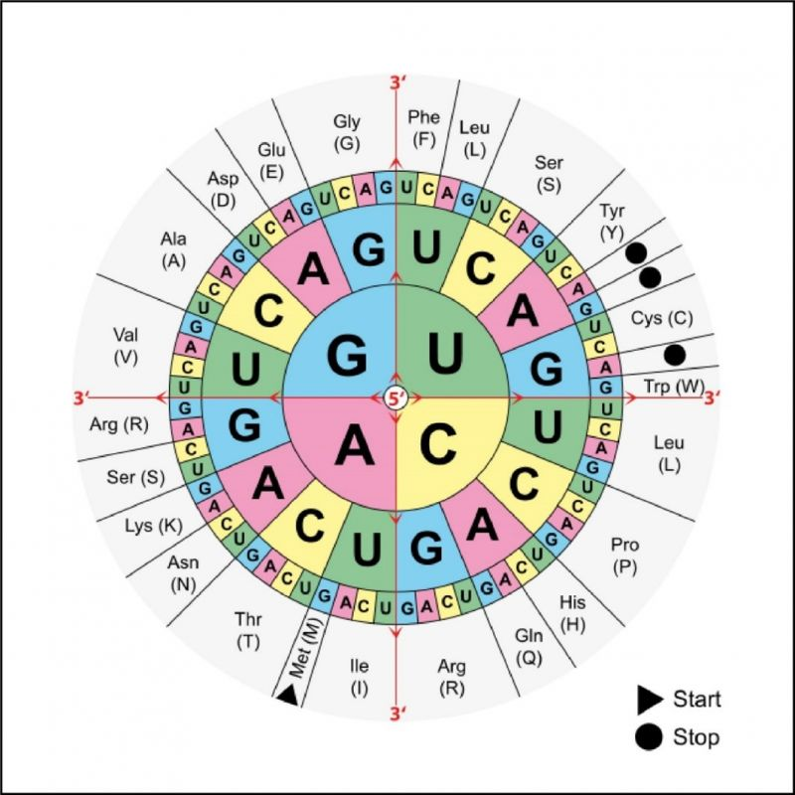

### Key Questions

* How do the words degenerate, unambiguous, commaless, nonoverlapping, and universal apply to the codons in a mRNA sequence?

### **Directionality of Polypeptide Chains**

The polypeptide chains synthesized during translation have directionality (polarity); however, since the language of proteins is different from the language of nucleic acids, the labels 5' and 3' do not apply to amino acid sequences.  Instead, the amino acid encoded by the start codon (closer to the 5’ end of the mRNA) contains a free amino (NH3+) chemical group and thus is said to be the **amino** or **N-terminus** of the polypeptide chain**.** As the polypeptide chain is synthesized, **peptide bonds** are formed between the carboxyl chemical group (COO-) of the growing amino acid chain and the amino groups of incoming amino acids (see **figure 11.3**).  The final amino acid added to a polypeptide contains a free carboxyl group and is called the **carboxyl terminal** orC-terminal end of the polypeptide chain. The C-terminal end of the polypeptide corresponds to the codon immediately before the stop codon (closer to the 3’ end of the mRNA).

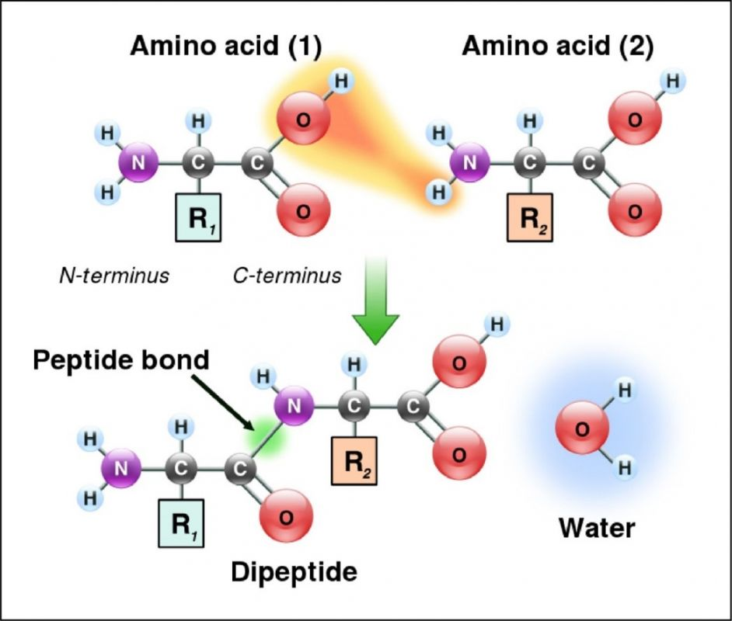

### Key Questions

* How do the N- (amino) and C-terminal (carboxyl) ends of a protein compare to the 5' and 3' ends of an mRNA molecule?

### **tRNAs are Adaptor Molecules**

**Transfer RNA** molecules **(tRNAs)** participate in translation as **adaptor molecules**.tRNAs function to:

* **Recognize the codon nucleotide sequence within the mRNA.** This recognition process involves hydrogen bonding between the mRNA codon and an **anticodon** nitrogenous base sequence within the tRNA.
* **Carry a specific amino acid.** tRNA molecules carry amino acids to the ribosome. The amino acid carried by the tRNA molecule is incorporated into the growing polypeptide chain.

There are many different types of tRNA molecules in a cell. Each tRNA type is encoded by a different gene in the genome and has a unique anticodon sequence. tRNA types are  distinguished by the amino acid carried.  For example, tRNAval carries the amino acid valine and contains an anticodon sequence that forms hydrogen bonds with a valine codon sequence in the mRNA.  Similarly, tRNAphe carries the amino acid phenylalanine and contains an anticodon that forms hydrogen bonds with a phenylalanine codon in the mRNA.  tRNA molecules are example **noncoding RNAs (ncRNAs)**,meaning that tRNA molecules themselves are untranslated; however, tRNAs function directly in the cell.

### Key Questions

* What are the two functions of tRNA molecules?

### **Features of tRNAs**

Even though different tRNA types (tRNAval tRNAphe) have unique anticodons and carry unique amino acids, all tRNA molecules share similar overall structural features (**figure 11.4**):

* **tRNA molecules are small**. Each tRNA type is only 75–90 nucleotides in length.
* **tRNA molecules are shaped like a cloverleaf**. tRNA molecules contain three stem-loop structures formed by hydrogen bonding within the tRNA molecule. The anticodon RNA sequence is located within one of these stem-loop structures (i.e., the so-called **anticodon loop**).
* **tRNA molecules contain a 3’ single-stranded region called an acceptor stem**. The acceptor stem region is covalently linked to the amino acid.
* **tRNA molecules contain variable regions**. The tRNA variable regions differ between tRNA types (e.g., tRNAval compared to tRNAphe) in the number of nucleotides and the specific nucleotide sequence that they contain. Variability in these regions can make the stem loops of different tRNA types larger or smaller.
* **tRNA molecules contain atypical nitrogenous bases**. Many tRNA types have unusual nitrogenous bases, such as inosine (I), methylinosine (mI), and dimethylguanine (m2G). These atypical nitrogenous bases are created from the four conventional RNA nitrogenous bases (A, U, G, C) after transcription of the tRNA molecule has occurred.

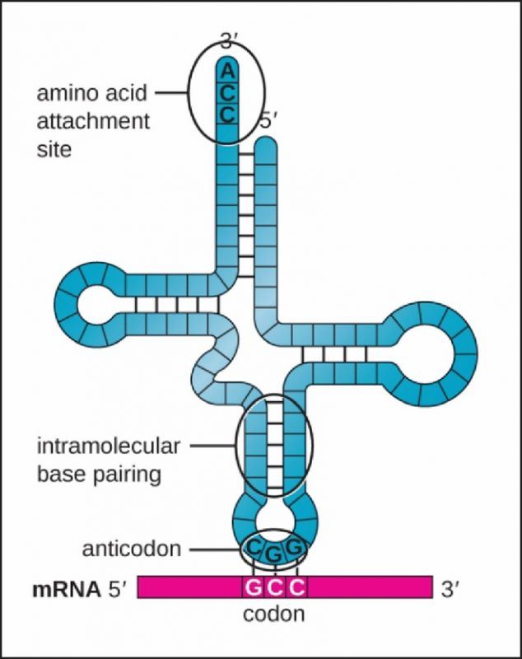

### Key Questions

* Where is the anticodon in a tRNA molecule?
* Where is the amino acid attached to a tRNA molecule?

### **Charging tRNAs**

The process of attaching an amino acid to the 3' end of a tRNA molecule is **charging**. Charging tRNAs involves cellular enzymes called **aminoacyl-tRNA synthetases**.  Aminoacyl-tRNA synthetases have the following features:

* There are twenty different group of aminoacyl-tRNA synthetases per cell, one group for each of the twenty amino acid types.
* Aminoacyl-tRNA synthetases are named for the amino acid that is attached to the tRNA. For example, alanyl-tRNA synthetases attach the amino acid alanine (ala) to a tRNA molecule, while prolyl-tRNA synthetases attach the amino acid proline (pro) to a tRNA molecule.
* Aminoacyl-tRNA synthetases attach the incorrect amino acid to a tRNA rarely. In fact, it is estimated that aminoacyl-tRNA synthetases attach the wrong amino acid only one time per 100,000 tRNA molecules charged.

The mechanism used by an aminoacyl-tRNA synthetase to charge a tRNA molecule has the following steps (see **figure 11.5**):

1. The aminoacyl-tRNA synthetase binds to its preferred amino acid type and ATP.  For example, the alanyl-tRNA synthetases bind to the amino acid alanine and ATP, while prolyl-tRNA synthetase binds to the amino acid proline and ATP.
2. The ATP molecule is cleaved, PPi (pyrophosphate) is released, and the remaining AMP is covalently linked to the amino acid.  When AMP is linked to the amino acid, the aminoacyl-tRNA synthetase changes its shape to produce the active form of the enzyme.
3. The aminoacyl-tRNA synthetase binds to a tRNA molecule that contains an anticodon sequence specific for the enzyme's preferred amino acid. For example, an alanyl-tRNA synthetase only binds to tRNA molecules that have anticodons that form hydrogen bonds with alanine codons in the mRNA.  If the anticodon on the incoming tRNA is incorrect, the tRNA is released from the aminoacyl-tRNA synthetase and a new tRNA binds instead.
4. The aminoacyl-tRNA synthetase attaches the amino acid to the 3’ end (acceptor stem) of the tRNA. AMP is released.
5. The **charged tRNA** (i.e., tRNA covalently linked to the amino acid) is released from the aminoacyl-tRNA synthetase.  This charged tRNA can then be delivered to the ribosome.

### Key Questions

* Which nucleotide triphosphate provides the energy for the tRNA charging reaction?
* Explain the major events that occur during tRNA charging.

### **Wobble**

Most synonymous mRNA codons (codons that encode the same amino acid) have identical bases at the first two nucleotide positions (the 5’-most nitrogenous base and the middle base of the codon). These first two mRNA bases obey the AU/GC base pairing rules when forming hydrogen bonds with the tRNA anticodon. Degeneracy in the genetic code typically occurs at the 3'-most base within the mRNA codon. This 3’-most mRNA base in the codon does not have to form conventional base pairing interactions with the 5’-most base of the tRNA anticodon, leading to “wobble.” The rules that govern codon-anticodon at this wobble position are called the **wobble rules** (see **Table 11.1**).  For example, a U base in the wobble position of the mRNA codon (3'-most base) forms hydrogen bonds with A, G, or I in the wobble position of the tRNA anticodon (5'-most base).  Similarly, a U in the wobble position of the tRNA anticodon (5'-most base)  forms hydrogen bonds with either A or G in the wobble position of the mRNA codon (3'-most base).

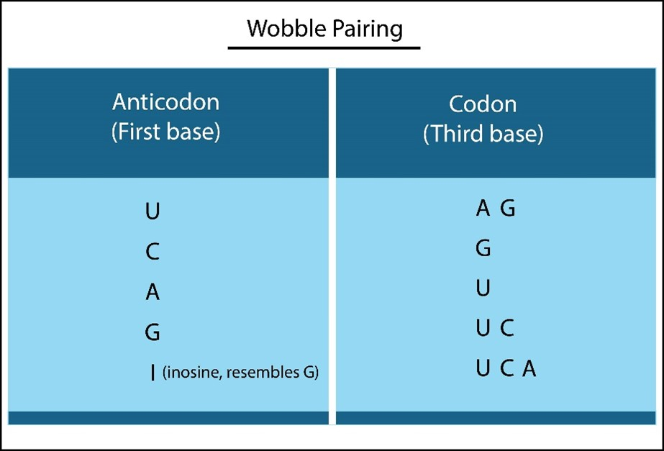

Table 11.1 **Wobble Rules Table.  When a U is found at the wobble position in the tRNA anticodon, this U can form hydrogen bonds with either A or G at the wobble position in the mRNA codon.  When a G is found at the wobble position in the mRNA codon, this G can from hydrogen bonds with either U or C at the wobble position in the tRNA anticodon.**

A group of tRNA types, with slightly different anticodon sequences, which recognize the same mRNA codon sequence are called **isoacceptor tRNAs**. For example, suppose we have the codon 5’-UUU-3’ in the mRNA. tRNA molecules containing either 3’-AAA-5’, 3’-AAG-5’, or 3’-AAI-5’ anticodons can recognize this mRNA codon, according to the wobble rules (see **Table 11.1**). Note that these three isoacceptor tRNA types are charged by the same aminoacyl-tRNA synthetase and therefore, bear the same amino acid (phenylalanine). Alternatively, a tRNA with the 3’-GGU-5’ anticodon can recognize two codons: 5’-CCA-3’ and 5’-CCG-3’ according to the wobble rules.  Both codons encode the amino acid proline.

Why is this wobble phenomenon advantageous to cells? Wobble gives the cell flexibility in codon: anticodon interactions.  A single mRNA codon can be recognized by more than one tRNA anticodon, and a single tRNA anticodon can bind to more than one mRNA codon.  This flexibility allows translation to occur at a reasonable rate and allows a cell to save energy in the synthesis of tRNA molecules. Instead of assembling 61 different types of tRNA molecules (one type for each possible sense codon, not including the three stop codons), a cell can get away with synthesizing only 30-40 types of tRNA molecules, with some individual tRNAs recognizing multiple mRNA codon sequences.

### Key Questions

* What is meant by wobble?
* Which nucleotide position is the wobble position in the mRNA codon?
* Which nucleotide position is the wobble position in the tRNA anticodon?
* What are isoacceptor tRNAs?
* What is the advantage of wobble?

### **Prokaryotic Ribosomes**

The **ribosome** is the central figure in the translation process. The ribosome binds to the mRNA, serves as the cellular site for mRNA codon: tRNA anticodon recognition, breaks the covalent bond between the 3’ end of the tRNA and the amino acid, and synthesizes peptide bonds between amino acids. A single bacterial cell is thought to contain approximately 10,000 ribosomes; each of these bacterial ribosomes is called a **70S ribosome**. The bacterial 70S ribosome consists of the following subunits (see **figure 11.6**):

* **Small subunit (30S subunit).**The small subunit of the ribosome is composed of several different ribosomal proteins and a **16S ribosomal RNA (rRNA)** molecule. The 16S rRNA molecule helps the ribosome bind to the bacterial mRNA molecule (see below).
* **Large subunit (50S subunit)**. The large subunit of the ribosome is composed of many ribosomal proteins, a 5S rRNA molecule, and a **23S rRNA** molecule.  The 23S rRNA molecule is the catalytic core of the ribosome; the 23S rRNA is the RNA enzyme (i.e., a ribozyme) that forms peptide bonds between amino acids during prokaryotic translation (see below).

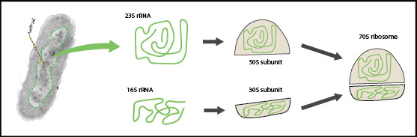

### **Eukaryotic Ribosomes**

Eukaryotic cells have cytosolic ribosomes called **80S ribosomes**.  The 80S ribosomes in the cytosol synthesize most cellular proteins and consist of the following subunits (see **figure 11.7**):

* **Small subunit (40S).**The 40S subunit is composed of many proteins and an 18S rRNA molecule.
* **Large subunit (60S).**The 60S subunit is composed of a collection of proteins, a 5S rRNA molecule, a 5.8S rRNA molecule, and a **28S rRNA** molecule. The 28S rRNA molecule is the RNA enzyme (ribozyme) that forms peptide bonds between amino acids during eukaryotic translation (see below).

Note that mitochondria and chloroplasts also contain ribosomes; however, these ribosomes closely resemble prokaryotic 70S ribosomes.

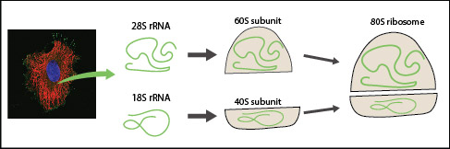

### Key Questions

* Compare and contrast the structural features of prokaryotic and eukaryotic ribosomes.
* What is the name of the enzyme that forms peptide bonds within the 70S ribosome?
* What is the name of the enzyme that forms peptide bonds within the 80S ribosome?

### **Overview of Translation**

Translation in prokaryotes and eukaryotes occurs in three stages (see **figure 11.8**):

1. During **initiation**, the large and small ribosomal subunits assemble on the mRNA start codon with an **initiator tRNA** molecule that has an anticodon sequence specific for the start codon mRNA sequence. Once all translation components have assembled correctly, the initiator tRNA is located at the P site (middle tRNA binding site; see below) within the ribosome.
2. During **elongation**, the ribosome moves or **translocates** along the mRNA in the 5’ to 3’ direction, reading triplet codons within the mRNA, translating the mRNA codon sequences into a chain of amino acids. During elongation, three tRNA binding sites within the ribosome are used. These tRNA binding sites are the:
   * **Aminoacyl site (A site).**Charged tRNAs enter the ribosome at the A site.
   * **Peptidyl site (P site).** During a translation elongation cycle (see below),the polypeptide chain attached to the tRNA molecule in the P site is transferred to the tRNA in the A site as peptide bonds are formed.
   * **Exit site (E site)**. The E site allows uncharged tRNA molecules to exit the ribosome.
3. When the ribosome reaches a stop codon, translation **terminates**. The mRNA and the polypeptide chain are released from the ribosome, and the large and small subunits of the ribosome dissociate from each other.  The ribosome subunits and the mRNA are then recycled to synthesize another copy of the protein.

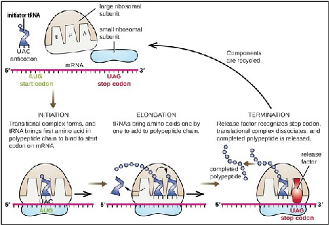

### Key Questions

* What major events are occurring during the initiation, elongation, and termination stages of translation?
* What are the functions of the A, P, and E tRNA binding sites within the ribosome?

### **Shine-Dalgarno Sequence**

The **5’-untranslated region (5’-UTR)** of prokaryotic mRNAs plays a critical role in translation initiation, as the 5’-UTR contains the ribosome-binding site. Specifically, the 5’-UTR contains a recognition sequence (5’-AGGAGGU-3’) called the **Shine-Dalgarno sequence** that forms hydrogen bonds with a complementary sequence within the **16S rRNA** molecule, found within the small ribosomal subunit (30S) (see **figure 11.9**). Hydrogen bond formation between the Shine-Dalgarno sequence and the 16S rRNA promotes ribosome assembly. Additionally, the Shine-Dalgarno sequence positions the P site of the ribosome properly at the start codon to initiate translation.

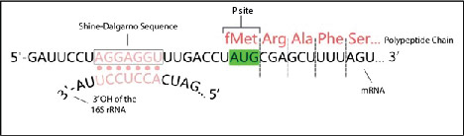

### Key Questions

* What are the two functions of the Shine-Dalgarno sequence?

### **Translation Initiation in Bacteria**

Translation initiation in the bacterium E. coli includes the following steps (see **figure 11.10**):

1. **The mRNA binds to the small ribosomal subunit (30S) via the Shine-Dalgarno sequence.** An initiation factor protein called **IF3** promotes the formation of hydrogen bonds between the 16S rRNA (ribosome) and the Shine-Dalgarno sequence (mRNA).
2. **The initiator tRNA (tRNAfmet)recognizes the start codon within the P site of the ribosome.** As mentioned earlier, the initiator tRNA anticodon forms hydrogen bonds with the mRNA start codon in the P site. In bacteria, this initiator tRNA is charged with a modified form of the amino acid methionine called **N-formylmethionine (fmet)**. Thus, the N-terminal amino acid in all newly synthesized prokaryotic proteins is fmet. Binding of the tRNAfmet to the start codon requires the initiation factor protein **IF2.** IF2 uses GTP to load the tRNAfmet into the ribosome P site. The complex of the 30S subunit, the mRNA, IF3, and IF2 is called the **initiation complex**.
3. **The 50S subunit of the ribosome is added to the initiation complex.** The addition of the 50S ribosome subunit releases the IF2 and IF3 translation factor proteins.

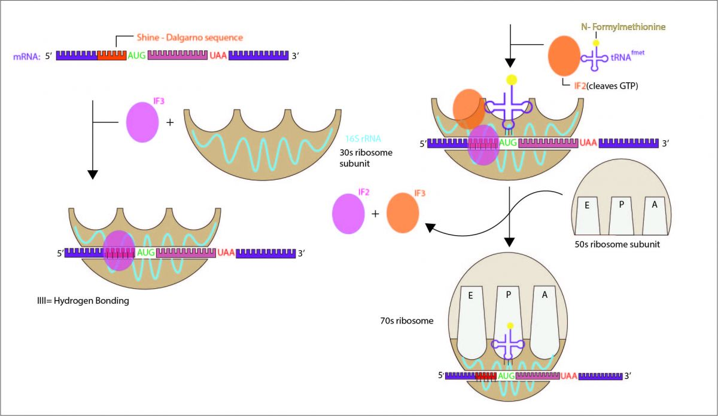

### Key Questions

* How do the IF2 and IF3 proteins function in translation initiation in bacteria?
* What molecule provides the energy for translation initiation in bacteria?

### **Translation Initiation in Eukaryotes**

Translation initiation is more complex in eukaryotes than in prokaryotes. Key differences between eukaryotic and prokaryotic translation initiation include (see **figure 11.11**):

* + More initiation factor proteins are involved in eukaryotes. These initiation factor proteins are called **eukaryotic initiation factor (eIFs) proteins**.
  + The initiator tRNA in eukaryotes is **tRNAmet**. This initiator tRNA is charged with the amino acid **methionine (met)**instead of fmet.
  + There is no Shine-Dalgarno sequence in the eukaryotic mature mRNA. Instead, the 5' UTRs of eukaryotic mature mRNAs contain a **7-methylguanosine (7-mG)** cap and a **Kozak sequence**.

The process of translation initiation in eukaryotes is as follows:

1. **The eIF2 protein brings tRNAmet to the 40S ribosomal subunit**. eIF2 uses GTP to deliver tRNAmet to the 40S ribosomal subunit.
2. **A multiprotein initiation complex is assembled on the 7-methylguanosine (7-mG) cap of the mature mRNA.** This initiation complex includes:
   * the 40S ribosome subunit.
   * an **eIF4** protein.
   * a complex composed of the eIF2 protein and tRNAmet.
   * **cap-binding protein 1 (CBP1)**. CBP1 is the protein responsible for recognizing the 7-mG structure on eukaryotic mature mRNAs.
3. **Identification of the start codon**. The multiprotein initiation complex moves from the 7-mG cap 5’ to 3’ along the mRNA looking for a start codon. This scanning process uses ATP. Not all 5’-AUG-3’ codons encountered are chosen to initiate translation. The 5’-AUG-3’ that is chosen as the start codon is within the **Kozak sequence:** 5’-GCC(A or G)CC**AUG**G-3’. When the tRNAmet forms hydrogen bonds with the start codon, tRNAmet is in the P site of the ribosome.
4. **Addition of the 60S ribosomal subunit to form the active 80S ribosome**.  When the 60S ribosome subunit is added, eIF2, eIF4, and CBP1 are released.

**Figure 9.11 - Translation initiation in eukaryotes.**

### Key Questions

* How do eIF2 and CBP1 function in translation initiation in eukaryotes?
* What is the function of the Kozak sequence?
* Which two molecules provide the energy for translation initiation in eukaryotes?

### **Translation Elongation**

Translation elongation in bacteria involves a series of cycles, one cycle per sense codon encountered in the mRNA. At the beginning of each cycle, the tRNA molecule located within the P site of the ribosome is either attached to single amino acid (beginning of elongation cycle one) or a chain of amino acids (later elongation cycles; see **figure 11.12**). The A and E sites of the ribosome are empty. Each elongation cycle then proceeds as follows:

1. **A charged tRNA is delivered to the ribosome A site**. The prokaryotic **elongation factor** protein **EF-Tu** is responsible for loading the charged tRNA into the A site of the ribosome. This loading of a charged tRNA into the A site uses GTP.
2. **The codon: anticodon hydrogen bonds are checked**. Of course, the anticodon within the newly delivered tRNA must form complementary hydrogen bonds with the mRNA codon according to the wobble rules (see above). The codon: anticodon hydrogen bonds within the A site is scanned by the **16S rRNA molecule**. If an incorrect anticodon is encountered, polypeptide synthesis is halted until the mismatched tRNA is released from the ribosome. This editing function of the 16S rRNA molecule allows for high fidelity in protein synthesis; it is estimated that only one mistake is made per 10,000 incorporated amino acids, or about one time in every 20 proteins synthesized by the prokaryotic ribosome.
3. **The formation of a peptide bond**. The amino acid or amino acid chain bound to the tRNA in the P site is transferred to the tRNA in the A site via the formation of a new peptide bond. This enzyme reaction is catalyzed by the **23S rRNA** component within the large ribosome subunit (50S); the 23S rRNA is an example of an RNA enzyme (i.e., a ribozyme). This 23S rRNA ribozyme is also called **peptidyl transferase**.
4. **Ribosome translocation**. The ribosome moves or **translocates** in the 5’ to 3’ direction to the next sense codon in the mRNA. The tRNAs within the ribosome stays put during ribosome translocation.  As a result, the tRNA in the A site moves to the P site. The uncharged tRNA that was in the P site moves to the E site and exits the ribosome. A bacterial elongation factor protein called **EF-G** uses GTP to translocate the ribosome to the next sense codon in the mRNA.
5. **Steps 1–4 are repeated for each sense codon in the mRNA**. The rate of protein synthesis is 15–18 cycles (i.e., 15-18 peptide bonds formed) per second in prokaryotes.

Translation elongation works similarly in eukaryotes; however, there are some minor differences:

* The **28S rRNA** component within the large ribosomal subunit (60S) functions as the peptidyl transferase to synthesize peptide bonds between amino acids. The 28S rRNA is another example of an RNA enzyme (ribozyme).
* Eukaryotes have **eukaryotic elongation factor** proteins **(eEFs)** that function similarly to the EF-Tu and EF-G proteins from bacteria. The eukaryotic **eEF1** protein functions similarly to EF-Tu, delivering charged tRNA molecules to the A site of the ribosome. The eukaryotic **eEF2** protein functions similarly to EF-G in bacteria, translocating the ribosome to the next sense codon after peptide bond formation has taken place. Both eEF1 and eEF2 use GTP molecules.

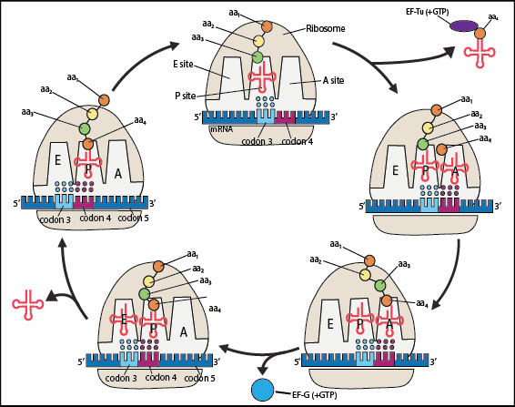

### Key Questions

* Describe the events within each translation elongation cycle.
* Explain when GTP is used during an elongation cycle.
* What is the eukaryotic equivalent of 23S rRNA, EF-Tu, and EF-G?

### **Translation Termination**

Translation termination in bacteria occurs as follows (see **figure 11.13**):

1. As the ribosome approaches the 3’ end of the mRNA, a **stop codon (5’-UGA-3’, 5’-UAG-3’,** or **5’-UAA-3’)** moves into the A site of the ribosome.
2. The stop codon is recognized by a **release factor** protein. The release factor protein mimics the three-dimensional structure of a tRNA molecule. In bacteria, the **release factor 1 (RF1)** protein recognizes the stop codons 5’-UAA-3’ and 5’-UAG-3’. The **release factor 2 (RF2)** protein recognizes the 5’-UAA-3’ and 5’-UGA-3’ stop codons.
3. The release factor protein cuts the covalent bond between the tRNA and the polypeptide chain in the ribosome P site. As a result, the tRNA and the polypeptide chain are released from the ribosome. The polypeptide chain later folds to become a functional protein.  This release of the tRNA and the polypeptide chain from the ribosome requires GTP.
4. The ribosome subunits, mRNA, and release factor protein dissociate, terminating translation.  The ribosome subunits and the mRNA can be recycled to begin translation again.

Translation termination works essentially the same way in eukaryotes. One minor difference is the use of a single **eukaryotic release factor (eRF)** protein that recognizes all three stop codons. The eRF protein uses GTP to terminate translation in eukaryotes.

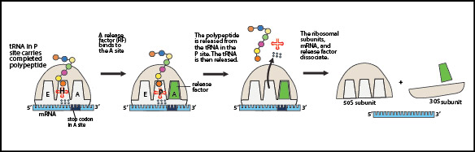

### Key Questions

* What is the difference between RF1 and RF2?
* What molecule provides the energy to terminate translation?
* Are some of the molecules involved in translation recycled? If so, which ones?

### **Polysomes and Coupled Transcription and Translation**

In the electron microscope, multiple ribosomes (**polyribosomes** or **polysomes**) are often observed attached to a single mRNA molecule (see **figure 11.14**). Polyribosomes have been observed attached to both prokaryotic mRNA and eukaryotic mature mRNA transcripts.

Since prokaryotic cells lack nuclei, transcription and translation are **coupled**, meaning that translation can begin before transcription is completed. In eukaryotes, transcription and translation are uncoupled. Transcription and the RNA modifications occur within the nucleus.  Translation occurs later, after the mature mRNA has been transported from the nucleus to the cell cytoplasm.

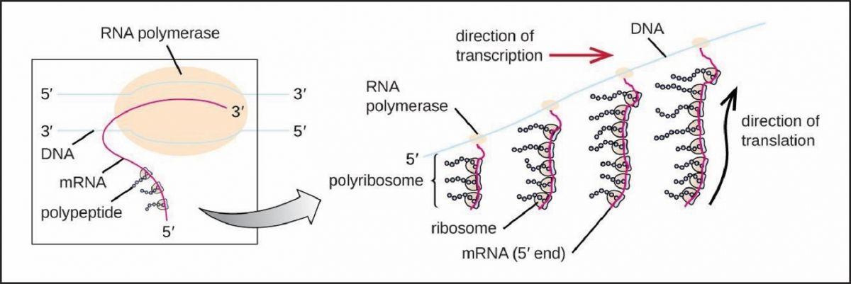

### Key Questions

* Why is it advantageous to have multiple ribosomes translating a single mRNA molecule?
* Why is prokaryotic transcription and translation coupled?
* Why is eukaryotic transcription and translation uncoupled?

## **Review Questions**

**Fill in the blanks:**

1. The ______________ portion of a eukaryotic mature mRNA contains the polyadenylation signal sequences.
2. The genetic code is said to be __________________, which means that each codon only specifies one type of amino acid. (For example, 5’-UUU-3’ always encodes phenylalanine)
3. The cloverleaf structure of the tRNA is such that the ____________________________ is a stem-loop that forms hydrogen bonds with the mRNA codon, and the ___________________________ is the single-stranded region where an amino acid is attached.
4. ____________________________ is an enzyme that links the amino acid alanine to a tRNA molecule.
5. The 30S and 50S ribosomal subunits in a prokaryotic cell combine to form a final size of _________ while in eukaryotes the _________ and __________ ribosomal subunits combine to form a final size of ______________.
6. The initiator tRNA binds to the __________ site of the ribosome, whereas the remaining charged tRNAs are loaded into the ___________ site of the ribosome.
7. An E. coli protein called _______________ delivers charged tRNAs to the ribosome during translation elongation.
8. The ribosome moves along the mRNA in the _______to _______ direction.
9. _______________ is a eukaryotic translation factor protein that delivers charged tRNAs to the ribosome during elongation.
10. ___________ is a eukaryotic translation factor that helps the ribosome move one codon in the 3’ direction along the mRNA.  The equivalent bacterial protein is called ______________.
11. The _________________ protein in bacteria mimics the structure of a tRNA and recognizes 5’-UGA-3’ in the A site of the ribosome.
12. An E. coli protein called __________ delivers tRNAfmet to the ribosome during translation.

Read this online at <https://books.byui.edu/genetics_and_molecul/21___translation>