# 13 - The lac Operon

In Chapter 13, we will learn about the mechanisms that regulate **gene expression** in bacteria. Gene expression refers to processes that activate structural genes, producing a mRNA molecule by transcription and a functional protein product by translation. Specifically, we will study the expression of the **lac operon** system from the bacterium E. coli. The lac operon contains the structural genes that produce protein products that metabolize lactose for energy.

Some bacterial structural genes are always transcribed. These genes that are always expressed are called **constitutive** or **housekeeping genes**. Note that constitutive genes produce constitutive or housekeeping proteins. Housekeeping proteins are required for the normal functioning of the bacterial cell, the so-called housekeeping functions.  The genes that produce the proteins involved in glycolysis are example housekeeping genes.

**Regulated genes** change expression under different environmental conditions. In one environment, the regulated gene is transcribed, while in another environment the regulated gene is silenced.  The mRNAs produced from regulated genes are translated to make **inducible proteins**. Inducible proteins are tightly controlled so that thousands of copies of the protein are present in one environment, while only a few or no copies of the protein are produced in other environments. Regulated genes and their protein products are advantageous because they allow bacteria to adapt to changing environments.  For example, the transcription patterns of regulated genes respond when resources, such as carbon or nitrogen, change in the environment.

### Key Questions

* What is the difference between a constitutive and a regulated gene?
* What is one metabolic process that is considered a housekeeping process?

## **Inducible Genes**

The regulation of genes in bacteria often involves controlling the initiation of transcription. Transcriptional regulation requires the binding of **regulatory transcription factor proteins** to **regulatory DNA sequences** near the promoter region of a gene. These regulatory transcription factor proteins function to either enhance or inhibit sigma (σ) factor protein and RNA polymerase core enzyme binding to the promoter.  Regulatory transcription factor proteins include:

* **Repressor proteins**. Repressor proteins prevent sigma (σ) factor protein and the RNA polymerase core enzyme from binding to the promoter.  As a result, repressor proteins decrease how often transcription starts (**negative control**).
* **Activator proteins.**Activator proteins encourage sigma (σ) factor protein and RNA polymerase core enzyme binding to the promoter. Thus, activator proteins increase how often transcription starts (**positive control**).

Repressor and activator proteins not only contain DNA binding domains but also have binding sites for small organic **effector** molecules, such as sugars, amino acids, and nucleotides. When an effector molecule binds, the three-dimensional structure of the repressor or activator protein changes.  This change in protein shape influences the ability of the activator protein or repressor protein to bind to the DNA.  Therefore, these effector molecules regulate the ability of repressor and activator proteins to bind to the DNA and influence transcription of a nearby gene.

How do bacteria turn a regulated gene from an off transcriptional state to an on state? For example, how does a bacterium activate the structural genes that lead to lactose metabolism when lactose becomes available in the environment? An **inducer** effector molecule causes transcription to increase (**figure 13.1**) in two different ways:

* **The inducer releases a repressor protein from the DNA**. When the inducer molecule binds to the repressor protein, the repressor protein is released from a binding site on the DNA, and transcription of the nearby structural gene increases.
* **The inducer guides an activator protein to the DNA**. In this case, the activator protein cannot bind to the DNA unless the inducer is present. When the inducer molecule binds to the activator protein, the activator binds to the DNA and transcription of the nearby structural gene increases.

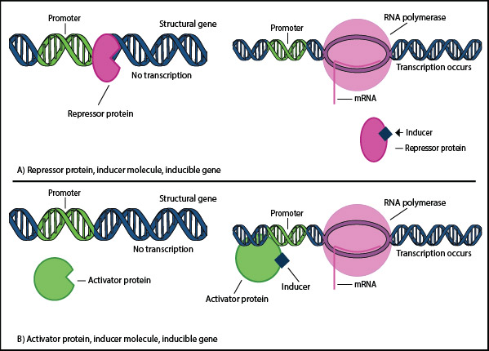

### Key Questions

* How do repressor and activator proteins affect transcription?
* What is the function of effector molecules?
* Describe two ways that an inducer can activate the transcription of a gene.

## **Repressible Genes**

How do bacteria turn a regulated gene from an on transcriptional state to an off state? For example, how does a bacterial cell stop transcribing the genes required to make the amino acid tryptophan, when there is plenty of tryptophan in the environment? Effector molecules inhibit transcription in two ways (**figure 13.2**):

* **A corepressor guides a repressor protein to the DNA.** Without the corepressor molecule, the repressor protein does not bind to the DNA. When the corepressor molecule binds the repressor protein, a conformational change occurs in the repressor. The repressor protein can then bind to the DNA and inhibit transcription of a nearby structural gene.
* **An inhibitor releases an activator protein from the DNA.** In this case, the activator protein is normally bound to the DNA and activates transcription. When the inhibitor molecule binds to the activator protein, a conformational change causes the activator protein to be released from the DNA, and transcription of a nearby structural gene ceases.

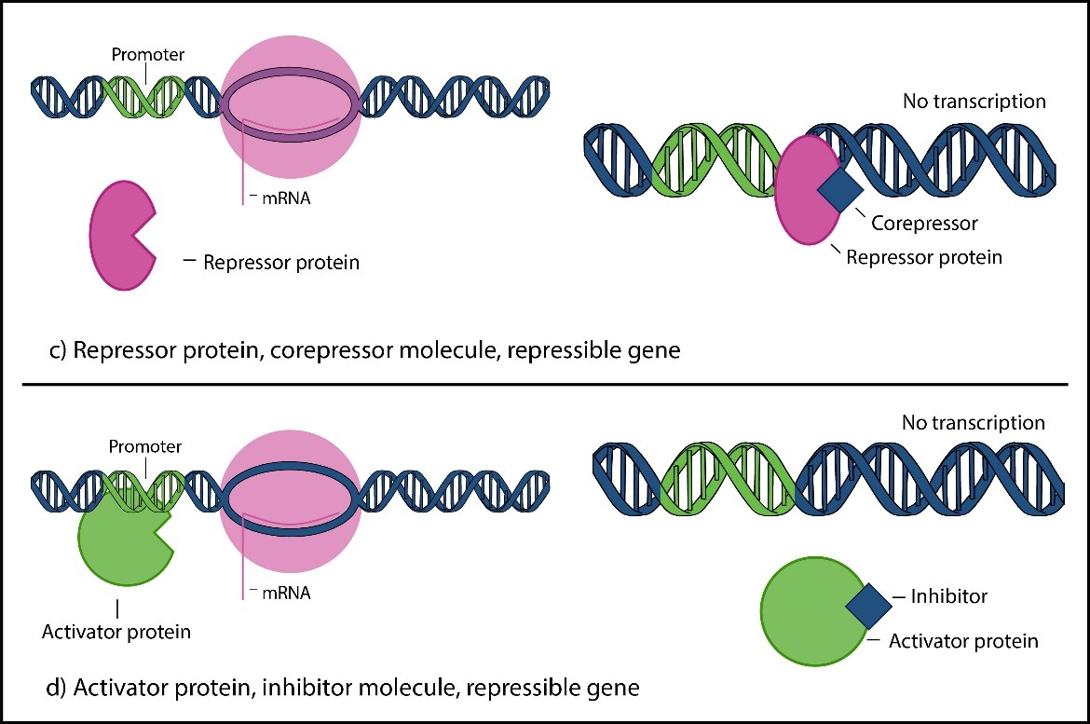

### Key Questions

* Describe how a corepressor and an inhibitor turn a transcribed gene to an off state.

## **Enzymes Involved in Lactose Metabolism in E. coli**

Now we will turn our attention to a specific example of gene regulation in the bacterium E. coli, involving the regulation of the structural genes involved in lactose metabolism.  Lactose is a sugar that can be used as a carbon and energy source when the preferred carbon source, glucose, is limited. Lactose breakdown by an E. coli cell involves the induction of three enzymes (**figure 13.3**):

* **Lactose permease.**Lactose permease is a cytoplasmic membrane protein involved in transporting lactose from the environment into the cytoplasm of the E. coli cell.
* **Beta (β)-galactosidase.**β-galactosidase cleaves the lactose imported by lactose permease, producing the monosaccharides galactose and glucose. Galactose and glucose can then be metabolized by the E. coli cell to produce energy.  β-galactosidase also catalyzes a side reaction that converts lactose into the effector molecule **allolactose**. Importantly, allolactose is one of the two inducers for the lac operon; allolactose releases the lac repressor protein from the operator sequence on the DNA (see below).
* **Galactoside transacetylase.**Galactoside transacetylase converts atypical forms of lactose into forms that can be metabolized readily by β-galactosidase.

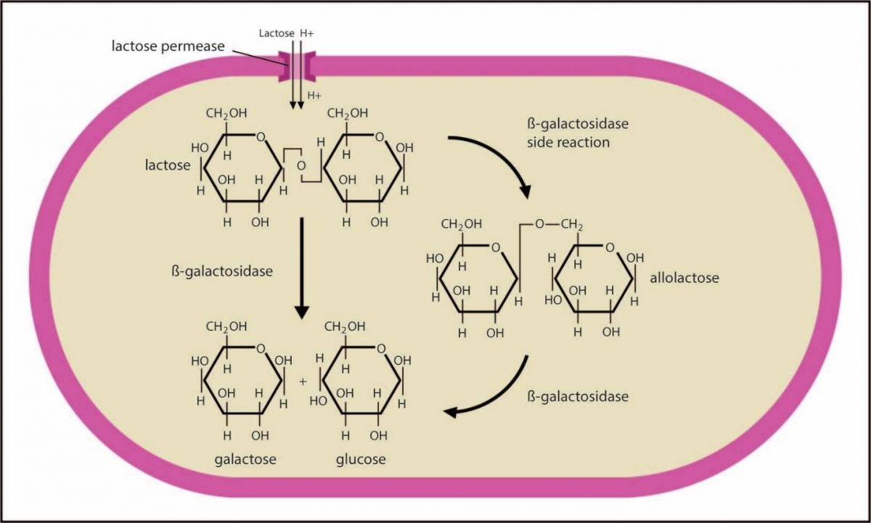

### Key Questions

* What are the functions of the three bacterial enzymes involved in lactose breakdown?

## **Operons**

In bacteria, a group of structural genes is often under the control of a single group of regulatory DNA sequences, a single promoter sequence, and a single terminator sequence. This grouping of structural genes is an **operon** (**figure 13.4**). The organization of structural genes into operons allows all of the structural genes involved in a single biochemical pathway (e.g., lactose metabolism) to be regulated in a coordinated way. When an operon is transcribed, a **polycistronic mRNA** is produced that contains the coding regions for multiple individual proteins.

Typical operons contain a **promoter**.  Recall that the promoter serves as the binding site for the sigma (σ) factor protein and contains the transcription start site (+1 site) for the operon. Operons also contain **operator** DNA sequences that serve as repressor proteinbinding sites, an **activator binding site**where an activator protein binds, **structural genes** that encode proteins, and a **terminator** sequence that signals the end of transcription. Recall that transcriptional termination in bacteria works either using the rho (ρ)-dependent or rho (ρ)-independent mechanism (see Chapter 9).

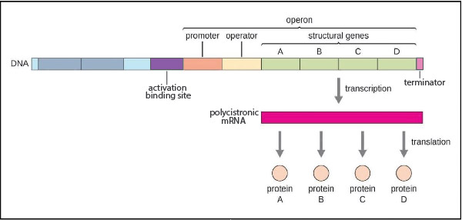

### Key Questions

* What is an operon?
* Why is it advantageous to organize structural genes into operons?
* What is a polycistronic mRNA?
* What is an operator and an activator binding site?

## **The Lactose (lac) Operon**

François Jacob and Jacques Monod first described transcriptional regulation by studying lactose metabolism in the bacterium E. coli. Jacob and Monod won the Nobel Prize in 1965 for their work.  Lactose metabolism in E. coli requires regulating structural genes within the **lactose (lac) operon**. The lac operon contains the following DNA sequences and structural genes (**figure 13.5**):

* **CAP site.**The CAP site is a DNA sequence that serves as the binding site for the **catabolite activator protein (CAP)**.
* lac **promoter (lacP).** The lacP DNA sequence contains the -35 sequence, the -10 sequence, and the +1 site. lacP determines where transcription of the lac operon will begin, serving as the binding site for the sigma (σ) factor protein. Recall that sigma (σ) factor directs the RNA polymerase core enzyme to the +1 site (see Chapter 9).
* **Operator site (lacO).**lacO is the binding site for the lac repressor protein.
* lacZ.lacZ is the structural gene that encodes the enzyme **β-galactosidase**.
* **lacY.** lacY is the structural gene that encodes the enzyme **lactose permease**.
* lacA.lacA is the structural gene that encodes the enzyme **galactoside transacetylase**.
* **lac terminator.** The lac terminator is the DNA sequence involved in terminating transcription of the lac operon. The lac operon is terminated by the rho (ρ)-dependent mechanism.

Upstream of the lac operon is another structural gene, called lacI, that contains its own promoter and terminator. The lacI gene encodes the **lac repressor** protein. The lac repressor protein binds to the lacO sequence and turns off the expression of the lac operon (in other words, the lac operon displays **negative control** via the lac repressor). The lacI gene is a constitutive (housekeeping) gene and is therefore always transcribed.  The CAP protein is also made by a constitutive gene.

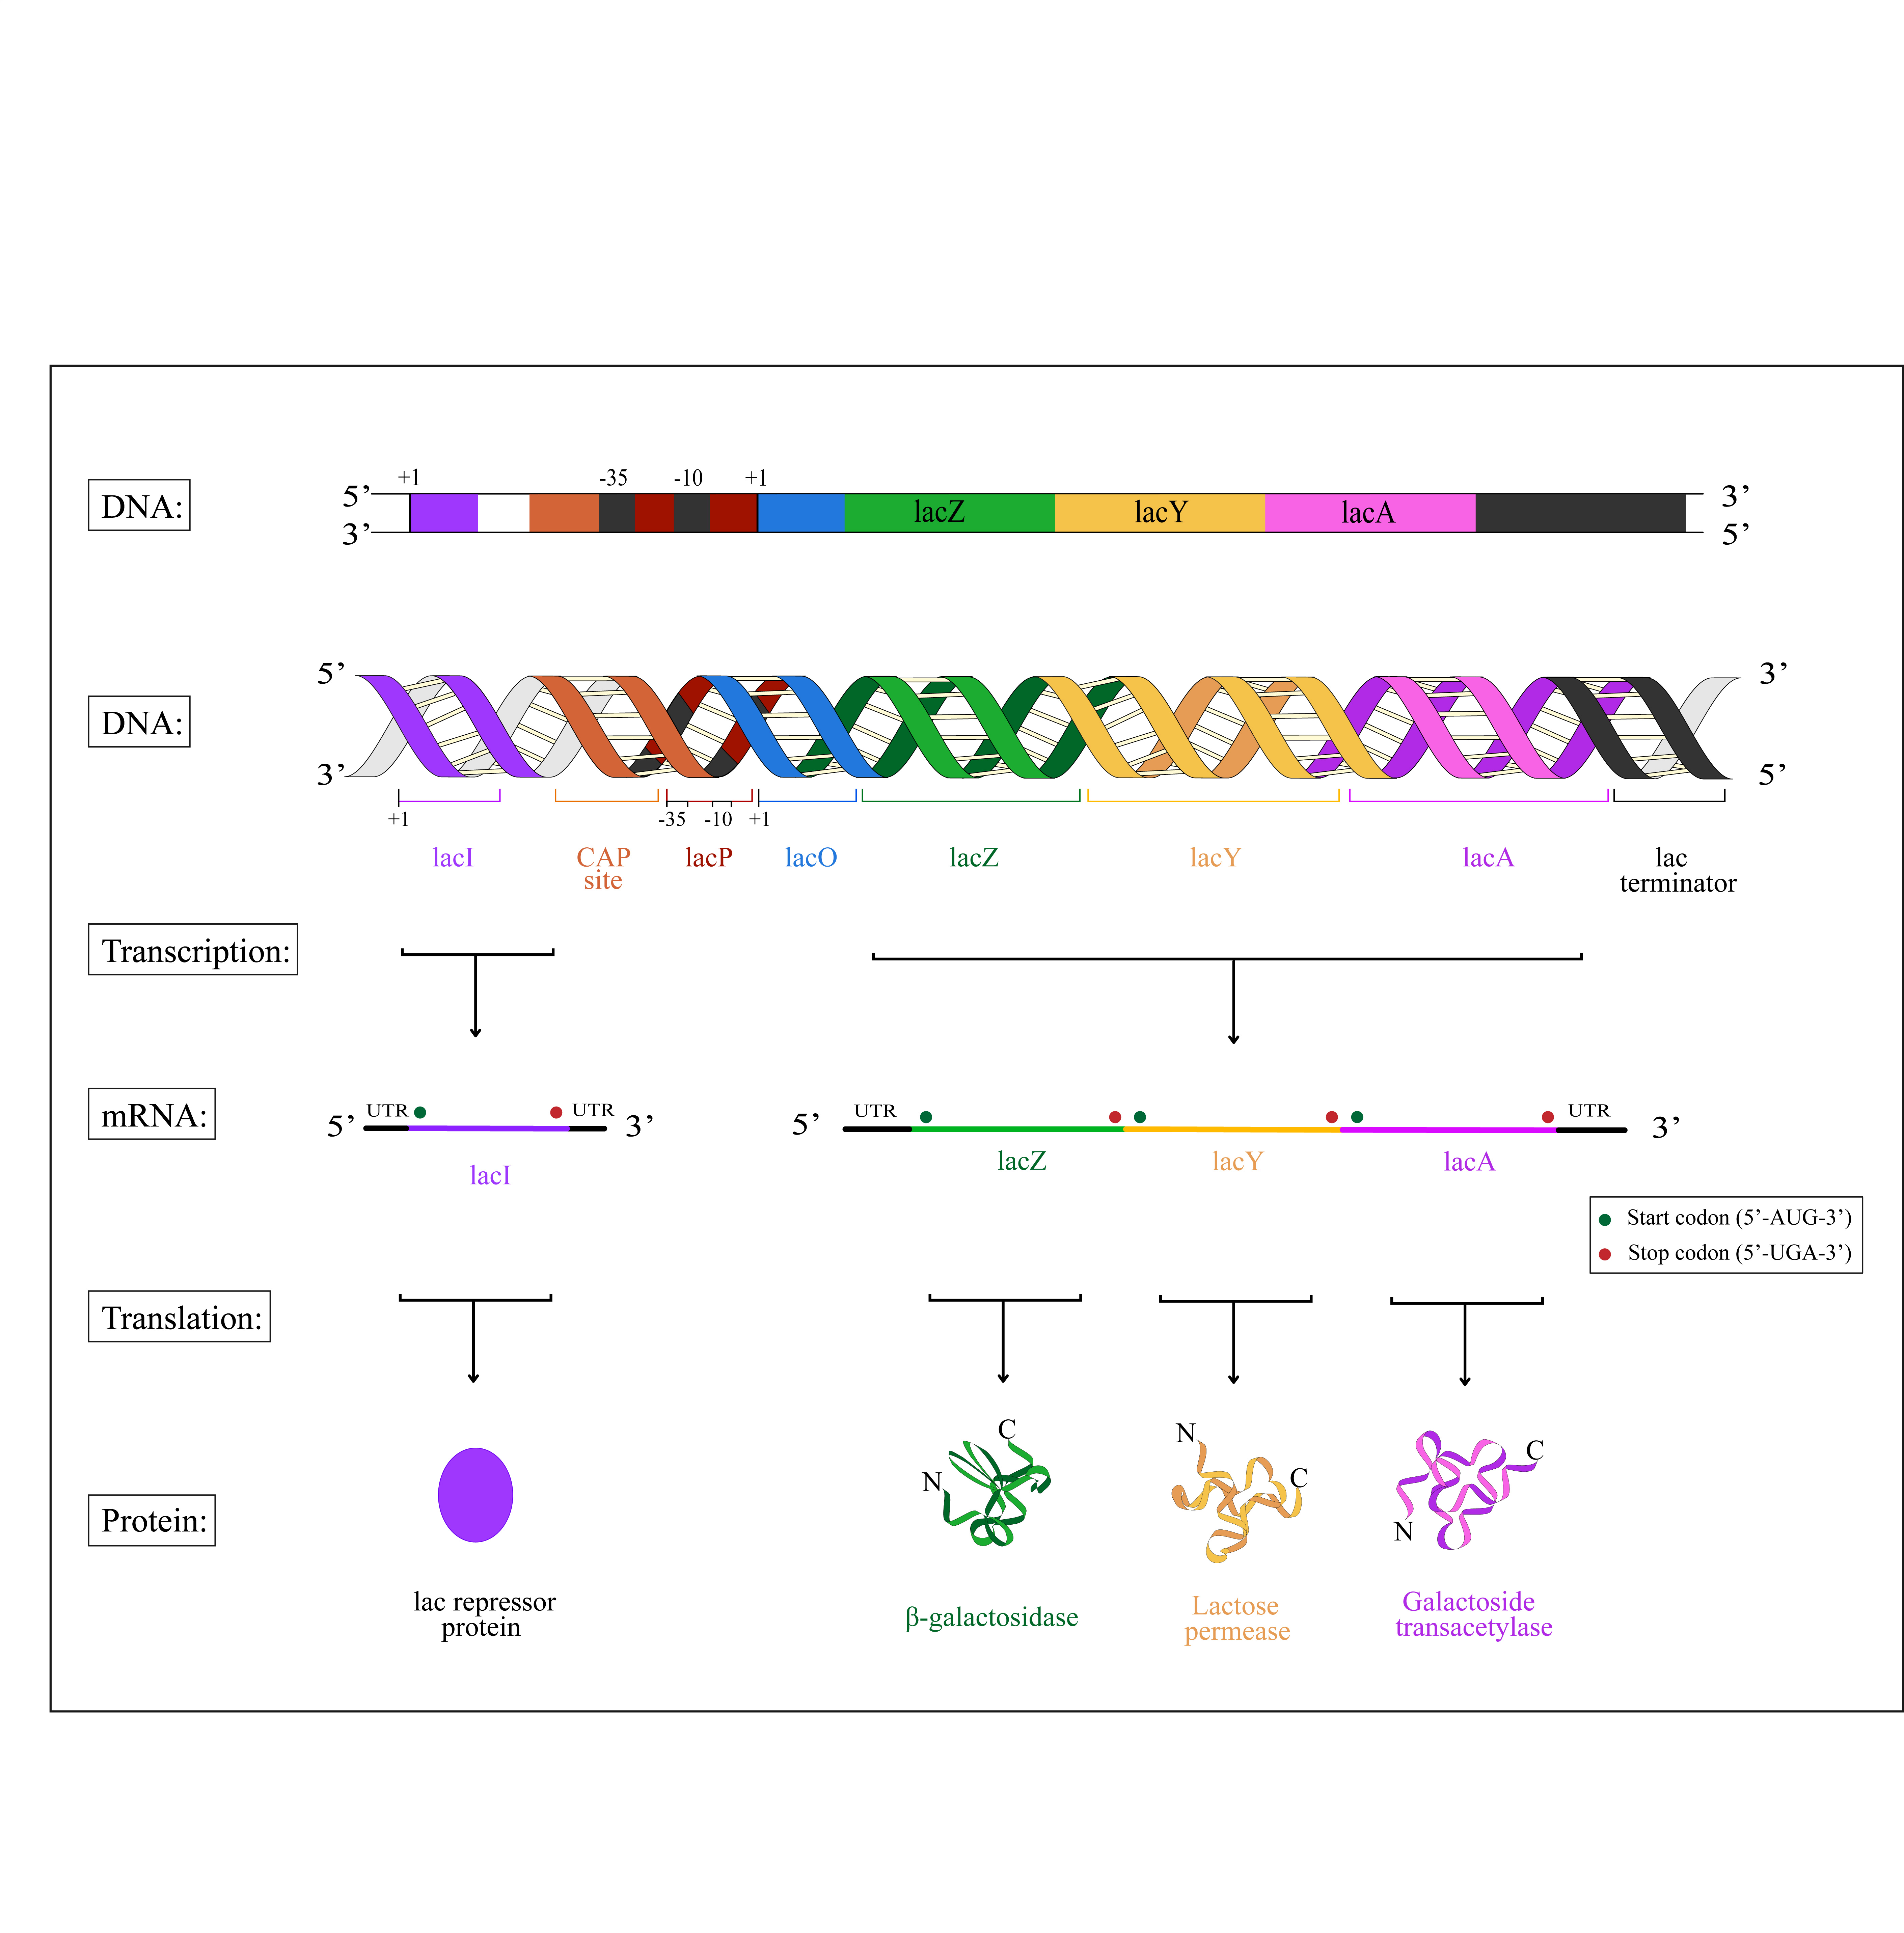

### Key Questions

* What are names and functions of the three structural genes of the lac operon?
* What are the names and functions of the four regulatory DNA sequences within the lac operon?
* What is the function of the lacI gene?

## lac Operon Expression

In the absence of lactose, **repression** of the lac operon occurs as follows (**figure 13.6** and **13.7**):

1. lacI is a constitutive gene, meaning that it is always transcribed. Transcription of the lacI gene produces a lacI mRNA that is then translated to produce the lac repressor protein.
2. The lac repressor protein binds to the operator (lacO) DNA sequence.
3. Sigma (σ) factor and the RNA polymerase core enzyme do not bind efficiently to lacP when the lac repressor is bound to lacO. As a result, the three structural genes (lacZ, lacY, and lacA) of the lac operon are transcribed at an extremely low level, producing only a few copies of the β-galactosidase, lactose permease, and galactoside transacetylase proteins per cell.

When lactose becomes available in the environment, the lac operon is **induced** as follows:

1. The few copies of lactose permease expressed by E. coli move lactose across the cytoplasmic membrane into the cytoplasm of the cell.
2. The few copies of β-galactosidase present convert lactose into **allolactose**.
3. Allolactose binds to the lac repressor protein.
4. The lac repressor protein changes shape.
5. The lac repressor protein is released from the lacO DNA sequence.
6. In the absence of the lac repressor protein, sigma (σ) factor protein and the RNA polymerase core enzyme bind to lacP efficiently.
7. The structural genes of the lac operon (lacZ, lacY, and lacA) are actively transcribed to produce polycistronic mRNAs.  The polycistronic mRNAs are then translated to produce thousands of copies each of the β-galactosidase, lactose permease, and galactoside transacetylase proteins.
8. Lactose is metabolized by the E. coli cell for energy.

Note that when lactose is no longer present in the environment, the lac operon resets.  Allolactose is released from the lac repressor protein, causing the lac repressor to bind once again to lacO.  The excess β-galactosidase, lactose permease, and galactoside transacetylase proteins in the cytoplasm are eventually degraded.

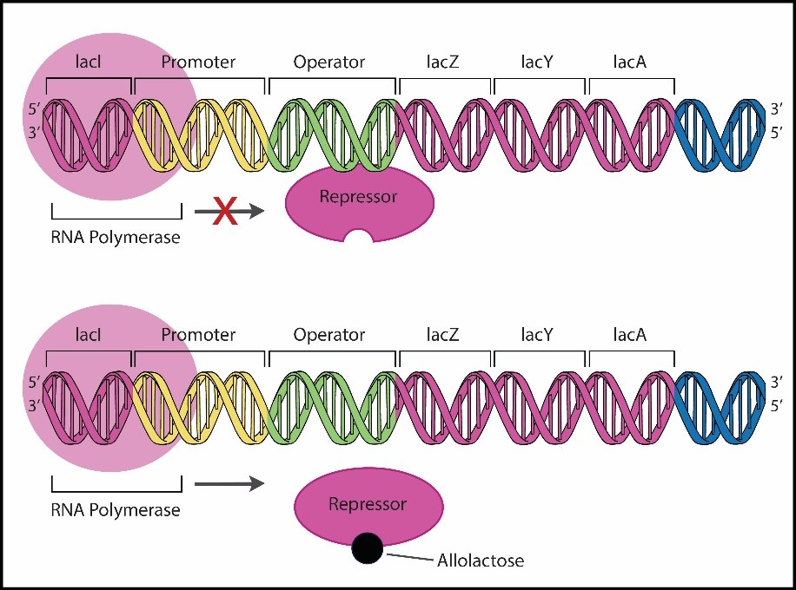

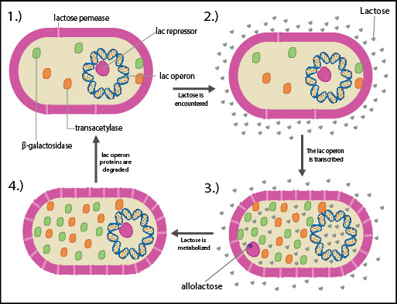

### Key Questions

* Describe the steps involved in inducing the lac operon.

## **The lacI - Strain Displays Constitutive Expression of the lac Operon**

To gain an appreciation of the discovery of the lac operon, let us turn our attention to the experiment that determined the function of the first lac operon gene: lacI, which we now know makes the lac repressor protein.  When François Jacob and Jacques Monod first started studying lactose metabolism, they identified a mutant strain of E. coli that they named lacI -. In this lacI -mutant strain, the enzymes involved in lactose metabolism were always produced, even when lactose was absent from the environment. Thus, the lacI -mutation is a **constitutive mutation** producing constitutive expression of the lac operon.

How could the constitutive phenotype of the lacI - strain be explained? Jacob and Monod reasoned that the lacI-constitutive phenotype could be explained in two ways:

* The lacI - mutation produces a defective activator protein that continually activates transcription, even in the absence of lactose (defective activator protein hypothesis).
* The lacI - mutation produces a defective repressor protein that fails to inhibit transcription, even in the absence of lactose (defective repressor protein hypothesis).

## Mutant and Merozygote Strains of E. coli

To distinguish between the defective activator and defector repressor hypotheses indicated above, Jacob and Monod compared two mutant E. coli strains.  Jacob and Monod studied the lacI- strain, and they studied an unusual strain of E. coli called a **merozygote**, or partial diploid. Recall that bacteria typically have a single circular chromosome; however, bacteria also contain small circular **plasmid** DNA molecules in addition to the chromosome. These plasmids are commonly adapted for use ingene cloning experiments (see Chapter 12) as vectors.  A common type of plasmid is the **F plasmid** that functions in bacterial fertility (i.e., DNA transfer between bacteria). The merozygote strain that Jacob and Monod examined in their experiments contained a modified F plasmid (**F’ plasmid**), which contained a lacI gene and a copy of the lac operon. Thus, E. coli cells that contain an F’ plasmid are merozygotes (partial diploids), containing a copy of lacI and the lac operon genes on both the chromosome and on the F’ plasmid.

The merozygote strain used by Jacob and Monod contained lacI-on the chromosome and a wild-type copy of the gene(lacI +) on the F’ plasmid; this E. coli strain was in essence a lacI +/lacI -heterozygote. The other DNA sequences within the lac operon (lacP, lacO, lacZ, lacY, and lacA) were wild-type and were found on both the chromosome and the F’ plasmid.  Thus, the E. coli merozygote strain was homozygous for lacP, lacO, lacZ, lacY, and lacA.

### Key Questions

* What is a merozygote bacterial cell?
* Why might it be advantageous for an E. coli cell to have two copies of each lac operon gene?

## **The Jacob and Monod Experiment**

The Jacob and Monod experiment compared the lacI - E. coli strain (lac operon is always expressed) to the lacI +/lacI - merozygote E. coli strain. The experiment was done as follows:

      1. The mutant (lacI -) and the merozygote (lacI +/lacI -) strains were grown in separate flasks.

      2. Each bacterial culture was then split into two smaller flasks, a control flask and an experimental flask.  For example:

* + Mutant strain (lacI -)
    - Control (flask 1)
    - Experimental (flask 2)
  + Merozygote strain (lacI +/lacI -)
    - Control (flask 3)
    - Experimental (flask 4)

     3.  Lactose was added to the experimental reactions (flasks 2 and 4).

     4. The bacterial cultures were incubated to allow transcription of the lac operon and translation of the β-galactosidase, lactose permease, and galactoside transacetylase proteins.

     5. The bacterial cells in each flask were then lysed to release the β- galactosidase, lactose permease, and galactoside transacetylase proteins.

     6. The β-galactosidase levels in each of the four bacterial cell lysates were measured. β-galactosidase converts the chemical β-O-nitrophenylgalactoside (β-ONPG), which is colorless, into galactose and O-nitrophenol, which is yellow. Note that if a yellow product is formed, β-galactosidase is present, meaning the lac operon was transcribed.

     7. The O-nitrophenol (yellow product) levels in each lysate were measured using a spectrophotometer.

### Key Questions

* Explain the purpose of flasks 1–4 in the Jacob and Monod experiment.
* Explain what is occurring when a reaction turns yellow.

## **lacI + Produces a Repressor Protein**

When Jacob and Monod did their experiments, yellow color was observed in flasks 1 and 2. Thus, in the lacI - strain, β-galactosidase is produced in the absence and in the presence of lactose (i.e., expressed constitutively). In the merozygote strain, no yellow color was produced in the absence of lactose (flask 3); however, two times the yellow product was produced in the presence of lactose (flask 4). This means that β-galactosidase is not produced when lactose is absent because the lacI + gene on the F’ plasmid produces a protein (i.e., the lac repressor protein) that binds to both the chromosomal and F’ plasmid copies of lacO in the cell, and thus inhibits expression of both genes that make β-galactosidase. This lac repressor protein diffuses throughout the cytoplasm of the cell and binds to any lacO sequence. Because the lac repressor can bind to any lacO sequence in the cell, the lac repressor is said to be an example of a **trans-acting factor**.

When lactose is added to the flask containing the merozygote E. coli strain, lactose is converted to allolactose, and allolactose releases the lac repressor proteins from both copies of lacO. The lac operons on both the chromosome and on the F’ plasmid are now expressed (flask 4). The expression of two copies of the lacZ gene produces two times as much β-galactosidase protein, leading to the production of two times the yellow color in flask 4.

This experimental result provided supporting evidence for the defective repressor hypothesis. It is worth noting that in the case of the defective activator hypothesis, the lac operon would have been expressed by the merozygote strain in both the absence (flask 3) and in the presence of lactose (flask 4).  Thus, both flasks 3 and 4 should have produced two times the yellow color at the conclusion of the experiment.

### Key Questions

* Explain how the flask 3 result showed that the lac repressor protein is an example of a trans-acting factor.

## **Glucose and the lac Operon**

The transcription of the lac operon is also regulated by glucose. Glucose is the preferred carbon and energy source used by E. coli, so the genes involved in glucose breakdown (**catabolism of glucose**) are expressed constitutively (always transcribed). Thus, in the presence of glucose, the lac operon is not needed, so transcription of the lac operon is turned off (so-called **catabolite repression** of the lac operon). When glucose levels decrease and lactose is present, this catabolite repression is alleviated, and the lac operon is transcribed. Lactose is then used by the E. coli cell as the next carbon and energy source.  The sequential use of sugars—first glucose, followed by lactose—is called **diauxic growth** (**figure 13.8**).

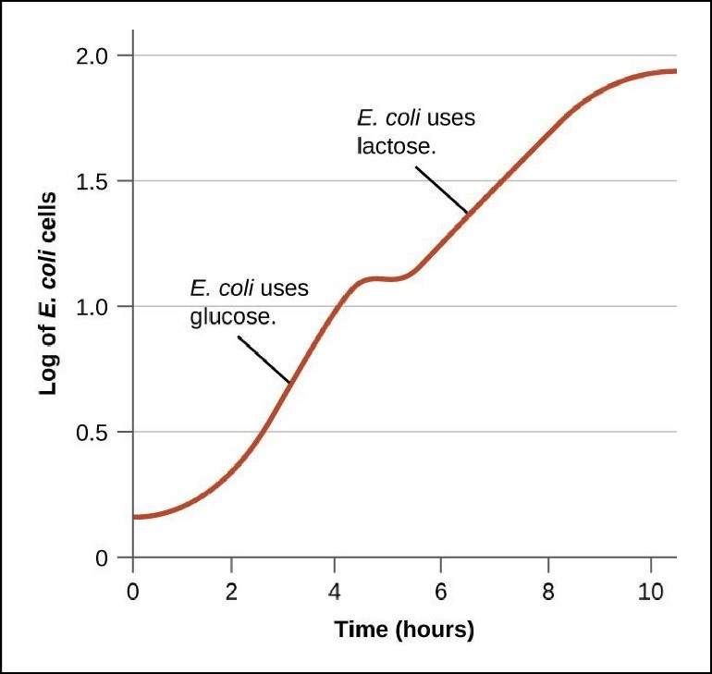

How is the lac operon repressed or turned off by glucose? Glucose repression of the lac operon involves a(n):

* **Regulatory transcription factor protein**. The regulatory transcription factor protein that is responsive to glucose levels is the **catabolite activator protein (CAP).**The CAP protein binds to the CAP binding site in the lac operon, which is located immediately upstream of the lac operon promoter (lacP).
* **Effector molecule**. It would be reasonable to assume that glucose is the effector molecule involved in catabolite repression, however; the effector involved in glucose regulation is actually **cyclic AMP (cAMP)** (**figure 13.9**).cAMP is produced from ATP by the bacterial enzyme **adenylyl cyclase**. When glucose is present in the environment, adenylyl cyclase activity is inhibited, and cellular cAMP levels are low. When glucose levels in the environment are low, adenylyl cyclase activity increases, resulting in higher levels of cAMP in the cell.

When the CAP protein binds to cAMP (i.e., in an environment with low glucose) the CAP protein changes shape and then binds to the CAP site in the DNA.  As a result, lac operon transcription is activated. In fact, for sigma (σ) factor and the RNA polymerase core enzyme to bind efficiently to the lac promoter and transcribe the lac operon, CAP must be bound to the CAP site.

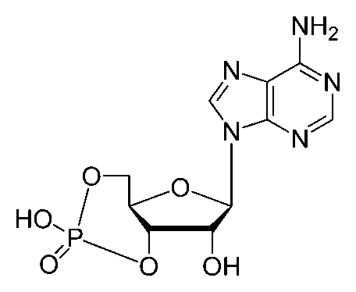

### Key Questions

* Describe how the lac operon responds when glucose levels are high or low (assuming that lactose is present).
* What is the function of adenylyl cyclase?
* Explain the relationship between cAMP levels and CAP function.
* Describe the relationship between CAP binding to the CAP site and the transcription of the lac operon.

## **Regulation of the lac Operon by the lac Repressor and CAP**

The interaction between a positive regulatory signal (CAP) and a negative regulatory signal (the lac repressor protein) makes transcriptional regulation of the lac operon complex. What happens to lac operon expression when an E. coli cell encounters the following four environmental conditions (**figure 13.10**)?

* **No glucose or lactose is found in the environment.** In this environment, cAMP levels are high, and the cAMP is bound to the CAP protein. The cAMP: CAP complex binds to the CAP site on the DNA and tries to promote transcription. However, in the absence of lactose, there is no allolactose, so the lac repressor is bound to the lacO DNA sequence, preventing transcription.**In this environment, the lac operon is not transcribed efficiently.**
* **Glucose is present in the environment; however, there is no lactose.**In this case, cAMP levels are low. At low cAMP levels, the CAP protein does not bind efficiently to the CAP site on the DNA. The absence of bound CAP protein inhibits transcription. Since there is no lactose, there is no allolactose, so the lac repressor is bound to the lacO DNA sequence. The **lac repressor bound to the lacO DNA sequence also inhibits transcription.  In this environment, the lac operon is not transcribed efficiently.**
* **Glucose and lactose are present in the environment.**In the presence of glucose, cAMP levels are low. Thus, cAMP is not bound to the CAP protein, and CAP does not bind to the CAP site on the DNA. The absence of bound CAP protein is a negative signal that inhibits transcription. In the presence of lactose, allolactose binds to the lac repressor, releasing it from the lacO DNA sequence. The release of the lac repressor tends to promote transcription.  **In this environment, the inability of the CAP protein to bind to the CAP site results in inefficient lac operon transcription**.
* **Glucose is absent but lactose is present in the environment.**In this case, cAMP levels are high. cAMP binding to CAP protein changes the conformation of CAP, allowing the CAP protein to bind to the CAP site on the DNA. This serves as a positive signal that tends to promote transcription. When lactose is present, allolactose is present. The lac repressor protein binds to allolactose and therefore is released from the lacO DNA sequence.  The release of the lac repressor protein from lacO also promotes transcription.  **In this environment, the lac operon is transcribed.**

**In summary, there is only one situation in which the lac operon is transcribed efficiently: glucose must be absent from the environment, and lactose must be present.**

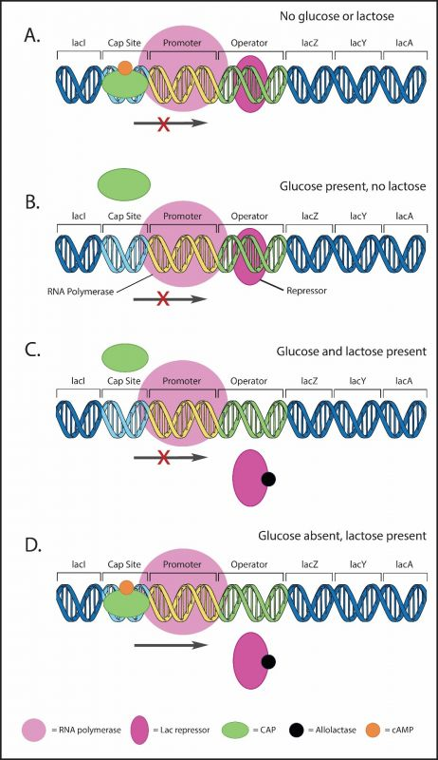

### Key Questions

* Why is the lac operon **off** if neither glucose nor lactose are present in the cell?
* Why is the lac operon **off** if glucose is present and lactose is absent in the cell?
* Why is the lac operon **off** if both glucose and lactose are present in the cell?
* Why is the lac operon **on** if glucose is absent and lactose is present in the cell?

## **Other Gene Regulation Mechanisms in Bacteria**

The lac operon is an example of how transcription regulation controls gene expression. There are other ways to control gene expression in bacteria, including attenuating transcription, regulating translation, and regulating the protein product produced by translation (**posttranslational regulation**).

* **Regulation of transcription**.
  + **Regulating transcription initiation**. Controlling how often transcription starts involves regulating sigma (σ) factor binding to the promoter. Regulatory transcription factors (activator and repressor proteins) promote or inhibit sigma (σ) factor binding. The lac operon is an example of this type of gene regulation.
  + **Attenuation of transcription**. Attenuation involves activating transcription to begin producing a mRNA molecule; however, transcription is terminated prematurely before the entire mRNA is made.  Many bacterial operons are regulated by attenuation, including the tryptophan (trp) operon.
* **Regulation of translation**.
  + **Translation repressor proteins.**Translation repressor proteins prevent the initiation of translation. These translation repressor proteins bind to the Shine-Dalgarno sequence on the mRNA, preventing the 16S rRNA component of the ribosome from binding to the mRNA.
  + **Antisense RNA.**Antisense RNA molecules are produced by E. coli cells to form hydrogen bonds with the Shine-Dalgarno sequence of a particular mRNA, preventing the 16S rRNA component of the ribosome from binding to the mRNA. Antisense RNA molecules are examples of **noncoding RNAs (ncRNAs)**.
* **Posttranslational regulation**.
  + **Feedback inhibition**. Feedback inhibition is a situation in which the chemical product of a metabolic pathway binds to and inhibits the enzymes that made the chemical product in the first place.
  + **Covalent modification**. Covalent modification involves altering the structure and function of a protein by attaching phosphate groups, methyl groups, sugars, or lipids.

### Key Questions

* What is an advantage of transcriptional regulation?
* What is an advantage of posttranslational regulation?

## **Review Questions**

**Fill in the blank:**

1. An _________________ protein is a type of regulatory transcription factor that increases transcription.
2. _________________ molecules are organic compounds that regulate the functions of repressor and activator proteins.
3. ___________________________ is the enzyme that catalyzes the cleavage of the disaccharide lactose into two simple sugars.
4. Identify each of the following genes of the lac operon:

* The ___________ gene encodes the lac repressor.
* The ___________ gene encodes lactose permease.
* The ___________ gene produces an enzyme that converts atypical isomers of lactose into forms that can be used in the bacteria cell.

1. The DNA binding site for the lac repressor protein is called _______________________.
2. The two inducers of the lac operon are ________________ and ________________.
3. A merozygote contains two copies of a gene; one gene is located on the ______________ while the other gene is located on the ________________.
4. _____________________ is an enzyme that is inhibited by glucose.
5. Lactose and glucose regulate expression of the lactose operon. The highest expression of the lac operon occurs when ________________ is absent and __________________ is present.

Read this online at <https://books.byui.edu/genetics_and_molecul/24___the_lac_operati>