# Neurotransmitters of the ANS

Neurotransmitters are chemicals that travel across the synapse connecting two neurons, or between a neuron and an effector. For example, **acetylcholine (ACH)** is an important neurotransmitter that we will discuss in this section and again when we discover that it is the neurotransmitter between neurons and skeletal muscle. Sometimes neurons can be classified by the type of neurotransmitter they release. **Cholinergic neurons** produce ACH and store ACH in their synaptic terminals. The preganglionic neuron for both the parasympathetic and sympathetic nervous systems is cholinergic. The postganglionic neuron of the parasympathetic division is also cholinergic. The postganglionic neuron for the sympathetic division is usually an **adrenergic neuron** which means that it produces neurotransmitter molecules that are related to "adrenaline". As a group, the molecules that can stimulate adrenergic receptors are called catecholamines. Catecholamines are an organic chemistry group that includes **norepinephrine (NE)**, **epinephrine (EPI) and dopamine**. In the Sympathetic nervous system, NE is the neurotransmitter found at the synapse between postganglionic neurons and the organ. There is one exception to this rule that we should know and remember. Sympathetic postganglionic neurons innervating general sweat glands and some reproductive system blood vessels are cholinergic and release ACH.

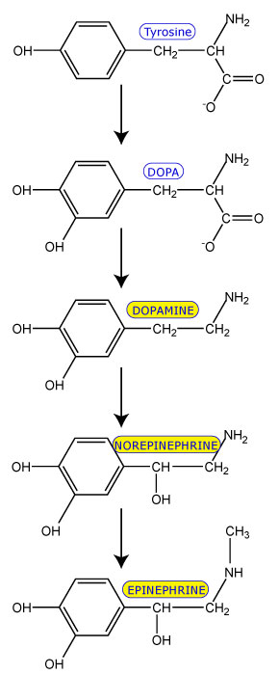

Image by JS S22

The image above shows how catecholamines are produced. The synthesis starts with the amino acid called Tyrosine. Adding a hydroxyl group to the aromatic ring creates DOPA. A carboxyl group is then removed from DOPA to yield dopamine. Once dopamine is created we have the first of the "catecholamines" used by the body to bind adrenergic receptors (shown in yellow in the picture). Dopamine is converted to Norepinephrine by the addition of a hydroxyl group to the side chain and finally Epinephrine is generated when a methyl group is added. The catecholamines are similar to each other and can all bind the several subtypes of adrenergic receptors. However, there are enough small molecular difference among the catecholamines to cause subtle differences in half-life and binding affinity. Dopamine is generally found as a neurotransmitter between neurons in the central nervous system. Dopamine can attach to adrenergic receptors called "D" receptors such as D1 and D2. It is important to note that as a catecholamine, dopamine can attach to all the adrenergic receptors, though it will have different affinities. Dopamine will attach to D1 and D2 receptors with much greater affinity than the other catecholamines. Dopamine is a frequent drug of choice to give individuals with low blood pressure as it can act as a cardiac and vasostimulant and because the kidney has dopmaine receptors that when stimulated can result in an increase of kidney blood flow.

Norepinephrine (NE) is a neurotransmitter that is produced between neurons of the central nervous system as well. However, NE is also important as a neurotransmitter released from sympathetic post ganglionic neurons and the adrenergic receptors of an effector (smooth muscle, cardiac muscle and gland). Norepinephrine has a strong affinity for alpha 1 receptors.

Epinephrine is generally produced in the adrenal medulla and secreted into the blood where it can travel through the body and affect a large breadth of adrenergic receptors. Epinephrine has a strong affinity for Beta 2 receptors.

### Clinical Pearl (L-DOPA)

Patients with Parkinson's Disease have a deficiency of dopamine secreting neurons that arise from an area of the brain called the substantia nigra. As the symptoms of this disease begin to manifest, patients can often find relief from medication that increases dopamine levels in the brain. A molecule called L-DOPA (the L references an isomer of dopa that is preferred by the human body) can be given orally to patients. L-DOPA can cross the blood brain barrier where it can be converted to dopamine.

While this drug can certainly increase dopamine in the brain and relieve symptoms of early Parkinson's disease, there is an unfortuante side effect. As L-DOPA travels through the blood on its way to the brain, it can meet up with an enzyme called aromatic L-amino acid decarboxylase that is expressed in many tissues of the body. This enzyme will remove a carboxyl group from the L-DOPA molecule and produces dopamine. The dopamine then becomes free to float through the circulation and bind to adrenergic receptors (similar to what epinephrine does). Therefore, you might imagine that the side effects of taking L-DOPA would involve similar effects to having an overdose of adrenaline. Among other things, blood pressure rises substantially and can be dangerous.

Clever scientists, in an effort to mitigate the side effects of taking L-DOPA for Parkinson's disease, discovered a drug called Carbidopa that functions as an L-DOPA decarboxylase inhibitor. However, this inhibitor cannot cross the blood brain barrier. Thus, if a patient takes L-DOPA simultaneously with Carbidopa, then the L-DOPA will not be converted as readily to dopamine, and instead finds its way to the brain.

Modern drug regiments involve a simultaneous consumption of both drugs.

Read this online at <https://books.byui.edu/bio_461_principles_o/156___neurotransmitt>