# Homeostatic Control Systems

In order to explain how homeostasis works, let's revisit changes that occur to maintain body temperature. How does the body know when to shiver or sweat? The body first needs to detect a temperature change. In the body, this function is attributed to a **receptor**, which is a type of sensor that monitors the environment and detects changes in variables. When conditions cause a change in a variable, we call those conditions **stimuli**. Once a receptor detects a change, it then communicates this change to a **control center**. Control centers are located throughout the body, often in the brain, and are responsible for determining the set point and the appropriate course of action to correct deviations from the set point. Control centers dictate a course of action by communicating with **effectors**. An effector provides the means to correct the deviation. In terms of temperature regulation, the control center is located in the hypothalamus, a small region in the brain, and the effectors would include skeletal muscles (shivering), sweat glands (sweating), and blood vessels (constriction and dilation). It is also interesting that the human body can change a set point for a particular variable. This change is generally temporary and beneficial. For example, the set point for body temperature can change to a higher value in response to infections, called a fever. This increase in temperature aids the immune system in eliminating the pathogen. Consider this critical thinking question: does the set point change observed during a fever represent a negative or positive feedback response? The answer is negative, but why?

An essential component of homeostasis is communication. Communication in the body occurs primarily through two systems: the nervous system and the endocrine system. Regardless of the system used, if communication flows toward the control center from the receptor, it is termed an **afferent** pathway. If information flows from the control center to the effector, it is termed an **efferent** pathway. Collectively, the receptor, afferent pathway, control center, efferent pathway, and effector comprise a **homeostatic control system**. Essentially, all organs and tissues of the body are part of homeostatic control systems and perform functions that help maintain the body's internal environment.

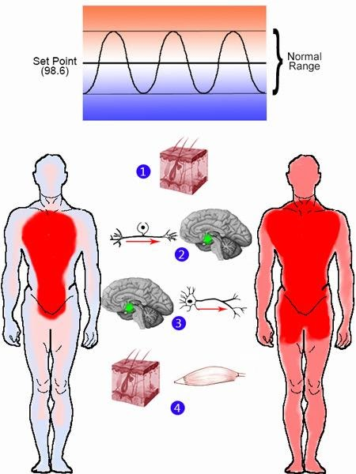

**Body Temperature Control by Homeostatic Control System.**Image modified from public domain images of brain and skin. Other elements freehand by JS at BYU-I 2013.

**Homeostatic Control System Steps: Body Temperature**

**\*The numbers below explain the numbers in the picture above**

**1.** Receptors in the skin and the brain can sense temperature.

**2.** Information about the temperature travels through afferent neurons to the control center. The control center in this story is the hypothalamus (green dot in the brain picture above).

**3.** The hypothalamus assesses where the temperature is in relationship to set point (98.6°F). The hypothalamus then sends a signal through efferent neurons to the skin and the muscle tissues.

**4.** The skin and the muscle tissues are effectors. If the control center determines that the temperature of the body is above the set point, then blood vessels in the skin dilate to divert some of the blood closer to the surface of the body, thus releasing heat in sweat and cooling down the body. Sweat glands can draw water from the blood, trapping heat and releasing it as the sweat (water) is evaporated at the surface of the skin. If the control center determines that the temperature of the body is below the set point, then the blood vessels of the skin constrict to decrease the amount of blood moving to the skin, so the warmer blood instead moves toward the core of the body. Also, sweat glands cease producing sweat. Muscles are another effector that can shiver when it is cold to produce heat in the body.

Read this online at <https://books.byui.edu/bio_264_anatomy_phy_I/122___homeostatic_co>