Peptide Bonds and Polypeptides
As mentioned in the introduction, proteins are polymers of amino acids. Like all of the polymers we have discussed so far, amino acids are linked together via dehydration (condensation) synthesis reactions. The bond that is formed between the amino acids is called a peptide bond. The figure below shows how these bonds are formed. In this simple example, we would call the resultant polymer a dipeptide. Small peptides are designated tripeptides, tetrapeptides, pentapeptides, etc. The generic term polypeptide is used to designate many amino acids linked together. The terms polypeptide and protein are often used interchangeably. A polypeptide chain has at its beginning an unbound amino group and is given the name amino- or N-terminus, while the other end of the chain is called carboxyl- or C-Terminus.
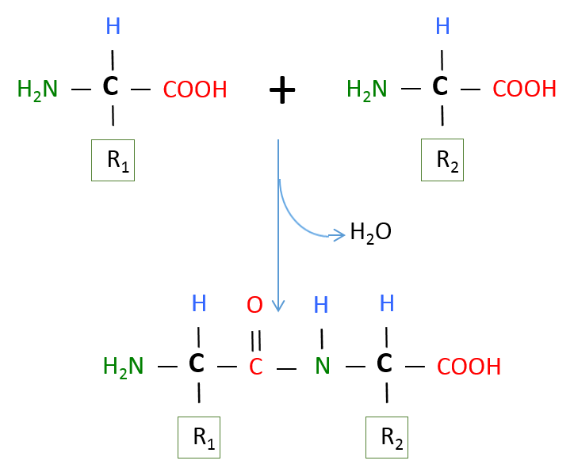
Peptide Bond formed through Dehydration Synthesis of Amino Acids.
Image created by MG BYU-I; 2013.

The image above represents a dehydration synthesis reaction between two amino acids to form a peptide bond. Peptide bonds form between the carboxyl group of one amino acid and the amine group of another.
As mentioned above, almost all living things contain proteins made from 20 amino acids. Our liver is a pretty effective amino acid factory and can synthesize 11 of these 20 amino acids even if we don't consume them in our diet. However, nine amino acids are essential amino acids. If we don't consume these essential amino acids in our food, our bodies won't have the necessary supplies available when new proteins need to be produced. These essential amino acids are histidine, isoleucine, leucine, lysine, methionine, phenylalanine, threonine, tryptophan, and valine.

To review, think of amino acids as Lego blocks. If you were given 20 packages of these blocks, each package containing a different color, you could start producing Lego proteins. Just think of the possible combinations of your Legos. The possibilities are essentially limitless. Some of your proteins may contain only a few Legos, while others may contain thousands, each with a different shape and color combination. This is the potential that our cells have at their fingertips to produce the molecules to carry out the many functions of proteins.
Read this online at https://books.byui.edu/bio_264_anatomy_phy_I/332___peptide_bonds_

