# Disaccharides

Disaccharides (Di = two, saccharide = sugar) are formed when two monosaccharide molecules are joined together. This link occurs between -OH functional groups called hydroxyl groups, as shown in the figure below. These groups are joined together by the removal of water. Because a molecule of water is generated, this reaction is called a dehydration synthesis reaction. This is a common type of synthesis reaction that we will see again when we learn about the formation of lipids and proteins.

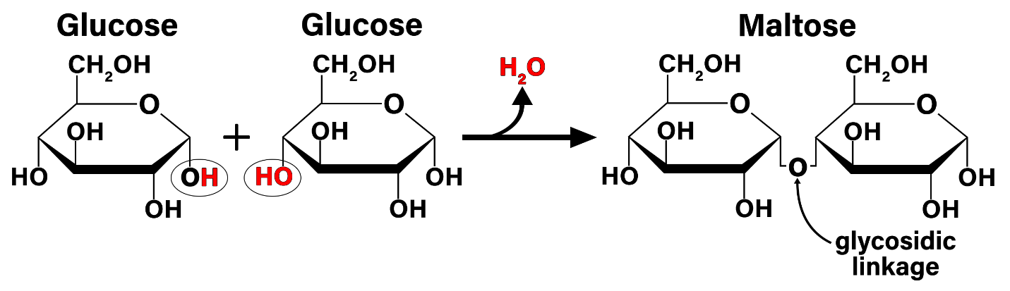

Dehydration Synthesis Reaction Showing the Formation of Maltose.

Image by BYU-Idaho professor Spring 2021

The image above shows a dehydration synthesis reaction. The reactive hydroxyl groups (-OH) are circled. The hydrogens and oxygen that will be removed to form water are colored red. The resulting linkage is called a glycosidic linkage.

There are three important disaccharides that we will discuss: sucrose, lactose, and maltose. In all three of these disaccharides, glucose is one of the monosaccharides that make them up. The figure below shows the structure of these disaccharides, and the table below outlines their characteristics.

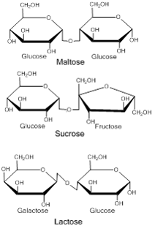

Disaccharide Structure: Image created by MG, 2013

The image above shows the structures of the three common dietary disaccharides. All contain glucose as one of their subunits. The difference between the three is the second subunit.

Table: Characteristics of three common disaccharides.

|  |  |  |
| --- | --- | --- |
| Name | Combined Monosaccharides | Nutritional Information |
| Sucrose | Glucose + Fructose | The most common dietary disaccharide. Naturally found in beets, cane sugar, brown sugar, maple syrup, and honey. You know it as table sugar. |
| Lactose | Glucose + Galactose | Found in dairy products. This is the least sweet of the disaccharides. |
| Maltose | Glucose + Glucose | Found in foods including breakfast cereals, germinating seeds, and beer. |

Only monosaccharides can be absorbed from the digestive tract into the blood. Therefore, in order to enter the body, disaccharides must first be broken down (or digested) into their monosaccharide subunits. In the small intestine, there are specific enzymes for each of these disaccharides: sucrase to digest sucrose, lactase to digest lactose, and maltase to digest maltose. The reaction for digestion is essentially the reverse of the dehydration synthesis reaction (i.e. water is added back into the bond to break it). This type of reaction is called a hydrolysis reaction. Because disaccharides are easily digested and quickly absorbed into the blood, they, along with the monosaccharides, are often referred to as the simple sugars.

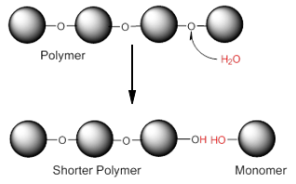

Hydrolysis Reaction. Image created by BYU-I Student Hannah Crowder, 2013

The image above shows a hydrolysis reaction. Bonds between the monomers in a polymer can be broken by the enzymatic addition of water to the bonds. Monomers can be defined as a single molecule that can bind to other molecules to form a polymer.

What if one of the enzymes that hydrolyze disaccharides is missing? This is actually the case for a vast majority of mammals, including humans. Because most mammals do not consume milk once they are adults, they no longer need the enzyme lactase to digest lactose. Because of this, the body stops making the enzyme. However, if lactose is not broken down into its monosaccharide subunits, it cannot be absorbed and instead passes into the large intestine. The bacteria that live in the large intestine love lactose and start eating it. Unfortunately, when they eat a lot of lactose, they produce a lot of gas. Also, the lactose pulls water into the large intestine by osmosis. Symptoms of lactose intolerance include abdominal bloating, diarrhea, abdominal cramps, flatulence (gas), and nausea. The symptoms are due to undigested lactose moving into the large intestine. Worldwide, about 75% of the adult population experiences some degree of lactose intolerance. However, the incidence differs greatly from country to country (see figure below). Typically, northern Europeans and their descendants have the lowest incidence, mainly due to the fact that in their culture, cattle and goats were domesticated long ago, and the milk products from these animals are an important source of nutrition.

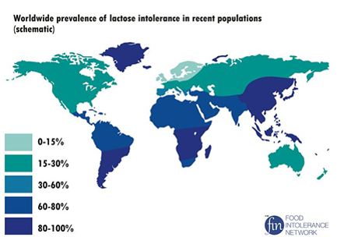

Worldwide Incidence of Lactose Intolerance. Image downloaded from Wikimedia Commons Dec 2013: Author: NmiPortal; Site: https://commons.wikimedia.org/wiki/File:Worldwide_prevalence_of_lactose_intolerance_in_recent_populations.jpg; License: Creative Commons Attribution-Share Alike 3.0 Unported

Read this online at <https://books.byui.edu/bio_264_anatomy_phy_I/disaccharides>