# Oligosaccharides

Oligosaccharides differ from polysaccharides primarily in their function. Oligosaccharides range in length from a few monosaccharides up to 100 or more. In humans, most oligosaccharides are between 5-30 monosaccharides in length. These sugars can be linear or branched and are made of a diverse pool of monosaccharides. The diversity in shape and composition facilitate their primary role as cell signaling molecules. Attached to the outer cell membrane, oligosaccharides aid in cell identification and function. A familiar example is blood type. A, B, and O blood types are all designated by a type of oligosaccharide found on the surface of red blood cells (see image below).

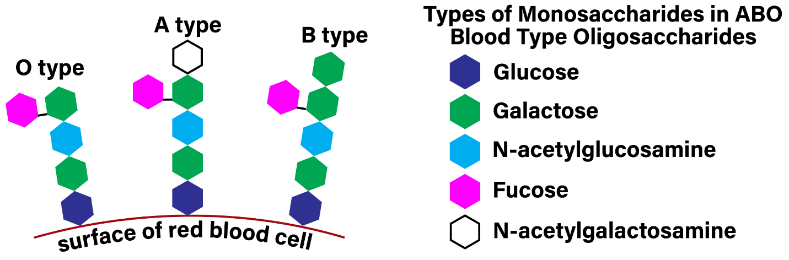

**ABO blood types are identifiable by different oligosaccharides on the surface of red blood cells.**

Image by BYU-Idaho professor Spring 2021

This image shows the different oligosaccharides expressed on the surface of red blood cells that contribute to blood type. These oligosaccharides are branched and are made of 5 different monosaccharides.

In summary, the Dietary Carbohydrate Concept Map shown below ties together the major relationship between and most common examples of monosaccharides, disaccharides and polysaccharides.



**Carbohydrate Concept Map:**

Image created by BYU-I student Hannah Crowder, 2013

#### Health Note

It is safe to say that carbohydrates are an important part of a healthy diet. Although, some carbohydrates are better than others. When we consume simple sugars, they are quickly absorbed, and blood sugar levels rise rapidly. This, in turn, results in secretion of large amounts of insulin, followed by a rapid drop in blood sugar. This is probably not ideal. Indeed, a recent study1 reported that consuming just one sugary soft drink per day increased the risk of developing coronary heart disease by 20% in men. Consumption of sugar-laden soft drinks has also been shown to increase the incidence of obesity, which increases the risk of type 2 diabetes. Complex carbohydrates found in whole grains, on the other hand, tend to offer positive health benefits.

One current topic of intense interest is the question of high-fructose corn syrup. High-fructose corn syrup is produced from corn starch, which is a polymer of glucose. The starch is hydrolyzed to separate the glucose monomers and then chemically treated to convert some of the glucose to fructose. Most high-fructose corn syrup is 55% fructose and 45% glucose. Fructose is handled by the body differently than glucose. Whereas glucose can enter nearly all cells of the body (some cells need a little help from insulin to take up glucose), fructose is metabolized almost exclusively by the liver. There seems to be mounting evidence that high amounts of fructose may act as a molecular fat switch. As an example, consider a bear who eats lots of berries in the Fall in order to store fat for the impending Winter hibernation. In a recent study, an experiment was done with rats to compare high-fructose corn syrup with sucrose. Rats consuming high-fructose corn syrup had greater weight gain, increased amounts of visceral fat (the fat around our abdominal organs), and an increase in the levels of circulating triglycerides2 (triglycerides are the main component of the fat in our adipose cells). Although there are those that still argue that high-fructose corn syrup is no worse for you than sucrose, the growing body of evidence seems to suggest differently. Therefore, next time you sit down with a nice, cold glass of Sprite, think about what you might be doing to your body.

References

1. Koning, L. de, et al. Sweetened Beverage Consumption, Incident of Coronary Heart Disease and Biomarkers of Risk in Men. Circulation (online). Mar 12, 2012

3. Bocarsly, M.E. et al. High Fructose Corn Syrup Causes Characteristics of Obesity in Rats: Increased Body Weight, Body Fat, and Triglyceride Levels. Pharmacology, Biochemistry, and Behavior. 97:101-106-2012

Read this online at <https://books.byui.edu/bio_264_anatomy_phy_I/oligosaccharides>