# Triglycerides

Triglycerides (also called triacylglycerol) constitute the major form of fat stored in plants and animals. Over 90% of our dietary fat exists as triglycerides, and over 90% of the fat in a human body resides as triglycerides in adipose tissue below our skin. It is this stored fat that helps cushion and insulate the body. It is also this stored fat that can become excessive and contribute to the many problems of obesity.

Triglycerides are composed of two molecular building blocks: glycerol and fatty acids. Glycerol is a 3-carbon sugar alcohol. A triglyceride is formed by attaching a fatty acid to the hydroxyl group (-OH) of each of these 3 carbons of glycerol through a process called esterification. This reaction is a dehydration synthesis reaction (water is removed) and the resulting bond is called an ester linkage (see figure below).

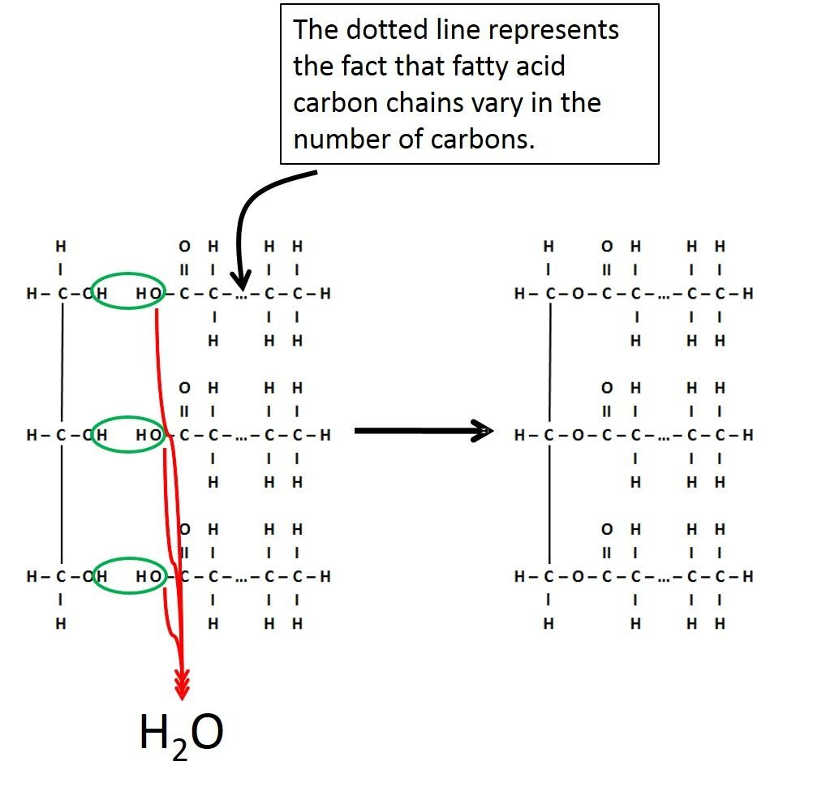

**Bonding of Three Glycerol and Fatty Acids by Dehydration Synthesis Reaction to Form Triglyceride.**

Image created by JS at BYU-Idaho 2014

To understand the properties of a triglyceride, you must first understand the properties of fatty acids. Fatty acids are hydrocarbon chains with a carboxyl group (-COOH) at one end. The hydrocarbon chain consists of carbon-carbon and carbon-hydrogen bonds, which are non-polar covalent bonds and therefore hydrophobic. The carboxyl group at the beginning of the hydrocarbon chain is considered a weak acid because it can donate a proton at physiologic pH. Hence the name “fatty acid”.

Fatty acid chains can vary in length, as well as the number and type of carbon-carbon double bonds contained within the hydrocarbon chain. Fatty acid chains with no carbon-carbon double bonds are referred to as saturated. This means that every carbon-carbon bond in the chain is a single bond, which allows two hydrogen atoms to link to every carbon in the chain, except for the last carbon which is bonded to three hydrogen atoms. However, if a double bond occurs between two carbons in the hydrocarbon chain, then the carbon atoms connected by a double bond will each bond with one less hydrogen atom in order to maintain four bonds per carbon atom. As such, the hydrocarbon chain is no longer "saturated" with hydrogen atoms at every carbon. Therefore, an unsaturated fatty acid will contain one or more double bonds (see the image below).

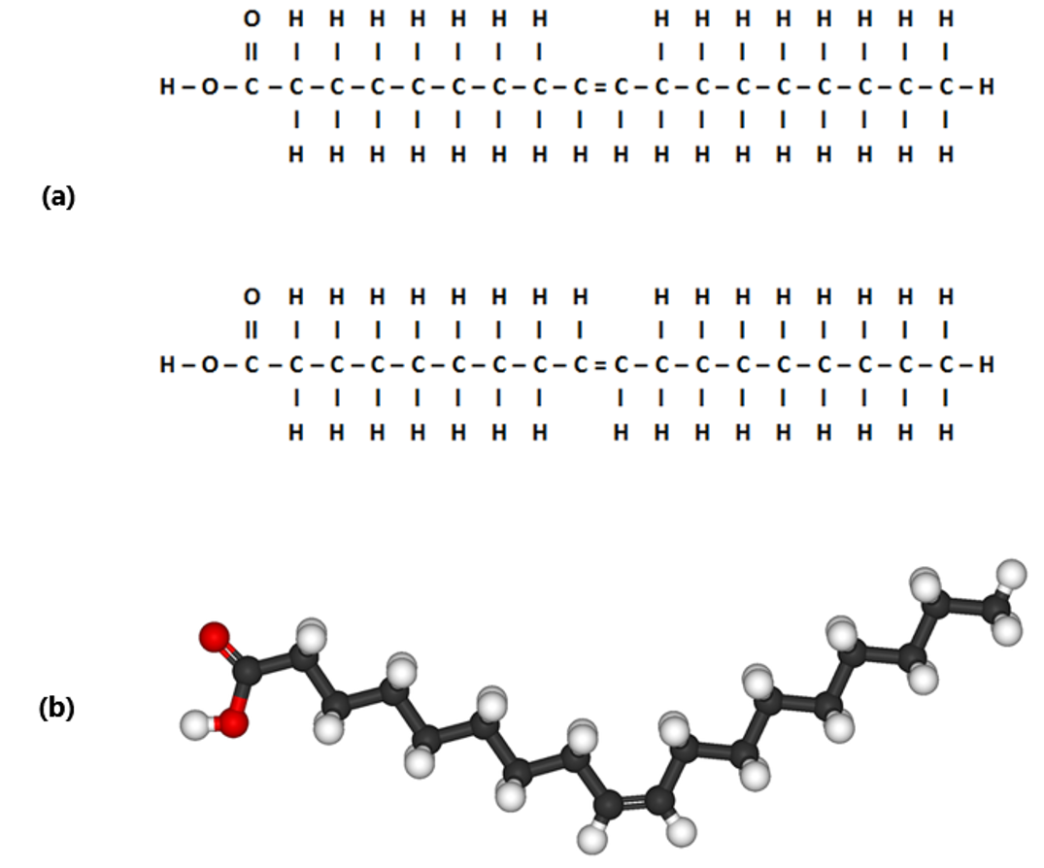

**(a) Cis & Trans Double Bond in Monounsaturated Fatty Acid; (b) Cis Double Bond in Unsaturated Fatty Acid.**

Image created by JS at BYU-Idaho 2014: Modified File: Oleic-acid-3D-ball-&-stick.png; Author: Benjah-bmm27; Site: https://commons.wikimedia.org/wiki/File:Oleic-acid-3D-ball-%26-stick.png; License: Public Domain

Carbon-carbon double bonds significantly affect the behavior of the fatty acid. These double bonds can occur in one of two states: cis (same) or trans (across). The figure above shows a line drawing of two monounsaturated fatty acids. Note that the first molecule in illustration (a) has the hydrogen atoms extending from the carbon chain on the same side of the double bond. This is called a cis double bond . Note that the second molecule in illustration (a) is nearly identical except that the hydrogen atoms extend from the carbons at the double bond on opposite sides. This is called a trans double bond. Illustration (b) shows a 3D representation of the cis double bond in the unsaturated fatty acid chain. Notice how cis bonds bend or put a kink in the carbon chain.  
  
A fatty acid with one double bond is referred to as a monounsaturated fat, and fatty acids with two or more double bonds are polyunsaturated fats. All lipid containing foods have a specific mixture of saturated and unsaturated fatty acids. Because saturated fatty acids tend to be straight, they can pack together more tightly. The more tightly packed molecules of fat are more dense and more likely to be solid at room temperature. In contrast, unsaturated fats with cis bonds allow for a kinked or angled geometry that makes it more difficult to pack together, causing them to be a liquid at room temperature. Most naturally occurring unsaturated fats are cis fats. Commercial trans fats, which retain a straight shape and behave like saturated fats, have been banned from use in culinary production due to an increased risk of heart disease associated with long-term consumption.

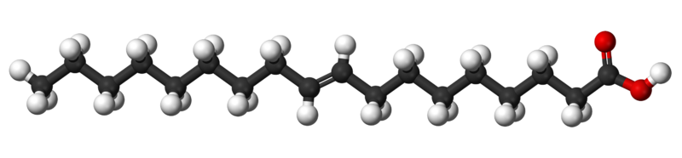

**Trans Double Bonds in Unsaturated Fatty Acid.**

Title: File: Tridecylic-acid-3D-balls.png; Author: Jynto and Ben Mills; Site: https://commons.wikimedia.org/wiki/File:Tridecylic-acid-3D-balls.png; License: public domain

Epidemiologic, clinical, and physiological studies are quite consistent in showing that saturated and trans fats cause adverse effects on our health if they are eaten in excess. Throughout the world, trans fats have been acknowledged as unhealthy, and many countries have outlawed their use. Substituting unsaturated fat for saturated and trans fat has sometimes been shown to lower LDL cholesterol which may have a "heart healthy" effect. There is also mounting evidence that some unsaturated fats may have the ability to decrease chronic inflammatory responses in the body. Omega 3 fatty acids have come into the spotlight lately as they may help to do this. Omega 3 refers to the existence of a double bond three carbons in from the end of a fatty acid chain.

Read this online at <https://books.byui.edu/bio_264_anatomy_phy_I/321___triglycerides>