# Lysosomes, Proteasomes, and Peroxisomes

As mentioned, **lysosomes** are also part of the endomembrane system. Lysosomes are specialized vesicles that bud off of the Golgi apparatus. A lysosome uses a pump within its membrane to transport high concentrations of H+ into its lumen, thus lowering the internal pH. The acidic environment of the lysosome allows it to break down macromolecules (such as proteins). Other organelles involved in recycling used or unneeded materials include **proteasomes** and **peroxisomes**. When a cell wants to quickly reduce the amount of a given protein, it can tag that protein with a specific signal (called ubiquitin) that sends that protein to the proteasome for degradation. The peroxisome is responsible for detoxifying harmful substances that may enter the cell by generation of hydrogen peroxide (H2O2). Perosisoes are also involved in some metabolic reactions.

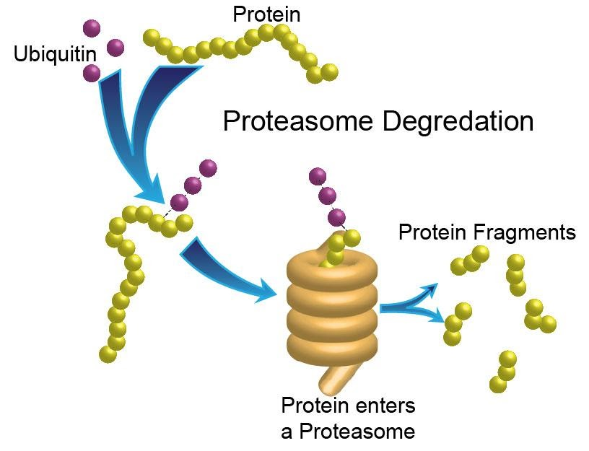

**Proteasome Degradation**. Original image drawn by BYU-I Biology Department Jan 2015

Read this online at <https://books.byui.edu/bio_264_anatomy_phy_I/415_lysosomes_protea>