# Active Transport

To this point, the transport processes we have discussed have all been passive processes in which the solute movement has been down a concentration gradient with no input of energy required. However, there are times when it is important for the cell to be able to move solutes against their concentration gradient (i.e. moving a solute across the membrane where it is higher in concentration). Just like moving water from the spillway of a dam back to the reservoir, these processes require an energy source and are called **active transport** processes.

#### Primary Active Transport

Primary active transport requires a carrier protein that is much like the proteins involved in carrier-mediated diffusion mentioned above. However in this case, the carrier has an ATP binding site, which upon hydrolysis into ADP and inorganic phosphate (Pi) provides the energy to move solute against its concentration gradient. These transport systems can move one or multiple ions across the membrane. One of the most important primary active transport proteins is the **Na+, K+-ATPase.** This protein moves three sodium ions out of the cell and two potassium ions into the cell for each ATP hydrolyzed. Potassium is the primary intracellular cation in the body while sodium is the primary extracellular cation, and the Na+, K+-ATPase is responsible for maintaining this distribution.

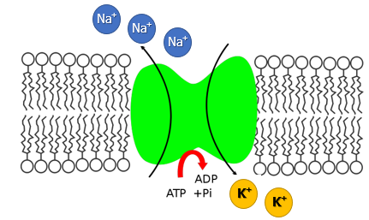

**Sodium Potassium- ATPase pumps.**

Image created at BYU-Idaho by MG 2013

#### Secondary Active Transport

Like primary active transport, secondary active transport also moves solutes against their concentration gradients. However, with secondary active transport, ATP is not directly involved in the pumping of the solute. Instead, this process uses the energy stored in concentration gradients to move the solute. Since sodium is always in higher concentration outside of the cell (due to primary active transport), the sodium gradient is often used to power secondary active transport. In this process, the carrier protein has a binding site for the solute to be transported against its concentration gradient and a binding site for sodium. Once both solutes have bound, sodium moves down its concentration gradient into the cell, much like what happens with carrier-mediated diffusion and in the process provides the energy required for the other solute to be transported into the cell (**symport**) or out of the cell (**antiport**), against its concentration gradient. A number of organic molecules are transported across membranes by this process, such as glucose and amino acids. ATP energy is required to generate the sodium concentration gradient but is not directly involved in moving the desired solute across the membrane. It is the dissipation of this sodium gradient that provides the energy required for secondary active transport.

#### Bulk Transport

To this point, we have been talking about the movement of relatively small solutes across the cell membranes (i.e. ions and small organic molecules). There are instances, however, when it is necessary to move much larger materials across the membrane, like when a macrophage engulfs a bacterium or when larger amounts of a given material are released from a cell, such as the release of a hormone. These processes also require ATP and are, therefore, examples of active transport, but they move materials in a very different way.

#### Endocytosis

Endocytosis is the bulk transport of materials into the cell. There are several types of endocytosis, and we will briefly explore each one. First, let's discuss **phagocytosis** (see figure below), which means cell eating. Only a limited number of cells are capable of phagocytosis, specifically cells of the immune system. In this process, the cell sends extensions of its plasma membrane, called **pseudopodia**, out and around the particle to be phagocytized. As these pseudopodia surround the particle, they eventually fuse, creating a vesicle containing the particle. This **phagosome** can then unite with a lysosome inside the cell, and the engulfed material can be digested for use within the cell. Watch an amoeba phagocytize a paramecium in this clip:

[https://books.byui.edu/-SLP](https://www.youtube.com/watch?v=aWItglvTiLc.) ([Transcription Available](https://content.byui.edu/file/9f4640bb-739d-4e38-a8c9-0ecb9968705e/1/Phagocytose%201.rtf))

In this next clip, watch a neutrophil, one of our white blood cells, chase down and phagocytize a bacterium (A humerus musical approach to viewing this).

[https://books.byui.edu/-qxyj](https://www.youtube.com/watch?v=VAhM9OxZDkU&amp;feature=related)

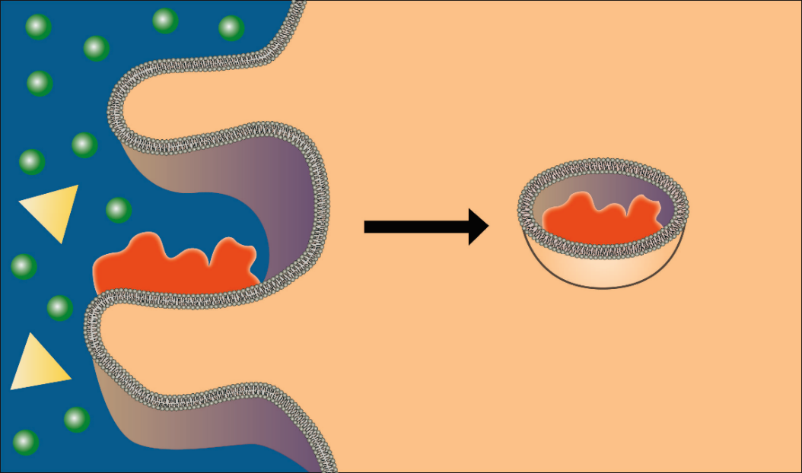

**Phagocytosis.**

Image created by BYU-Idaho student, Hannah Crowder, 2013.

A second type of endocytosis is **pinocytosis**, which means cell drinking. In this process, rather than send out pseudopodia, the cell membrane simply invaginates (forms a pocket) and engulfs anything in the fluid that is taken into the cell (see figure below). Unlike phagocytosis, pinocytosis occurs in most cells of the body. The cells are not interested in the water in the vesicles but any solutes that might be brought in. As you can imagine, this is not a very efficient way of bringing materials into the cell because it is nonspecific and brings whatever is in the fluid into the cell. It provides cells with a nonselective mechanism for sampling the extracellular environment. It is prominent in cells involved in moving large amounts of material across the membrane, like cells of the intestines and the kidneys.

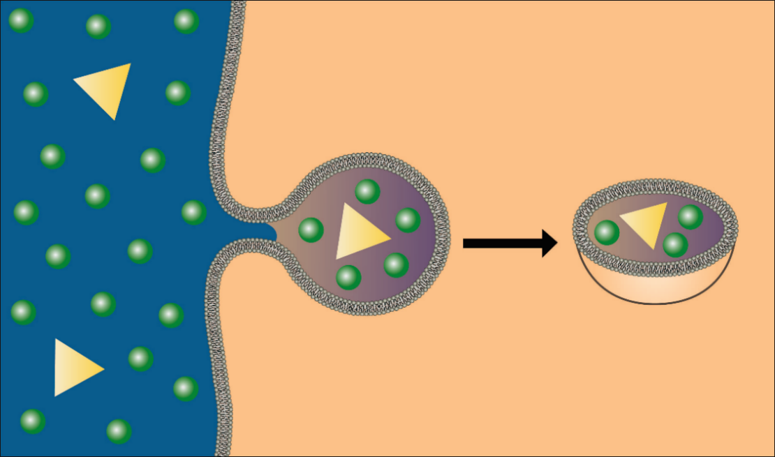

**Pinocytosis.**

Image created by BYU-Idaho student, Hannah Crowder, 2013.

A much more efficient mechanism for bringing specific solutes into the cell is **receptor‐mediated endocytosis**. As the name implies, this mechanism employs specific receptors that bind to specific compounds (**ligands**) within the extracellular space. Once the specific ligand binds with its receptor, the resulting complex migrates to a specific area of the membrane called a clathrin‐coated pit. The clathrin protein is activated by the bound receptor which initiates endocytosis in a process similar to pinocytosis (see figure below). The advantage of receptor‐mediated endocytosis is that it can engulf large amounts of a specific solute. The following two images demonstrate how this process occurs. The first is a general mechanism for receptor-mediated endocytosis, and the second shows how a specific molecule, cholesterol, is brought into the cell by this process.

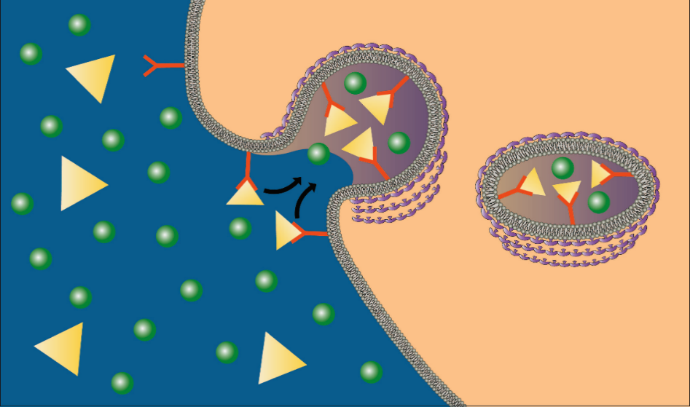

**Receptor-Mediated Endocytosis.**

Image created by BYU-Idaho student, Hannah Crowder, 2013.

**In receptor-mediated endocytosis, ligands bind to specific receptors, which then migrate to a clathrin‐coated pit. The contents are then brought into the cell by a process similar to pinocytosis. Below a LDL particle is taken into the cell through endocytosis to retrieve cholesterol molecules.**

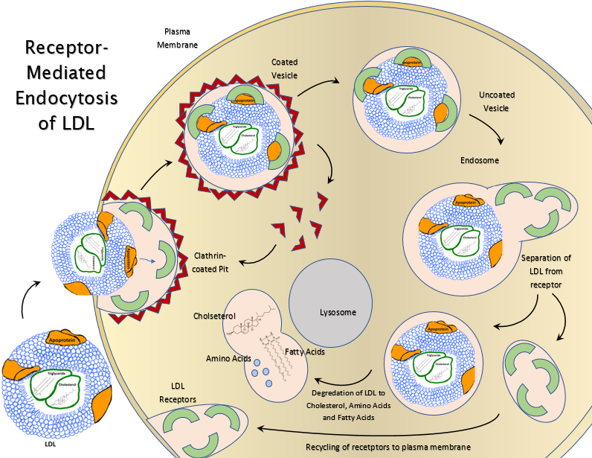

**Receptor-Mediated Endocytosis of LDL.**

Image created for BYU-Idaho by T. Orton, 2017

#### Exocytosis

Thus far, we have been discussing bulk transport, bringing material into the cell. There is also a need to export material from the cell into the extracellular fluid. This process is called **exocytosis**. Exocytosis is the process by which the beta cells of the pancreatic islets secrete insulin into the extracellular fluids. The mechanism is essentially the reverse of endocytosis. **Secretory vesicles** filled with the material to be released migrate to the plasma membrane where the membrane of the vesicle fuses with and actually becomes a part of the plasma membrane (see figure below). The material that was in the vesicle suddenly finds itself outside of the cell, and any integral protein within the vesicle membrane now becomes a protein expressed on the cell membrane (See example below of GLUT4). While this is a complex process, the usual signal that initiates exocytosis is the entry of calcium ions into the cell which bind to specific proteins (e.g. SNARE proteins) that initiate this process. Since calcium concentration is higher outside the cell, it is common that activation of gated calcium channels in the membrane precede exocytosis.

The links below show how endocytosis and exocytosis work.

[https://books.byui.edu/-yFo](https://www.youtube.com/watch?v=4gLtk8Yc1Zc) ([Transcription Available](https://content.byui.edu/file/9f4640bb-739d-4e38-a8c9-0ecb9968705e/1/Cell%20Membrane%2C%20Exocitosis%20%26%20Endocitosis.rtf))

[https://books.byui.edu/-kANn](https://www.youtube.com/watch?v=K7yku3sa4Y8&amp;NR=1)

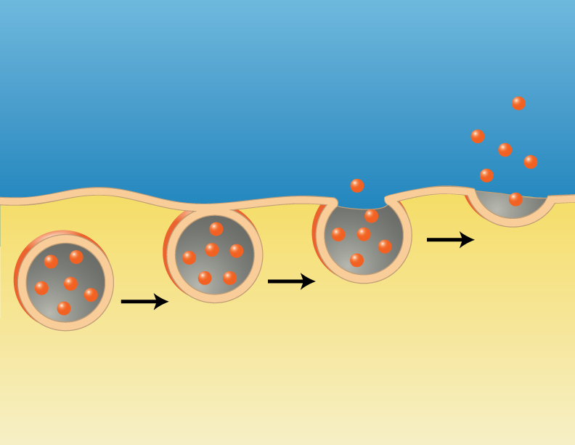

**Exocytosis**

.

Image created by BYU-Idaho student, Hannah Crowder, 2013.

In skeletal muscle, GLUT4 proteins (glucose transporters) are found in intracellular vesicular membranes. When insulin binds to its cell surface receptor, exocytosis is initiated to allow GLUT4 expression on the plasma membrane and subsequent glucose uptake.

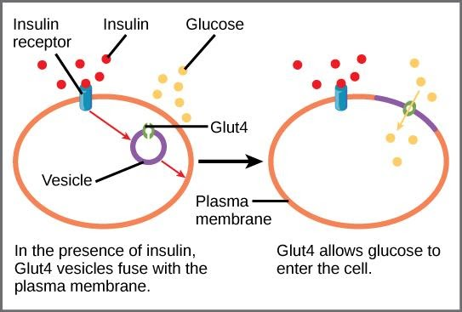

**GLUT 4 Carrier Protein.**

By CNX OpenStax [CC BY 4.0 (https://books.byui.edu/-CjnG],

via Wikimedia Commons

Read this online at <https://books.byui.edu/bio_264_anatomy_phy_I/523___active_transpo>