Graded Potentials
Let’s cover some new terminology. Because we are dealing with charge differences and electrical currents (flow of ions), we use some unique terms to describe certain states of the membrane. At rest, the membrane is in a polarized state—polarized means there is a separation of charge across the membrane due to different ion concentrations on either side of the membrane (see table above). This polarized state is often referred to as the resting membrane potential. Already emphasized, the inside of the cell membrane will be negative in relation to the outside of the membrane. We can show this graphically by plotting membrane potential in mV on the y-axis and time in msec on the x-axis (see figure below). Any change in the membrane potential toward zero mV is termed a depolarization since the membrane is becoming less charged (i.e. there is less charge separation across the membrane). Any change in the membrane potential that moves back toward the resting potential is called a repolarization. And finally, any further decrease (more negative) in membrane potential below resting membrane potential is termed hyperpolarization. Note the prefixes of these terms as their meanings explain what is happening to the membrane potential. Opening channels for Na⁺ or Ca⁺⁺ would cause a depolarization, while opening channels for K⁺ or Cl⁻ would cause a repolarization or even a hyperpolarization.

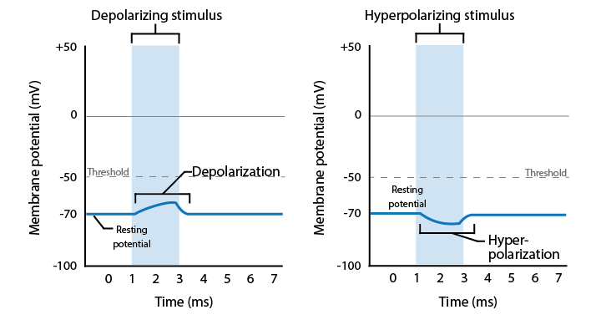
Graded Potentials.
Image created at BYU-Idaho, 2013.
Graphical representation of graded potentials. The left graph shows a graded depolarization. Note that the membrane potential acutely increases (closer to 0mV) and then repolarizes to its resting membrane potential. The graph on the right shows a graded hyperpolarization as the membrane potential acutely becomes more negative than resting membrane potential.

Graded potentials are small in magnitude, meaning they don’t drastically change the membrane potential. The magnitude of the graded potential is proportional to the strength of the stimulus. Hence, a strong stimulus might result in a 10mV change in the membrane potentials, while a weaker stimulus may produce only a 5mV change. Graded potentials are also localized to a small area of the cell membrane and are sometimes called local potentials. Graded potentials are fast-acting, meaning that the membrane potential typically returns to resting membrane potential quickly, within a couple msec. The opening of mechanical or ligand-gated ion channels are what induce graded potentials. Something unique to graded potentials is that they can be summed (added together) to increase the change in membrane potential. For example, if a depolarizing stimulus is repeated over and over in a short period of time, it can result in an even larger depolarization as each subsequent graded potential further depolarizes the membrane before it can fully repolarize back to the resting membrane potential. If a strong depolarizing graded potential (or multiple depolarizing graded potentials) increase the membrane potential above the threshold potential for the cell, an action potential will occur. This is the great significance of graded potentials: They determine whether action potentials occur or not. You can think of graded potentials as the triggers that initiate action potentials; without them, action potentials would not happen. Let’s now discuss action potentials.

Read this online at https://books.byui.edu/bio_264_anatomy_phy_I/533___graded_potenti

