# ORGANIZATION OF THE NERVOUS SYSTEM

The nervous system coordinates voluntary and involuntary actions in the body by sending and receiving information. The nervous system is comprised of an enormous number of cells (over 100 billion), primarily of two types: **neurons** (the signaling units) and **glial cells** (the supporting units). However, nervous system function is mostly a story of the neuron. The neuron is the functional unit of the nervous system and is designed to transmit information between cells. Interestingly, neurons with a particular function are found in a predictable location. This regularity in structure has permitted neurobiologists to categorically organize the nervous system based on location and function (see figure below).

Thus, the nervous system can first be divided into two major parts: the central nervous system (CNS) and the peripheral nervous system (PNS). The CNS consists of neurons associated with central processing and which are located in the brain and spinal cord. The peripheral nervous system (PNS) consists of neurons associated with sensory input (afferent) and motor output (efferent) and functions to connect the central nervous system to all other parts of the body. Stated another way, if the entire structure of the neuron is contained within the brain and/or spinal cord, the neuron would be considered part of the CNS. In contrast, if any part of the neuronal structure is located outside of the brain and/or spinal cord, the neuron would be considered part of the PNS (see image below).

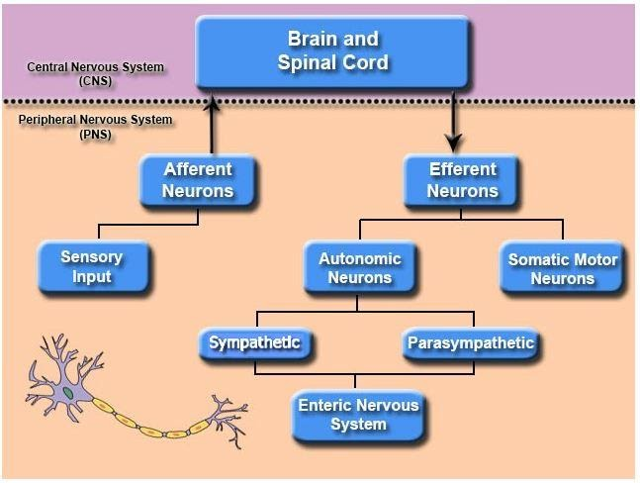

**Organization of the Nervous System.**

Image generated at BYU-Idaho Spring 2013

For the most part, information is transmitted between these two systems following this basic pattern: stimulus, receptor, afferent pathway (input signal), control center, efferent pathway (output signal), effector, and response. In other words, sensory receptors located throughout the body constantly monitor the conditions of the environment and send this information via the PNS to the CNS for central processing. If a response is needed (i.e. to maintain homeostasis), the CNS will send new information through the PNS to target organs that will help adjust to the initial stimulus. It should be noted that some functions can be contained entirely within the CNS: for example, dreaming, thinking, or even information storage.

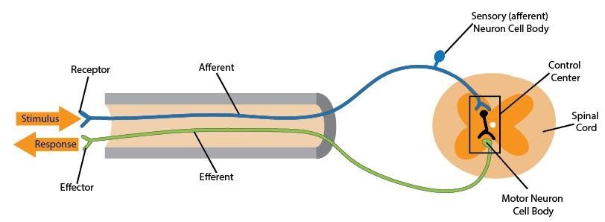

**Peripheral Nervous System (PNS) Communication with Central Nervous System (CNS).**

Image generated at BYU-Idaho Spring 2013

Neurons of the efferent division of the PNS can be further subdivided into the somatic nervous system, which controls the voluntary movement of skeletal muscle, and the autonomic nervous system, which regulates involuntary functions of organs (such as the heart, lungs, glands, etc.) and smooth muscle tissues (airways, blood vessels, etc). Autonomic neurons are further subdivided into sympathetic and parasympathetic systems (see first figure). The autonomic nervous system will be addressed in a separate module.  
  
A third division of the PNS is a semi-independent nervous system called the enteric nervous system, which controls the gastrointestinal tract. This system is considered semi-independent because it can run independently or through modulation by the autonomic nervous system, particularly from the parasympathetic system (see first figure). It is also interesting to note that the enteric nervous system contains more neurons than the entire spinal cord.

Read this online at <https://books.byui.edu/bio_264_anatomy_phy_I/61_organization_of_t>