# Neuron Structure and Classification

Neurons have four specialized structures that allow for the sending and receiving of information: the cell body (soma), dendrites, axon, and axon terminals (see figure below, lower left).

#### Cell body or Soma

The cell body is the portion of the cell that surrounds the nucleus and plays a major role in synthesizing proteins.

#### Dendrites

Dendrites are short, branched processes that extend from the cell body. Dendrites function to receive information and do so through numerous receptors located in their membranes that bind to chemicals called neurotransmitters. Many of these receptors are lignad-gated channels.

#### Axon

An axon is a large process that extends from the cell body at a point of origin—called the axon hillock—and functions to send information. In contrast to the shorter dendrites, the axon can extend for more than a meter. Because of this length, the axon contains microtubules and is surrounded by myelin. Microtubules are arranged inside the axon as parallel arrays of long strands that act as highways for the movement of materials to and from the soma. Specialized motor proteins "walk" along the microtubules, carrying material away from the soma (**anterograde transport**) or back to the soma (**retrograde transport**). This system can move materials down the axon at rates of 400 mm a day (see lowest figure). Myelin consists of totally separate cells that coil and wrap their membranes around the outside of the axon. These are essential for electrical insulation and to speed up action potential propagation.

#### Axon Hillock

As described above, the axon hillock is the origin of an axon. It has many voltage=gated Na+ channels. When thes channels reach threshold an action potential is initiated which will the propagate down the zxon to the axon terminal. In essence, the is region is when a neuron “decides” whether or not to have an ation potential.

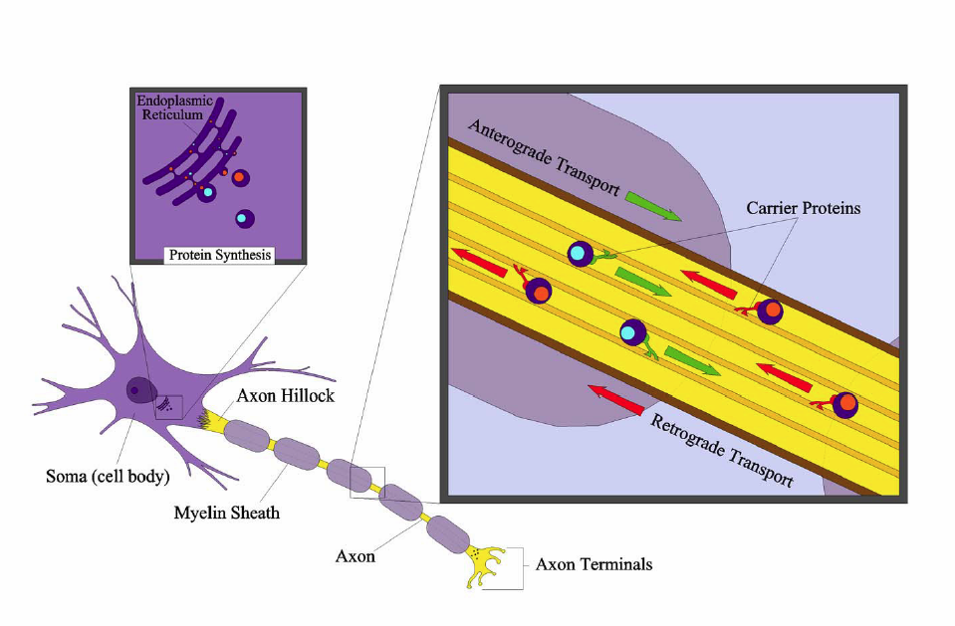

**Anterograde and Retrograde Transport in an Axon.**

Image produced by BYU-Idaho Student Jared Cardinet 2013

#### Axon terminals

Where an axon reaches a target, it terminates into multiple endings, called axon terminals. The axon terminal is designed to convert the electrical signal of an action potential into a chemical signal to be sent to a neighboring cell in a process called synaptic transmission (further explained in the section "Physiology of the Neuron"). This region contains many voltage-gated Ca2+ channels that play a critical role in synaptic transmission.

#### Neuron Life Cycles

Most neurons are amitotic (lose their ability to divide). Exceptions to this rule are found in olfactory neurons (those associated with smell) and hippocampal regions of the brain (those associated with memory). Fortunately, lifespans of amitotic neurons is near 100 years. Still, if a neuron is damaged or lost, it is not easily replaced. For this reason, there is usually limited recovery from serious brain or spinal cord injuries. Perhaps the slow recovery rate or lack of regeneration is to ensure that learned behavior and memories are preserved throughout life. Neurons also have exceptionally high metabolic rates and subsequently require high levels of glucose and oxygen. The body will go to great lengths to ensure that neurons are adequately fed; in fact, if for some reason the brain detects that it is not receiving adequate amounts of nutrition, the body will shut down immediately (i.e. faint).

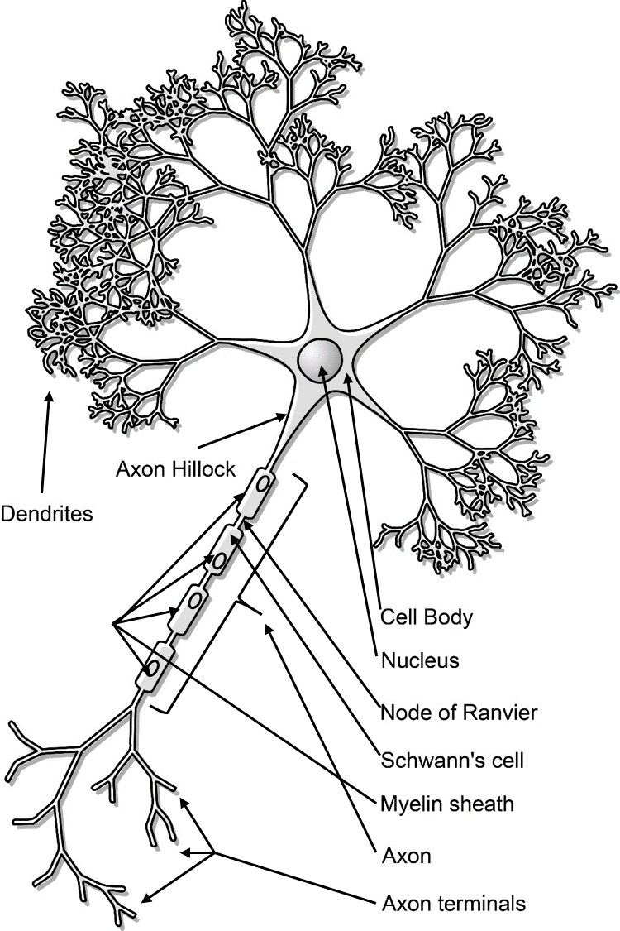

**Key Neural Structures.**

Title: Neuron-figure-notext.svg; Author: Nicolas.Rougier;

Site: https://books.byui.edu/-jtcV

License: This file is licensed under the Creative Commons Attribution-Share Alike 3.0 Unported license.

#### Structural Classification of Neurons

Neurons can be classified base up their structure or morphology. Structural classification of neurons is based upon the number of processes that extend out from the cell body. Three major groups arise from this classification: **multipolar, bipolar,** and **unipolar** neurons.

Multipolar neurons are defined as having three or more processes that extend out from the cell body. They comprise more than 99% of the neurons in humans and are the major neuron type found in the CNS and the efferent division of the PNS.

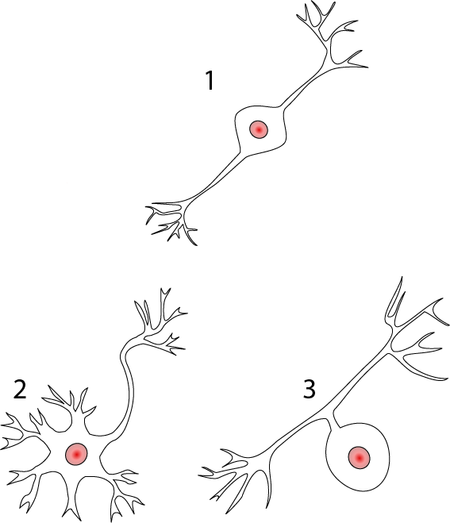

**Structural classification of neurons. 1) Bipolar 2) Multipolar 3) Unipolar.**

Title: Neurons uni bi multi pseudouni.svg; Author: Pseudounipolar_bipolar_neurons.svg: Juoj8 derivative work: Jonathan Haas;

Site: https://books.byui.edu/-VIRq;

License: This file is licensed under the Creative Commons Attribution-Share Alike 3.0 Unported license.

Bipolar neurons have only two processes that extend in opposite directions from the cell body. One process is called a dendrite, and another process is called the axon. Although rare, these are found in the retina of the eye and in the olfactory system.

Unipolar neurons have a single, short process that extends from the cell body and then branches into two more processes that extend in opposite directions. The process that extends peripherally is known as the peripheral process and is associated with sensory reception. The process that extends toward the CNS is the central process. Unipolar neurons are found primarily in the afferent division of the PNS.

#### Functional Classification of Neurons

Neurons can also be classified functionally according to the direction in which they transmit signals, in relation to the CNS. This classification also results in three different types of neurons: **sensory neurons, motor neurons**, and **interneurons**.

Sensory neurons, or afferent neurons, transmit information from sensory receptors in the skin or the internal organs toward the CNS for processing. Almost all sensory neurons are unipolar.  
  
Motor, or efferent, neurons transmit information away from the CNS toward some type of effector. Motor neurons are typically multipolar.  
  
Interneurons are located between motor and sensory pathways and are highly involved in signal integration. The vast majority of interneurons are confined within the CNS.

Read this online at <https://books.byui.edu/bio_264_anatomy_phy_I/611_neuron_structure>