# GLYCOLYSIS

**Glycolysis** literally means the breakdown of sugar (Glyc = sugar or sweet and Lysis = to cut or loosen). Glycolysis occurs in the cytoplasm of the cell. Beginning on the next page, you will find depictions of the step by step biochemical reactions that make up Glycolysis. In short, glycolysis takes 1 glucose molecule of 6 carbons and makes two 3 carbon molecules called pyruvate. In the process, electrons and hydrogen atoms are captured by NAD+.  Any energy liberated will be released as heat, or captured as ATP or NADH.

|  |  |
| --- | --- |
| **Molecule** | **Net Yield through Glycolysis** |
| ATP  NADH  Pyruvate | 2  2  2 |

#### Glycogenesis

It should be noted that when there is a surplus of glucose, some of the glucose will be converted to glycogen. Later, when blood sugar begins to fall, glycogen can be broken down into monomers of glucose again, which will enter glycolysis. Glycogen synthesis is an important process to help us store" sugar for use when we are not eating but need to maintain appropriate blood sugar levels.  
  
We have next a very detailed figure for the 10 steps of glycolysis. It has more information than you will need for the exam (remember, the exam will test you at the level of the "summary" figure that you got previously). However, this image is nice to have as a reference and can help you if you find videos or information in your online research that uses terminology not found in the summary figure.

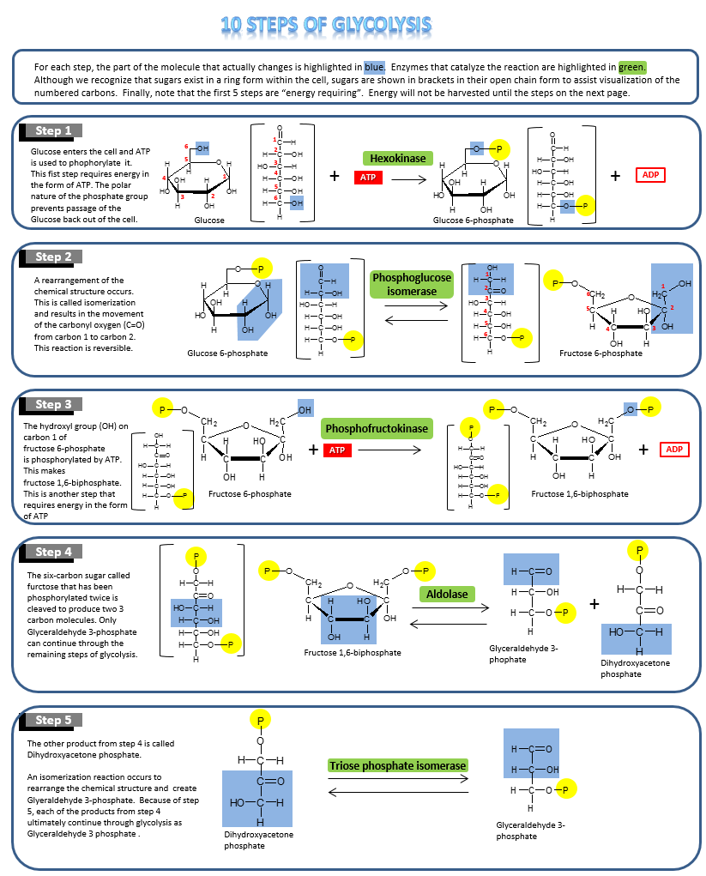

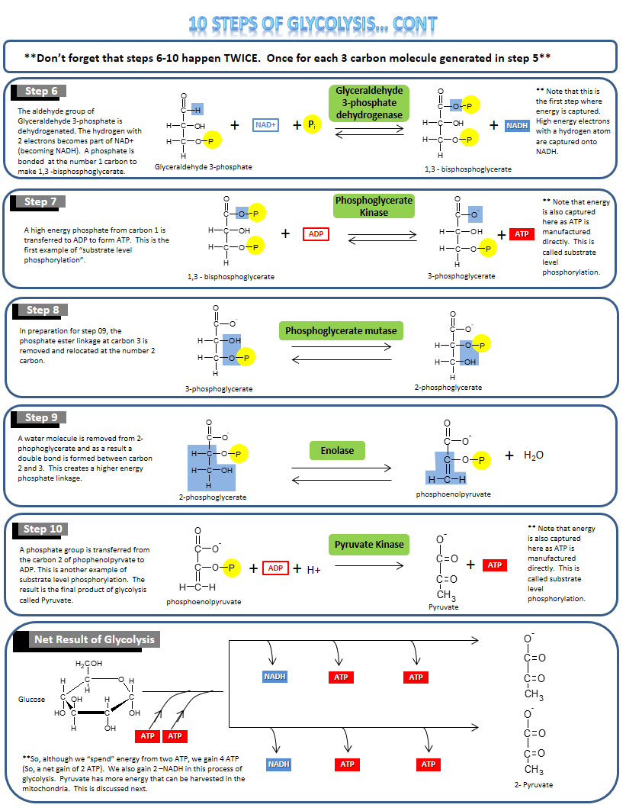

#### Anaerobic and Aerobic Use of Pyruvate

**Anaerobic**

The last step of glycolysis leaves us with two 3-carbon molecules, called pyruvate. The fate of pyruvate depends on the availability of oxygen. If oxygen is available, then pyruvate is shuttled into the mitochondria and continues through several more biochemical reactions called the "Citric Acid Cycle." This is called **aerobic metabolism**. If oxygen is not available in sufficient quantity to the cell, then pyruvate goes through a reduction reaction that results in the production of Lactate (see image below). This is called **anaerobic metabolism**.

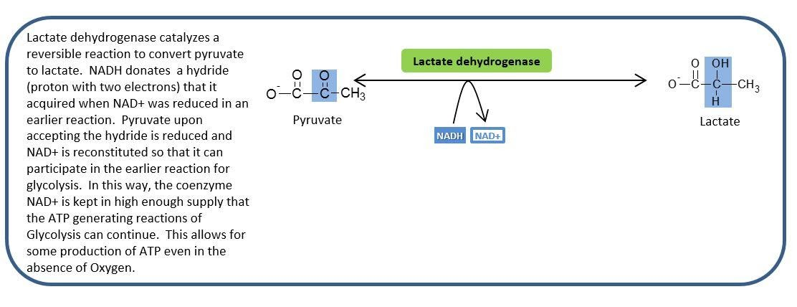

**Anaerobic Metabolism: Pyruvate Reduction to Lactase.**

Image created by JS at BYU-Idaho Fall 2013.

**Aerobic**

When there is enough oxygen available to the cell, pyruvate crosses the mitochondrial membrane and is quickly converted to Acetyl CoA. Acetyl CoA enters the Citric Acid Cycle where CoA is removed and the acetate is added to a 4 carbon molecule to make a 6 carbon molecule called “Citric Acid.” As the biochemical steps of the Citric Acid Cycle continue, 2 more carbons are lost as CO2 and so ultimately all the carbons of pyruvate are lost as CO2. After 2 pyruvates complete the citric acid cycle, all the carbons of the original Glucose molecule have been released as CO2.

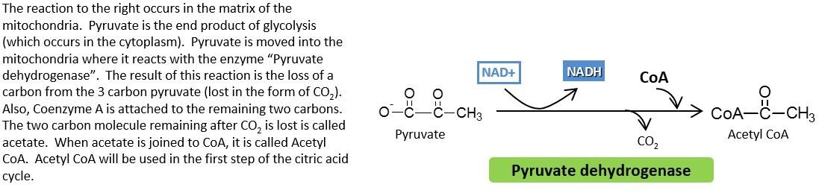

**Conversion of Pyruvate to Acetyl CoA.**

Image created by JS at BYU Idaho F2013.

**The image above shows the conversion of Pyruvate to Acetyl CoA occurs in the mitochondria and results in the loss of a Carbon as CO2 and the creation of Acetyl CoA.**

#### Metabolism Summary Part 1: Glycolysis

Below is an image of the process of Glycolysis magnified from the Metabolism Summary image you saw in 8.1. A summary follows for the process of Glycolysis that you have just read about. The green numbers in the image correlate with each of the steps listed below:

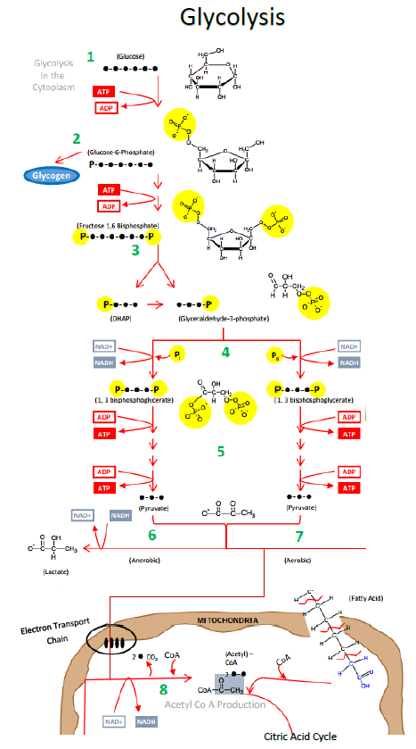

**Glycolysis, from the “Big Picture” of Metabolism:**

**Glycolysis, Citric Acid (Krebs) Cycle, Electron Transport Chain, Beta Oxidation and Lipolysis.**

Image created at BYU-Idaho by JS 2010

**1** Glucose enters a cell and is quickly phosphorylated (meaning a phosphate group is added to the glucose molecule) on the 6th carbon by ATP. This “traps” the glucose in the cell as the charged phosphate group changes the way glucose fits in a glucose transport protein (GLUT). Glucose with a phosphate attached is too large and polar to escape by passive diffusion through a bi-lipid membrane layer.

**2** If the enzyme “glycogen synthase” is available, and the cell has enough energy that it does not necessarily need the glucose to make ATP, then this newly phosphorylated glucose may be attached to a chain of glucose molecules called **glycogen**.  This is handy because later, when blood sugar begins to drop, glucose will be cleaved from glycogen and made available to go through glycolysis.  Also, the phosphate may be removed and the glucose will be put back in the blood to bolster blood sugar levels.  These processes called **glycogenesis** (glycogen synthesis) and **glycogenolysis** (glycogen break down) occur in muscle cells to a small extent and in liver cells to a large extent.

**3** A phosphorylated glucose that does not become part of the stored glycogen will undergo a conformational change and become fructose. The fructose molecule has another phosphate attached to it from ATP. This double phosphorylated 6 carbon fructose is now primed to be divided into two 3-carbon sugars – each with one phosphate attached. The remaining glycolytic reactions will now happen twice because there are two 3-carbon molecules called Glyceraldehyde-3-phosphate.

**4** The energy available in the glucose molecule is found in the form of “chemical energy”.  This energy exists in the C-H bonds – or more specifically within the electrons that constitute the carbon – hydrogen bonds.  The dehydrogenase enzyme in step 4 will remove two hydrogens (2 protons and 2 electrons) from Glyceraldehyde-3-phosphate.  Oxidized **Nicotinamide Adenine Dinucleotide (NAD+)** accepts and bonds with one of the protons and both of the electrons.  The other proton does not bond with the NAD+ but will be found nearby.  This may be written as   :H-  +  H+  +  NAD+   🡪  NADH  +  H+.

Because NAD+ acquires 2 new electrons, we say that NAD+ is reduced. The 3 carbon molecule that the protons and electrons were removed from is oxidized. This is an example of a redox reaction. For simplification, the reduced form of NAD+ will be referred to as NADH (instead of NADH + H+).

Think of NAD+ as an electron carrier. It is like an empty taxi cab. It comes in and parks near the “dehydrogenase” enzyme and as the reaction occurs, NAD+ acquires 2 high energy electrons and a proton as passengers. This “taxi” is now occupied and will be referred to as NADH. Later, we will see that these new “passengers” will need to be dropped off for other metabolic reactions to proceed. When NADH unloads its “passengers” NAD+ is reconstituted and becomes available to go back and participate in reactions again. Without NAD+ involvement, the dehydrogenase enzyme would not be able to complete the reaction and glycolysis would stop at this point. Notice that if glycolysis stopped at this point, ATP would not be generated in glycolysis because the ATP generation steps are yet to come. It is important to have enough NAD+ around to keep the reactions going.

Another important effect of the dehydrogenase reaction in step 4 is that an inorganic phosphate (Pi) ends up being bonded to the 3 carbon molecule from step 3. We now have two 3 carbon molecules called 1,3 bisphosphoglycerate.

**5** In step 5 there are several biochemical reactions that ultimately accomplish one very important outcome – **Substrate-Level Phosphorylation**.  In glycolysis, Substrate-Level Phosphorylation is the transfer of a phosphate group from a 3 carbon organic molecule to ADP.  This reconstitutes ATP which can be used in other important energy consuming processes of the cell.  Substrate-Level Phosphorylation is different from Oxidative Phosphorylation which will be discussed in Step 12.

Notice that because there are two 3-carbon molecules to donate phosphate groups, 4 ATP molecules will be generated.  Notice that for every glucose molecule in glycolysis, 4 ATP are made.  However, 2 ATP are required at the beginning steps of glycolysis, so the net production of ATP in glycolysis is 2 new ATP for every glucose molecule.

**6**The two 3-carbon molecules left after Substrate-Level Phosphorylation are called pyruvate.  **Pyruvate** is the end product of glycolysis.  The fate of pyruvate will depend on whether there is enough oxygen available to the cell or not.

If a hypoxic (meaning that oxygen is deficient) condition exists, then a dehydrogenase enzyme will perform a reaction that is actually the reverse of what we saw in step 4.  A hydrogen ion and 2 electrons will be removed from NADH and put onto pyruvate.  This causes pyruvate to become **lactate**.  You have probably heard of lactic acid before.  Lactic acid is acid form of the conjugate base lactate.  It has often mistakenly been referred to as a negative thing – a waste product or a product that makes muscles fatigue or maybe even a product that causes muscle soreness. While it is true that lactate is produced when muscles work very hard (because the body cannot deliver oxygen fast enough), it is **not** true that lactate causes pain or fatigue.  In fact, lactate is easily absorbed and converted back to pyruvate by other cells of the body.  Lactate does not last long in the blood and it is **not** something that courses through us like a poison causing all kinds of trouble.

You might be asking why this conversion of pyruvate to lactate is even necessary. Remember that the reactions of step 4 are not possible without NAD+.  If we continually made NADH and had no way to reconstitute or recycle back NAD+, then we would soon have to stop glycolysis and wait until more NAD+ became available. Since none of the ATP producing steps of glycolysis can happen until NAD+ arrives, we would not be making ATP which could kill the cell.  Making lactate is a quick way to free up NAD+ to go back to step 4 and allow the Substrate-Level Phosphorylation reactions to take place.  This is called **Anaerobic Metabolism**.  Anaerobic metabolism is very fast, but not very efficient (not a lot of ATP per glucose molecule). It is good for sudden bursts of intense activity but cannot sustain activity for very long.

**7** If Oxygen is available then pyruvate is transported to the mitochondria.  Pyruvate moves across the two mitochondrial membranes and a whole new sequence of metabolic steps proceed in the mitochondrial matrix. The culmination of all the metabolic reactions in the cytoplasm and the matrix of the mitochondria are called **Aerobic Metabolism**.  It is called aerobic because oxygen is used in step 11. Aerobic Metabolism results in much more ATP than were produced by glycolysis alone.

**Summary To Be Continued:** We will pause our metabolism summary there as we move on to the next stage of metabolism: The Citric Acid Cycle.

Read this online at <https://books.byui.edu/bio_264_anatomy_phy_I/82_glycolysis>