Lipid Metabolism
Beta oxidation is the term used to describe a series of reactions that break down a fatty acid into 2 carbon acetyl groups which are associated with Coenzyme A (see figure 12). Each time an acetyl CoA is generated from a fatty acid, the fatty acid re-enters the Beta oxidation biochemical pathways to remove the next 2 carbon fragment. This occurs until the entire fatty acid chain has been broken down in this way. Each time a beta oxidation cycle occurs, NADH and FADH₂ are generated. Also, each time an acetyl CoA from beta oxidation goes through the Citric Acid Cycle, 3 NADH, 1 FADH₂ and 1 ATP are generated. Since a fatty acid is many carbons long (most often found in lengths of 16 or 18 carbons), many acetyl CoA molecules can be acquired from a triglyceride molecule. Enough ATP is made from all the NADH and FADH₂ that it becomes clear that fat molecules give us more ATP per gram than glucose molecules.
Lipogenesis is the term used to describe the process of making new fat. Fatty acid chains can be synthesized by combining Acetyl groups which adds carbons to a growing fatty acid chain. It is almost like Beta oxidation in reverse, but the reactions use different enzymes and occur in a different place. While beta oxidation occurs in the matrix of the mitochondria, lipogenesis occurs in the cytoplasm of cells (mostly in the liver and adipocytes). Cells that synthesize fat have an enzyme complex made up of about 7 protein enzymes called Fatty Acid Synthase. When cells have excess glucose, there arises an excess of Acetyl CoA molecules. This upregulates lipogenesis and explains how diets high in sugar can cause increased adipose tissue.
Ketoacidosis is a complication that occurs when the body is not metabolizing sugar. This may occur in times of excessive dieting, fasting, or malnutrition. The most common cause of ketoacidosis is Type I Diabetes. In type I diabetes, there is no endogenous insulin and sugar cannot get into the fat and muscle cells which make up the largest percentage of body tissue by volume and weight. This means that these cells will catabolize predominately fat for ATP production (fat does not require insulin to get into cells). As increasing amounts of fat molecules are broken down through beta oxidation, accumulation of acetate and acetyl CoA may occur as the Citric Acid Cycle reaches a limit on how many acetyl CoA molecules it can take in at the first biochemical step. These two carbon products begin to spontaneously react with each other and produce 4 carbon molecules referred to as ketone bodies. The three most common ketone bodies are acetone, acetoacetate, and beta-hydroxybutyrate. These molecules are acidic and in high quantities can lower the pH of the blood. Also, acetone is volatile and can escape through the lungs and give a particular smell to a person’s exhaled breath. The smell has been described as being similar to finger nail polish remover (which contains acetone).
Fatty acids must be "activated" before they are transported into the mitochondria. Activation involves the attachment of Coenzyme (CoA). The result is a fatty acid derivative called Fatty acyl-CoA. Fatty acyl-CoA goes through a series of steps illustrated below. This process is called beta oxidation which suggests that the molecule will be oxidized at the beta carbon and then cleaved to yield Acetyl CoA (last step below). The Acetyl group is highlighted in blue in the figure below. The alpha (α) and beta (ß) carbons are labeled on the fatty acid. Notice that after Acetyl CoA is produced, the α and ß carbons for the next cycle are illustrated in gray. Palmitoleic acid is one of the most common fatty acids in animals and is the fatty acid used in this illustration. However, fatty acids can be any length with the most common ones between 14 and 18 carbons long. Complete beta oxidation of palmitoleic acids yields 8 Acetyl CoA molecules that can metabolize further in the citric acid cycle. The enzymes that catalyze each step are depicted in green boxes.
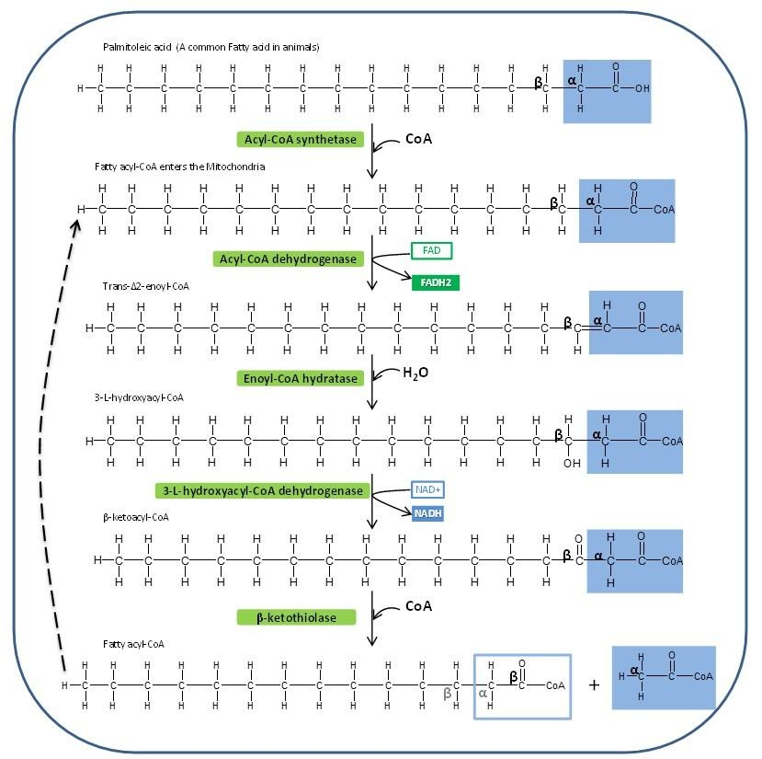
Image created by JS at BYU-Idaho Fall 2013.

Metabolism Summary Part 4: Beta Oxidation and Lipolysis:
Below is the final installment of the Metabolism Summary:
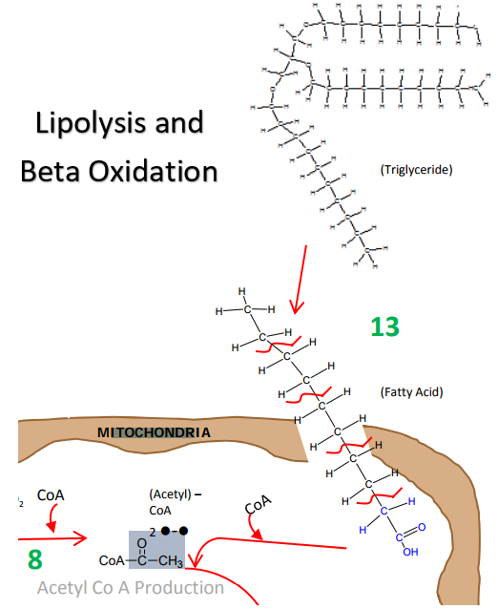
Lipolysis and Beta Oxidation, from the “Big Picture” of Metabolism:
Glycolysis, Citric Acid (Krebs) Cycle, Electron Transport Chain, Beta Oxidation and Lipolysis.
Image created at BYU-Idaho by JS 2010

13 Fat can also be used to make ATP. The metabolism of fat is called Beta Oxidation. Triglycerides are dismantled into glycerol and fatty acids. The glycerol can actually be converted into Glyceraldehyde-3-phosphate and then it completes the glycolytic reactions. The fatty acids are transported into the Mitochondria. Once in the Mitochondrial matrix, fatty acids are dismantled 2 carbons at a time and each 2 carbon piece is converted to Acetyl CoA. Acetyl CoA enters the Citric Acid Cycle. A single triglyceride molecule can ultimately yield a lot more Acetyl CoA than a glucose molecule. So, we say that fat is much more energy dense than sugar because we get more ATP per gram of fat than we do with sugar. However, notice that the end product of Beta oxidation is Acetyl CoA (not pyruvate). So, anaerobic metabolism is not possible with fat metabolism. We can only burn fat when there is enough oxygen available to the cell.
Read this online at https://books.byui.edu/bio_264_anatomy_phy_I/851_lipid_metabolism

