# Cerebral Cortex

The functions of the cerebral cortex include memory, attention, perception, thought, movement, language and consciousness. In other words, it allows us to be aware of ourselves, to remember names, to communicate to others and to move voluntarily. It contains billions of neuron cell bodies and dendrites, glial cells and blood vessels. Some specific functions of the cerebral cortex can be associated with the different lobes. For example, the frontal lobe is associated with motor behavior, the parietal lobe with processing and perception of sensory information. The occipital lobe is visual processing and perception and the temporal lobe processes hearing, vision, balance and language. Because of the vast array of functions, the cerebral cortex can be further divided into three generalized areas: **motor** areas, **sensory** area, and **association** areas.

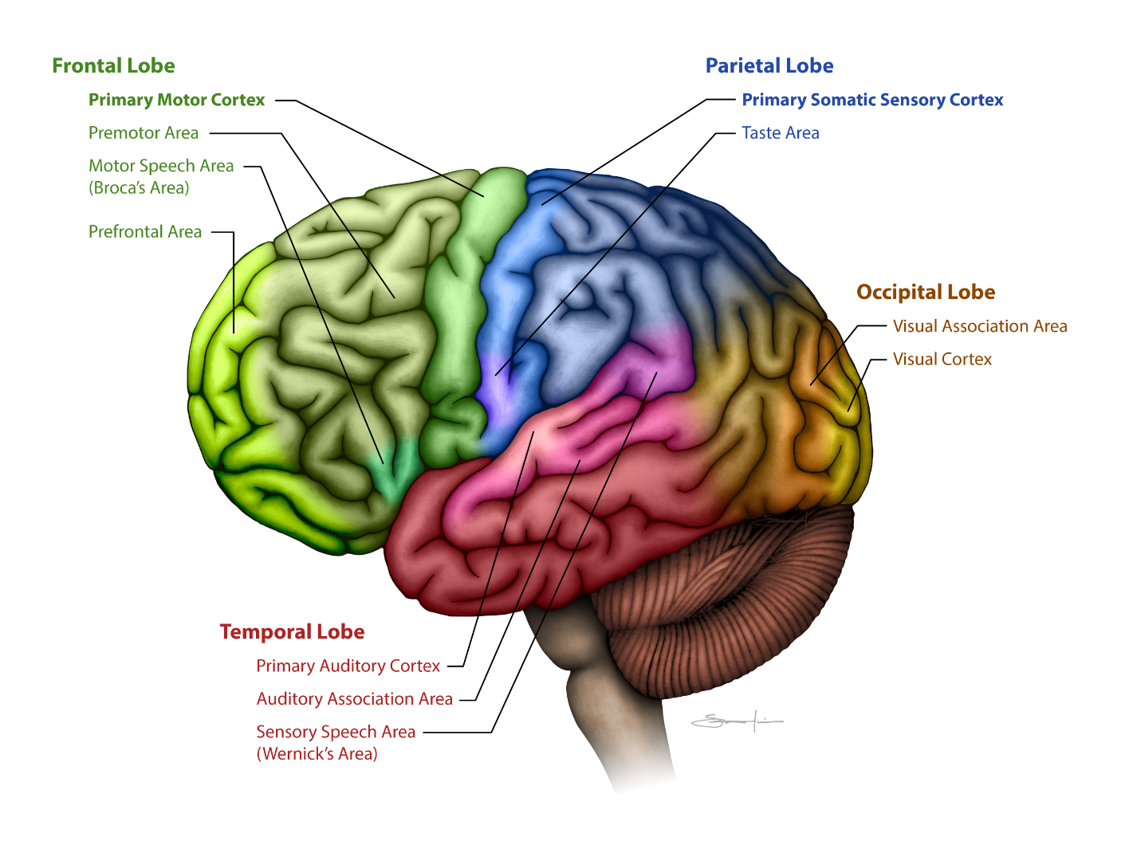

**Locations of Sensory and Association in the Brain.**

Created by BYU-Idaho student, 2013.

#### Motor Areas

One key function of the cerebrum is control of skeletal muscle. The motor areas of the cerebral cortex control voluntary movement and are localized in the frontal lobe, they include the **prefrontal cortex**, the **premotor cortex** and the **primary motor cortex**. Decisions to perform a specific motor function originate in the prefrontal cortex (we will discuss other functions of this region later). Once the decision is made, information is sent to the premotor cortex. This is the staging or programming area. It must be determined which muscles will contract, what is the order of contraction, how much force each must generate, etc. for the desired movement. Once programmed, signals are sent to the primary motor cortex, which then relays the signal to the spinal cord via the upper motor neurons. It should be noted that this is a simplification of the process. For example, not all upper motor neurons originate from the primary motor cortex but may also come from the premotor area, or even the somatosensory cortex of the parietal lobe.

Anatomically the prefrontal cortex is the anterior-most region of the frontal lobe. Moving posteriorly the premotor cortex comes next. Finally, the primary motor cortex is the most posterior region of the frontal lobe. The frontal and parietal lobes are separated by the central sulcus. The gyrus just anterior to the central sulcus is the **pre-central gyrus**. This gyrus houses the primary motor cortex. Neurobiologist have mapped the primary motor cortex based on which parts of the body they control and found that primary motor cortex is organized in a toe to mouth arrangement. That is, the neurons that control the lower parts of the body are at the top of the pre-central gyrus while those that control the upper parts of the body are located at the bottom of the pre-central gyrus. Additionally, the neural areas are not proportional in size in the body part that they control. The next image shows the body parts superimposed on the pre-central gyrus drawn in proportion amount of brain tissue devoted to controlling them. It becomes obvious that those areas responsible for the most motor units control fine, intricate movement. The hands for example, have much more of the primary motor cortex devoted to them than areas that principally produce more gross movements like the legs and torso. It should be noted that this map of the body is not cleanly segregated and contains a considerable amount of overlap. Studies have shown that even a single neuron in the primary motor cortex can influence the activity of multiple muscles related to multiple joints. Still, the map does provide a starting point.

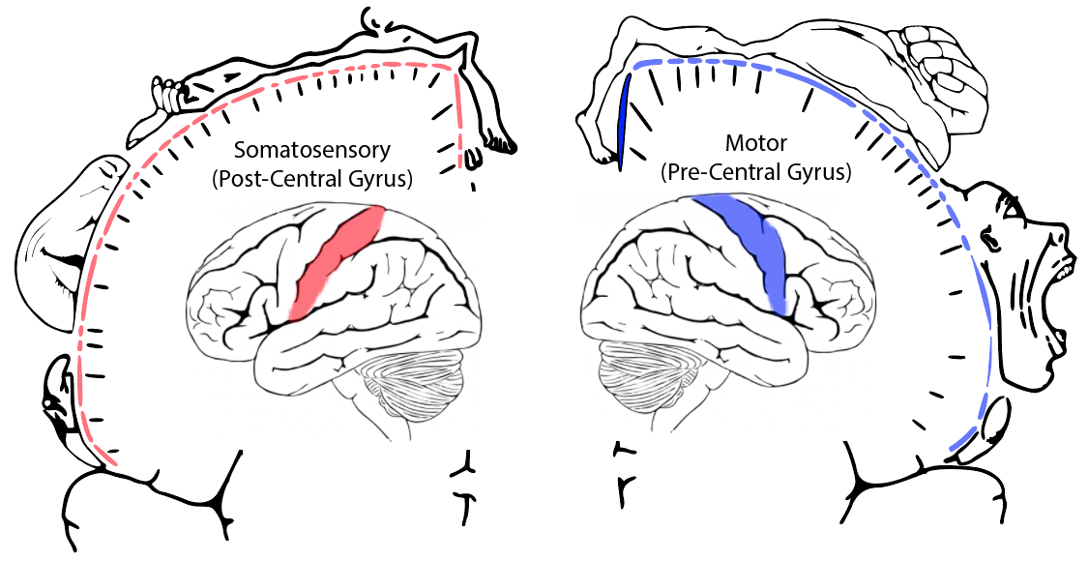

Image created using public domain images from the following sources **https://commons.wikimedia.org/wiki/File:Homunculus-ja.svg; http://cliparting.com/free-brain-clipart-5051/.**

**Image above represents the proportion of the primary motor cortex and the somatosensory cortex that controls different regions of the body. The hands have the largest region of the brain devoted to motor control. The face and hands receive a large amount of sensory information. A map like this is called a homunculus (or topographic diagram).**

#### Sensory and Association Areas

For each of the different senses, there is a region of the cortex designated for perceiving that sense. In figure 5 several of these primary sensory cortexes are labeled.

The primary somatic sensory cortex is located in the postcentral gyrus of the parietal lobe. This region receives sensory information from the skin and from the proprioceptors. It is therefore responsible for perceiving our senses of touch, pressure, temperature and pain, as well as informing us about the position and movement of the body. Note that the word somatic or soma means body. As is seen with the primary motor cortex, the sensory positioning of the body is also represented upside down on the primary somatic sensory cortex. Likewise, the size of the area in the brain devoted to a particular area of the body is dictated by the density of sensory receptors. For example, fingers and lips have large areas in the somatosensory cortex devoted to them compared to the torso or legs. If you want to feel the texture of an object you typically use your fingertips rather than rubbing the object on your leg! The primary visual cortex is located in the occipital lobe. It receives input from the eyes and generates images from the input it receives. The primary auditory cortex is located in the temporal lobe and converts signals coming from the ears into sounds. Not shown on the image is the primary olfactory cortex (smell) which is located at the junction of the temporal and frontal lobes (recall that the division of the cerebrum into lobes was based solely on anatomical position and not on function). Also not shown is the primary gustatory cortex (taste) which is found in the boundary between the insula and frontal lobes. Two other sensory cortexes, the primary visceral cortex and the primary equilibrium cortex are found in the insula.

Near each of the primary sensory cortexes is a sensory association area for that particular sense. As the name implies, these regions help us associate what we are currently sensing with our past experiences. For example, when you see a face after the image is perceived in the primary visual cortex it is sent to the visual association area for recognition. Do I know this person, have I seen this face before, is this person safe or are they a threat? The association areas allow us to make sense of what we are experiencing and react appropriately.

#### Executive Functions

We have been discussing the motor and sensory functions of the cortex, but all animals possess these regions. An important difference between humans and all other species is the development of the prefrontal cortex. This region is well developed only in primates and particularly in humans. It is this part of the brain that is responsible for what have been called executive functions. These include planning, reasoning, abstract thought, self-control, decision making, differentiation between good and bad, between better and best, and in understanding consequences of our actions. In addition, it is thought that our personalities are determined by this region as well as the storage of short-term or working memory. Interestingly, this is the last region of the brain to fully develop and mature. It has been suggested that full development isn't completed until our late teens or early twenties. Did you ever wonder why you did that really stupid thing when you were a teenager? It is likely that at the time you were not completely capable of connecting the action with the consequences. Not that you can use this as an excuse but maybe we should be a bit more patient with children and teenagers, realizing that it may be beyond their capability to think the same way you do.

#### Lateralization of the Hemispheres

As mentioned above the commissural fibers of the white matter allow the two hemispheres to communicate with each other. Many functions, like movement and sensations, are carried out equally between the two hemispheres. It is true that our right hemisphere controls the left side of our bodies and our left hemisphere controls the right side of the body. Sensory information is usually shared between the two hemispheres, which allows for some interesting things to happen, like depth perception and localizing the origin of sounds. A few functions, however, seem to be restricted to one hemisphere or the other. Speech, for example, is a left hemisphere function in most people (there are always exceptions). There are two important cortical regions found in the left hemisphere that do not have counterparts in the right hemisphere. These are **Broca's area** and **Wernicke's area**. Broca's area is located in the frontal lobe (figure above) and is the motor speech area. The ability to speak and write is associated with this region. Damage to Broca's area results in the inability to speak or to write clearly. This is called “expressive aphasia”. Wernicke's area is located in the posterior temporal lobe (actually exists in an area where the temporal and parietal lobes meet) and is required for understanding both spoken and written words. Damage to this region results in the inability to understand spoken or written words. This is called “receptive aphasia”. If you were asked to read this paragraph out loud the following sequence of events would have to happen. Information from the eyes would reach the primary visual cortex where they would be perceived as words. This information would be sent to the visual association area for recognition of the words. A signal would then be sent to Wernicke's area for the words to be understood. Wernicke's area would then send a signal to Broca's area where the words are formulated to be spoken. Broca's area then sends the information to the premotor cortex for programming. Once the motor activity is programmed, it is sent to the primary motor cortex which relays the signals to the muscles involved in generating speech.

Other functions that seem to be more prominent in one hemisphere than the other are analytical skills, which like speech seems to be a left hemisphere function in most people. Similarly, spatial perception and musical ability are more right hemisphere functions in most people. One interesting theory was that left-handed individuals, who are right brain dominant in their motor function, should be more artistically inclined since the right hemisphere is considered the artistic side of the brain. However, studies indicate that handedness does not increase or decrease the likelihood of someone being artistically talented.

Read this online at <https://books.byui.edu/bio_264_anatomy_phy_I/1111_cerebral_cortex>