The Meninges
The body goes to great lengths to feed and protect the central nervous system. Part of the protective mechanism is found in the meninges which are membranes that envelop the central nervous system. The meninges consist of three layers: the duramater, the arachnoidmater (membrane), and the piamater.
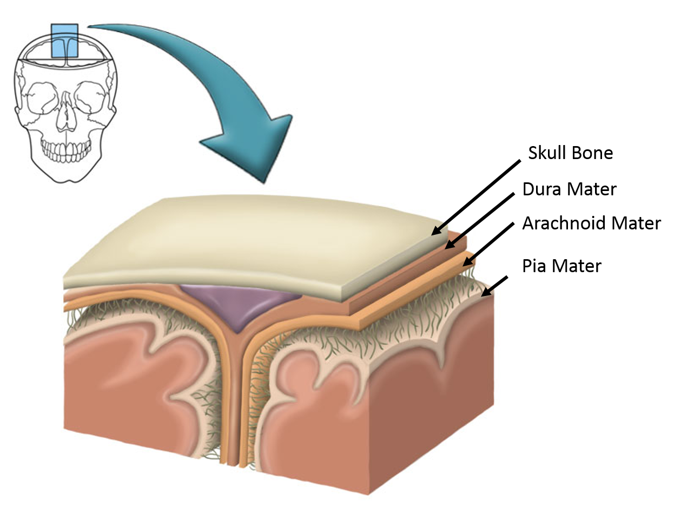
Layers of the Meninges.
Image was drawn by a BYU-Idaho student Winter 2014.

The dura mater is a thick, tough, and durable membrane composed of dense fibrous connective tissue. The dura mater of the brain is composed of two layers, an outer periosteal layer that connects to the inside of the skull, and a deep meningeal layer. In certain areas these two layers separate and the meningeal layer forms folds that extend into the brain forming physical partitions in the brain. The Falx cerebri separates the two cerebral hemispheres, the tentorium cerebelli separates the occipital lobes of the cerebrum from the cerebellum and the falx cerebelli separates the two cerebellar hemispheres.

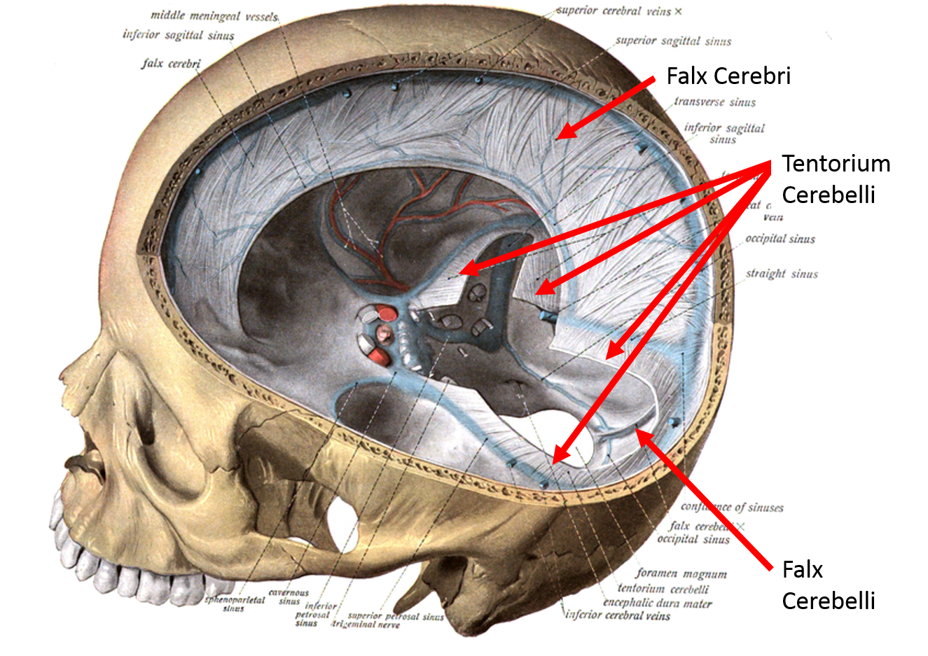
Falx Cerebri, Tentorium Cerebelli, Falx Cerebelli.
From Sobotta's Human Anatomy 1908. Public Domain.

The arachnoid mater or arachnoid membrane is directly under the dura mater. These two membranes are not physically connected and there is a space (more like a virtual space) between the dura mater and the arachnoid mater. The arachnoid mater is a very thin and transparent membrane that lies on top of a fluid filled space directly inferior to the membrane. This space, the subarachnoid space, is filled with cerebrospinal fluid. The arachnoid membrane together with the cerebral spinal fluid helps to cushion the central nervous system and fits like a loose sac over it.
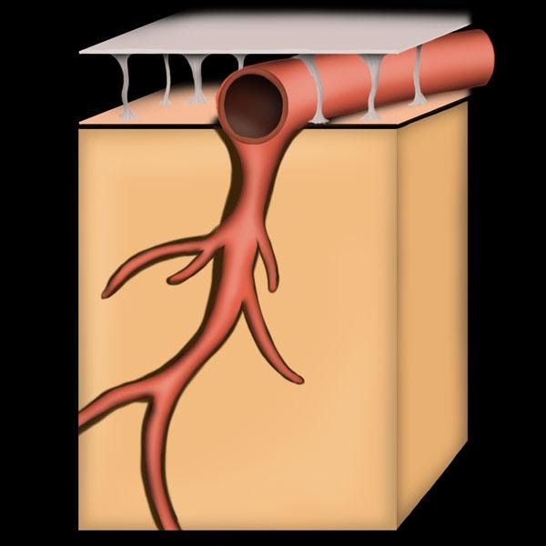
Layers of Brain: Dura Mater, Arachnoid Mater, Subarachnoid Space, Pia Mater, Brain.
Image drawn by BYU-Idaho Student, Spring 2014.

The arachnoid mater got its name from the many processes that extend down from the membrane through the subarachnoid space to the pia mater on the brain surface. These processes are very fine and look a bit like spider web fibers.
The pia mater is a very delicate membrane that adheres to the surface of the brain and spinal cord, following the contours (gyri and sulci) of the brain. The cerebral spinal fluid of the central nervous system sits on top of the pia mater (and underneath the arachnoid membrane).
There are some subtle differences between the meninges of the brain and the spinal cord, primarily with the dura mater. First, the dura mater of the spinal cord is composed of just a single layer, rather than two like we described in the brain. Second, the dura mater does not connect to the bones of the vertebra, instead, there is a space between the vertebra and the dura mater called the epidural space. This space is filled with adipose that acts as a cushion and helps protect the spinal cord.
Read this online at https://books.byui.edu/bio_264_anatomy_phy_I/1151_the_meninges

