# The Layers of the Heart Wall

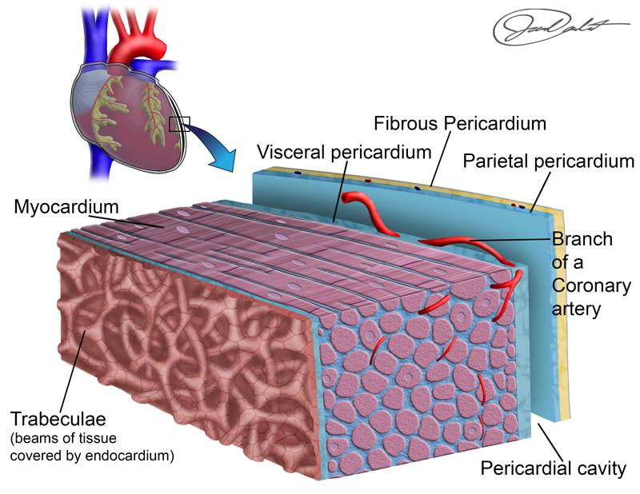

**Layers of the Heart Wall.**

Created by BYU-Idaho student Jared Cardinet Winter 2015

Within the thoracic cavity, the heart is contained or held in place by a fibrous "bag" called the **pericardial sac.** The sac completely surrounds the heart. It is comprised of two serous membranes, one called the parietal (sac side) and the other the visceral (heart side) pericardium. Between the two membranes is a fluid filled space filled with a slippery liquid called pericardial fluid. The fluid allows the two membranes to slide past each other, allowing the heart to move freely within the supportive sac. If injury or damage occurs to the pericardial sac, excessive fluid may enter this pericardial space. This fluid entry can be very dangerous as it may cause a buildup of pressure that compromises efficient pumping of the heart. This condition would be referred to as **cardiac tamponade.** The treatment is to insert a long needle through the chest and into the pericardial space to remove the excess fluid. This treatment is a Hollywood favorite, think of the doctor Christine Palmer who inserts the needle into the chest cavity of Stephen Strange to save his life in the Marvel movie Dr. Strange.

Another purpose of the pericardium is to provide resistance to prevent the distension of the heart from stretching beyond the available pericardial space. The pericardium not only protects the heart from friction and overdistension with each heartbeat, but this bag also anchors the heart into the correct position within the mediastinum, or central part of the thoracic cavity (or chest cavity).

The wall of the heart is comprised of the **epicardium, myocardium,** and **endocardium.** The epicardium is the outer layer of the heart and forms the visceral pericardium. The myocardium is the muscular layer of the heart. The endocardium is the squamous cells that line the inner surface of the heart and are similar to the cells that line the inner surface of blood vessels that the heart is continuous with. The structure of the inner surface of the heart chambers is quite rough in appearance creating folds called **trabeculae.**

Read this online at <https://books.byui.edu/bio_265_anatomy_phy_II/112___the_layers_of_>