Composition of Blood
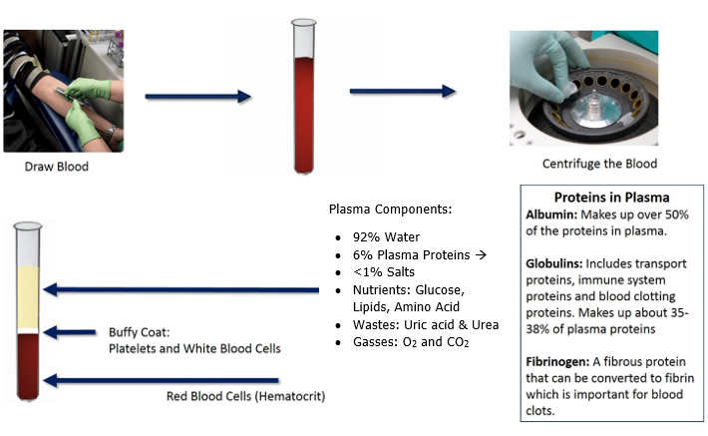
Composition of Blood.
This image was created at BYU-Idaho by J. Shaw in 2013

Plasma makes up about 55% of an average individual's blood volume and is itself composed of around 92% water. Plasma is a type of colloid. A colloid can be a bit difficult to understand because it is actually different from a solution (even though both of these terms refer to the mixture of particles in a solvent like water). A solution is a mixture of very small particles like ions or small molecules in a solvent (like water). Salt ions in water is a good example of a solution. This solution is transparent because the dissolved particles are not tremendously larger than the molecules of the aqueous solvent. A colloid, on the other hand, is a mixture of much larger particles. The particles are not "dissolved" in the aqueous environment, but are homogeneously mixed throughout the solvent. The mixed particles are much larger and tend to scatter light. This means that a colloid is usually going to be cloudy. In the human body, the most common reference to a colloid is proteins in the plasma.

The major colloidal proteins in blood plasma include albumin, globulins, and fibrinogens. Albumin is by far the most abundant plasma protein, comprising around 60% of the total blood proteins. Albumin is largely responsible for maintaining a relatively constant osmotic pressure within the cardiovascular system. Its relatively large size does not allow it to easily pass out of the bloodstream, and its negative charge (polarity) attracts water, thus keeping water inside the vessel instead of being lost to the surrounding tissues. Albumin also serves as a type of transport vehicle for many other substances dissolved in the blood.

Globulin is the next most abundant plasma protein and also plays an important role in transporting substances within the blood. Globulin proteins also include what are often called "antibodies".

Fibrinogen is the least abundant plasma protein and it plays a critical role in coagulation, or clotting. Blood plasma without any clotting factors is known as serum.

The formed element component of blood is comprised of red blood cells, white blood cells and cell fragments (platelets). However, the largest contributor of the formed element portion of blood is the red blood cells. The red blood cells alone make up about 45% of the total volume of blood. When the percentage of total blood that is red blood cells is calculated it is called a hematocrit. Women generally have slightly lower hematocrit than males and living at higher elevations can increase a hematocrit slightly. Running and training in cardiovascular exercise can also cause a slight increase in hematocrit. The white blood cells and platelets make up a much smaller percentage of the total blood volume. In the picture above, these formed elements are found in a thin line between the red blood cells and the plasma. This thin white line is called the "buffy coat" or the "buffy layer".

Read this online at https://books.byui.edu/bio_265_anatomy_phy_II/212___composition_of

