# Clotting (Coagulation) Cascade

Once activated, platelets can accumulate and clump, but to get them to stay put and really form a plug that stops blood fluids from leaking out, requires another process called **coagulation.** As stated earlier this process will activate fibrinogen, a very important protein used to link all of the platelets together. To activate fibrinogen, coagulation requires an array of proteins known as **coagulation factors** or **clotting factors** which are found circulating within the plasma in an inactive state. These factors are typically represented by Roman numerals which indicate the order in which they were identified, but offer no explanation as to their function (yes, sort of annoying but at least they have numbers!). Upon encountering vessel damage, certain of these factors become activated and initiate complex chemical cascades which ultimately lead to the formation of a blood clot. This activation may occur through either an **intrinsic pathway** (within the bloodstream) or an **extrinsic pathway** (outside of the blood stream). Both pathways ultimately lead to a **common pathway** through which a blood clot forms.

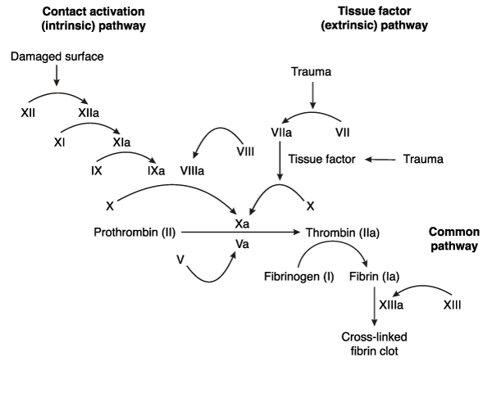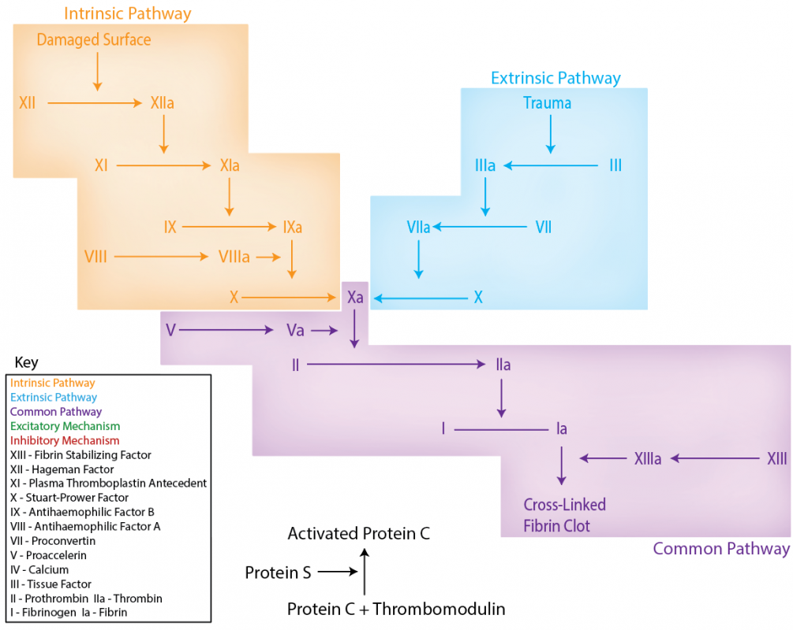

**Coagulation Cascade. The clotting factors are numbered with roman numerals and also have names. The clotting factors with an “a” after the roman numeral are “activated”. Some activated clotting factors have different names from the roman numeral without the “a”.**

Image by Becky T. S20

The chart above shows the cascade of clotting factor activation. The pathway has two entry points to begin the cascade, the "intrinsic" and "extrinsic" pathways. The common pathway begins with the activation of clotting factor X, which is also called "Stuart Factor". The image below is just another artist rendition of the same thing (showing the intrinsic and extrinsic pathways of the clotting cascade).

#### Intrinsic Pathway

When blood vessels incur damage, collagen within the vessel walls is exposed to the circulating bloodstream. Contact with collagen reacts with factor XII which in turn activates factor XI which sequentially initiates factor IX. Factor IX recruits factor VIII, platelet phospholipids, and Ca2+ ion cofactors to form a complex that activates factor X, thereby initiating the common pathway.

#### Extrinsic Pathway

Unlike the intrinsic pathway which is activated by exposed collagen, the extrinsic pathway is activated by chemical signals released by damaged tissues external to the bloodstream. Damage to these tissues destroys cellular plasma membranes yielding a collection of phospholipids and an integral receptor protein known as **tissue thromboplastin** (alternatively known as factor III or tissue factor). As blood rushes into these damaged tissues, circulating molecules of factor VII associate with the released combination of factor III molecules and phospholipids to form an enzymatic complex. Ca2+serves as a required cofactor for the formation of this complex. This complicated enzymatic complex reacts with and activates factor X and the common pathway is again initiated. This factor III, VII, phospholipid and calcium complex are also capable of activating factor IX within the intrinsic pathway, indicating a one-way connection between the two pathways.

#### Common Pathway

Upon activation, factor X joins with factor V, Ca2+, and platelet surface phospholipids to form a **prothrombin activating complex.** This complex targets **prothrombin** (factor II) and converts it to a molecule known as thrombin. Thrombin is an important enzyme which converts a protein known as **fibrinogen** into a fibrous clot forming protein known as **fibrin.**

Fibrin plays a critical role in the formation of a clot by forming a dense, fibrous weave against which blood "congeals" into a thicker, gel-like clot capable of clogging damaged areas of vessels.

The activation of thrombin initiates a positive feedback mechanism, as thrombin is capable of activating numerous factors within the coagulation pathways. Consequently, thrombin exerts a stimulatory effect on its own production. Furthermore, thrombin also activates factor XIII which stabilizes the clot by catalyzing the formation of covalent bonds between fibrin strands. Finally, thrombin initiates additional platelet activation. Thus, the thrombin positive feedback mechanism stimulates further platelet plug proliferation in addition to its coagulation effects.

|  |
| --- |
| Clotting Factors: Number, Name and Description |
| Factor Number | Name | Description |
| I | Fibrinogen | Plasma protein produced by the liver. Fibrinogen can form bridges between activated platelets, but is more known for its major function as a precursor to fibrin. |
| II | Prothrombin | Plasma protein produced by the liver. It is activated by a complex of factor X and V to become thrombin. Thrombin is important because it converts fibrinogen to fibrin. |
| III | Tissue Thromboplastin (Tissue Factor) | This is an integral membrane protein produced by cells outside of the vascular conduits of the circulatory system. It is necessary for the first step of the extrinsic pathway. This protein is a receptor for a plasma protein called factor VII. When exposed to factor VII, a large enzyme complex is formed that can activate factor X (the common pathway). |
| IV | Calcium ions | Required as a cofactor for many of the enzymatic reactions that take place in the clotting cascade. |
| V | Proaccelerin (Labile Factor) | A plasma protein produced by the liver. Factor V is a cofactor that can associate with Factor X and accelerate the conversion of Prothrombin to Thrombin. |
| VI |  | Now known to be just activated Factor V, so a distinct factor VI is no longer considered to exist. |
| VII | Serum Prothrombin Conversion Accelerator (stable factor, proconvertin) | Plasma protein synthesized in the liver. Important in the extrinsic pathway as it helps form an enzyme complex with tissue thromboplastin. |
| VIII | Antihemophilic factor (antihemophilic globulin) | A plasma protein that is synthesized in the liver as well. It is a cofactor with factor IX to activate factor X of the common pathway. Factor VIII is an important component of the intrinsic pathway. |
| IX | Plasma Thromboplastin Component (Christmas Factor) | Another plasma protein synthesized by the liver. It is important for the activation of factor X. This factor is another component of the intrinsic pathway. |
| X | Stuart Factor (Stuart - Prower factor) | Synthesized in the liver and is found as a plasma protein that when activated can form a complex with Factor V, phospholipids and calcium. This complex is the first step of the common pathway and has the job of activating prothrombin to thrombin. |
| XI | Plasma Thromboplastin Antecedent | Another plasma protein synthesized in the liver. It is an important intermediary in the intrinsic pathway as it is responsible for activating factor IX. |
| XII | Hageman Factor | Yet another plasma protein coming from the liver that travels in the blood. It is activated by contact with polyanions (molecules with a lot of negative charges). If a blood vessel has damage to the endothelium, the collagen comes into contact with factor XII. The collagen proteins have multiple negative charges throughout the macromolecule and this is enough to activate factor XII. Factor XII activation is the first step of the intrinsic pathway. |
| XIII | Fibrin Stabilizing Factor | A plasma protein synthesized in the bone marrow. It is thought that the liver can synthesize this as well, but it is unknown how much of a contribution the liver makes with this particular clotting factor. This protein, once activated, can covalently bond with fibrin in a way that "cross links" are formed. This makes the fibrin network insoluble and more stable. |

#### Thrombus vs Embolus

A blood clot, which will include platelets and fibrin, is also called a **thrombus** if it is anchored to the vessel wall where it was created. If this thrombus breaks away from the vessel wall and begins to circulate in the vascular system, it is called an **Embolus** or an Embolism. An embolus can be very dangerous because it may get stuck in a small blood vessel and block blood flow from reaching cells further downstream. Cells die without constant blood flow reaching them. If an Embolus blocks enough blood flow to cells in the heart or the brain, it can quickly become lethal.

Read this online at <https://books.byui.edu/bio_265_anatomy_phy_II/223___clotting_coagu>