Arteries and Veins
“My blood pressure can’t take it any more”. This phrase has been shouted by many a mother in her child raising years! Maybe she meant that she was going to blow up or maybe she meant that her blood pressure would fail until she fainted. After this section you should understand that either would be bad as life depends on a careful homeostatic regulation of blood pressure. The readings in this section will examine the vessels, forces and systems responsible for moving life sustaining blood to all of our trillions of cells. Three main kinds of blood vessels are found in the human body: arteries, capillaries, and veins. Arteries are systemic vessels which transport blood from the left ventricle to cells and tissues throughout the body. The arteries nearest the left ventricle are massive vessels, having walls composed mostly of elastic tissue and to a lesser extent, smooth muscle. As blood travels further through the system, the arteries become increasingly branched and decrease in size. As this branching occurs, arterial wall composition changes as well, incorporating more smooth muscle and less elastic tissue. Owing to this change in composition, arteries are categorized from largest to smallest as elastic arteries, muscular arteries, and finally arterioles. Arterioles are particularly sensitive to neural and endocrine influences. Arterioles change diameter under these influences and this impacts the amount of resistance to blood flow. Blood within arterioles courses into the smallest type of vessels known as capillaries. Capillary walls are extremely thin which allows the blood to exchange oxygen, nutrients, and waste products with surrounding cells and tissues. Capillaries connect the arterial blood flow to veins, which transport blood from the cells and tissues of the body back to the right atrium of the heart. Veins are categorized from smallest to largest as venules, small veins, and medium/large veins. Venous wall composition differs from arterial wall composition because they have less smooth muscle and elastic tissue.

Tunica Adventitia
The outermost tunica adventitia is made up of connective tissue which vary in consistency and tissue type based on depth. The deepest layers are composed of dense connective tissue while the outermost layers are composed of loose connective tissue continuous with that of the surrounding tissues.

Tunica Media
The tunica media is the most variable of all the layers between different types of arteries. It is composed of circular bands of smooth muscle cells which can contract or relax and change a vessel's diameter. The tunica media also contains various amounts of elastic and collagen fibers. An elastic layer known as the external elastic membrane divides the tunica media from the tunica adventitia. This layer is especially prominent in large vessels like the aorta.

Tunica Intima
The innermost tunica intima is composed of an endothelial layer, a connective tissue basement membrane and a slim layer of connective tissue known as the lamina propria. An elastic layer known as the internal elastic membrane divides the tunica intima from the tunica media.
Vasa Vasorum
Recall that blood vessels exist because all cells within the human body require oxygen, nutrients, and the disposal of waste products in order to survive. Considering that the vessels themselves are composed of living cells many layers thick, they are not exempt from these requirements. The requirements of vessels under 1 mm in diameter are easily satisfied by diffusion between the lumen of the vessel and its surrounding layers. However, vessels larger than this size must be sustained by a capillary network of vessels known as vasa vasorum within the tunica adventitia and tunica media layers.
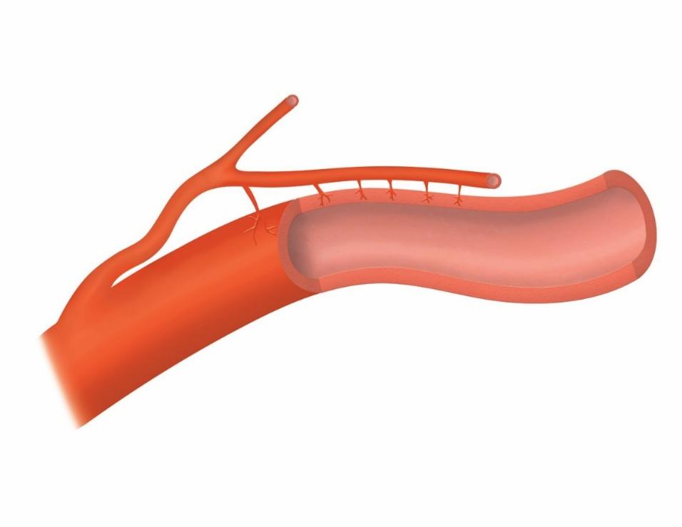
Vasa Vasorum. This image was drawn by BYU-Idaho student Nate Shoemaker Spring 2016.

Elastic arteries
Elastic arteries are the largest type of artery in the body, possessing a tunica media composed of many elastic fibers and relatively few smooth muscle cells. This elastic nature is critical due to close proximity to the heart. Stretching is required in order to accommodate alternating periods of high and low-pressure blood flow as the ventricles contract and relax. The tunica intima is quite thick and contains a high concentration of elastin fibers as well.

Muscular arteries
Muscular arteries are intermediate arteries (meaning between large elastic arteries and small arterioles). The tunica media is composed of fewer elastic fibers but more smooth muscle cells compared to elastic arteries. The tunica media is predominantly composed of many layers of smooth muscle which allows for greater control of vessel diameter. The tunica intima is thinner than that of an elastic artery. Keep in mind that the category of muscular arteries includes medium and small-sized arteries, with a wide range in size from 40 µm to 300 µm (A human hair is about 100 µm in size).

Arterioles
Arterioles are the smallest type of artery and are similar in composition to muscular arteries. The tunica adventitia is extremely thin and devoid of an external elastic membrane. The tunica media is composed of smooth muscle tissue, but contains few layers. The tunica intima does not have an internal elastic membrane.

Veins

Venules
Venules are the smallest type of vein. Venules receiving blood directly from capillaries are very similar to the capillaries themselves. As the venules increase in size, an increasing number of smooth muscle cells are found surrounding the tunica intima.

Small Veins
Once venules reach a certain diameter, a tunica media layer of smooth muscle cells completely surrounds them. At this point they are known as small veins. A tunica adventitia layer of collagen fibers is also found surrounding the smooth muscle tissue of the tunica media. All veins tend to be larger than arteries at a similar point in the vascular tree. This is because veins have thinner walls and Tunica layers. These thin layers allow veins to stretch a lot. This ability to stretch is called “compliance”. Veins have a lot more compliance than arteries.

Medium/Large Veins
The tunica adventitia is the thickest layer of large and medium veins and is composed mainly of connective tissues. The tunica media incorporates a thin layer of smooth muscle cells and, to a lesser extent, collagen and elastic fibers.

Valves
Valves are common components of medium and large veins greater than 2 mm in diameter. A valve is formed by two overlapping sections of tunica intima tissue that converge to close off their respective vein should backflow occur. Valves are far more prevalent in medium veins and in veins of the legs than in veins of the arms. Sometimes valves can be stretched if there are excessive amounts of pressure in the vein. This can sometimes happen if a person stands or sits for long periods of time (over many months and years). In these situations, blood can have a hard time moving up the venous vessels because of gravity or compression of lower extremity soft tissue. We tend to find more valves in the veins of the lower extremities. This is likely because we spend so much time upright and gravity pulls on the venous blood. Having more valves will allow more "gates" that blood would have to move past to descend downward toward the feet (under the pull of gravity).

Read this online at https://books.byui.edu/bio_265_anatomy_phy_II/241___arteries_and_v

