# Structure of Hair

In cross section, each strand of hair or **pilus (pili = pleural)** is made up of three regions, the medulla, cortex, and cuticle ([Figure Link Structure of Hair](https://images.search.yahoo.com/images/view;_ylt=AwrTcXZ.nLlU1E4Ay0SJzbkF;_ylu=X3oDMTIzbjhkY2YzBHNlYwNzcgRzbGsDaW1nBG9pZANjODZiOThiNTVjNjA1YTY2OGJhODg0YmQ2N2FmNjZjYwRncG9zAzE1BGl0A2Jpbmc-?.origin=&amp;back=https%3A%2F%2Fimages.search.yahoo.com%2Fyhs%2Fsearch%3Fp%3Dhair%2Bshaft%26n%3D60%26ei%3DUTF-8%26fr%3Dyhs-mozilla-001%26fr2%3Dsb-top-images.search.yahoo.com%26ri%3D15%26hsimp%3Dyhs-001%26hspart%3Dmozilla%26tab%3Dorganic%26ri%3D15&amp;w=261&amp;h=228&amp;imgurl=hair-and-makeup-artist.com%2Fwordpress%2Fwp-content%2Fuploads%2F2013%2F04%2FHair-Shaft.jpg&amp;rurl=http%3A%2F%2Fhair-and-makeup-artist.com%2Fcolour-theory-hairdressing%2F&amp;size=12.8KB&amp;name=%3Cb%3EHair+Shaft%3C%2Fb%3E&amp;p=hair+shaft&amp;oid=c86b98b55c605a668ba884bd67af66cc&amp;fr2=sb-top-images.search.yahoo.com&amp;fr=yhs-mozilla-001&amp;tt=%3Cb%3EHair+Shaft%3C%2Fb%3E&amp;b=0&amp;ni=200&amp;no=15&amp;ts=&amp;tab=organic&amp;sigr=11tvhar4t&amp;sigb=15g93iqjj&amp;sigi=12eudujmq&amp;sigt=10hjglfr9&amp;sign=10hjglfr9&amp;.crumb=v6GfDSN/zG8&amp;fr=yhs-mozilla-001&amp;fr2=sb-top-images.search.yahoo.com&amp;hsimp=yhs-001&amp;hspart=mozilla)). The **medulla** or center of the hair shaft is composed of two or three layers of cells surrounded by air spaces. The keratin in these cells is the same as found in the epidermis and is called soft keratin. The bulk of the hair shaft is the **cortex.** This region has many layers, depending on the thickness of the hair. The diameter of human hair varies from 17 to 180 micrometers. The cortex is highly structured and is important for strength, shape and hair color. The keratin in these cells is tougher and less pliable than that found in the epidermis and is called hard keratin. The shape of the hair shaft determines whether the hair is straight, wavy or curly. In people with straight hair the shafts are round. Those with wavy hair have oval shaped shafts, while curly hair fibers are more ribbon shaped. The shape of the hair shaft is ultimately determined by the shape of the follicle. The final, outer layer of the hair shaft is the **cuticle.**

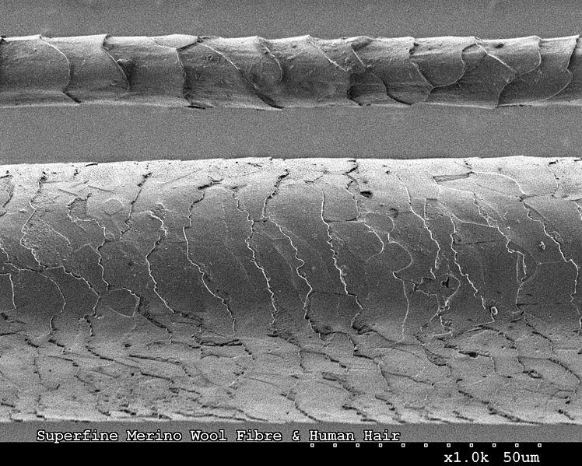

**Hair Cuticle.** CSIRO [CC BY 3.0 (http://creativecommons.org/licenses/by/3.0)], via Wikimedia Commons Link: https://upload.wikimedia.org/wikipedia/commons/2/2c/CSIRO_ScienceImage_8115_Human_hair_and_Merino_wool_fibre.jpg

It is composed of a single layer of cells that overlap each other like the shingles of a roof. The other layer of the hair follicle has a complementary structure of overlapping cells that secure the hair in the follicle. The portion of the pili that extends above the surface of the skin is called the shaft and the part that is below the surface is the root. Structurally the shaft and the root are identical.

#### Hair Follicle

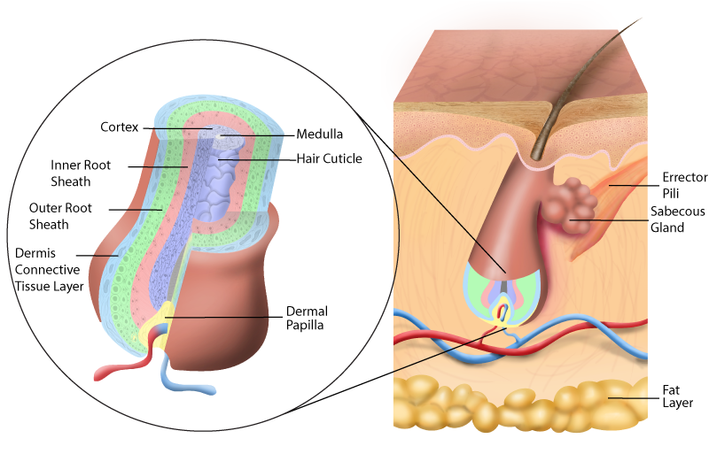

**Hair Anatomy. The text describes these layers. The brown color on the outside of the follicle is not a layer but made brown to distinguish the hair follicle from the surrounding connective tissue. It would be ok and accurate to consider the outermost brown color to be part of the dermis connective tissue layer.**Image drawn by BYU-Idaho student Austin Dean Spring 2016

The **hair follicle** is the structure from which the hair grows and it also anchors the hair to the skin. This structure extends down into the dermis of the skin. As we move from the outside toward the center of the follicle we will cross three layers. The outermost layer is the **dermal root sheath (also called dermis connective tissue layer),** which is the layer of the dermis that surrounds the follicle. Next, we pass through the **external epithelial root sheath (also called the outer root sheath).** This layer is a continuation of the epidermis that follows the follicle down into the dermis. The portion nearest the surface has all of the layers of the epidermis but as it descends into the follicle it begins to lose layers until the base of the follicle only the stratum basale remains. The innermost layer of the follicle is the relatively thin **internal epithelial root sheath (also called the inner root sheath).** As mentioned above, this layer has overlapping cells that match those of the cuticle and secure the hair to the follicle. The deepest portion of the follicle is enlarged in the previous picture and is known as the **hair bulb.** Within the hair bulb is the hair matrix, a dome-like structure of highly proliferative keratinocytes, which partially surround a cluster of specialized dermal fibroblasts called the **hair papilla.** Within the hair papilla are the capillaries that nourish the cells of the matrix and the newly formed hair cells. Hair growth begins inside the follicle within the matrix and as new cells are formed the older ones are pushed toward the surface and the hair grows. The cells that are produced are keratinocytes, like the cells of the epidermis. They undergo similar changes as those seen in the epidermis, hence, the hair shaft is considered to be a modified stratum corneum.

Associated with the hair follicle are the **arrector pili muscles.** This band of smooth muscle attaches to the base of the follicle and angles up to the underside of the epidermis. Arrector pili muscle contraction is triggered by cold temperatures and by sympathetic activity. When these muscles contract, the hair follicle is pulled up and more vertical resulting in our hair standing up and the follicle pushing up out of the skin (goosebumps). The reason for this is twofold. First, when it is cold it increases the height of the hair, increasing its insulation factor. Second, during flight-or-fight situations it makes the animal seem larger to intimidate a possible attacker.

The variation in hair color is determined by the same variations in melanin that impact skin color: the quantity of eumelanin (black & browns) and pheomelanin (orange & reds). Hair may gradually darken as we age and eventually melanin may cease to be produced at the hair root and new hairs will grow without pigment turning the hair gray or white. Besides genetics, stress, medical conditions (albinism, vitiligo, pernicious anemia), malnutrition, tobacco smoking can lead to premature graying.

Read this online at <https://books.byui.edu/bio_265_anatomy_phy_II/422___structure_of_h>