Gas Laws Important in Gas Exchange
So far we have learned that Oxygen is inhaled into the lungs and then moves into the bloodstream for transport and eventually out of the bloodstream and into the tissues. We have also learned that Carbon dioxide is released by the tissues and travels the reverse route and is ultimately exhaled. To understand how these gasses move through the different areas in the body, it is important to discuss Dalton's and Henry's gas laws.

Dalton's law
Dalton's law states that individual gasses in a mixture of gasses exert partial pressures and that by adding each partial pressure of the mixture, the total pressure exerted by the mixture of gasses can be determined.

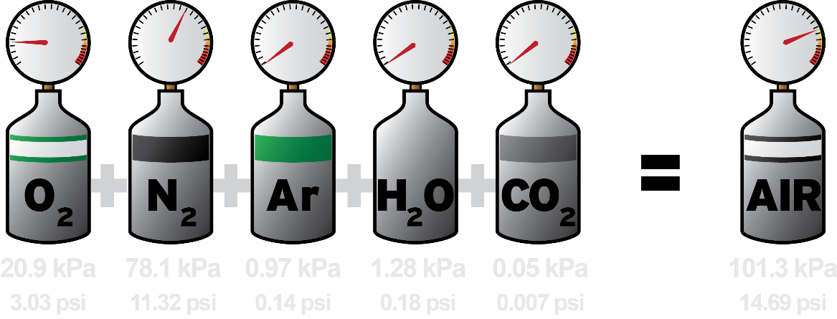
Dalton’s Law: The total pressure of air is the sum of the partial pressure of each gas.
By Max Dodge (Own work) [CC BY-SA 4.0 (https://creativecommons.org/licenses/by-sa/4.0)], via Wikimedia Commons Link: https://commons.wikimedia.org/wiki/File%3ADalton's_law_of_partial_pressures.png

At sea level, the total pressure of the different gasses in the atmosphere pushing down on us is 760 mm Hg or 1 atm. Nitrogen makes up 78.6% of this gas, oxygen 20.9%, carbon dioxide 0.04%, and water 0.46%. Each one of these gasses contributes a portion to the total atmospheric pressure. We can determine their partial pressure by multiplying their percentage by 760 mm Hg.

Atmosphere
Nitrogen partial pressure = 78.6 % X 760 mmHg = 597 mmHg
Oxygen partial pressure = 20.9 % X 760 mmHg = 159 mmHg
Carbon dioxide partial pressure = 0.04 % X 760 mmHg = 0.3 mmHg
Water partial pressure = 0.46 % X 760 mmHg = 3.5 mmHg
Partial pressures in the alveoli for air is different than those of the atmosphere for several reasons including: 1) the air is humidified by respiratory structures on the way to the alveoli so the partial pressure of water becomes greater; 2) oxygen readily enters the blood at the alveoli so it is decreased; carbon dioxide enters the alveoli from the blood so it is increased; 3) and alveolar gasses are only partially replaced by air from the atmosphere with each inhalation.
Alveoli
Nitrogen partial pressure = 74.9 % X 760 mmHg = 569 mmHg
Oxygen partial pressure = 13.7 % X 760 mmHg = 104 mmHg
Carbon dioxide partial pressure = 5.2 % X 760 mmHg = 40 mmHg
Water partial pressure = 6.2 % X 760 mmHg = 47 mmHg
Gasses are transported to and from the lungs by the blood which is a liquid.

Henry’s Law
Henry's law describes the factors that determine whether or not a gas will dissolve in a liquid. The following two factors determine how readily a gas will enter a liquid.

- The partial pressure of the gas surrounding the liquid. If the pressure of the gas around the liquid is high, movement of the gas into the liquid will be favored.
- The solubility of the gas in a particular liquid or the tendency of the gas to "dissolve" in a liquid. Carbon dioxide is about 24 times more soluble in water compared to oxygen, and nitrogen is half as soluble as oxygen.

To summarize Henry's Law:

Gas Pressure X Coefficient of Solubility = Dissolved Gas Concentration

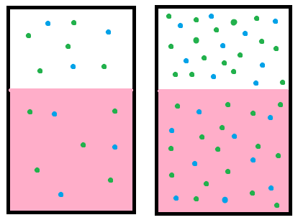
Henry’s Law: When a gas is in contact with the surface of a liquid, the amount of the gas which will go into solution is proportional to the partial pressure of that gas and how soluble that gas is. Author: Boundless License: Public Domain Creative Commons.Link: https://courses.lumenlearning.com/boundless-ap/chapter/gas-laws/

During respiration, Henry’s law predicts how gas is exchanged in the alveoli and the bloodstream. The amount of oxygen that will dissolve is proportional to the partial pressure of oxygen. Because the partial pressure of oxygen is greater in the alveolar air than in deoxygenated blood, oxygen will dissolve into the blood. Carbon dioxide is just the opposite and has a greater partial pressure in the deoxygenated blood than in the alveolar air, so it will diffuse out of the solution and back into a gas in the alveoli. Because carbon dioxide has a much higher solubility in the blood than oxygen (24 times more), the difference in the partial pressures between the bloodstream and the alveoli can be much smaller (See Fig. Gas gradients in the next section). Because there is a wider difference in partial pressure gradients for oxygen, it’s lower solubility isn’t a problem during gas exchange.
*Note: Atmospheric pressure increases by about 760 mmHg per each 33 feet divers descend below sea level. Upon descending 100 feet, the partial pressure of each gas is 4 times that at sea level, so according to Henry's law, nitrogen will more easily dissolve in the blood at these depths. As a diver ascends, nitrogen becomes less soluble, bubbles out of the blood, and may cause clots or damage tissue (the bends).

Read this online at https://books.byui.edu/bio_265_anatomy_phy_II/532___gas_laws_impor

